Student Name ____________________________________ Date ____________

Brrr…Baby It’s Cold Outside
Dear Parent,
We are learning to write a sentence that describes a scene. I hope you enjoy this activity with your child. This assignment is due ____________________________. Thank you!

LET’S DO THIS

- Ask your child: Tell me a few things that are happening in this winter scene.

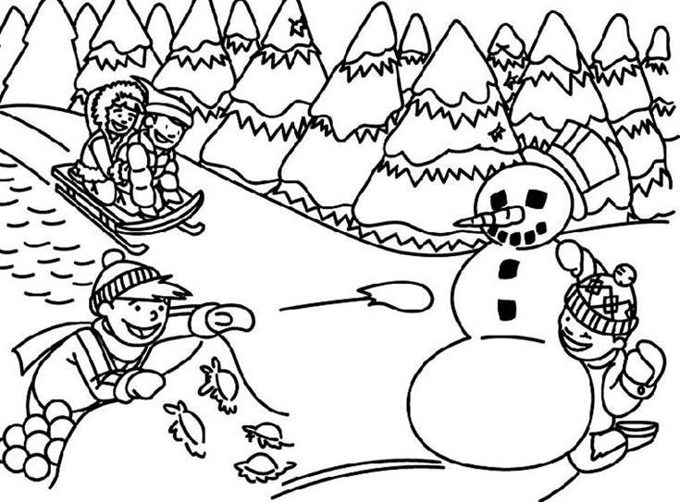



LET’S FIND OUT

- Ask your child: We can write a sentence about what you see.
Tell me 1 sentence about something that is
happening in the picture on the front page.

Say your sentence, word by word, and write it down.
(You may help your child sound out and write his or her sentence.)

_______________________________________________________________

_______________________________________________________________.

- Point to each word and ask your child to read the sentence to you.

- With your child: Look out the window.
Ask your child: Tell me one sentence to compare what you see from our
window with the winter scene in the picture.

Say your sentence, word by word, and write it down.
(You may help your child sound out and write his or her sentence.)

_______________________________________________________________

_______________________________________________________________.

- Point to each word and ask your child to read the sentence to you.

HOME-TO-SCHOOL COMMUNICATION

Dear Parent,

Please give your reactions to your child’s work on this activity.
Write YES or NO for each statement.
______ 1. My child understood the homework and was able to complete it.
______ 2. My child and I enjoyed the activity.
______ 3. This assignment helped me know what my child is learning in class.

Comment ________________________________________________________________________

Parent Signature __________________________________________________________________

Sampish, A., Wallace, R., Epstein, J., & Greenfeld, M. (2016). Teachers Involve Parents in Schoolwork (TIPS) Interactive Homework-Literacy K-3. Colorado Series. Baltimore: Center on School, Family, and Community Partnerships, Johns Hopkins University.

