Student Name ____________________________________________ Date __________________

Get Moving!
Dear Parent,
We are learning that words have meanings and help us describe things. We are thinking about different forms of transportation. I hope you enjoy this activity with your child. This assignment is due ____________________________. Thank you!

LET’S DO THIS

1. Talk with your child: Let’s talk about a few ways that people travel
from one place to another.

2. Sing with your child: Here are a few easy songs about transportation.
Which one should we sing?

TRAIN BOAT BUS
Down By the Station  Down by the station  Early in the morning  See the little pufferbellies  All in a row.  See the station master  Turn the little handle.  Puff, puff! Toot, toot!  Off we go! | Row, Row, Row Your Boat  Row, row, row your boat  Gently down the stream.  Merrily, merrily, merrily,  merrily –  Life is but a dream. | The Wheels of The Bus  The wheels of the bus go  round and round,  Round and round,  round and round.  The wheels of the bus go  round and round  All through the town.
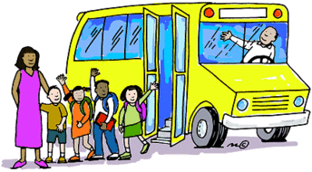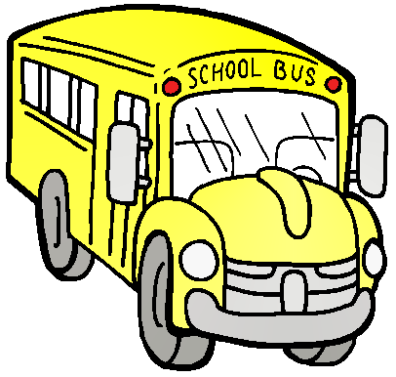

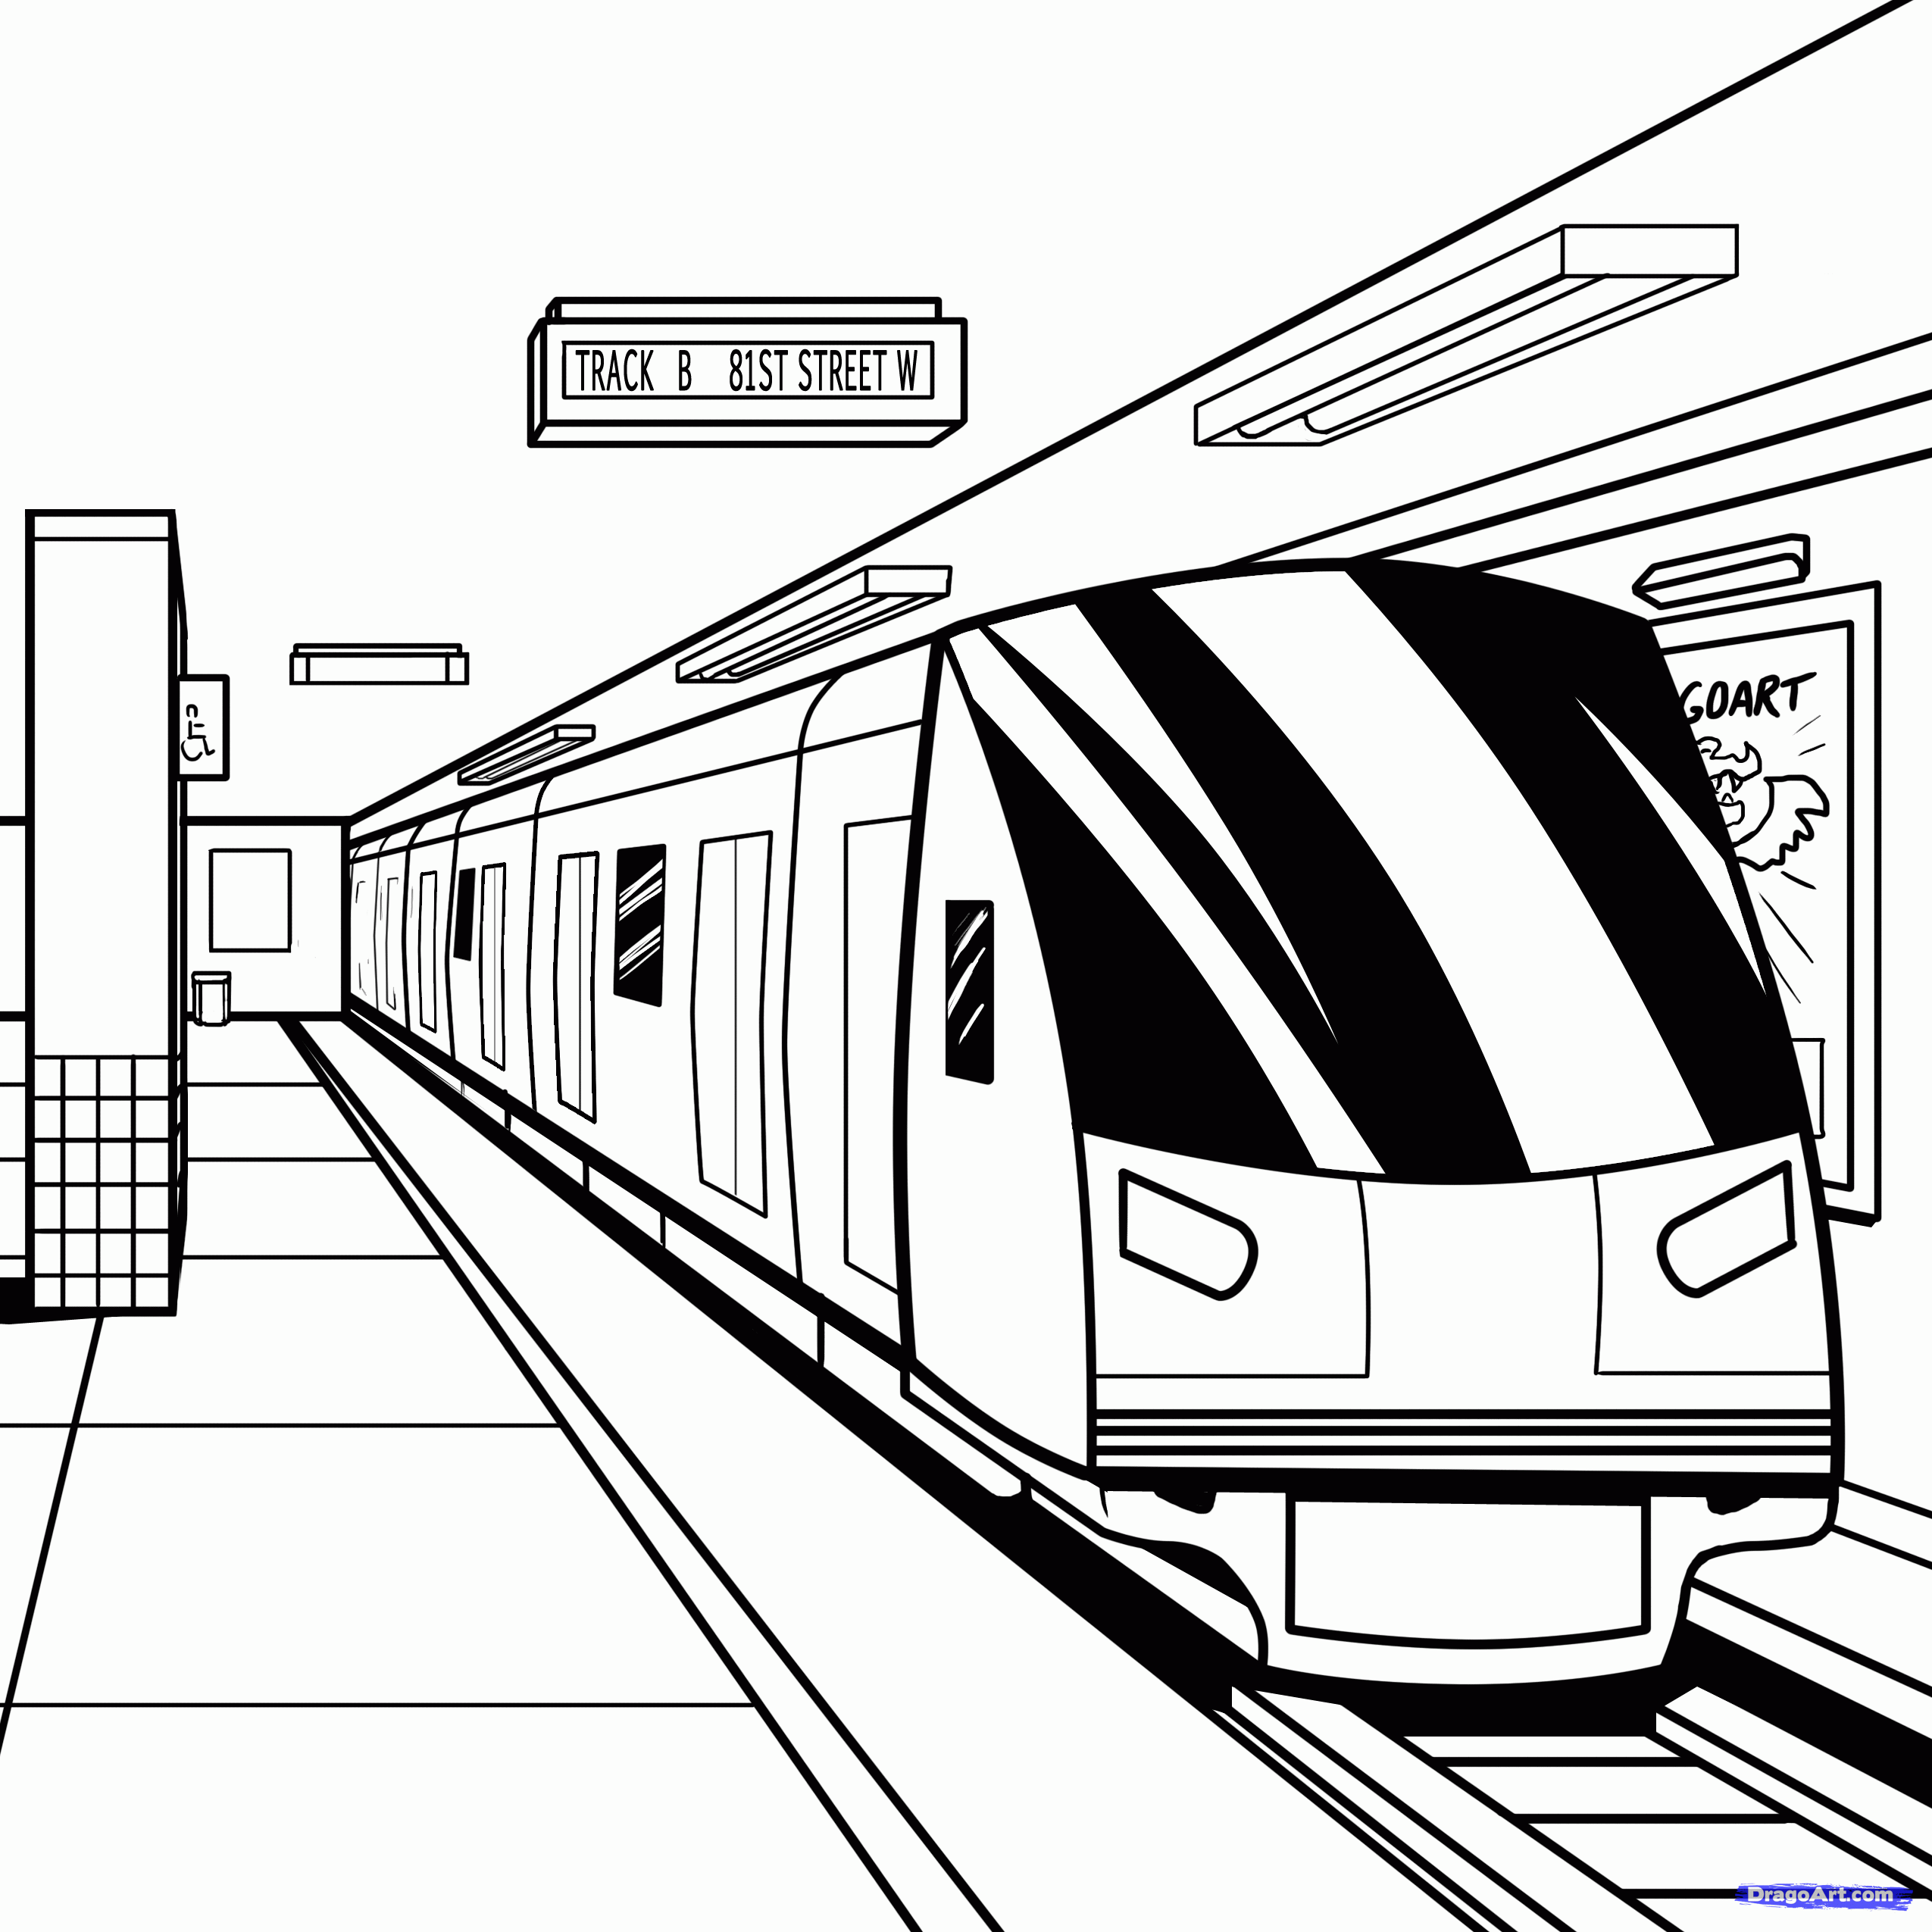
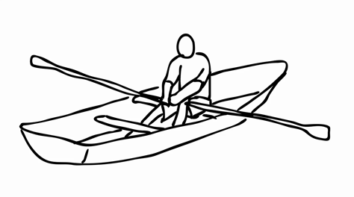

Do you know another transportation song that you like to sing?

Teach the song to your child and sing it together.

LET’S FIND OUT

- Ask your child: What means of transportation did you use to get to school today?

How did it feel to move in this way?

What did you do on the way to school?

What things happened on the way to school?

What transportation would be silly to use to get to school?
Why would that be a silly way to go to school?

2. Ask your child: What are different kinds of transportation that we use in our family?

Why do we use these different ways to move from place to place?

3. Ask your child: What are 5 different kinds of transportation?

Please write them here.
Talk about how each one moves.

- ______________________________
- ______________________________
- ______________________________
- ______________________________
- ______________________________

Draw your favorite form of transportation.

HOME-TO-SCHOOL COMMUNICATION

Dear Parent,

Please give your reactions to your child’s work on this activity.
Write YES or NO for each statement.
______ 1. My child understood the homework and was able to complete it.
______ 2. My child and I enjoyed the activity.
______ 3. This assignment helped me know what my child is learning in class.

Comment ________________________________________________________________________

Parent Signature __________________________________________________________________
Sampish, A., Wallace, R., Epstein, J., & Greenfeld, M. (2016). Teachers Involve Parents in Schoolwork (TIPS) Interactive Homework-Literacy K-3. Colorado Series. Baltimore: Center on School, Family, and Community Partnerships, Johns Hopkins University.

