Student Name ____________________________________ Date_________________

Now Featuring…
Dear Parent:
We are learning about the features that help us understand non-fiction text. I hope you enjoy this activity with me. This assignment is due _____________________________.
Sincerely,
___________________________
Student Signature

THINGS TO REMEMBER

There are several kinds of helpful features in non-fiction, informational text.
- Caption – explains a picture
- Map - shows a location
- Heading - tells what the paragraph is about
- Graphic or picture - shows something about the topic
- Glossary - tells the meaning of words

LET’S DO THIS

- Work with a family partner. Who is working with you? ______________________

Talk with your family partner about what you both know about dolphins.

YOU fill in up to 2 things in the first two sections of the chart BEFORE reading the paragraph.

What We Know NOW What We Want to Know What We Learned by Reading
1. | 1. | 1.
2. | 2. | 2.

- Read the paragraph aloud to your family partner.
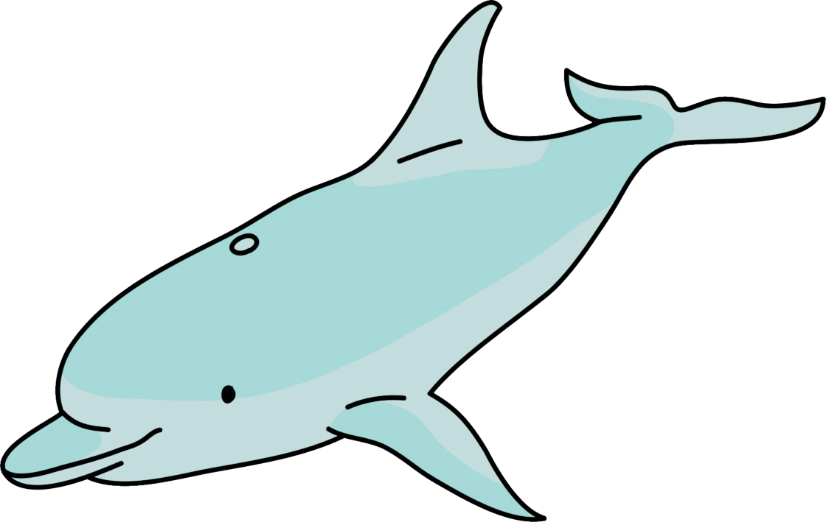

DOLPHINS
Dolphins are marine mammals. That means that they breathe air, have live young, feed their babies milk, and are warm-blooded even though they live in the ocean. Dolphins have a blowhole on the top of their heads that allows them to breathe when they come to the surface of the water. They live in pods or groups of up to 12 dolphins. Dolphins are carnivorous, which means that they eat meat. Female dolphins are called cows and males are called bulls. Dolphins communicate by making clicking and whistling sounds.

LET’S FIND OUT

- Talk with your family partner about new information that you learned by reading the paragraph.

- Add two things that you both learned to the last section of the chart.

With your family partner, discuss the picture below.

Together, write a caption under the picture using information from the story.
Remember, a caption explains the picture using facts from the story.

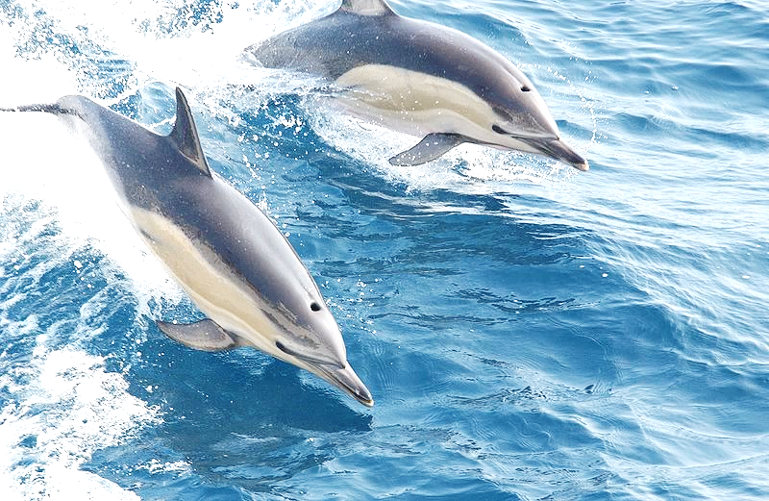

Our Caption

_____________________________________________________________

_____________________________________________________________

HOME-TO-SCHOOL COMMUNICATION

Dear Parent,

Please give your reactions to your child’s work on this activity.
Write YES or NO for each statement.
______ 1. My child understood the homework and was able to complete it.
______ 2. My child and I enjoyed the activity.
______ 3. This assignment helped me know what my child is learning in class​.

Comment ________________________________________________________________________

Parent Signature ________________________________________________________________

Marshall, J.M., Izzo, A., Schimmel, I., Epstein, J. L., Greenfeld, M. (2016). Teachers Involve Parents in Schoolwork (TIPS) Interactive Homework, Literacy K-3. Colorado Series. Baltimore: Center on School, Family, and Community Partnerships, Johns Hopkins University.

Photo credit: NOAA NMFS (2004). Common dolphin, NOAA’s Ark-Animal Collection. Retrieved from http://www.photolib.noaa.gov/htmls/anim0916.htm

