Student Name____________________________________ Date____________

It All Adds Up
Dear Parent,
We are learning to summarize a fictional story. I hope you enjoy this activity with me.
This assignment is due ________________________________.
Sincerely,
___________________________
Student Signature

\
THINGS TO REMEMBER

A summary is a short version of a story.
It tells the main idea and most important events.
To summarize a story, we may follow a pattern.
- Tell the title of the story.
- Tell what the main character wants or needs.
    - Tell the main problem that comes up.
        - Tell how the problem is solved and the story ends.
LET’S DO THIS

- Work with a family partner. Who is working with you? _____________________
Read aloud to your family partner the summary plan and the written summary
of The Three Little Pigs.

SUMMARY PLAN
Name it: The Three Little Pigs

Someone wanted: The big, bad wolf wanted to eat the three pigs.

But (problem): The three pigs lived in houses made of straw, sticks, and bricks.

So: (solution): The big bad wolf blew down the houses made of straw and sticks.
All of the pigs ran to the house of bricks.

In the end: The big, bad wolf could not blow down the house made of bricks.
All of the pigs were safe.

WRITTEN SUMMARY

In the story The Three Little Pigs, the big, bad wolf wanted to eat the piggies. The pigs lived in houses made of straw, sticks, and bricks. The wolf blew down the houses made of straw and sticks. All the pigs ran to the house of bricks. In the end, the big, bad wolf could not blow down the brick house. The pigs got the better of the wolf and they all were safe.

LET’S FIND OUT

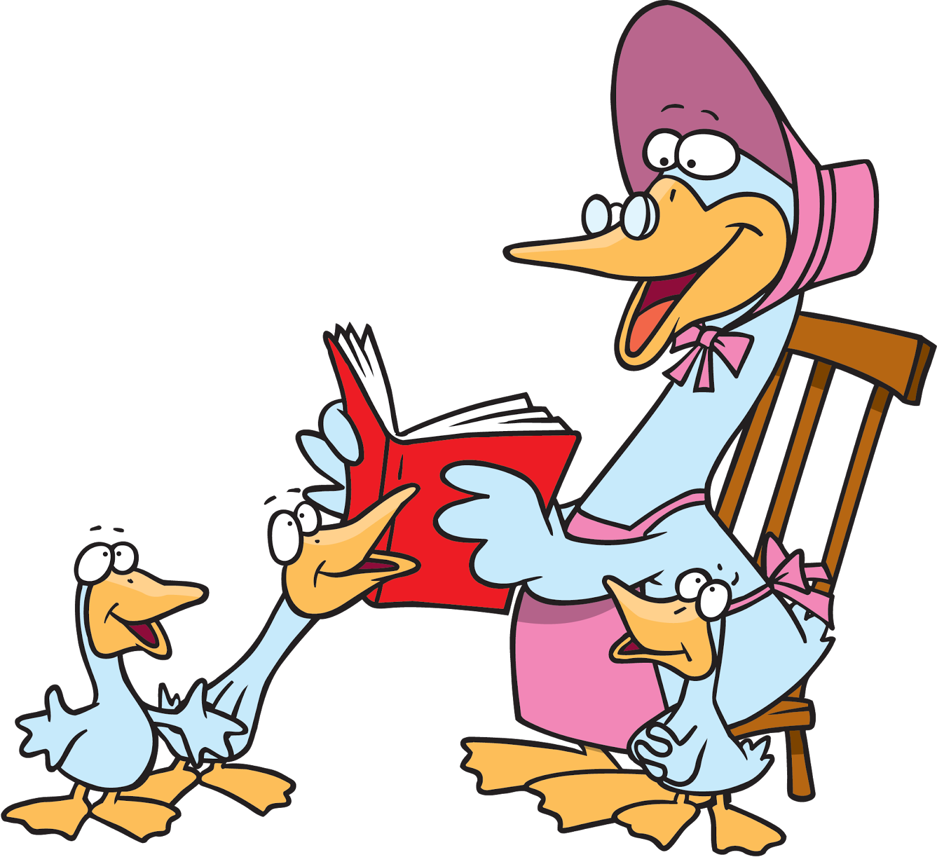
- Ask your family partner to tell you their favorite children’s story.
You fill out a SUMMARY PLAN.

SUMMARY PLAN

Name it:________________________________________
Someone wanted: ____________________________________________
But (problem): _______________________________________________
So (solution): ________________________________________________
In the end: __________________________________________________

Now, write a summary of the story with complete sentences.
Use your PLAN as a guide.

Summary:____________________________________________________

____________________________________________________________

____________________________________________________________

____________________________________________________________

____________________________________________________________
Read your summary to your family partner to see if you heard the story correctly.
HOME-TO-SCHOOL COMMUNICATION

Dear Parent,

Please give your reactions to your child’s work on this activity.
Write YES or NO for each statement.
______ 1. My child understood the homework and was able to complete it.
______ 2. My child and I enjoyed the activity.
______ 3. This assignment helped me know what my child is learning in class​.

Comment ________________________________________________________________________

Parent Signature __________________________________________________________________

Marshall, J.M., Izzo, A., Schimmel, I., Epstein, J. L., Greenfeld, M. (2016). Teachers Involve Parents in Schoolwork (TIPS) Interactive Homework-Literacy K-3. Colorado Series. Baltimore: Center on School, Family, and Community Partnerships, Johns Hopkins University.

