Student Name____________________________________ Date ________________

New Words from Old
Dear Parent,
We are learning new words by adding prefixes to the beginning of a base word or root word.
I hope you enjoy this activity with me. This assignment is due __________________________.
Sincerely,
___________________________
Student Signature
- With your family partner, complete the table below.
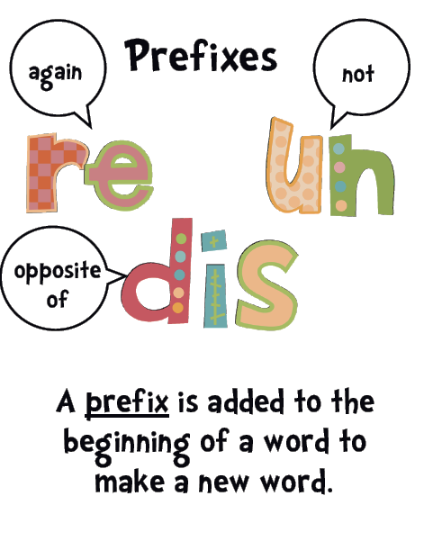
LET’S DO THIS

3 examples done for you. Build the missing new words.
Write the prefix, new word, and meaning of the new word.

Add the Prefix un- | ROOT  WORD | NEW  WORD | Definition
un- = not | happy | unhappy | not happy
 | lucky
 | fair
Add the Prefix re- | ROOT  WORD | NEW  WORD | Definition
re- = again | read | reread | read again
 | build
 | name

Add the Prefix dis- | ROOT  WORD | NEW  WORD | Definition
dis = not | like | dislike | does not like
 | obey
 | agree

LET’S FIND OUT

- Think of other words that you use. Give 1 more word for each prefix.
PREFIX | ROOT WORD | NEW WORD | Meaning of NEW WORD
un-
re-
dis-

- Write 1 complete sentence for each new word.

____________________________________________________________________________

____________________________________________________________________________

____________________________________________________________________________

Read the sentences to your family partner.
HOME-TO-SCHOOL COMMUNICATION

Dear Parent,
Please give your reactions to your child’s work on this activity.
Write YES or NO for each statement.
______ 1. My child understood the homework and was able to complete it.
______ 2. My child and I enjoyed the activity.
______ 3. This assignment helped me know what my child is learning in class​.
Comment ________________________________________________________________________

Parent Signature ___________________________________________________________________

Marshall, J.M., Izzo, A., Schimmel, I., Epstein, J. L., Greenfeld, M. (2016). Teachers Involve Parents in Schoolwork (TIPS) Interactive Homework, Literacy K-3. Colorado Series. Baltimore: Center on School, Family, and Community Partnerships, Johns Hopkins University.

