Student Name____________________________________ Date_________________

Ship Shape Sounds
Dear Parent,
We are learning to identify words that begin with the sh sound. I hope you enjoy this activity with your child. This assignment is due _____________________________. Thank you!

LET’S DO THIS

Tell your child: We hear the sh sound at the start of words such as –

sheep

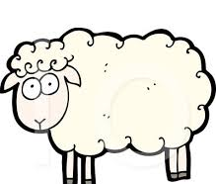
shirt

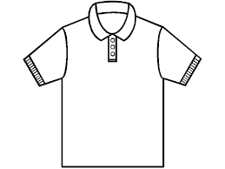

Ask your child: Name these pictures

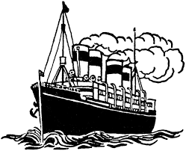
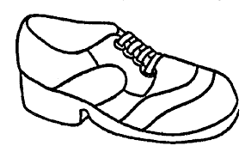
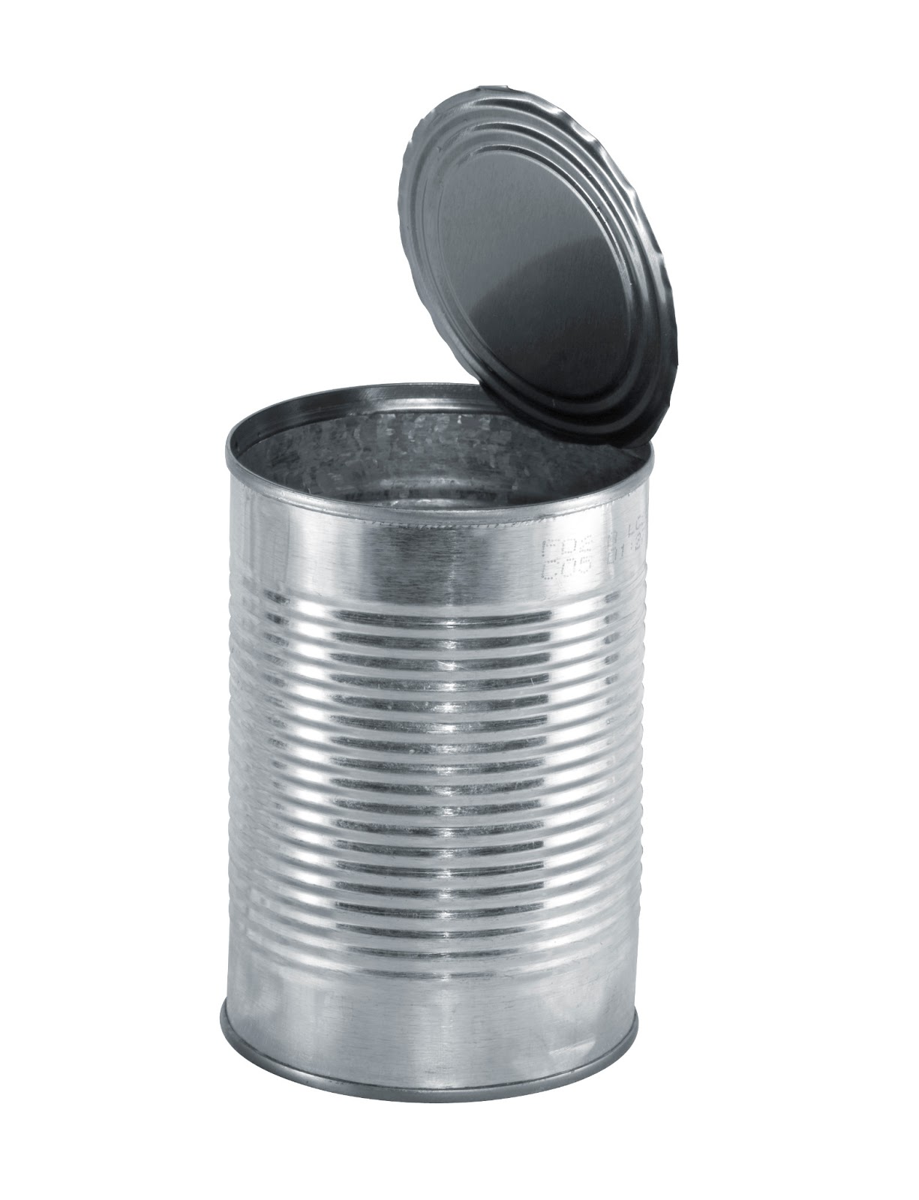




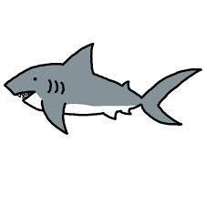

Circle
the pictures, above, that begin with the sh sound.
Ask your child:

Ask your child; Name the pictures, below, and fill in the beginning sound below the picture.
Read the word and listen for the sh sound.

__ __ ark __ __ irt __ __ ell __ __ ip

LET’S FIND OUT

Ask your child: Let’s think of other words that begin with the sh sound.
Draw three sh words in these boxes.
With your child, write the sh words below the pictures.

_________________________ _________________________ _________________________

With your child: Think about words that have the sh sound at the end of the word. Example: hush

Ask your child: Find 3 things at home that have the sh sound at the beginning
OR end of the word. Write the 3 words. (Please help your child, as needed.)

- ___________________ 2. ____________________ 3. ____________________

HOME-TO-SCHOOL COMMUNICATION

Dear Parent,

Please give your reactions to your child’s work on this activity.
Write YES or NO for each statement.
______ 1. My child understood the homework and was able to complete it.
______ 2. My child and I enjoyed the activity.
______ 3. This assignment helped me know what my child is learning in class.

Comment ________________________________________________________________________

Parent Signature __________________________________________________________________

Wilshusen, M., Bognar, J., Handy, T., Epstein, J., & Greenfeld, M. (2016). Teachers Involve Parents in Schoolwork (TIPS) Interactive Homework-Literacy K-3. Colorado Series. Baltimore: Center on School, Family, and Community Partnerships, Johns Hopkins University.

