Student Name____________________________________ Date_____________

What a Character!
Dear Parent,
We are learning about character traits in class. We talk about what a character looks like, acts like, and feels like. This helps us understand the story we are reading. I hope you
enjoy this activity with your child. This assignment is due ___________________________. Thank you!

THINGS TO REMEMBER

The words and pictures of a story tell us what a character SAYS, ACTS, and FEELS.

LET’S DO THIS

Ask your child: Read the words with your child, pointing to each one.
Then, ask your child to read the words, pointing to each one.

Draw a line to match the pictures with the word that
describes the character.

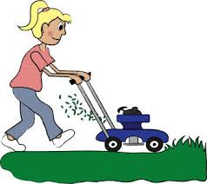
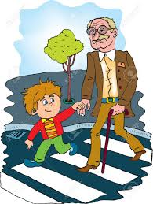


TOOT!
TOOT!
TOOT!
hard-working
angry
kind
noisy
friendly



LET’S FIND OUT

Ask your child: Draw a picture of one of your favorite characters in a story.

Tell me 4 words that describe what the character
says, how the character acts, or feels in the story.

With your child: Write the 4 words that describe the character in the box.
Ask your child to read the words.
One of MY Favorite Story Characters

__________________ _________________

__________________ _________________

Example: Ms. Frizzle

happy

smart creative

helpful

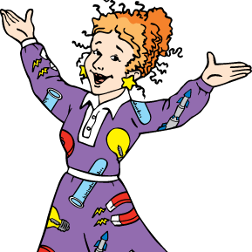

HOME-TO-SCHOOL COMMUNICATION

Dear Parent,

Please give your reactions to your child’s work on this activity.
Write YES or NO for each statement.
______ 1. My child understood the homework and was able to complete it.
______ 2. My child and I enjoyed the activity.
______ 3. This assignment helped me know what my child is learning in class.

Comment ________________________________________________________________________

Parent Signature __________________________________________________________________

Wilshusen, M., Bognar, J., Handy, T., Epstein, J., & Greenfeld, M. (2016). Teachers Involve Parents in Schoolwork (TIPS) Interactive Homework-Literacy K-3. Colorado Series. Baltimore: Center on School, Family, and Community Partnerships, Johns Hopkins University.

