Student Name ______________________________________ Date ______________

Sound It Out
Dear Parent,
We are learning to read new words by saying one sound at a time and blending the sounds together. We also are writing the sounds at the beginning and ending of words using the consonant-vowel-consonant patterns for 3 letters. I hope you enjoy this activity with your child. This assignment is due _________________________________. Thank you!

LET’S DO THIS

- With your child: Say each sound in the boxes and then blend the sounds
together to make a word. See the example.

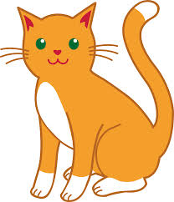
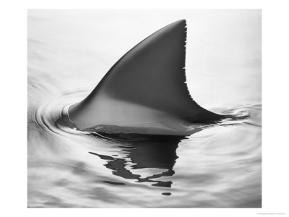

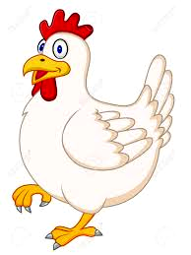
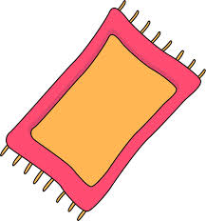

c a t
f i n
d o t
h e n
r u g g

= cat = = = =


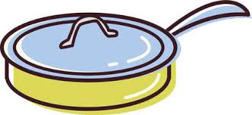
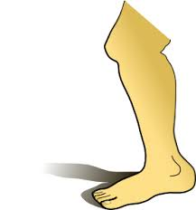


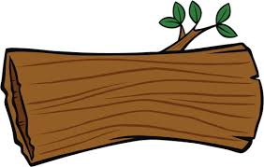

v a n
l i d
l e g
b u s
l o g

= = = = =

- Ask your child: Name the pictures and write the beginning sound of the word
in the blank. Then read the word.
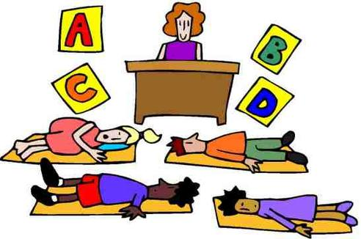




__ ap __og __un __at

- With your child, name the pictures and write the ending sound in the blank.
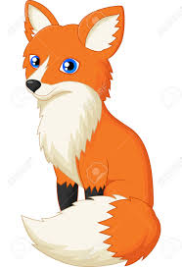
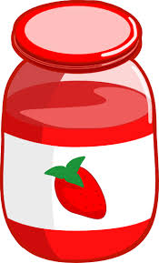

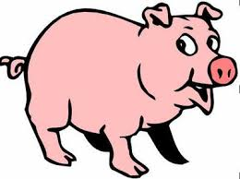

fo__ pi__ ja__ pe__

LET’S FIND OUT

- With your child: Think of 3 new words each with 3 letters that have the consonant-vowel-consonant pattern as any of the words on the front page. Think of the a t , i t , or a n family of words.

- Ask your child: Draw a picture for each word and then write the whole word with the beginning and ending sounds on the lines.

____ ____ ____ ____ ____ ____ ____ ____ ____

HOME-TO-SCHOOL COMMUNICATION

Dear Parent,

Please give your reactions to your child’s work on this activity.
Write YES or NO for each statement.
______ 1. My child understood the homework and was able to complete it.
______ 2. My child and I enjoyed the activity.
______ 3. This assignment helped me know what my child is learning in class.

Comment ________________________________________________________________________

Parent Signature __________________________________________________________________

Wilshusen, M., Bognar, J., Handy, T., Epstein, J., & Greenfeld, M. (2016). Teachers Involve Parents in Schoolwork (TIPS) Interactive Homework-Literacy K-3. Colorado Series. Baltimore: Center on School, Family, and Community Partnerships, Johns Hopkins University.

