Student Name ______________________________________ Date ______________

Make a Word Picture
Dear Parent,
We are learning to use adjectives to describe people, places, and things. I hope you enjoy this activity with your child. This assignment is due ___________________________. Thank you!

THINGS TO REMEMBER

Words that describe people, places, and things are called adjectives.

Adjectives may describe size (big), color (red), patterns (striped), or texture (hard).

Color | Size | Patterns | Texture  (how something feels)
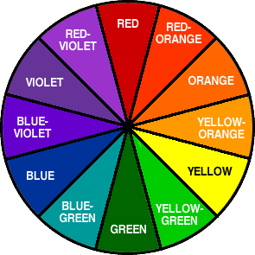 | 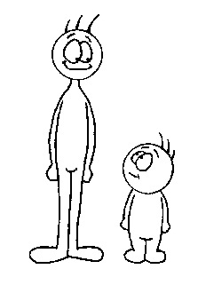  tall  short  big  small  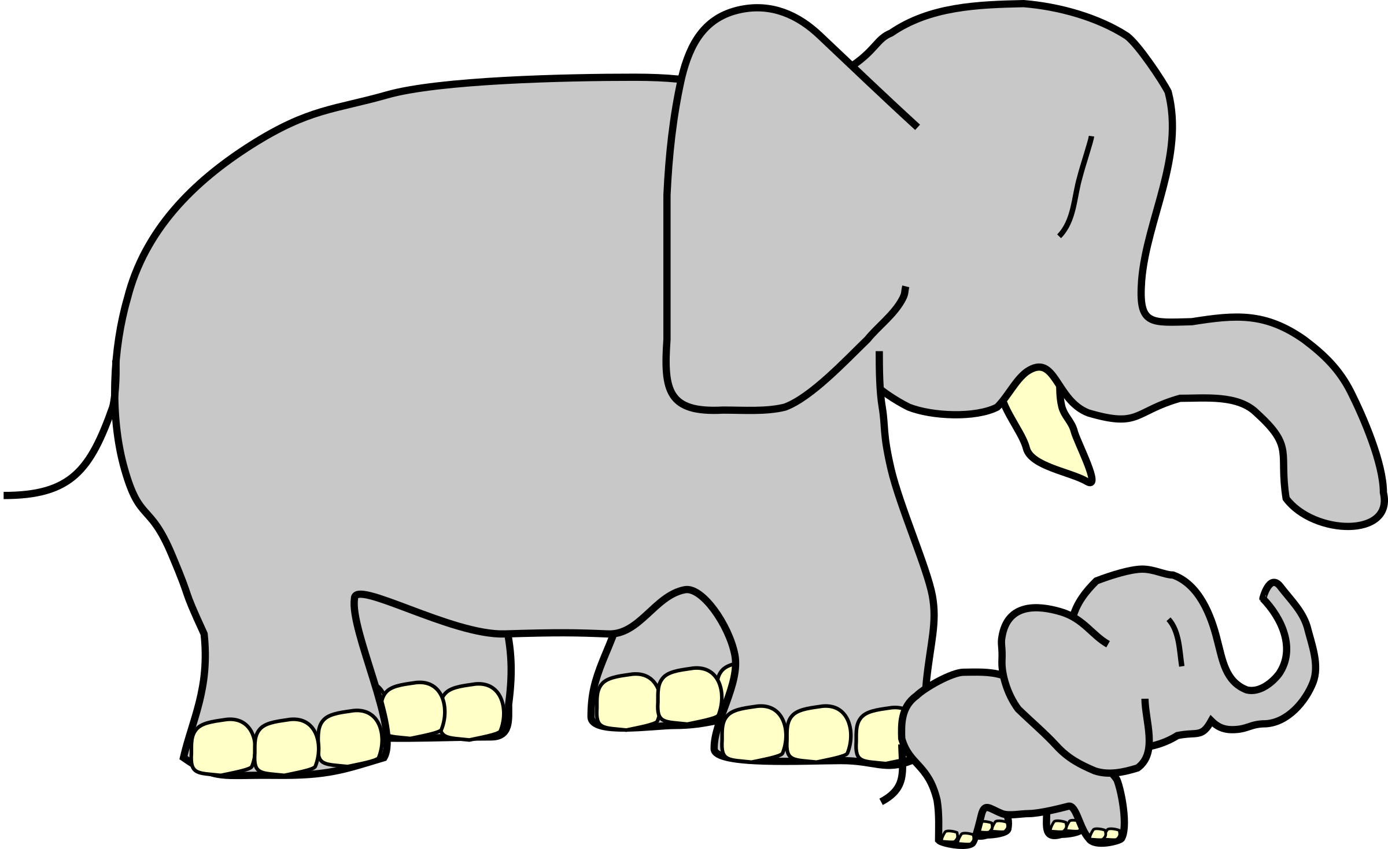 |  striped   swirled  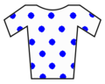 polka dot | 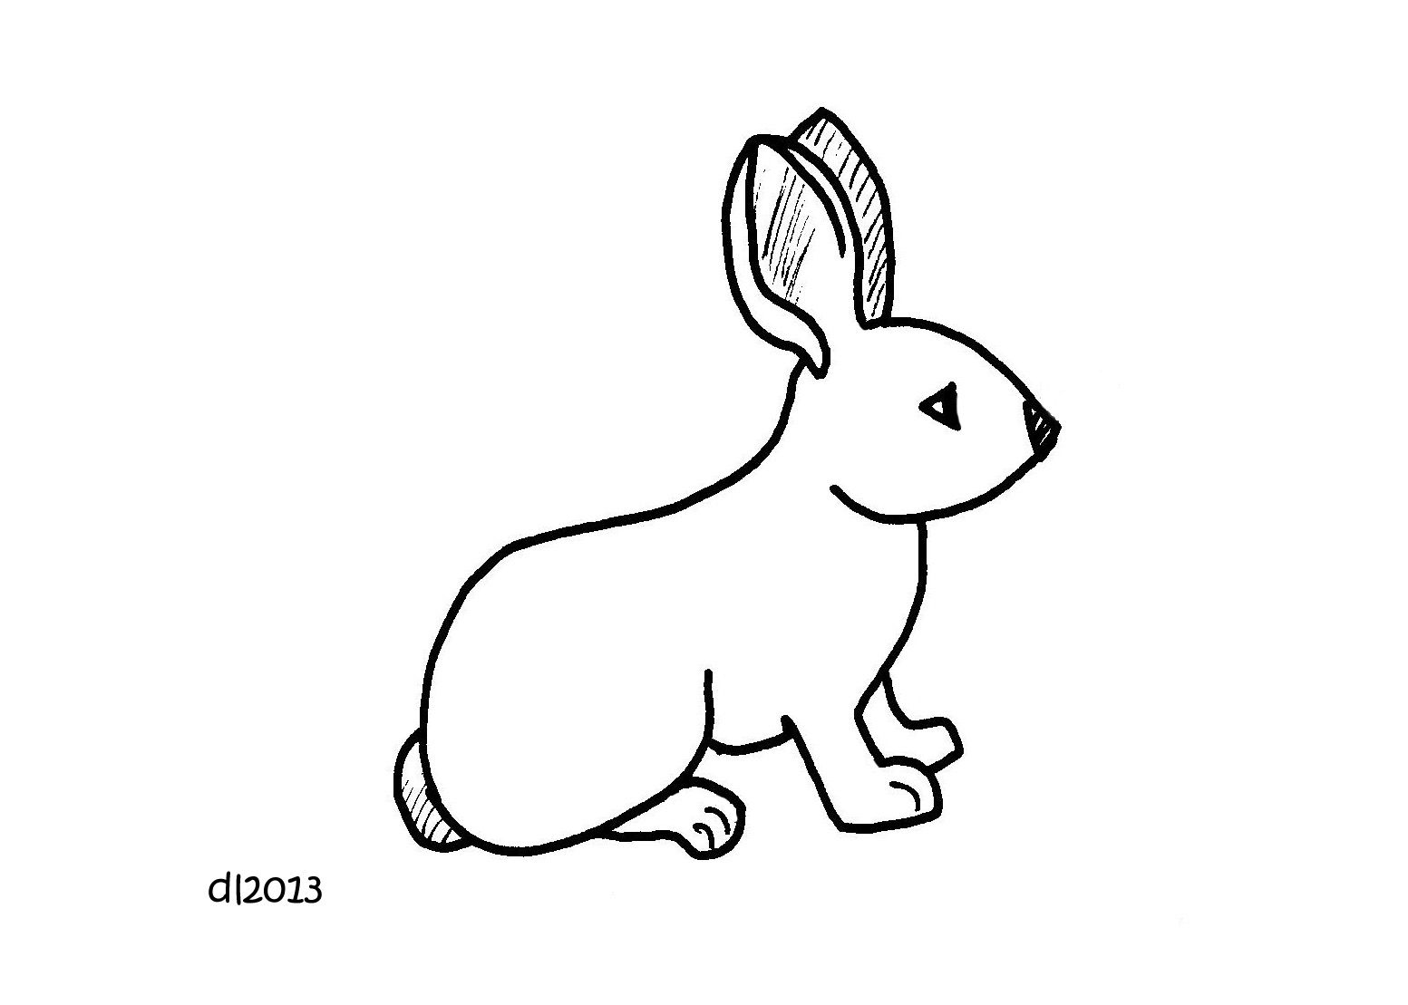 soft hard  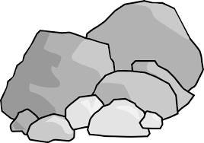  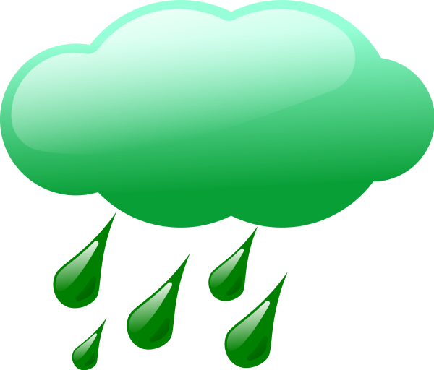    wet sharp

LET’S DO THIS

- With your child: Each of you pick a favorite piece of clothing.

Describe the item to each other using adjectives to talk about
the color, size, pattern, and texture.

Tell each other why it is a favorite.

LET’S FIND OUT

- Ask your child: Draw a picture of the two favorite pieces of clothing.
Show the color, pattern, size, and texture of the item.

One of My Favorite One of My Family Partner’s
Pieces of Clothing Pieces of Clothing

- Play I-Spy

Ask your child: Let’s take turns describing an object in this room.
I will go first. I spy an object that is ____________. (big? small?)

Add one adjective to describe the object until your child guesses
the object.

Then, your child will take a turn, and you guess.

Take at least 2 turns each.

HOME-TO-SCHOOL COMMUNICATION

Dear Parent,

Please give your reactions to your child’s work on this activity.
Write YES or NO for each statement.
______ 1. My child understood the homework and was able to complete it.
______ 2. My child and I enjoyed the activity.
______ 3. This assignment helped me know what my child is learning in class.

Comment ________________________________________________________________________

Parent Signature __________________________________________________________________

Wilshusen, M., Bognar, J., Handy, T., Epstein, J., & Greenfeld, M. (2016). Teachers Involve Parents in Schoolwork (TIPS) Interactive Homework-Literacy K-3. Colorado Series. Baltimore: Center on School, Family, and Community Partnerships, Johns Hopkins University.

