Student Name____________________________________ Date____________

1, 2, 3
Dear Parent,
We are learning about the beginning, middle, and end of a story. I hope you enjoy this activity with your child. This assignment is due _______________________________. Thank you!

LET’S DO THIS

- Ask your child: Look at the pictures.
Put them in order to show the beginning, middle, and end.
Write 1 next to the beginning, 2 next to the middle, and
3 next to the end.

Tell each story in 1-2-3 order.

Example:

3

1

2






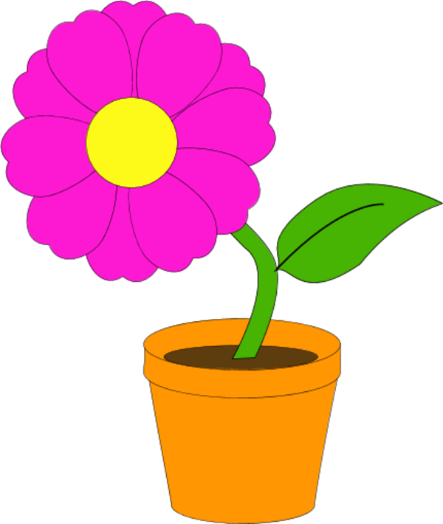







- Please read these sentences to your child.

__ We stayed in the house.
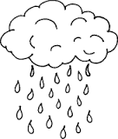

__ It rained all day.

__ We played many games.

Ask your child: Now, read the sentences to me. Point to each word.

Number the sentences 1, 2, and 3 to tell a story with
a beginning, middle, and end.

LET’S FIND OUT

- With your child: Talk about a fun activity that you did together.

Talk about the beginning, middle, and end of the activity.

- Ask your child: Draw a picture in each box to show the beginning, middle, and
end of the activity.

1 2 3

- Ask your child: What is the title of this activity?
Please help your child write the title, as needed.

_________________________________________________________________

HOME-TO-SCHOOL COMMUNICATION

Dear Parent,

Please give your reactions to your child’s work on this activity.
Write YES or NO for each statement.
______ 1. My child understood the homework and was able to complete it.
______ 2. My child and I enjoyed the activity.
______ 3. This assignment helped me know what my child is learning in class.

Comment ________________________________________________________________________

Parent Signature __________________________________________________________________

Wilshusen, M., Bognar, J., Handy, T., Epstein, J., & Greenfeld, M. (2016). Teachers Involve Parents in Schoolwork (TIPS) Interactive Homework-Literacy K-3. Colorado Series. Baltimore: Center on School, Family, and Community Partnerships, Johns Hopkins University.

