Student Name____________________________________ Date_____________

What’s The Big Idea?
Dear Parent,
We are learning to identify the main idea of a story or text. I hope you enjoy this activity with your child. This assignment is due __________________________________. Thank you!

LET’S DO THIS

- With your child: Read the text below to your child pointing to each word.

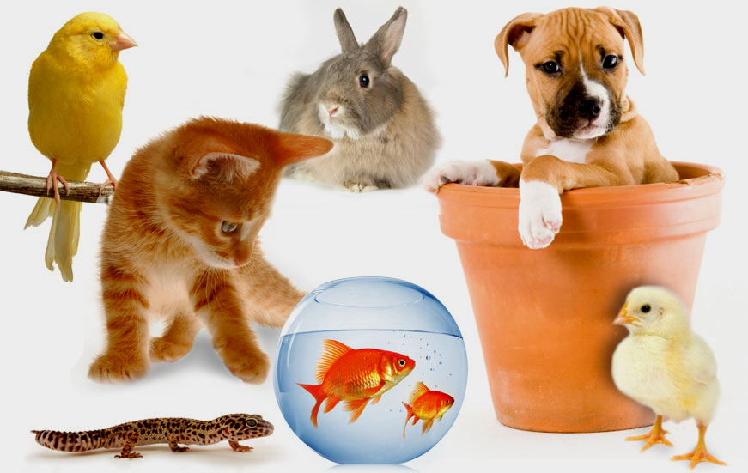
There are many kinds of pets.
Many people have cats or dogs.
Some people have colorful pet fish.
Others have lizards, turtles, or birds as pets.
What kind of pet would you like?

- Ask your child: Tell me what is this story mostly about?

Circle the main idea?

a. Fish are colorful.

b. Different kinds of pets.

c. How to care for pets.

- Ask your child: What title would you give this story?

_____________________________________________

LET’S FIND OUT

Ask your child: Tell me 3 things that you know about your pet

OR a pet you would like to have.

Draw a picture of your pet OR a pet you would like to have.

HOME-TO-SCHOOL COMMUNICATION

Dear Parent,

Please give your reactions to your child’s work on this activity.
Write YES or NO for each statement.
______ 1. My child understood the homework and was able to complete it.
______ 2. My child and I enjoyed the activity.
______ 3. This assignment helped me know what my child is learning in class.

Comment ________________________________________________________________________

Parent Signature __________________________________________________________________

Wilshusen, M., Bognar, J., Handy, T., Epstein, J., & Greenfeld, M. (2016). Teachers Involve Parents in Schoolwork (TIPS) Interactive Homework-Literacy K-3. Colorado Series. Baltimore: Center on School, Family, and Community Partnerships, Johns Hopkins University.

