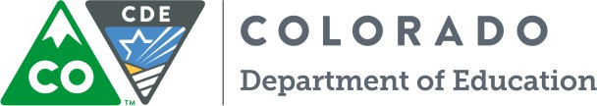
Interagency Foster Care Templates, Reports and Research Links
The following links may be useful in obtaining commonly used forms and templates for the educational needs of students in foster care. The Foster Care Education Program at CDE partners with several state and local agencies to provide resources for multiple stakeholders in working with children and youth in foster care. The following links are divided by agency and resources.
Colorado Department of Human Services
Sample Forms and Templates
The Colorado Department of Human Services created several sample templates for child welfare agencies and school districts to coordinate transitions and transfers for children and youth in foster care. The following link connects to the Colorado Department of Human Services website: https://www.colorado.gov/pacific/cdhs/forms-20

To access the sample forms and templates, click "Child Welfare Forms & Helpful Documents" then scroll down to the "educational success" folder.

This file contains:
- Colorado Confirmation of Foster Care Dependency
- Sample best interest determination worksheet
- Notice to receiving school district of out-of-home placement
- Notice to school district of origin of out-of-home placement
- Sample transportation agreement between child welfare and school districts

Note: These forms were created by the Colorado Department of Human Services. The use of the documents in this folder is not required by the Colorado Department of Education. County child welfare agencies and local education agencies may use these documents as a guide in creating local practices.
University of Northern Colorado Research of Students in Foster Care
The Colorado Study of Students in Foster Care
Is located on the University of Northern Colorado Webpage at: http://www.unco.edu/cebs/foster-care-research/

This webpage contains current research, reports, infographics, and needs assessment data for Colorado children and youth in foster care.

There is an optional link to subscribe to news and updates about current projects underway for students in foster care.

