Content Area | Physical Education |  |  | Grade Level | Kindergarten
Relationships with Others | Movement and Spatial Awareness
Standard | Grade Level Expectations (GLE) |  |  |  |  |  | GLE Code
Movement Competence and Understanding | 1. Demonstrate body and spatial awareness through safe movement |  |  |  |  |  | PE09-GR.k-S.1-GLE.1
 | 2. Locate the major parts of the body |  |  |  |  |  | PE09-GR.k-S.1-GLE.2
Physical and Personal Wellness | 1.Understand that physical activity increases the heart rate, making the heart stronger |  |  |  |  |  | PE09-GR.k-S.2-GLE.1
Emotional and Social Wellness | 1.Demonstrate respect for self, others, and equipment |  |  |  |  |  | PE09-GR.k-S.3-GLE.1
 | 2.Demonstrate the ability to follow directions |  |  |  |  |  | PE09-GR.k-S.3-GLE.2
Prevention and Risk  Management | Expectations for this standard are integrated into the other standards at this grade level movement control for safe participation in games and sports
Colorado 21st Century Skills  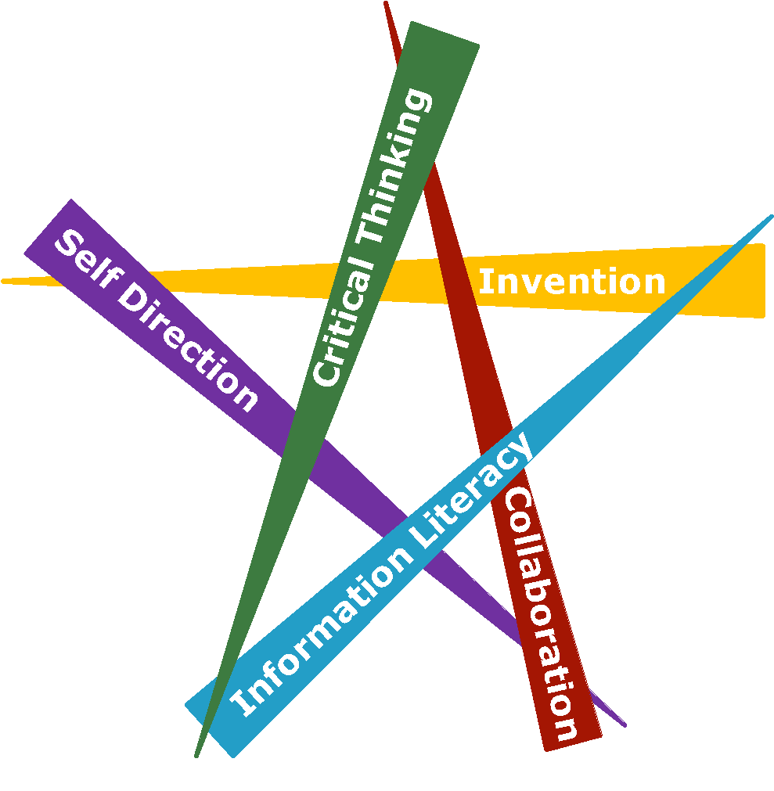  Critical Thinking and Reasoning: Thinking Deeply, Thinking Differently  Information Literacy: Untangling the Web  Collaboration: Working Together, Learning Together  Self-Direction: Own Your Learning  Invention: Creating Solutions |  | 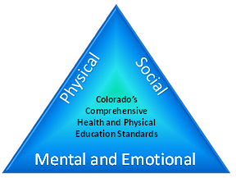
Unit Titles |  |  | Length of Unit/Contact Hours |  |  | Unit Number/Sequence
Movement and Spatial Awareness |  |  | Teacher’s Discretion

Unit Title | Movement and Spatial Awareness |  | Length of Unit |  | Teacher's Discretion
Focusing Lens(es) | Competent Movers | Standards and Grade Level Expectations Addressed in this Unit |  | PE09-GR.K-S.1-GLE.1  PE09-GR.K-S.1-GLE.2
Inquiry Questions (Engaging- Debatable): | - When moving in a group, how do you keep from bumping into each other? (PE09-GR.k-S.1-GLE.1-EO.a,f,g; IQ.1,3,4; RA.1,2; N.2 )  - ·Why is moving at a faster speed safer, and when is moving at a slow speed safer? (PE09-GR.k-S.1-GLE.1-EO.a,f,g; IQ.1,3,4; RA.1,2 ; N.2)  - Why is it easier to move in the same direction in which a group is moving than to move against them? (PE09-GR.k-S.1-GLE.1-EO.a,f,g; IQ.3,4; RA.1, 2; N.2)
Unit Strands | Movement Competence and Understanding in Physical Education
Concepts | Identification, Demonstration, Variation, Traveling, Space, Levels, Creation, Locomotion, Pathways, (All) Citizenship, Respect, Laws and Rules, Sequencing, Responsibility

Generalizations  My students will Understand that… | Guiding Questions  Factual Conceptual
Variation of movement patterns will lead to a more responsible mover traveling through space. (PE09-GR.k-S.1-GLE.1-EO.a,f,g; IQ.1,3,4; RA.1,2; N.1,2) | Is moving in the gym similar to when people drive on the street? | Why should someone understand responsibility when moving?  Why is it easier to move in the same direction in which a group is moving than to move against them?
Identification of different pathways and levels while performing similar movements demonstrates variation. (PE09-GR.k-S.1-GLE.1-EO.c,d; IQ.1,2; RA.3; N.3) | What is the name of an animal, other than a human, that moves by hopping? | How are different ways that a person can demonstrate a jump?
Respect of others while moving keeps everyone safe. (PE09-GR.k-S.1-GLE.1-EO.a,f,g; IQ.1,3,4; RA.1,2; N.1,2) | What will happen if people do not respect others when moving? | Why is it important to keep your head up and eyes forward when moving?

Critical Content:  My students will Know… | Key Skills:  My students will be able to (Do)…
- Specific body parts (PE09-GR.k-S.1-GLE.2-EO.a)  - Opposition and alternation (PE09-GR.k-S.1-GLE.1-EO.e)  - Contrasts between slow and fast speeds while using locomotor skills (PE09-GR.k-S.1-GLE.1-EO.b)  - Variety of locomotor skills without bumping into others or falling within a large group (PE09-GR.k-S.1-GLE.1-EO.a)  - Body planes such as front, back and side (PE09-GR.k-S.1-GLE.2-EO.b)  - Shapes at high, medium, and low levels using hands, arms, torso, feet and legs in a variety of combinations (PE09-GR.k-S.1-GLE.1-EO.c)  - Straight, curved and zigzag pathways (PE09-GR.k-S.1-GLE.1-EO.d)  - Skills in different game situations (PE09-GR.k-S.1-GLE.1-EO.d)  - Group responsibilities (PE09-GR.k-S.1-GLE.1-EO.g) | - Move specified body parts in response to a variety of sensory cues such as auditory or visual (PE09-GR.k-S.1-GLE.2-EO.a)  - Move in opposition and alternately (PE09-GR.k-S.1-GLE.1-EO.e)  - Demonstrate contrasts between slow and fast speeds while using locomotor skills (PE09-GR.k-S.1-GLE.1-EO.b)  - Travel within a large group without bumping into others or falling, while using a variety of locomotor skills (PE09-GR.k-S.1-GLE.1-EO.a)  - Identify body planes such as front, back and side (PE09-GR.k-S.1-GLE.2-EO.b)  - Create shapes at high, medium, and low levels by using hands, arms, torso, feet and legs in a variety of combinations (PE09-GR.k-S.1-GLE.1-EO.c)  - Travel in straight, curved and zigzag pathways (PE09-GR.k-S.1-GLE.1-EO.d)  - Put skills into different game situations (PE09-GR.k-S.1-GLE.1-EO.d)  - Work within a group (PE09-GR.k-S.1-GLE.1-EO.g)

Critical Language: includes the Academic and Technical vocabulary, semantics, and discourse which are particular to and necessary for accessing a given discipline.
EXAMPLE: A student in Language Arts can demonstrate the ability to apply and comprehend critical language through the following statement: “Mark Twain exposes the hypocrisy of slavery through the use of satire.”
A student in ______________ can demonstrate the ability to apply and comprehend critical language through the following statement(s): |  | Aaron is able to move, around others, in a way that shows different movement styles while being safe.
Academic Vocabulary: | Relationships, Rules, Responsibilities, Cooperation, Movement, Participation, Strategies, Laws and Rules, Sequencing,
Technical Vocabulary: | Chase-and-Flee, Empathy, Social Cues, Sequencing, Personal Needs, Spatial Awareness, Boundaries

Unit Description: | The purpose of this unit is to allow students to move competently in physical education. Concepts that are focused on include: locomotion, pathways, levels and space. Additionally, skills are being developed to create a safe environment of trust and respect while following rules and understanding the importance of movement, spatial awareness, and pathways. The unit culminates with a performance assessment in which each student becomes an animated movie character to move safely at various speeds within the character’s movie environment.
Unit Generalizations
Key Generalization (s): | Variation of movement patterns will lead to a more responsible mover traveling through space.
Supporting Generalizations: | Identification of different pathways and levels while performing similar movements demonstrates variation.  Respect of others while moving keeps everyone safe.
Considerations: | Before teaching a movement and spatial awareness unit in physical education, please consider:  - Culture and language  - Space  - Equipment  - Length of class  - Time of year the unit would be taught  - Full day versus half day  - Accommodations (e.g. IEP, 504, etc.) and modifications

Performance Assessment: The capstone/summative assessment for this unit.
Claims:  (Key generalization(s) to be mastered and demonstrated through the capstone assessment.) | Variation of movement patterns will lead to a more responsible mover traveling through space.
Stimulus Material:  (Engaging scenario that includes role, audience, goal/outcome and explicitly connects the key generalization) | You will become an animated movie character (e.g. Lightning McQueen, Bambi, Nemo, etc.) to move safely at various speeds within your character’s environment (e.g. woods, roads, ocean, etc.). You will travel (e.g. slow, medium, fast, etc.) through your environment using various pathways (e.g. straight, curved, zigzag, etc.) without bumping into other characters, to get to your destination. You will demonstrate this to your teacher’s signal (e.g. music, whistle, timer, etc.).
Product/Evidence:  (Expected product from students) | Students will create a journey using their animated movie character (e.g. Lightning McQueen, Bambi, Nemo, etc.) performing locomotor movements (e.g., walk, run, gallop, etc.) and demonstrating multiple pathways (e.g. straight, curved, zigzag, etc.) to travel through their environment (e.g. plumbing, ocean/marine life, race track, etc.) to get to their destination. Students will demonstrate travel through space, levels, creation, respect and responsibility for the teacher and/or peers.  Examples of Elements in Travel:  - Hurdles  - Hoops  - Tunnel  - Cones  - Mats
Differentiation:  (Multiple modes for student expression) | Students may:  - dress as the animated character  - perform one on one with the teacher  - discuss one on one with the teacher  - work with a partner to develop the movement/skill

Texts for independent reading or for class read aloud to support the content
Informational/Non-Fiction | Fiction
Ages & Stages: All About Body Awareness by Carla Poole, Susan A. Miller 7, Ellen Booth Church (Lexile 550)  Baseball Saved Us by Ken Mochizuki (Lexile 550) | Personal Space Camp by Julia Cook (Lexile range 300-500)  LUCY IN THE CITY: A STORY ABOUT DEVELOPING SPATIAL THINKING SKILLS, by Julie Dillemuth (Lexile 250)  ROSIE’S WALK, Pat Hutchins Macmillan (Lexile 200-250)  That Rule Doesn’t Apply to Me! by Julia Cook (Lexile 200-250)  Play Ball, Amelia, Bedelia by Peggy Parish (Lexile 220)  Jump! by Scott M. Fischer (Lexile 250)

Ongoing Discipline-Specific Learning Experiences
1. | Description: | Think like/Work like a responsible physical education student to demonstrate a variation of movement patterns traveling through space. | Teacher Resources: | http://www.pecentral.org/lessonideas/ViewLesson.asp?ID=9471#.WEMF97IrLIU (Hula Hoop Car Road Trip Variation)  http://www.pecentral.com/lessonideas/ViewLesson.asp?ID=11920#.WEMdxKIrIU0 (Locomotor Movement Game)
 |  |  | Student Resources: | http://www.pecentral.org/lessonideas/ViewLesson.asp?ID=9471#.WEMF97IrLIU (Hula Hoop Car Road Trip Variation)  http://www.pecentral.com/lessonideas/ViewLesson.asp?ID=11920#.WEMdxKIrIU0 (Locomotor Movement Game)
 | Skills: | - Move specified body parts in response to a variety of sensory cues such as auditory or visual.  - Travel within a large group without bumping into others or falling, while using a variety of locomotor skills.  - Put skills into different game situations.  - Work within a group.  - Demonstrate contrasts between slow and fast speeds while using locomotor skills. | Assessment: | Students will demonstrate examples of body and spatial awareness throughout activities/games during physical education.
2. | Description: | Think like/Work like a responsible physical education student to demonstrate different pathways and levels. | Teacher Resources: | http://www.playworks.org/playbook/games/everyones-it-tag (Everyone’s It Tag)  http://www.pecentral.com/lessonideas/ViewLesson.asp?ID=495#.WEMZmrIrLIU (Locomotor Treasure Hunt Variation)
 |  |  | Student Resources: | http://www.playworks.org/playbook/games/everyones-it-tag (Everyone’s It Tag)  http://www.pecentral.com/lessonideas/ViewLesson.asp?ID=495#.WEMZmrIrLIU (Locomotor Treasure Hunt Variation)
 | Skills: | - Move specified body parts in response to a variety of sensory cues such as auditory or visual.  - Move in opposition and alternately.  - Demonstrate contrasts between slow and fast speeds while using locomotor skills.  - Travel within a large group without bumping into others or falling, while using a variety of locomotor skills.  - Identify body planes such as front, back and side.  - Create shapes at high, medium, and low levels by using hands, arms, torso, feet and legs in a variety of combinations.  - Travel in straight, curved and zigzag pathways. | Assessment: | Students will demonstrate examples of different levels, pathways, speeds, and directions.
3. | Description: | Think like/Work like a responsible physical education student to demonstrate respect of others while moving and keeping everyone safe. | Teacher Resources: | https://www.youtube.com/watch?v=YbmeGiRuaCA (Freeze Dance)  http://www.pecentral.org/lessonideas/ViewLesson.asp?ID=12627#.WEMm8aIrIU0 (Wax Museum Creative Movements Game)
 |  |  | Student Resources: | https://www.youtube.com/watch?v=YbmeGiRuaCA (Freeze Dance)  http://www.pecentral.org/lessonideas/ViewLesson.asp?ID=12627#.WEMm8aIrIU0 (Wax Museum Creative Movements Game)
 | Skills: | - Demonstrate contrasts between slow and fast speeds while using locomotor skills.  - Travel within a large group without bumping into others or falling, while using a variety of locomotor skills.  - Identify body planes such as front, back and side.  - Travel in straight, curved and zigzag pathways.  - Put skills into different game situations. | Assessment: | Students will demonstrate examples of respecting others when moving that includes being safe. Additionally, students will demonstrate the ability to travel using various locomotor motor skills such as skipping, galloping, walking, running, and hopping.

Prior Knowledge and Experiences
It is presumed that kindergarten students have prior learning experiences and/or working knowledge of: spatial awareness, personal awareness, vocabulary, ability to follow instructions, and basic motor skills. However, it cannot be assumed that all students have had the same family infrastructure and opportunity to attend preschool/daycare to achieve the same developmental milestones.

Learning Experience # 1
Task Description:  The teacher may… so that students can… | The teacher may discuss the importance of respectful and responsible movement (e.g. self, peers, environment, etc.) so students can begin to explore their own body motions through space.
Generalization Connection(s): | Variation of movement patterns will lead to a more responsible mover traveling through space.  Respect of others while moving keeps everyone safe.
Teacher Resources: | http://www.playworks.org/playbook/games/sharks-and-minnows (Sharks and Minnows Tag Game)  http://www.playworks.org/playbook/games/everyones-it-tag (Everyone’s It Tag)  http://physedgames.com/?s=line+tag (Line Tag Game)
Student Resources: | http://www.playworks.org/playbook/games/sharks-and-minnows (Sharks and Minnows Tag Game)  http://www.playworks.org/playbook/games/everyones-it-tag (Everyone’s It Tag)  http://physedgames.com/?s=line+tag (Line Tag Game)
Assessment: | Students will participate in a variety of tag games (e.g. Everybody's It Tag, Line Tag, Sharks and Minnows, etc.) to demonstrate body and spatial awareness. Each student will model respectful and responsible movements to the teacher.
 | Access (Resources and/or Process) |  | Expression (Products and/or Performance)
Differentiation:  (Multiple means for students to access content and multiple modes for student to express understanding.) | The teacher may provide examples of respectful and responsible movement to students. |  | Students may:  - choose a pathway to move responsibly among peers and environment  - choose space that demonstrates respect to others (boundaries, distance, time, etc.)
Extensions for depth and complexity: | N/A |  | N/A
Critical Content: | - Specific body parts.  - Variety of locomotor skills without bumping into others or falling within a large group.  - Skills in different game situations.  - Group responsibilities.  - Contrasts between slow and fast speeds while using locomotor skills. | Key Skills: | - Move specified body parts in response to a variety of sensory cues such as auditory or visual.  - Travel within a large group without bumping into others or falling, while using a variety of locomotor skills.  - Put skills into different game situations.  - Work within a group.  - Demonstrate contrasts between slow and fast speeds while using locomotor skills.
Critical Language: | Demonstration, Space, Respect, Responsibility

Learning Experience # 2
Task Description:  The teacher may… so that students can… | The teacher may introduce spatial concepts (e.g. personal, general, boundaries, etc.) so students can begin to apply during activities and games.
Generalization Connection(s): | Variation of movement patterns will lead to a more responsible mover traveling through space.
Teacher Resources: | http://www.pecentral.org/lessonideas/ViewLesson.asp?ID=9471#.WEMF97IrLIU (Hula Hoop Car Road Trip Variation)  http://physedgames.com/?s=line+tag (Line Tag Game)
Student Resources: | http://www.pecentral.org/lessonideas/ViewLesson.asp?ID=9471#.WEMF97IrLIU (Hula Hoop Car Road Trip Variation)  http://physedgames.com/?s=line+tag (Line Tag Game)
Assessment: | Students will participate in a variation of Hula Hoop Cars to demonstrate spatial awareness (e.g. lines, boundaries, speed, etc.). The activity requires students to navigate their environment.
 | Access (Resources and/or Process) |  | Expression (Products and/or Performance)
Differentiation:  (Multiple means for students to access content and multiple modes for student to express understanding.) | The teacher may:  - use visuals/pictures so students can change movements.  - provide a variety of equipment with different texture and sizes (hoops, frisbees, rings, etc.). |  | Students may:  - use pictures to participate in the movements.  - access a variety of equipment that meets their needs.
Extensions for depth and complexity: | N/A |  | N/A
Critical Content: | - Variety of locomotor skills without bumping into others or falling within a large group.  - Straight, curved and zigzag pathways.  - Skills in different game situations.  - Contrasts between slow and fast speeds while using locomotor skills. | Key Skills: | - Travel within a large group without bumping into others or falling, while using a variety of locomotor skills.  - Travel in straight, curved and zigzag pathways.  - Put skills into different game situations.  - Demonstrate contrasts between slow and fast speeds while using locomotor skills.
Critical Language: | Personal Space, General Space, Boundaries, Movement, Participation, Speed

Learning Experience # 3
Task Description:  The teacher may… so that students can… | The teacher may model an array of pathways (e.g. straight, zigzag, curve, etc.) so students can begin to identify different ways to travel.
Generalization Connection(s): | Variation of movement patterns will lead to a more responsible mover traveling through space.  Identification of different pathways and levels while performing similar movements demonstrates variation.
Teacher Resources: | http://www.pecentral.com/lessonideas/ViewLesson.asp?ID=495#.WEMZmrIrLIU (Locomotor Treasure Hunt Variation)  http://www.pecentral.com/lessonideas/ViewLesson.asp?ID=11920#.WEMdxKIrIU0 (Locomotor Movement Game)
Student Resources: | http://www.pecentral.com/lessonideas/ViewLesson.asp?ID=495#.WEMZmrIrLIU (Locomotor Treasure Hunt Variation)  http://www.pecentral.com/lessonideas/ViewLesson.asp?ID=11920#.WEMdxKIrIU0 (Locomotor Movement Game)
Assessment: | Students will follow different pathways (e.g. straight, zigzag, curve, etc.) to travel (e.g. skip, jog, walk, etc.) in different directions (e.g. forward, backwards, sideways, etc.) by participating in a treasure hunt.
 | Access (Resources and/or Process) |  | Expression (Products and/or Performance)
Differentiation:  (Multiple means for students to access content and multiple modes for student to express understanding.) | The teacher may:  - provide verbal and visual cues to assist students.  - provide shorter distances for students to travel. |  | Students may:  - use shorter distances for traveling.  - choose a locomotor skill to perform.
Extensions for depth and complexity: | N/A |  | N/A
Critical Content: | - Contrasts between slow and fast speeds while using locomotor skills.  - Variety of locomotor skills without bumping into others or falling within a large group.  - Body planes such as front, back and side.  - Straight, curved and zigzag pathways.  - Skills in different game situations. | Key Skills: | - Demonstrate contrasts between slow and fast speeds while using locomotor skills.  - Travel within a large group without bumping into others or falling, while using a variety of locomotor skills.  - Identify body planes such as front, back and side.  - Travel in straight, curved and zigzag pathways.  - Put skills into different game situations.
Critical Language: | Identification, Demonstration, Variation, Traveling, Space, Levels, Locomotion, Pathways, Speed

Learning Experience # 4
Task Description:  The teacher may… so that students can… | The teacher may cultivate an appreciation of diversity through differentiation, creativity, change, and alteration so students can explore movement variations (e.g. body awareness, spatial awareness, relationship concepts, etc.).
Generalization Connection(s): | Identification of different pathways and levels while performing similar movements demonstrates variation.
Teacher Resources: | https://www.youtube.com/watch?v=YbmeGiRuaCA (Freeze Dance)  http://www.pecentral.org/lessonideas/ViewLesson.asp?ID=12627#.WEMm8aIrIU0 (Wax Museum Creative Movements Game)
Student Resources: | https://www.youtube.com/watch?v=YbmeGiRuaCA (Freeze Dance)  http://www.pecentral.org/lessonideas/ViewLesson.asp?ID=12627#.WEMm8aIrIU0 (Wax Museum Creative Movements Game)
Assessment: | Students will create and perform a movement (e.g. blowing like the wind, walking through peanut butter, moving like water, etc.) using their imagination through a variation of Freeze Dance.
 | Access (Resources and/or Process) |  | Expression (Products and/or Performance)
Differentiation:  (Multiple means for students to access content and multiple modes for student to express understanding.) | The teacher may provide pictures of movements for students to choose. |  | Students may choose movements from pictures.
Extensions for depth and complexity: | N/A |  | N/A
Critical Content: | - Specific body parts  - Opposition and alternation  - Contrasts between slow and fast speeds while using locomotor skills  - Variety of locomotor skills without bumping into others or falling within a large group  - Body planes such as front, back and side  - Shapes at high, medium, and low levels using hands, arms, torso, feet and legs in a variety of combinations  - Straight, curved and zigzag pathways | Key Skills: | - Move specified body parts in response to a variety of sensory cues such as auditory or visual.  - Move in opposition and alternately.  - Demonstrate contrasts between slow and fast speeds while using locomotor skills.  - Travel within a large group without bumping into others or falling, while using a variety of locomotor skills.  - Identify body planes such as front, back and side.  - Create shapes at high, medium, and low levels by using hands, arms, torso, feet and legs in a variety of combinations.  - Travel in straight, curved and zigzag pathways.
Critical Language: | Identification, Demonstration, Variation, Traveling, Space, Levels, Creation, Locomotion, Pathways, Sequencing, Speed

