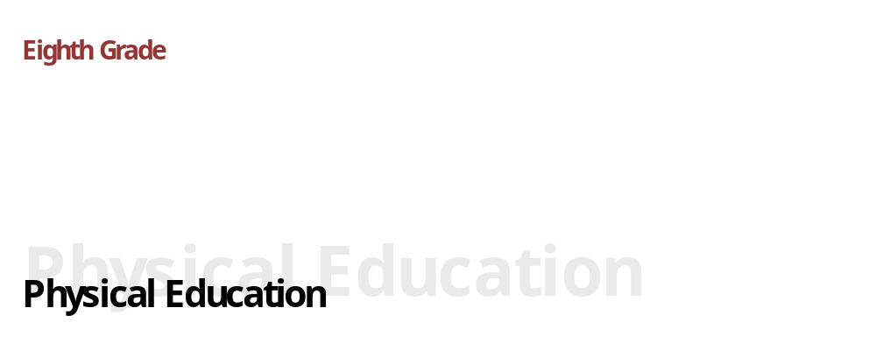
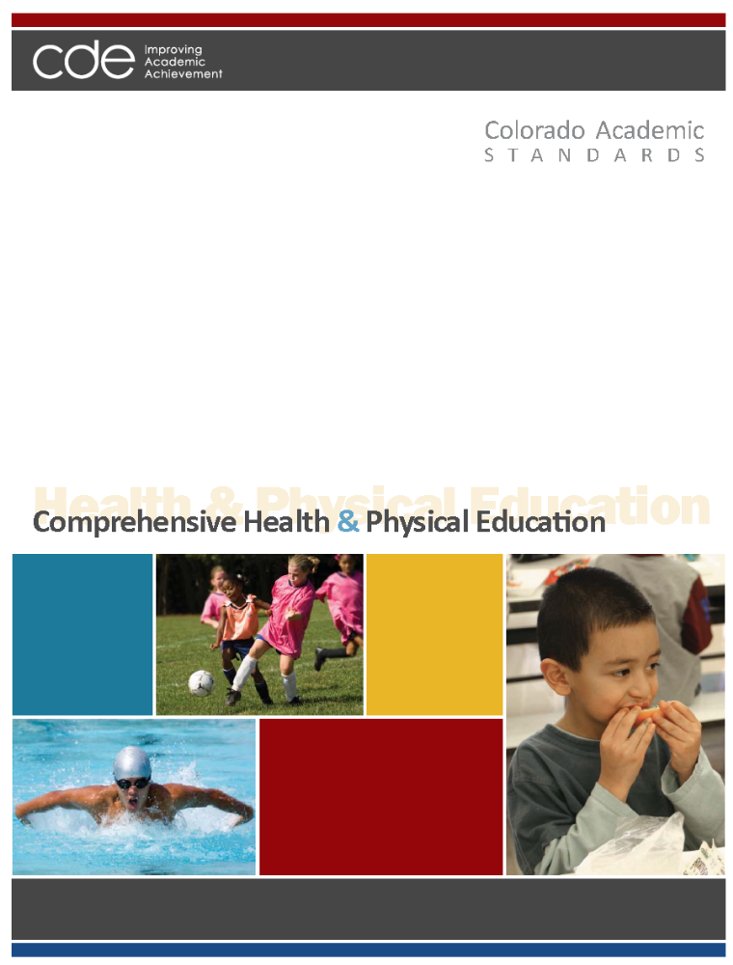
Adopted: December 10, 2009

Colorado Academic Standards
Comprehensive Health and Physical Education Standards

“In the great work of education, our physical condition, if not the first step in point of importance, is the first in order of time. On the broad and firm foundation of health alone can the loftiest and most enduring structures of the intellect be reared.” ~Horace Mann
~~~~~~~~~~~~~~~~~~~~~~~~~~~~~~~~~~
"We know what the Greeks knew: that intelligence and skill can only function at the peak of their capacity when the body is healthy and strong, and that hardy spirits and tough minds usually inhabit sound bodies." ~John F. Kennedy
~~~~~~~~~~~~~~~~~~~~~~~~~~~~~~~~~~

Preparing students for the 21st century cannot be accomplished without a strong and sustained emphasis on all students’ health and wellness. It no is longer acceptable to think of “gym class” and “hygiene lessons.” Today’s world has exploded with physical, mental, and social influences that affect not only learning in school, but also the lifelong health of the citizens that schools are preparing for graduation. Health and physical education prepare students to function optimally as students, global citizens, and workers who demonstrate personal responsibility for one’s health and fitness through an active, healthy lifestyle that fosters a lifelong commitment to wellness.

Health education and physical education are separate disciplines, each with a distinct body of knowledge and skills. However, the two disciplines are naturally interdisciplinary and clearly complement and reinforce each other to support wellness. Schools have a unique role and responsibility to address both health and physical education from preschool through twelfth grade to instill and reinforce knowledge and skills needed to be healthy and achieve academically.

Colorado's comprehensive health and physical education standards lay out a vision for these vitally important disciplines, and describe what all students should know and be able to do at each grade level through eighth grade and in high school. The authors of this document were preschool through twelfth-grade educators, higher education professors, business representatives, and community members. The group developed a set of competencies starting with "the end in mind." What concepts and skills would a "prepared graduate" in the 21st century posses when he or she left high school? The answers to this question framed the work that led to the development of four standards in comprehensive health and physical education for preschool through twelfth grade.
Standards Organization and Construction

As the subcommittee began the revision process to improve the existing standards, it became evident that the way the standards information was organized, defined, and constructed needed to change from the existing documents. The new design is intended to provide more clarity and direction for teachers, and to show how 21st century skills and the elements of school readiness and postsecondary and workforce readiness indicators give depth and context to essential learning.

The “Continuum of State Standards Definitions” section that follows shows the hierarchical order of the standards components. The “Standards Template” section demonstrates how this continuum is put into practice.

The elements of the revised standards are:

Prepared Graduate Competencies: The preschool through twelfth-grade concepts and skills that all students who complete the Colorado education system must master to ensure their success in a postsecondary and workforce setting.

Standard: The topical organization of an academic content area.

High School Expectations: The articulation of the concepts and skills of a standard that indicates a student is making progress toward being a prepared graduate. What do students need to know in high school?

Grade Level Expectations: The articulation (at each grade level), concepts, and skills of a standard that indicate a student is making progress toward being ready for high school. What do students need to know from preschool through eighth grade?

Evidence Outcomes: The indication that a student is meeting an expectation at the mastery level. How do we know that a student can do it?

21st Century Skills and Readiness Competencies: Includes the following:

- Inquiry Questions:
Sample questions are intended to promote deeper thinking, reflection and refined understandings precisely related to the grade level expectation.

- Relevance and Application:
Examples of how the grade level expectation is applied at home, on the job or in a real-world, relevant context.

- Nature of the Discipline:
The characteristics and viewpoint one keeps as a result of mastering the grade level expectation.

Continuum of State Standards Definitions
Prepared Graduate Competency
Prepared Graduate Competencies are the P-12 concepts and skills that all students leaving the Colorado education system must have to ensure success in a postsecondary and workforce setting.

Standards

Standards are the topical organization of an academic content area.
Grade Level Expectations

Expectations articulate, at each grade level, the knowledge and skills of a standard that indicates a student is making progress toward high school.

What do students need to know?
High School Expectations

Expectations articulate the knowledge and skills of a standard that indicates a student is making progress toward being a prepared graduate.

What do students need to know?
Evidence Outcomes
Evidence outcomes are the indication that a student is meeting an expectation at the mastery level.

How do we know that a student can do it?
Evidence Outcomes
Evidence outcomes are the indication that a student is meeting an expectation at the mastery level.

How do we know that a student can do it?
High School
P-8
21st Century and PWR Skills
Inquiry Questions:
Sample questions intended to promote deeper thinking, reflection and refined understandings precisely related to the grade level expectation.
Relevance and Application:
Examples of how the grade level expectation is applied at home, on the job or in a real-world, relevant context.
Nature of the Discipline:
The characteristics and viewpoint one keeps as a result of mastering the grade level expectation.

21st Century and PWR Skills
Inquiry Questions:
Sample questions intended to promote deeper thinking, reflection and refined understandings precisely related to the grade level expectation.
Relevance and Application:
Examples of how the grade level expectation is applied at home, on the job or in a real-world, relevant context.
Nature of the Discipline:
The characteristics and viewpoint one keeps as a result of mastering the grade level expectation.

STANDARDS TEMPLATE

Content Area: NAME OF CONTENT AREA
Standard: The topical organization of an academic content area.
Prepared Graduates:
- The P-12 concepts and skills that all students who complete the Colorado education system must master to ensure their success in a postsecondary and workforce setting
High School and Grade Level Expectations
Concepts and skills students master:
Grade Level Expectations: The articulation, at each grade level, the concepts and skills of a standard that indicates a student is making progress toward being ready for high school.

What do students need to know?

Evidence Outcomes | 21st Century Skills and Readiness Competencies
Students can:  Evidence outcomes are the indication that a student is meeting an expectation at the mastery level.  How do we know that a student can do it? | Inquiry Questions:  Sample questions intended to promote deeper thinking, reflection and refined understandings precisely related to the grade level expectation.
Relevance and Application:

Examples of how the grade level expectation is applied at home, on the job or in a real-world, relevant context.

Nature of the Discipline:

The characteristics and viewpoint one keeps as a result of mastering the grade level expectation.

Prepared Graduate Competencies in
Comprehensive Health and Physical Education

The prepared graduate competencies are the preschool through twelfth-grade concepts and skills that all students who complete the Colorado education system must master to ensure their success in a postsecondary and workforce setting.

Prepared Graduates in Movement Competence and Understanding:
- Demonstrate competency in motor skills and movement patterns needed to perform a variety of physical activity
- Demonstrate understanding of movement concepts, principles, strategies, and tactics as they apply to learning and performing physical activities

Prepared Graduates in Physical and Personal Wellness:
- Participate regularly in physical activity
- Achieve and maintain a health-enhancing level of physical fitness
- Apply knowledge and skills to engage in lifelong healthy eating
- Apply knowledge and skills necessary to make personal decisions that promote healthy relationships and sexual and reproductive health
- Apply knowledge and skills related to health promotion, disease prevention, and health maintenance

Prepared Graduates in Emotional and Social Wellness:
- Utilize knowledge and skills to enhance mental, emotional, and social well-being
- Exhibit responsible personal and social behavior that respects self and others in physical activity settings

Prepared Graduates in Prevention and Risk Management:
- Apply knowledge and skills to make health-enhancing decisions regarding the use of alcohol, tobacco, and other drugs
- Apply knowledge and skills that promote healthy, violence-free relationships
- Apply personal safety knowledge and skills to prevent and treat intentional or unintentional injury

Colorado Academic Standards
Comprehensive Health and Physical Education

The Colorado Academic Standards in comprehensive health and physical education are the topical organization of the concepts and skills every Colorado student should know and be able to do throughout their preschool through twelfth-grade experience.

- Movement Competence and Understanding (Physical Education)
Includes motor skills and movement patterns that teach skill and accuracy in a variety of routines, games, and activities that combine skills with movement; demonstrates the connection between body and brain function; and creates patterns for lifelong physical activity.

- Physical and Personal Wellness (Shared Standard)
Includes physical activity, healthy eating, and sexual health and teaches lifelong habits and patterns for a fit, healthy, and optimal childhood and adulthood; examines society, media, family, and peer influence on wellness choices; practices decision-making and communication skills for personal responsibility for wellness; and identifies the consequences of physical inactivity, unhealthy eating, and early sexual activity. Includes health promotion and disease prevention, and teaches responsibility and skills for personal health habits as well as behavior and disease prevention; sets personal goals for optimal health; examines common chronic and infectious diseases and causes; and recognizes the physical, mental, and social dimensions of personal health.

- Emotional and Social Wellness (Shared Standard)
Includes mental, emotional, and social health skills to recognize and manage emotions, develop care and concern for others, establish positive relationships, make responsible decisions, handle challenging situations constructively, resolve conflicts respectfully, manage stress, and make ethical and safe choices; examines internal and external influences on mental and social health; and identifies common mental and emotional health problems and their effect on physical health.

- Prevention and Risk Management (Shared Standard)
Includes alcohol, tobacco, and other drug prevention; violence prevention; and safety; teaches skills to increase safe physical and social behavior in at home, in school, in the community, and in personal relationships; provides specific knowledge on avoidance of intentional and unintentional injuries; and practices decision-making and communication skills to avoid drug use, bullying, and dating violence.

The standards are organized in the following manner:

  - Physical Education Standards
- Movement Competence and Understanding
- Physical and Personal Wellness
- Emotional and Social Wellness
- Prevention and Risk Management

  - Comprehensive Health Education Standards
- Physical and Personal Wellness
- Emotional and Social Wellness
- Prevention and Risk Management

21st Century Skills and Readiness Competencies in

Comprehensive Health and Physical Education

Colorado's Description of 21st Century Skills
Colorado’s description of 21st century skills is a synthesis of the essential abilities students must apply in our rapidly changing world. Today’s students need a repertoire of knowledge and skills that are more diverse, complex, and integrated than any previous generation. Comprehensive health and physical education are inherently demonstrated in each of Colorado’s 21st century skills, as follows:

Critical Thinking and Reasoning
Health and physical education are disciplines grounded in critical thinking and reasoning. Developing and maintaining lifelong wellness habits involves decision-making and communication skills that sometimes can determine life-and-death outcomes. The skills and knowledge gained in health and physical education provide the structure that makes it possible to prevent risk behavior and adopt healthy lifestyles. Without good health and physical activity, critical thinking and reasoning are compromised.

Information Literacy
The disciplines of health and physical education equip students with the tools and habits of mind to organize and interpret a multitude of rapidly changing information resources. Students who are literate in health and physical education can analyze effectively primary and secondary sources, detect bias, use learning tools, including technology and media, and clearly communicate thoughts using sound reasoning.

Collaboration
The health and physical education content areas directly involve students in teams, problem-solving groups, and community connections to support the overall health of the individual and the community. Students offer ideas, strategies, solutions, justifications, and proofs for others to evaluate. In turn, students use feedback to improve performance and interpret and evaluate the ideas, strategies, solutions, and justifications of others.

Self-Direction
Understanding and participating in health and physical education requires a productive disposition, curiosity, personal motivation, and self-direction. Health and physical education are more than passive learning. Individual active participation, practice, and competence are underlying principles of these content areas.

Invention
The health and physical education disciplines are a dynamic set of content area disciplines, ever expanding with new research, ideas, and understandings. Invention is the key element of the expansion as students make and test theories and skills, create and use tools, search for patterns and themes, and make connections among ideas, strategies, and solutions.

Colorado’s Description for School Readiness
(Adopted by the State Board of Education, December 2008)
School readiness describes both the preparedness of a child to engage in and benefit from learning experiences, and the ability of a school to meet the needs of all students enrolled in publicly funded preschools or kindergartens. School readiness is enhanced when schools, families, and community service providers work collaboratively to ensure that every child is ready for higher levels of learning in academic content.

Colorado’s Description of Postsecondary and Workforce Readiness
(Adopted by the State Board of Education, June 2009)
Postsecondary and workforce readiness describes the knowledge, skills, and behaviors essential for high school graduates to be prepared to enter college and the workforce and to compete in the global economy. The description assumes students have developed consistent intellectual growth throughout their high school career as a result of academic work that is increasingly challenging, engaging, and coherent. Postsecondary education and workforce readiness assumes that students are ready and able to demonstrate the following without the need for remediation: Critical thinking and problem-solving; finding and using information/information technology; creativity and innovation; global and cultural awareness; civic responsibility; work ethic; personal responsibility; communication; and collaboration.

How These Skills and Competencies are Embedded in the Revised Standards
Three themes are used to describe these important skills and competencies and are interwoven throughout the standards: inquiry questions; relevance and application; and the nature of each discipline. These competencies should not be thought of stand-alone concepts, but should be integrated throughout the curriculum in all grade levels. Just as it is impossible to teach thinking skills to students without the content to think about, it is equally impossible for students to understand the content of a discipline without grappling with complex questions and the investigation of topics.

Inquiry Questions – Inquiry is a multifaceted process requiring students to think and pursue understanding. Inquiry demands that students (a) engage in an active observation and questioning process; (b) investigate to gather evidence; (c) formulate explanations based on evidence; (d) communicate and justify explanations, and; (e) reflect and refine ideas. Inquiry is more than hands-on activities; it requires students to cognitively wrestle with core concepts as they make sense of new ideas.

Relevance and Application – The hallmark of learning a discipline is the ability to apply the knowledge, skills, and concepts in real-world, relevant contexts. Components of this include solving problems, developing, adapting, and refining solutions for the betterment of society. The application of a discipline, including how technology assists or accelerates the work, enables students to more fully appreciate how the mastery of the grade level expectation matters after formal schooling is complete.

Nature of Discipline – The unique advantage of a discipline is the perspective it gives the mind to see the world and situations differently. The characteristics and viewpoint one keeps as a result of mastering the grade level expectation is the nature of the discipline retained in the mind’s eye.

Physical Education
Grade Level Expectations at a Glance
Standard | Grade Level Expectation
Eighth Grade
1. Movement Competence and Understanding | 1. | Demonstrate knowledge of principles and concepts for effective rhythmic motor development
1. Movement Competence and Understanding | 2. | Understand and apply game strategies to physical activities and sports
2. Physical and Personal Wellness | 1. | Identify the personal, physiological, and fitness benefits of participating in a variety of physical activities
2. Physical and Personal Wellness | 2. | Identify preferences for lifetime physical activity
2. Physical and Personal Wellness | 3. | Determine one's responsibility for developing skills, acquiring knowledge, and achieving fitness

- Movement, Competence and Understanding

Includes motor skills and movement patterns that teach skill and accuracy in a variety of routines, games, and activities that combine skills with movement; demonstrates the connection between body and brain function; and creates patterns for lifelong physical activity.

Prepared Graduates
The prepared graduate competencies are the preschool through twelfth-grade concepts and skills that all students who complete the Colorado education system must master to ensure their success in a postsecondary and workforce setting.

Prepared Graduates in the Movement Competence and Understanding standard are:
- Demonstrate competency in motor skills and movement patterns needed to perform a variety of physical activity
- Demonstrate understanding of movement concepts, principles, strategies, and tactics as they apply to learning and performing physical activities

Content Area: Comprehensive Health and Physical Education
Standard: 1. Movement Competence and Understanding in Physical Education
Prepared Graduates:
- Demonstrate competency in motor skills and movement patterns needed to perform a variety of physical activities
Grade Level Expectation: Eighth Grade
Concepts and skills students master:
- Demonstrate knowledge of principles and concepts for effective rhythmic motor development
Evidence Outcomes | 21st Century Skills and Readiness Competencies
Students can:  - Use a variety of motor skill patterns to create a gymnastics or dance routine(DOK 3-4)  - Create and perform a timed routine using rotational, balancing, and supporting skills (DOK 3-4)  - Create, develop, and refine movement routines based on self-generated themes and self-selected music (DOK 3-4)  - Integrate information from other subject matter into a movement activity or routine (DOK 1-4)  - Explain the bio-mechanical principles used in performing various manipulative skills (DOK 1-3)  - Describe and demonstrate how movement skills learned in one physical activity can be transferred and used to help to learn another physical activity (DOK 1-4)  - Explain how growth in height and weight affects performance and influences the selection of developmentally appropriate physical activities (DOK 1-3)  - Identify the characteristics of a highly skilled performance for the purpose of improving one’s own performance (DOK 3) | Inquiry Questions:  - Which sport would be easiest or hardest to integrate into a movement routine, and why?  - What are activities and sports in which balance and body rotation are integral for success?  - Under which conditions could the transfer of skills be detrimental?  - How can body type such as a gymnast’s small body affect success in certain sports?
Relevance and Application:
- Individuals participate in activities such as social dances that require the integration of skills and knowledge in their social life.
- Individuals understand that the principles of locomotion provide the basics for new skill acquisition.
- Individuals make decisions about the activities and sports in which they choose to participate as their interests change over their lifetime.
Nature of Physical Education:
- Individuals who learn to move safely, effectively, and efficiently and who feel comfortable and confident in the performance of motor skills are more likely to participate in health-enhancing forms of physical activity throughout life.
- Knowing and understanding concepts of movement and skill mechanics can improve performance in a specific skill, and provide the foundation for transfer of skills in a variety of sports and activities.

Content Area: Comprehensive Health and Physical Education
Standard: 1. Movement Competence and Understanding in Physical Education
Prepared Graduates:
- Demonstrate competency in motor skills and movement patterns needed to perform a variety of physical activities
Grade Level Expectation: Eighth Grade
Concepts and skills students master:
- Understand and apply game strategies to physical activities and sports
Evidence Outcomes | 21st Century Skills and Readiness Competencies
Students can:  - Demonstrate basic offensive and defensive skills and strategies in games and sports (DOK 1-3)  - Apply locomotor, nonlocomotor, and manipulative skills to games and sports (DOK 1-3)  - Diagram, explain, and justify offensive and defensive strategies in net/wall, target, invasion, and fielding/run scoring games (DOK 1-3)  - Identify relevant bio-mechanical principles such as force production, compactness, spin or rebound, and rotation and their importance to the successful performance of a variety of activities ) (DOK 1-2)  - Develop and teach a game that incorporates designated offensive and defensive space, a penalty system, and a scoring system (DOK 3-4) | Inquiry Questions:  - Is it better to have a strong offense or a strong defense? Why?  - As a defense, how does one decide where to force the offense to move with the ball in an invasion game? How does one decide (group decision-making), why does one decide (reading game strategy), and what does one decide (making game strategy)?  - To what extent does strategy influence performance in competitive games and activities?  - What would a game without a scoring system look like?
Relevance and Application:
- Individuals participate and apply game strategies in a wide range of sports and games in community-organized sports leagues.
- Individuals implement effective offensive, defensive, and cooperative strategies to be successful in game situations.
- Individuals understand that game strategy can increase enjoyment and participation in a range of activities.

Nature of Physical Education:
- Individuals who learn to move safely, effectively, and efficiently and feel comfortable and confident in the performance of motor skills are more likely to participate in health-enhancing forms of physical activity throughout life.
- A strong foundation in physical education prepares an individual for a lifetime of physical activity.

2. Physical and Personal Wellness

Includes physical activity, healthy eating, and sexual health and teaches lifelong habits and patterns for a fit, healthy, and optimal childhood and adulthood; examines society, media, family, and peer influence on wellness choices; practices decision-making and communication skills for personal responsibility for wellness; and identifies the consequences of physical inactivity, unhealthy eating, and early sexual activity. Includes health promotion and disease prevention, and teaches responsibility and skills for personal health habits as well as behavior and disease prevention; sets personal goals for optimal health; examines common chronic and infectious diseases and causes; and recognizes the physical, mental, and social dimensions of personal health.

Prepared Graduates
The prepared graduate competencies are the preschool through twelfth-grade concepts and skills that all students who complete the Colorado education system must master to ensure their success in a postsecondary and workforce setting.

Prepared Graduates in the Physical and Personal Wellness standard are:
- Participate regularly in physical activity
- Achieve and maintain a health-enhancing level of physical fitness
- Apply knowledge and skills to engage in lifelong healthy eating
- Apply knowledge and skills necessary to make personal decisions that promote healthy relationships and sexual and reproductive health
- Apply knowledge and skills related to health promotion, disease prevention, and health maintenance

Content Area: Comprehensive Health and Physical Education
Standard: 2. Physical and Personal Wellness in Physical Education
Prepared Graduates:
- Achieve and maintain a health-enhancing level of physical fitness
Grade Level Expectation: Eighth Grade
Concepts and skills students master:
- Identify the personal, physiological, and fitness benefits of participating in a variety of physical activities
Evidence Outcomes | 21st Century Skills and Readiness Competencies
Students can:  - Plan and implement an extended personal physical fitness plan in collaboration with an instructor (DOK 1-4)  - Explain the relationship among physical activity, nutrition, adequate rest and sleep, and weight management (DOK 1-3)  - Participate safely in moderate to vigorous physical activity when conditions are atypical (weather, travel, or injury) (DOK 1-3) | Inquiry Questions:  - How can individuals who do not meet ideal standards for body weight be fit?  - Why are fitness plans not "one size fits all?”  - Which physical activities do you enjoy performing in the rain or snow?  - Which is more important – good nutrition or adequate sleep? Why?
Relevance and Application:
- Individuals engage in wellness behavior such as yoga or meditation that acknowledges its holistic nature.
- Individuals use technology such as computer spreadsheets to record activity goals, and monitor progress toward those goals.
- Individuals record how much sleep they get every night, and see how it affects their fitness.

Nature of Physical Education:
- Good health-related fitness is interrelated with nutrition and other personal health habits.
- Physical activities can be performed in a variety of conditions that are not typical.

Content Area: Comprehensive Health and Physical Education
Standard: 2. Physical and Personal Wellness in Physical Education
Prepared Graduates:
- Participate regularly in physical activity
Grade Level Expectation: Eighth Grade
Concepts and skills students master:
- Identify preferences for lifetime physical activity
Evidence Outcomes | 21st Century Skills and Readiness Competencies
Students can:  - Participate in a variety of recreational activities appropriate to a geographical area (DOK 1-2)  - Match personal preferences in physical activities with each of the five components of health-related physical fitness (body composition, cardiovascular endurance, flexibility, muscular endurance, and muscular strength) (DOK 1-3) | Inquiry Questions:  - Which component of health-related fitness is most important, and why?  - What recreational activities do you and your family participate in weekly, and where do you go to participate?  - How does your physical fitness compare to peers from other countries around the world?  - What is your favorite adventure sport?
Relevance and Application:
- Individuals choose appropriate physical activities at home for wellness such as stretching or jogging.
- Individuals use the Internet to learn about the health benefits of physical activities appropriate to their area such as mountain biking, rock climbing, skiing, or hiking.

Nature of Physical Education:
- Physical activity choices that change throughout a lifetime have a positive effect on the individual’s overall health.
- Being aware of personal strengths, individual needs, and specific health risks is essential for safely starting a new physical activity.
- The selection of activities in which to participate requires knowledge of benefits and outcomes for a wide range of activities.
- A variety of physical activities can be performed in any geographical area.

Content Area: Comprehensive Health and Physical Education
Standard: 2. Physical and Personal Wellness in Physical Education
Prepared Graduates:
- Participate regularly in physical activity
Grade Level Expectation: Eighth Grade
Concepts and skills students master:
- Determine one's responsibility for developing skills, acquiring knowledge, and achieving fitness
Evidence Outcomes | 21st Century Skills and Readiness Competencies
Students can:  - Create an individual physical activity portfolio that includes:  - Identifying reasons for choosing a particular physical fitness activity such as have fun, gain flexibility, increase core strength, increase fitness level, and lose weight  - Reflecting on how and why this activity may differ from now and when one is 25, 40, 55+ (DOK 1-4)  - Set realistic fitness goals, and strive to attain them through participation in activities of individual choosing (DOK 1-3)  - Maintain a physical activity log for an extended period, documenting progress toward achievement of personal goals (DOK 1-3)  - Accumulate a recommended number of minutes of moderate to vigorous physical activity outside of physical education class on five or more days during the week (DOK 1)  - Design and participate activities that will improve all components of health-related fitness (DOK 1-3) | Inquiry Questions:  - How do one's age, community, and friends affect the choices about participating in physical activities?  - What do you think of your personal fitness assessment results, and what changes should you make in your exercise routine to improve those results?  - If you were the editor of a fitness magazine for teenagers, what headlines would you include on your cover page? What hot topics would you include in the magazine?  - How are your parents’ and grandparents’ physical fitness activities similar to or different from your physical fitness activities?
Relevance and Application:
- Individuals enjoy participating in physical activity such as regular jogging or walking throughout a lifetime.
- Individuals use a computer to monitor their physical activity, and meet guidelines for wellness.
- Individuals discuss with family members the physical fitness activities that can be done together as a family.
Nature of Physical Education:
- An individual's success in and enjoyment of and physical activity choices are affected by changes in geographical and community setting, lifestyles, friends, and age.
- Taking responsibility for one's own health is an essential step toward developing and maintaining a healthy, active lifestyle.
- It takes commitment and dedication to successfully attain personal goals in fitness and physical activities.
- Goal-setting is a critical component of successful behavior change.

3. Emotional and Social Wellness

Includes mental, emotional, and social health skills to recognize and manage emotions, develop care and concern for others, establish positive relationships, make responsible decisions, handle challenging situations constructively, resolve conflicts respectfully, manage stress, and make ethical and safe choices; examines internal and external influences on mental and social health; and identifies common mental and emotional health problems and their effect on physical health.

Prepared Graduates
The prepared graduate competencies are the preschool through twelfth-grade concepts and skills that all students who complete the Colorado education system must master to ensure their success in a postsecondary and workforce setting.

Prepared Graduates in the Emotional and Social Wellness standard are:
- Utilize knowledge and skills to enhance mental, emotional, and social well-being
- Exhibit responsible personal and social behavior that respects self and others in physical activity settings

Content Area: Comprehensive Health and Physical Education
Standard: 3. Emotional and Social Wellness in Physical Education
Prepared Graduates:

Grade Level Expectation: Eighth Grade
Concepts and skills students master:
THERE ARE NO EXPECTATIONS AT THIS GRADE LEVEL IN THIS STANDARD
Evidence Outcomes | 21st Century Skills and Readiness Competencies
Students can: | Inquiry Questions:
Students can: | Relevance and Application:
Students can: | Nature of Physical Education:

4. Prevention and Risk Management

Includes alcohol, tobacco, and other drug prevention; violence prevention; and safety; teaches skills to increase safe physical and social behavior in at home, in school, in the community, and in personal relationships; provides specific knowledge on avoidance of intentional and unintentional injuries; and practices decision-making and communication skills to avoid drug use, bullying, and dating violence.

Prepared Graduates
The prepared graduate competencies are the preschool through twelfth-grade concepts and skills that all students who complete the Colorado education system must master to ensure their success in a postsecondary and workforce setting.

Prepared Graduates in the Prevention and Risk Management standard are:
- Apply knowledge and skills to make health-enhancing decisions regarding the use of alcohol, tobacco, and other drugs
- Apply knowledge and skills that promote healthy, violence-free relationships
- Apply personal safety knowledge and skills to prevent and treat intentional or unintentional injury

Content Area: Comprehensive Health and Physical Education
Standard: 4. Prevention and Risk Management in Physical Education
Prepared Graduates:

Grade Level Expectation: Eighth Grade
Concepts and skills students master:
THERE ARE NO EXPECTATIONS AT THIS GRADE LEVEL IN THIS STANDARD
Evidence Outcomes | 21st Century Skills and Readiness Competencies
Students can: | Inquiry Questions:
Students can: | Relevance and Application:
Students can: | Nature of Physical Education:

Colorado Department of Education
Office of Standards and Instructional Support
201 East Colfax Ave. • Denver, CO 80203
http://www.cde.state.co.us/CoHealthPE/StateStandards.asp

