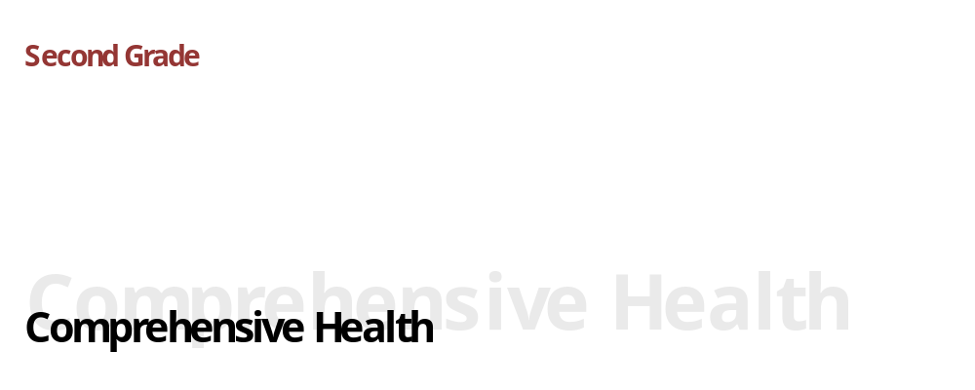
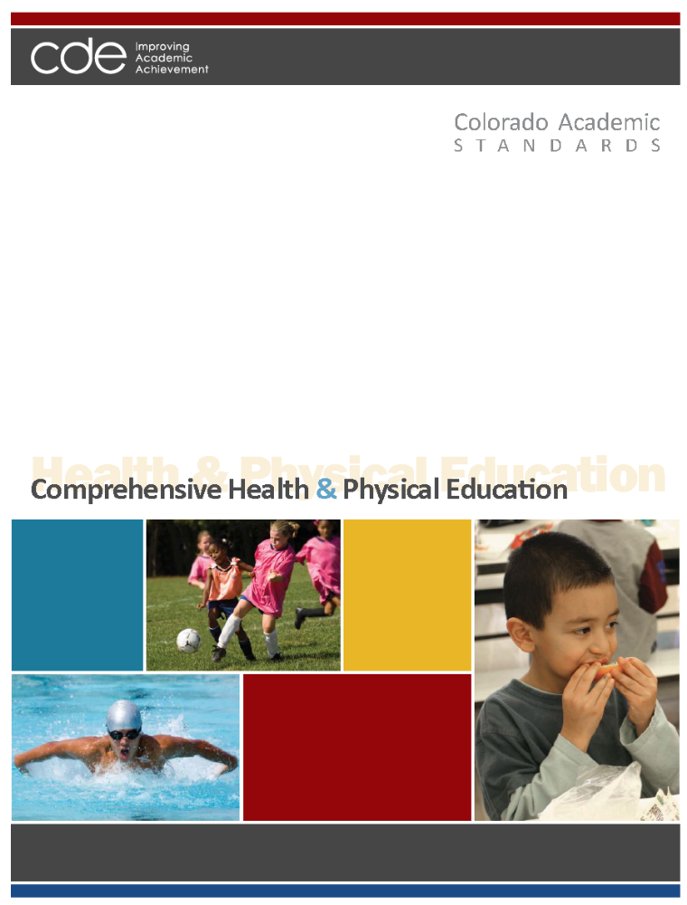
Adopted: December 10, 2009

Colorado Academic Standards
Comprehensive Health and Physical Education Standards

“In the great work of education, our physical condition, if not the first step in point of importance, is the first in order of time. On the broad and firm foundation of health alone can the loftiest and most enduring structures of the intellect be reared.” ~Horace Mann
~~~~~~~~~~~~~~~~~~~~~~~~~~~~~~~~~~
"We know what the Greeks knew: that intelligence and skill can only function at the peak of their capacity when the body is healthy and strong, and that hardy spirits and tough minds usually inhabit sound bodies." ~John F. Kennedy
~~~~~~~~~~~~~~~~~~~~~~~~~~~~~~~~~~

Preparing students for the 21st century cannot be accomplished without a strong and sustained emphasis on all students’ health and wellness. It no is longer acceptable to think of “gym class” and “hygiene lessons.” Today’s world has exploded with physical, mental, and social influences that affect not only learning in school, but also the lifelong health of the citizens that schools are preparing for graduation. Health and physical education prepare students to function optimally as students, global citizens, and workers who demonstrate personal responsibility for one’s health and fitness through an active, healthy lifestyle that fosters a lifelong commitment to wellness.

Health education and physical education are separate disciplines, each with a distinct body of knowledge and skills. However, the two disciplines are naturally interdisciplinary and clearly complement and reinforce each other to support wellness. Schools have a unique role and responsibility to address both health and physical education from preschool through twelfth grade to instill and reinforce knowledge and skills needed to be healthy and achieve academically.

Colorado's comprehensive health and physical education standards lay out a vision for these vitally important disciplines, and describe what all students should know and be able to do at each grade level through eighth grade and in high school. The authors of this document were preschool through twelfth-grade educators, higher education professors, business representatives, and community members. The group developed a set of competencies starting with "the end in mind." What concepts and skills would a "prepared graduate" in the 21st century posses when he or she left high school? The answers to this question framed the work that led to the development of four standards in comprehensive health and physical education for preschool through twelfth grade.
Standards Organization and Construction

As the subcommittee began the revision process to improve the existing standards, it became evident that the way the standards information was organized, defined, and constructed needed to change from the existing documents. The new design is intended to provide more clarity and direction for teachers, and to show how 21st century skills and the elements of school readiness and postsecondary and workforce readiness indicators give depth and context to essential learning.

The “Continuum of State Standards Definitions” section that follows shows the hierarchical order of the standards components. The “Standards Template” section demonstrates how this continuum is put into practice.

The elements of the revised standards are:

Prepared Graduate Competencies: The preschool through twelfth-grade concepts and skills that all students who complete the Colorado education system must master to ensure their success in a postsecondary and workforce setting.

Standard: The topical organization of an academic content area.

High School Expectations: The articulation of the concepts and skills of a standard that indicates a student is making progress toward being a prepared graduate. What do students need to know in high school?

Grade Level Expectations: The articulation (at each grade level), concepts, and skills of a standard that indicate a student is making progress toward being ready for high school. What do students need to know from preschool through eighth grade?

Evidence Outcomes: The indication that a student is meeting an expectation at the mastery level. How do we know that a student can do it?

21st Century Skills and Readiness Competencies: Includes the following:

- Inquiry Questions:
Sample questions are intended to promote deeper thinking, reflection and refined understandings precisely related to the grade level expectation.

- Relevance and Application:
Examples of how the grade level expectation is applied at home, on the job or in a real-world, relevant context.

- Nature of the Discipline:
The characteristics and viewpoint one keeps as a result of mastering the grade level expectation.

Continuum of State Standards Definitions
Prepared Graduate Competency
Prepared Graduate Competencies are the P-12 concepts and skills that all students leaving the Colorado education system must have to ensure success in a postsecondary and workforce setting.

Standards

Standards are the topical organization of an academic content area.
Grade Level Expectations

Expectations articulate, at each grade level, the knowledge and skills of a standard that indicates a student is making progress toward high school.

What do students need to know?
High School Expectations

Expectations articulate the knowledge and skills of a standard that indicates a student is making progress toward being a prepared graduate.

What do students need to know?
Evidence Outcomes
Evidence outcomes are the indication that a student is meeting an expectation at the mastery level.

How do we know that a student can do it?
Evidence Outcomes
Evidence outcomes are the indication that a student is meeting an expectation at the mastery level.

How do we know that a student can do it?
High School
P-8
21st Century and PWR Skills
Inquiry Questions:
Sample questions intended to promote deeper thinking, reflection and refined understandings precisely related to the grade level expectation.
Relevance and Application:
Examples of how the grade level expectation is applied at home, on the job or in a real-world, relevant context.
Nature of the Discipline:
The characteristics and viewpoint one keeps as a result of mastering the grade level expectation.

21st Century and PWR Skills
Inquiry Questions:
Sample questions intended to promote deeper thinking, reflection and refined understandings precisely related to the grade level expectation.
Relevance and Application:
Examples of how the grade level expectation is applied at home, on the job or in a real-world, relevant context.
Nature of the Discipline:
The characteristics and viewpoint one keeps as a result of mastering the grade level expectation.

STANDARDS TEMPLATE

Content Area: NAME OF CONTENT AREA
Standard: The topical organization of an academic content area.
Prepared Graduates:
- The P-12 concepts and skills that all students who complete the Colorado education system must master to ensure their success in a postsecondary and workforce setting
High School and Grade Level Expectations
Concepts and skills students master:
Grade Level Expectations: The articulation, at each grade level, the concepts and skills of a standard that indicates a student is making progress toward being ready for high school.

What do students need to know?

Evidence Outcomes | 21st Century Skills and Readiness Competencies
Students can:  Evidence outcomes are the indication that a student is meeting an expectation at the mastery level.  How do we know that a student can do it? | Inquiry Questions:  Sample questions intended to promote deeper thinking, reflection and refined understandings precisely related to the grade level expectation.
Relevance and Application:

Examples of how the grade level expectation is applied at home, on the job or in a real-world, relevant context.

Nature of the Discipline:

The characteristics and viewpoint one keeps as a result of mastering the grade level expectation.

Prepared Graduate Competencies in
Comprehensive Health and Physical Education

The prepared graduate competencies are the preschool through twelfth-grade concepts and skills that all students who complete the Colorado education system must master to ensure their success in a postsecondary and workforce setting.

Prepared Graduates in Movement Competence and Understanding:
- Demonstrate competency in motor skills and movement patterns needed to perform a variety of physical activity
- Demonstrate understanding of movement concepts, principles, strategies, and tactics as they apply to learning and performing physical activities

Prepared Graduates in Physical and Personal Wellness:
- Participate regularly in physical activity
- Achieve and maintain a health-enhancing level of physical fitness
- Apply knowledge and skills to engage in lifelong healthy eating
- Apply knowledge and skills necessary to make personal decisions that promote healthy relationships and sexual and reproductive health
- Apply knowledge and skills related to health promotion, disease prevention, and health maintenance

Prepared Graduates in Emotional and Social Wellness:
- Utilize knowledge and skills to enhance mental, emotional, and social well-being
- Exhibit responsible personal and social behavior that respects self and others in physical activity settings

Prepared Graduates in Prevention and Risk Management:
- Apply knowledge and skills to make health-enhancing decisions regarding the use of alcohol, tobacco, and other drugs
- Apply knowledge and skills that promote healthy, violence-free relationships
- Apply personal safety knowledge and skills to prevent and treat intentional or unintentional injury

Colorado Academic Standards
Comprehensive Health and Physical Education

The Colorado Academic Standards in comprehensive health and physical education are the topical organization of the concepts and skills every Colorado student should know and be able to do throughout their preschool through twelfth-grade experience.

- Movement Competence and Understanding (Physical Education)
Includes motor skills and movement patterns that teach skill and accuracy in a variety of routines, games, and activities that combine skills with movement; demonstrates the connection between body and brain function; and creates patterns for lifelong physical activity.

- Physical and Personal Wellness (Shared Standard)
Includes physical activity, healthy eating, and sexual health and teaches lifelong habits and patterns for a fit, healthy, and optimal childhood and adulthood; examines society, media, family, and peer influence on wellness choices; practices decision-making and communication skills for personal responsibility for wellness; and identifies the consequences of physical inactivity, unhealthy eating, and early sexual activity. Includes health promotion and disease prevention, and teaches responsibility and skills for personal health habits as well as behavior and disease prevention; sets personal goals for optimal health; examines common chronic and infectious diseases and causes; and recognizes the physical, mental, and social dimensions of personal health.

- Emotional and Social Wellness (Shared Standard)
Includes mental, emotional, and social health skills to recognize and manage emotions, develop care and concern for others, establish positive relationships, make responsible decisions, handle challenging situations constructively, resolve conflicts respectfully, manage stress, and make ethical and safe choices; examines internal and external influences on mental and social health; and identifies common mental and emotional health problems and their effect on physical health.

- Prevention and Risk Management (Shared Standard)
Includes alcohol, tobacco, and other drug prevention; violence prevention; and safety; teaches skills to increase safe physical and social behavior in at home, in school, in the community, and in personal relationships; provides specific knowledge on avoidance of intentional and unintentional injuries; and practices decision-making and communication skills to avoid drug use, bullying, and dating violence.

The standards are organized in the following manner:

  - Physical Education Standards
- Movement Competence and Understanding
- Physical and Personal Wellness
- Emotional and Social Wellness
- Prevention and Risk Management

  - Comprehensive Health Education Standards
- Physical and Personal Wellness
- Emotional and Social Wellness
- Prevention and Risk Management

Comprehensive Health
Grade Level Expectations at a Glance
Standard | Grade Level Expectation
Second Grade
2. Physical and Personal Wellness | 1. | Identify eating behaviors that contribute to maintaining good health
2. Physical and Personal Wellness | 2. | Recognize basic childhood chronic diseases
4. Prevention and Risk Management | 1. | Identify the dangers of using tobacco products and being exposed to second hand smoke.
4. Prevention and Risk Management | 2. | Identify safe and proper use of household products
4. Prevention and Risk Management | 3. | Explain why bullying is harmful and how to respond appropriately
4. Prevention and Risk Management | 4. | Demonstrate interpersonal communication skills to prevent injury or to ask for help in an emergency or unsafe situation

21st Century Skills and Readiness Competencies in

Comprehensive Health and Physical Education

Colorado's Description of 21st Century Skills
Colorado’s description of 21st century skills is a synthesis of the essential abilities students must apply in our rapidly changing world. Today’s students need a repertoire of knowledge and skills that are more diverse, complex, and integrated than any previous generation. Comprehensive health and physical education are inherently demonstrated in each of Colorado’s 21st century skills, as follows:

Critical Thinking and Reasoning
Health and physical education are disciplines grounded in critical thinking and reasoning. Developing and maintaining lifelong wellness habits involves decision-making and communication skills that sometimes can determine life-and-death outcomes. The skills and knowledge gained in health and physical education provide the structure that makes it possible to prevent risk behavior and adopt healthy lifestyles. Without good health and physical activity, critical thinking and reasoning are compromised.

Information Literacy
The disciplines of health and physical education equip students with the tools and habits of mind to organize and interpret a multitude of rapidly changing information resources. Students who are literate in health and physical education can analyze effectively primary and secondary sources, detect bias, use learning tools, including technology and media, and clearly communicate thoughts using sound reasoning.

Collaboration
The health and physical education content areas directly involve students in teams, problem-solving groups, and community connections to support the overall health of the individual and the community. Students offer ideas, strategies, solutions, justifications, and proofs for others to evaluate. In turn, students use feedback to improve performance and interpret and evaluate the ideas, strategies, solutions, and justifications of others.

Self-Direction
Understanding and participating in health and physical education requires a productive disposition, curiosity, personal motivation, and self-direction. Health and physical education are more than passive learning. Individual active participation, practice, and competence are underlying principles of these content areas.

Invention
The health and physical education disciplines are a dynamic set of content area disciplines, ever expanding with new research, ideas, and understandings. Invention is the key element of the expansion as students make and test theories and skills, create and use tools, search for patterns and themes, and make connections among ideas, strategies, and solutions.

Colorado’s Description for School Readiness
(Adopted by the State Board of Education, December 2008)
School readiness describes both the preparedness of a child to engage in and benefit from learning experiences, and the ability of a school to meet the needs of all students enrolled in publicly funded preschools or kindergartens. School readiness is enhanced when schools, families, and community service providers work collaboratively to ensure that every child is ready for higher levels of learning in academic content.

Colorado’s Description of Postsecondary and Workforce Readiness
(Adopted by the State Board of Education, June 2009)
Postsecondary and workforce readiness describes the knowledge, skills, and behaviors essential for high school graduates to be prepared to enter college and the workforce and to compete in the global economy. The description assumes students have developed consistent intellectual growth throughout their high school career as a result of academic work that is increasingly challenging, engaging, and coherent. Postsecondary education and workforce readiness assumes that students are ready and able to demonstrate the following without the need for remediation: Critical thinking and problem-solving; finding and using information/information technology; creativity and innovation; global and cultural awareness; civic responsibility; work ethic; personal responsibility; communication; and collaboration.

How These Skills and Competencies are Embedded in the Revised Standards
Three themes are used to describe these important skills and competencies and are interwoven throughout the standards: inquiry questions; relevance and application; and the nature of each discipline. These competencies should not be thought of stand-alone concepts, but should be integrated throughout the curriculum in all grade levels. Just as it is impossible to teach thinking skills to students without the content to think about, it is equally impossible for students to understand the content of a discipline without grappling with complex questions and the investigation of topics.

Inquiry Questions – Inquiry is a multifaceted process requiring students to think and pursue understanding. Inquiry demands that students (a) engage in an active observation and questioning process; (b) investigate to gather evidence; (c) formulate explanations based on evidence; (d) communicate and justify explanations, and; (e) reflect and refine ideas. Inquiry is more than hands-on activities; it requires students to cognitively wrestle with core concepts as they make sense of new ideas.

Relevance and Application – The hallmark of learning a discipline is the ability to apply the knowledge, skills, and concepts in real-world, relevant contexts. Components of this include solving problems, developing, adapting, and refining solutions for the betterment of society. The application of a discipline, including how technology assists or accelerates the work, enables students to more fully appreciate how the mastery of the grade level expectation matters after formal schooling is complete.

Nature of Discipline – The unique advantage of a discipline is the perspective it gives the mind to see the world and situations differently. The characteristics and viewpoint one keeps as a result of mastering the grade level expectation is the nature of the discipline retained in the mind’s eye.

2. Physical and Personal Wellness

Includes physical activity, healthy eating, and sexual health and teaches lifelong habits and patterns for a fit, healthy, and optimal childhood and adulthood; examines society, media, family, and peer influence on wellness choices; practices decision-making and communication skills for personal responsibility for wellness; and identifies the consequences of physical inactivity, unhealthy eating, and early sexual activity. Includes health promotion and disease prevention, and teaches responsibility and skills for personal health habits as well as behavior and disease prevention; sets personal goals for optimal health; examines common chronic and infectious diseases and causes; and recognizes the physical, mental, and social dimensions of personal health.

Prepared Graduates
The prepared graduate competencies are the preschool through twelfth-grade concepts and skills that all students who complete the Colorado education system must master to ensure their success in a postsecondary and workforce setting.

Prepared Graduates in the Physical and Personal Wellness standard are:
- Participate regularly in physical activity
- Achieve and maintain a health-enhancing level of physical fitness
- Apply knowledge and skills to engage in lifelong healthy eating
- Apply knowledge and skills necessary to make personal decisions that promote healthy relationships and sexual and reproductive health
- Apply knowledge and skills related to health promotion, disease prevention, and health maintenance

Content Area: Comprehensive Health and Physical Education
Standard: 2. Physical and Personal Wellness in Health
Prepared Graduates:
- Apply knowledge and skills to engage in lifelong healthy eating
Grade Level Expectation: Second Grade
Concepts and skills students master:
- Identify eating and drinking behaviors that contribute to maintaining good health
Evidence Outcomes | 21st Century Skills and Readiness Competencies
Students can:  - Explain the importance of choosing healthy foods and beverages (DOK 1-2)  - Identify the benefits of drinking plenty of water (DOK 1)  - Describe the benefits of eating breakfast every day (DOK 1-2)  - Identify a variety of healthy snacks (DOK 1)  - Understand that the body exhibits signals that tell people when they are hungry and when they are full (DOK 1) | Inquiry Questions:  - Why do many people claim that breakfast is the most important meal of the day?  - Why is it important to pay attention to your body when it feels hungry or full?
Relevance and Application:
- Water is essential for optimal body functioning.
- A healthy diet, which includes eating breakfast, helps provide the energy you need to move, think clearly, and solve problems, throughout the day.
Nature of Health:
- A healthy, balanced diet includes eating appropriate portion sizes from multiple food groups throughout the the day.

Content Area: Comprehensive Health and Physical Education
Standard: 2. Physical and Personal Wellness in Health
Prepared Graduates:
- Apply knowledge and skills related to health promotion, disease prevention, and health maintenance
Grade Level Expectation: Second Grade
Concepts and skills students master:
- Recognize basic childhood chronic diseases
Evidence Outcomes | 21st Century Skills and Readiness Competencies
Students can:  - Identify problems associated with common childhood chronic diseases or conditions, including but not limited to asthma, allergies, type-1 diabetes, and epilepsy (DOK 1-3)  - Communicate concern to an appropriate adult when a person is having an allergic reaction or difficulty breathing (DOK 1-3) | Inquiry Questions:  - How can you tell if someone is having an allergic reaction?  - What actions might you take if you saw a person who was having trouble breathing?
Relevance and Application:
- Food allergies are common and it is important to understand how to decrease exposure to allergens..
- If someone is having difficulty breathing or is not responding, it is important to know how to seek help.
Nature of Health:
- Chronic diseases and allergies can be effectively managed.
3. Emotional and Social Wellness

Includes mental, emotional, and social health skills to recognize and manage emotions, develop care and concern for others, establish positive relationships, make responsible decisions, handle challenging situations constructively, resolve conflicts respectfully, manage stress, and make ethical and safe choices; examines internal and external influences on mental and social health; and identifies common mental and emotional health problems and their effect on physical health.

Prepared Graduates
The prepared graduate competencies are the preschool through twelfth-grade concepts and skills that all students who complete the Colorado education system must master to ensure their success in a postsecondary and workforce setting.

Prepared Graduates in the Emotional and Social Wellness standard are:
- Utilize knowledge and skills to enhance mental, emotional, and social well-being
- Exhibit responsible personal and social behavior that respects self and others in physical activity settings

Content Area: Comprehensive Health and Physical Education
Standard: 3. Emotional and Social Wellness in Health
Prepared Graduates:

Grade Level Expectation: Second Grade
Concepts and skills students master:
THERE ARE NO EXPECTATIONS AT THIS GRADE LEVEL IN THIS STANDARD
Evidence Outcomes | 21st Century Skills and Readiness Competencies
Students can: | Inquiry Questions:
Students can: | Relevance and Application:
Students can: | Nature of Physical Education:

4. Prevention and Risk Management

Includes alcohol, tobacco, and other drug prevention; violence prevention; and safety; teaches skills to increase safe physical and social behavior in at home, in school, in the community, and in personal relationships; provides specific knowledge on avoidance of intentional and unintentional injuries; and practices decision-making and communication skills to avoid drug use, bullying, and dating violence.

Prepared Graduates
The prepared graduate competencies are the preschool through twelfth-grade concepts and skills that all students who complete the Colorado education system must master to ensure their success in a postsecondary and workforce setting.

Prepared Graduates in the Prevention and Risk Management standard are:
- Apply knowledge and skills to make health-enhancing decisions regarding the use of alcohol, tobacco, and other drugs
- Apply knowledge and skills that promote healthy, violence-free relationships
- Apply personal safety knowledge and skills to prevent and treat intentional or unintentional injury

Content Area: Comprehensive Health and Physical Education
Standard: 4. Prevention and Risk Management in Health
Prepared Graduates:
- Apply knowledge and skills to make health-enhancing decisions regarding the use of alcohol, tobacco, and other drugs
Grade Level Expectation: Second Grade
Concepts and skills students master:
- Identify the dangers of using tobacco products and being exposed to second-hand smoke
Evidence Outcomes | 21st Century Skills and Readiness Competencies
Students can:  - Describe the benefits of not using tobacco (DOK 1-2)  - Identify the short- and long-term physical effects of using tobacco and being exposed to tobacco smoke (DOK 1-2)  - State reasons why one should avoid second-hand smoke (DOK 1-2)  - Demonstrate the ability to assertively refuse an unwanted item or pressure from a peer (DOK 1-3) | Inquiry Questions:  - Why do people choose to smoke when they know it is bad for them?  - Why is it important to be able to refuse something that you do not want?  - What might happen if I saw a friend pick up a cigarette and I didn't say anything...I just walked away?
Relevance and Application:
- Researchers explore the impact of tobacco on the body’s ability to function normally.
- Second-hand smoke impacts air quality .

Nature of Health:
- Effective communication skills enhance a person's ability to express wants and defend their beliefs.
- Research has clearly established that tobacco has a variety of harmful effects on the human body.

Content Area: Comprehensive Health and Physical Education
Standard: 4. Prevention and Risk Management in Health
Prepared Graduates:
- Apply knowledge and skills to make health-enhancing decisions regarding the use of alcohol, tobacco, and other drugs
Grade Level Expectation: Second Grade
Concepts and skills students master:
- Identify safe and proper use of household products
Evidence Outcomes | 21st Century Skills and Readiness Competencies
Students can:  - Identify and distinguish between substances that are safe and unsafe to be taken orally (DOK 1-2)  - Explain that taking medications incorrectly can be harmful, including vitamins (DOK 1-2)  - Articulate the proper and safe use of household products (DOK 1-2) | Inquiry Questions:  - What could happen if there were not any labels on medicines, foods, vitamins or other household products?  - What is safe or unsafe to eat?
Relevance and Application:
- Pharmacists work to explain and protect individuals from unsafe substances or mistaken consumption of medication.
- New technologies are being developed to prevent unintentional poisoning.
Nature of Health:
- Medicines must be used correctly in order to be safe and have maximum benefit.

Content Area: Comprehensive Health and Physical Education
Standard: 4. Prevention and Risk Management in Health
Prepared Graduates:
- Apply knowledge and skills that promote healthy, violence-free relationships
Grade Level Expectation: Second Grade
Concepts and skills students master:
- Explain why bullying is harmful and how to respond appropriately
Evidence Outcomes | 21st Century Skills and Readiness Competencies
Students can:  - Understand why it is wrong to tease others (DOK 1-3)  - Identify why making fun of others is harmful to self and others (DOK 1-3)  - Describe the difference between bullying and teasing (DOK 1-2)  - Explain what to do if you or someone else is being bullied (DOK 1-2) | Inquiry Questions:  - How does the old saying, "walk a mile in the other person's shoes" apply to teasing and bullying?  - If it's just "making fun" then how can it be harmful?
Relevance and Application:
- A number of professionals can help when someone is being bullied or teased, including but not limited to counselors, psychologists, police, or trusted adults.

Nature of Health:
- Tolerance, appreciation, and understanding of diversity are important skills to learn and practice.

Content Area: Comprehensive Health and Physical Education
Standard: 4. Prevention and Risk Management in Health
Prepared Graduates:
- Apply personal safety knowledge and skills to prevent, and treat unintentional injury
Grade Level Expectation: Second Grade
Concepts and skills students master:
- Demonstrate interpersonal communication skills to prevent injury or to ask for help in an emergency or unsafe situation
Evidence Outcomes | 21st Century Skills and Readiness Competencies
Students can:  - Demonstrate how to make a decision to call 911 or other emergency numbers for help  - Demonstrate verbal and nonverbal ways to ask an adult for help about an emergency  - Demonstrate effective refusal skills to avoid unsafe situations  - Describe the use of safety equipment for specific activities and sports such as biking, skateboard, riding a scooter and inline skating (DOK 1-2)  - Identify ways to reduce or prevent the risk of injuries around water (DOK 1-2) | Inquiry Questions:  - How do I know when to call 911?  - What do individuals do when they need to communicate and they cannot speak?  - What are the decisions made by emergency workers?  - What happens if a player does not wear a helmet or kneepads?  - Why is it important to be careful around water?  - Why do lifeguards say "walk don't run" at swimming pools?
Relevance and Application:
- Ambulance personnel are skilled at considering situations from a variety of aspects.
- Young people often get trained to perform CPR or other forms of resuscitation.
- Injury prevention requires preparation and communication.
- Coast Guard and lifeguards are equipped to prevent and provide help in a water safety situation.
- A 911 operator is trained to send help in an emergency and provide help over the phone.
- Safety equipment, such as helmets, knee pads, and life jackets, exist to help prevent unintentional injuries.

Nature of Health:
- Personal strategies can be learned to develop and enhance healthy behaviors and to avoid, reduce, and cope with unhealthy, risky, or potentially unsafe situations.

Colorado Department of Education
Office of Standards and Instructional Support
201 East Colfax Ave. • Denver, CO 80203
http://www.cde.state.co.us/CoHealthPE/StateStandards.asp

