Teachers notes page:

This DBQ was designed as an end of unit assessment. From the start of the unit students are introduced to the question, grading rubric and through every lesson they begin building background knowledge necessary to answer the question; approaching responses around economic, political, cultural and geographic perspectives. The teacher is conscious of every document used in the assessment and structures lessons to speak indirectly to each document.

A true DBQ assessment for 6th graders is a rigorous task in itself, especially if it is the students’ first exposure to the practice. Plan for at least 5-7 days of instructional time for students to prepare and write their constructed response (10-12 if is their first DBQ experience). Everything from the creation of a thesis statements, the flow of an introduction, to the analysis, synthesis and use of documents takes time. Plans must be structured and modified per student needs.
Possible Assessment timeframe and approach:
Day 1: Review of prompt, rubric and creation of thesis statement. Provide students with example thesis statements (they don’t necessarily have to answer provided prompt due to generic rubric) so students have examples of advance, proficient, partially proficient and unsatisfactory thesis statements.
Day 2: Creation of introduction: Using the rubric as a guide, have students create an (again providing examples of DBQ introduction) introduction, that pays specific attention to the elements graded(hook, restatement of question (thesis achieves this), definition of key terms and thesis statement).
Day 3-4: Being planning using graphic organizer (tree map) for a five bodied paragraph. A possible approach is have the students complete their organizer using their background knowledge and then introduce the documents and have student either modify thesis statement or being supporting their arguments with the various documents (ideas for differentiation, depending on students’ needs, provide an organizer with sentence stems and only require one to three documents needed for support)
Day 5/6: Document Analysis, students should have document analysis sheet that they are familiar with pushing their thinking of each document while connecting it to the DBQ prompt(don’t hold students to this time frame, if they are ready for the next step they should continue).
Day 6-7: Student write essay.

Interconnectedness DBQ:
In the United States, the advantages of being globally interconnected outweigh the disadvantages. You can agree with this statement or disagree with this statement.



Prompt:
Countries throughout the world are now intimately connected. These connections range from the spread of cultures, trade among nations, influences of governments and the role of international organizations. Interconnectedness carries many advantages and disadvantages, depending on who and where your place is in the world.

In the United States, the advantages of being globally interconnected outweigh the disadvantages. Your task is to use what you know and have learned as well as the documents to defend or refute this statement. Begin your essay with an introductory paragraph that includes an obvious thesis statement. Explain your thesis with appropriate examples and quotes from the documents. Support your claims fully with evidence from the documents and clearly explain how the documents you use support your thesis.

Name: __________________________________ Date: __________________________
Document-Based Question (DBQ): Interconnectedness (100 points)
Task: In the United States, the advantages of being globally interconnected outweigh the disadvantages. You agree with this statement or you disagree with this statement; your task is to use the documents along with what you know and learned through this unit to defend or refute. Begin your essay with an introductory paragraph that includes an obvious thesis statement. Explain your thesis with appropriate examples and quotes from the documents. Support your claims fully with evidence from the documents and clearly explain how the documents you use support your thesis.
 | Beginning | Partially Proficient | Proficient | Advanced
Outline/  Planning  10 points | Incomplete or missing planning, which shows a lack of document understanding; effort is missing. | Incomplete or unclear planning, which neglects to mention documents; unclear thesis; inconsistent effort. | Organized draft; thesis obviously stated; identified where and why documents will be used in response; includes a conclusion. | Complete draft; sophisticated and clear thesis; clearly states where and how the documents will be used; includes an introduction, body paragraph, and conclusion that are thoroughly mapped out.
Thesis  Statement  and  Introduction  30 points | Thesis is missing or in the wrong place; is awkwardly written or does not make sense; confuses the reader; introduction is missing many of the required parts: a restatement of the question, definitions of any key terms, and appropriate background knowledge. | Thesis is the last sentence in the introduction, but lacks substance; awkwardly written; suggests an arguable statement, but is confusing or unclear; introduction is missing some of the required parts: a restatement of the question, definitions of any key terms, and appropriate background knowledge. | Thesis is the last sentence in the introduction; provides a well-worded statement makes an arguable statement; introduction includes most of the following: restatement of the question, definitions of any key terms, and appropriate background knowledge. | Thesis is the last sentence in the introduction; provides a well-worded and compelling statement; makes an arguable and sophisticated statement; introduction includes a restatement of the question, definitions of any key terms, and interesting and appropriate background knowledge.
Argument  and  Document  Use  30 points | Few documents, if any, are used to support response or documents are merely mentioned; neglects to provide direct quotes and/or explain how the documents support thesis; lists documents; does not support thesis with background knowledge | Mentions and uses few documents to support response; provides few direct quotes from documents and/or struggles to use the documents to support thesis; tends to list or merely describe documents; struggles to explain their significance/importance in relation to the thesis; struggles to synthesize documents; attempts to use background knowledge in support of thesis. | Meaningfully uses many documents to support response; provides direct quotes from documents AND uses the documents to support thesis (does not merely list or describe documents), but could give more explanation; analyzes and synthesizes documents by using the documents in more supporting reason; uses background knowledge as support for the thesis. | Meaningfully uses all of or all but one of the documents to support response; directly quotes from documents AND provides a thorough explanation of their significance/importance in relation to the thesis; analyzes and synthesizes documents by grouping them in varied ways; uses background knowledge to persuasively argue the author’s perspective.
Writing  and  Language  Use  30 points | Response is in rough draft form and needs several revisions before being considered a finished product; response is lacking organization; response is not organized into paragraphs | Reader’s understanding of the response is interrupted because of the number of spelling and grammatical errors; paper needs to be edited carefully; response needs to be revised for organization; topic sentences are missing; conclusions are missing; transitions between paragraphs are missing; details and explanations are missing. | Response has only a few spelling and/or grammatical errors; final response is clear, interesting, and easy to read; response is organized and the writing is logical; topic sentences flow into each paragraph; conclusions summarize each section of the response; thesis is supported and explained, but explanation could be more meaningful. | Response is nearly absent of spelling and/or grammatical mistakes; the response is expertly organized; powerful topic sentences and transitions statements add to the reader’s understanding. Conclusion is complete and interesting; writer always uses enough details and explains thoroughly while providing interesting and appropriate examples.

Document 1

The World Map by McDonalds & Starbucks
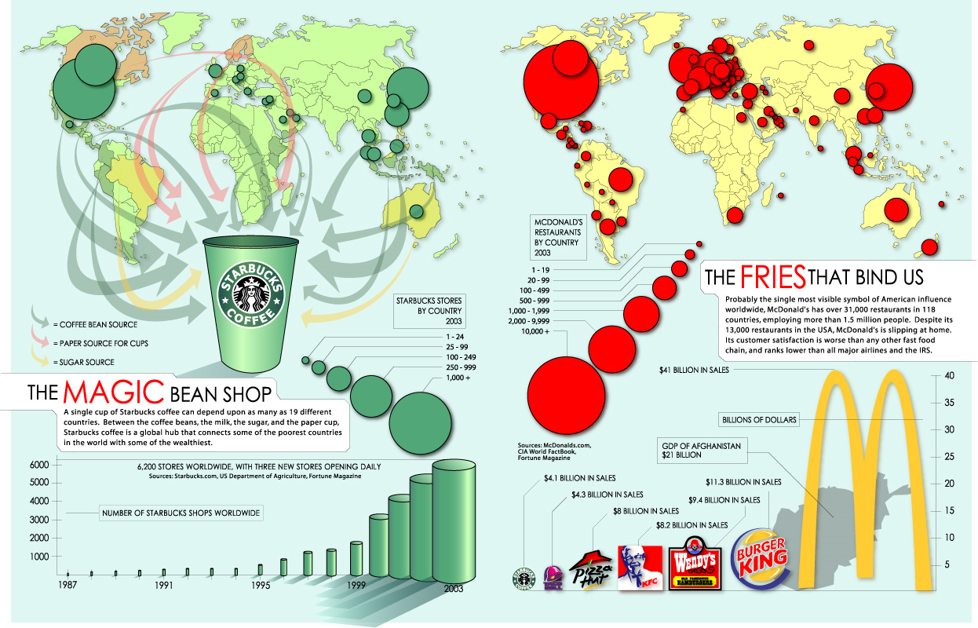
July 9, 2008
http://www.princeton.edu/~ina/infographics/starbucks.html

Document 2

The United Nations
www.un.org/en/


The United Nations is an international organization founded in 1945 after the Second World War by 51 countries committed to maintaining international peace and security, developing friendly relations among nations and promoting social progress, better living standards and human rights.

There are currently 192 countries who are part of the United Nations.

The UN has 4 main purposes
- To keep peace throughout the world;
- To develop friendly relations among nations;
- To help nations work together to improve the lives of poor people, to conquer hunger, disease and illiteracy, and to encourage respect for each other’s rights and freedoms;
- To be a centre for harmonizing the actions of nations to achieve these goals.

Document 3


Walmart Home Page
May 20, 2011

Always Low Prices
"Always Low Prices." That was Sam Walton's pricing philosophy when he opened the first Wal-Mart in 1962. Today, we're still committed to bringing you great products at our Every Day Low Prices, whether you're shopping in your local store or at Walmart.com.

Document 4

Six Emerging Economies Will Account For Over Half Of Economic Growth By 2025, World Bank Says

The Huffington Post Maxwell Strachan First Posted: 05/18/11 03:37 PM ET Updated: 05/18/11 03:50 PM ET
The world economy, so long defined by the dominance of a few advanced countries, has entered a period of “transformative change,” according to a new report by the World Bank.
Globalization is shifting the balance of power toward a handful of increasingly prominent emerging economies, mostly notably China and India. That, in turn, could soon end the U.S. dollar’s era of dominance, the report, entitled “Global Development Horizons 2011—Multipolarity: The New Global Economy,” says.
Six emerging economies could account for half of all economic growth by 2025, the report says, matching the output of the “euro area,” including Brazil, China, India, Indonesia, South Korea, and Russia. That’s assuming an annual growth rate in emerging economies of 4.7 percent until 2025. Advanced economies like the U.S. are expected to grow at a 2.3 percent rate.

Document 5

Democracy and the Middle East
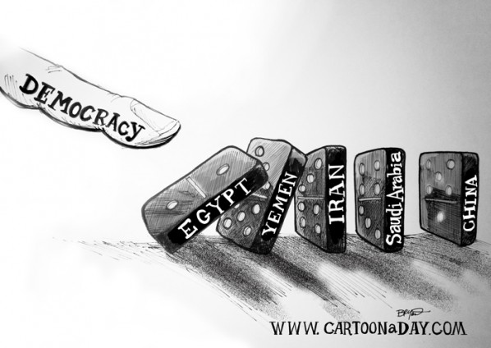

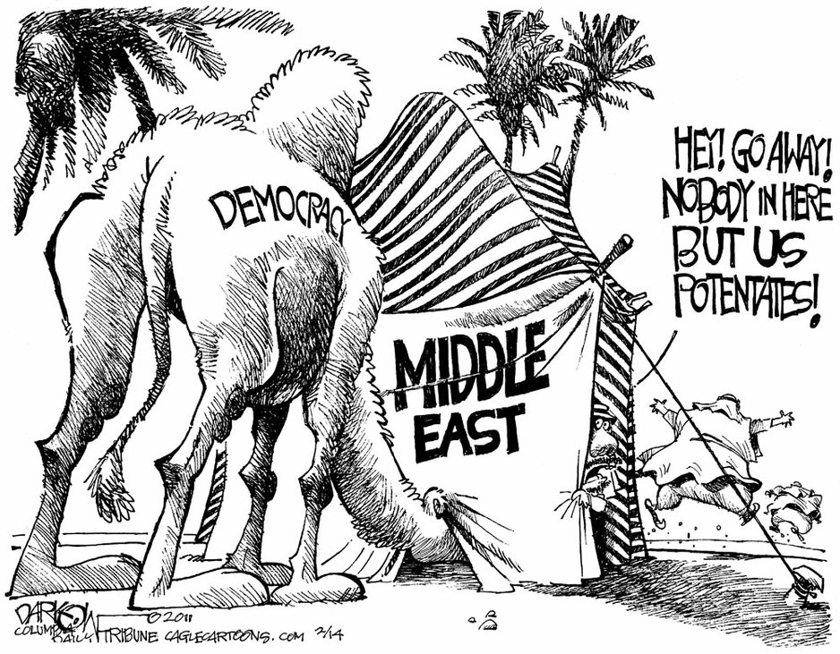

Columbia Daily Tribune
February 14, 2011

