Goal | Progress/Date: Fall/1st visit | Spring/2nd visit | Additional visit (optional)
1.

2.

3.

4.

5.

6.

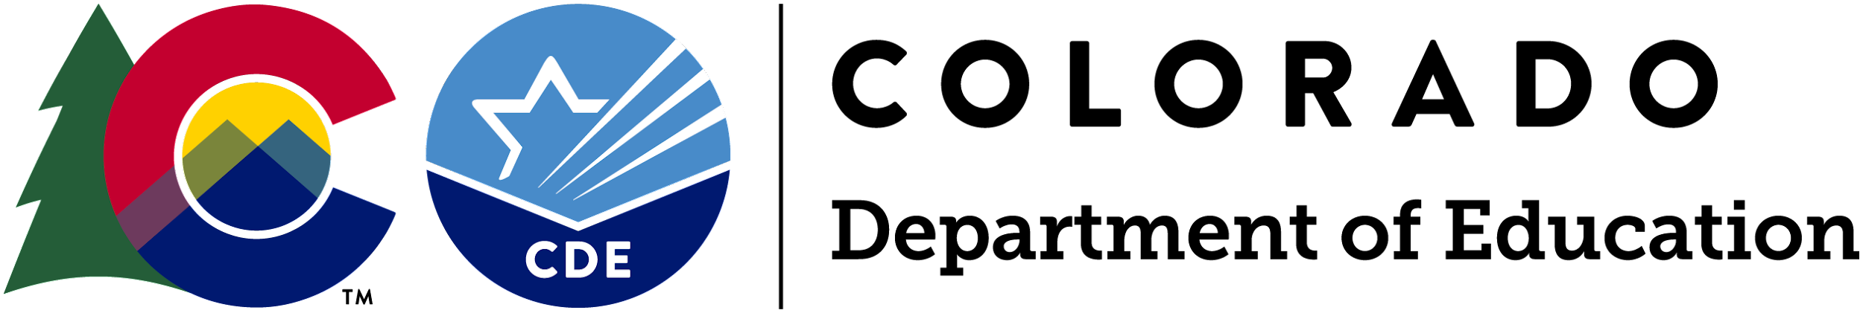
August 2021

