Purpose
The Initiative Inventory helps multidisciplinary implementation teams provide an overall picture of existing initiatives, programs, and/or community partnerships related to school safety/violence prevention and clarify the relationships between ongoing commitments. It can be used to facilitate the integration and alignment of initiatives and provide opportunities for cross collaboration and cohesion among the 4 key areas of comprehensive school safety planning (prevention/mitigation, protection, response, & recovery).

Process
Step One: Fill in the rows of the Initiative Inventory by naming the major initiatives taking place that are related to one of the 4 key areas of comprehensive school safety planning (prevention/mitigation, protection, response, & recovery). Fill in as much of the information as possible.
Step Two: Reflect on your Initiative Inventory using the discussion questions.

Initiative Inventory Reflection
Initiative Inventory
- What initiatives share similar areas of comprehensive safety planning? Are certain areas of safety planning more represented/less represented than others?
- How many different teams/personnel are involved in the identified initiatives? Are there opportunities within your system for these teams/individuals to align and/or integrate their work and efforts?
- What initiatives share similar training, education, and technical assistance?
- What initiatives share similar outcomes?
- Where might alignment and integration improve the implementation and outcomes of initiatives?
- Where might there be a need for further learning opportunities targeting groups with different levels of involvement: awareness, participation, engagement?
- Identify actionable items that can facilitate prioritization, collaboration, and integration of work.
Initiative Inventory

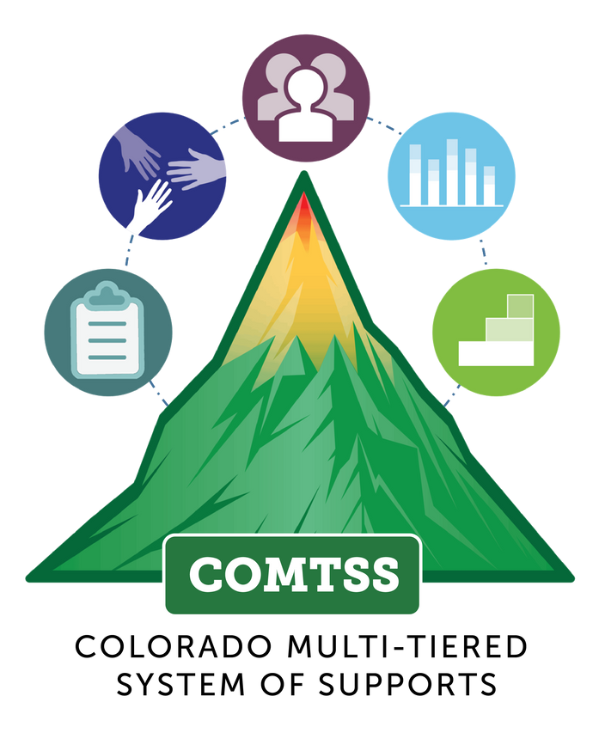
School/District/Region Name
C O L O R A D O M U L T I - T I E R E D S Y S T E M O F S U P P O R T S
Date of Completion
Names
Name of Initiative (practice or innovation) | What area(s) of comprehensive safety planning does it address (prevention/ mitigation, protection, response, & recovery? | What personnel are involved in the implementation? | What is the expected outcome and how is it measured? | Is there evidence/data that it is having a positive impact? What is the evidence? | How are you ensuring the initiative is implemented as intended? What are you measuring? | What learning opportunities exist for different levels of involvement (awareness, participation, and engagement) in this initiative? | What is the financial commitment and source of funding?
Focus Area(s)
Name of Initiative (practice or innovation) | What area(s) of comprehensive safety planning does it address (prevention/ mitigation, protection, response, & recovery? | What personnel are involved in the implementation? | What is the expected outcome and how is it measured? | Is there evidence/data that it is having a positive impact? What is the evidence? | How are you ensuring the initiative is implemented as intended? What are you measuring? | What learning opportunities exist for different levels of involvement (awareness, participation, and engagement) in this initiative? | What is the financial commitment and source of funding?
Initiative Inventory
C O L O R A D O M U L T I - T I E R E D S Y S T E M O F S U P P O R T S

