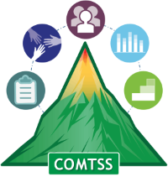
Colorado Multi-Tiered System of Supports
OFFICE OF LEARNING SUPPORTS

Colorado Multi-Tiered System of Supports Initiative Inventory Completion Protocol:

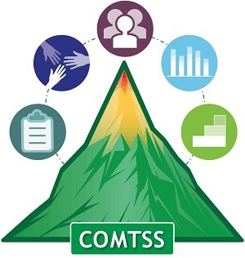
Introduction: The Colorado Multi-Tiered System of Supports (COMTSS) Initiative Inventory is a tool used by an implementation team to assess current efforts related to areas of focus prior to adding new initiatives.
Purpose: The Initiative Inventory helps implementation teams analyze the status of current initiatives and clarify the relationships between ongoing commitments. It can be used to facilitate the prioritization of initiatives and provide opportunities to create common language, identify common goals, share resources, and build collective capacity.
Outcomes:
- Identification of initiatives that share similar outcomes and/or customers
- Identification of where integration of initiative efforts would improve outcomes
- Identification of gaps in implementation processes
- Collaboration amongst initiatives to decrease duplication of efforts
- Facilitate conversations about prioritization of initiatives, opportunities for collaboration, and integration of work

Materials: All team members should have access to the initiative inventory.
Procedure for Completion:
- Use the protocol to complete the tool in groups. Start by naming the major initiatives taking place that are related to the focus area and involve training and/or technical assistance. Be as explicit as possible when describing the work that is being done (e.g., provide the name of tools, outcomes, and trainings).
- After each individual or group has completed the tool, combine the responses into one larger document that can be discussed as a whole.
- You may also want to go through the combined tool and highlight areas of overlap (e.g., highlight initiatives that share customers or training content).
- Then, as a team, answer the questions on the final page of the Initiative Inventory to consider potential collaboration.

Colorado Multi-Tiered System of Supports (COMTSS) Initiative Inventory
District/Region Name: _____________________________________________ Date of Completion: ____________________________
Names:____________________________________________________________________________________________________________________________________________________________________________________________________________________________________
Focus area(s) this initiative inventory is addressing: ________________________________________________________________________

Name of Initiative (practice or innovation) | What personnel are involved in coordinating the implementation of this initiative? | What training and learning opportunities are delivered for this initiative? Who and when? | What technical assistance (coaching and/or consulting) is provided for this initiative? | Who are the customers of the training and technical assistance? | How are you ensuring the initiative is implemented as intended? What are you measuring? | What are the expected outcomes of this initiative? | How are you measuring those outcomes?

Use the Initiative Inventory to consider areas for potential collaboration by comparing your responses with the responses of other people, offices, or units. Then, identify actionable items that can facilitate prioritization, collaboration, and integration.
What initiatives share similar customers?

What initiatives share similar training, education, and technical assistance?

What initiatives share similar outcomes?

Where might alignment and integration improve the implementation and outcomes of initiatives?

Identify actionable items that can facilitate prioritization, collaboration, and integration of work.

Adapted from the initiative inventory from the National Implementation Research Network (NIRN): https://nirn.fpg.unc.edu/resources/initiative-inventory

