Purpose
Identify all the sources of school safety and violence prevention data your system currently collects at the student and system level (e.g., schoolwide, culture and climate, hotspots).

Process
Step One: Fill in the rows of the Data Audit for all data your system is collecting related to school safety and violence prevention efforts. Be as specific as possible.
Step Two: Reflect on your data sources. Look for and take note of overlaps, gaps, and needs.
- What do you notice about the types of data you collect? Do you have data representing schoolwide, culture and climate, and hotspots? Are you over-assessing in certain areas? Under-assessing in others?
- Do you collect data that looks at both risk and protective factors? Prevention and promotion efforts?
- Are there any data types or assessment methods that could be combined or eliminated to increase efficiency? List any overlaps that may exist:
- Do the members of different teams overlap?
- Does this data align with the outcomes you are trying to achieve as it relates to school safety and violence prevention efforts?
Step Three: Reflect on your systems and structures, as it relates to your ability to use your data to inform decision making.
- Are you collecting and analyzing data frequently enough to use the data for decision making?
- Do the assessments you use address all of your school’s needs? List any gaps that may exist:

- Do you have a data management system(s) that allows for the right information, in the right format, to the right people to make timely decisions?
- How many different teams are represented related to school safety and violence prevention data? Do members of different teams overlap? If not, what communication loops are in place to share and use data to problem solve?
- Do you engage in a problem-solving process with this data? Is data triangulated in order to identify system strengths and needs as it relates to school safety and violence prevention?

Data Audit Reflection
Data Audit Protocol
- What do you notice about the data that is collected in service of violence prevention and school safety efforts? How do they align with your intended outcomes that you are trying to achieve?
- Is your system collecting both prevention and promotion data? How are you supporting mindset shifts to be inclusive of strength-based efforts?
- Have you identified any structural and/or system needs (e.g., teaming, problem-solving protocols, data management systems) to improve your use of data to inform decisions?
- How might school safety efforts be strengthened by considering the above?

Data Audit Protocol

Data Tool | Data Level | School Safety Area | Frequency of Data Collection | Where Are the Data Housed | What Goal/Outcome is this Measuring | Team(s) Responsible for Data Review and Use

Data Audit
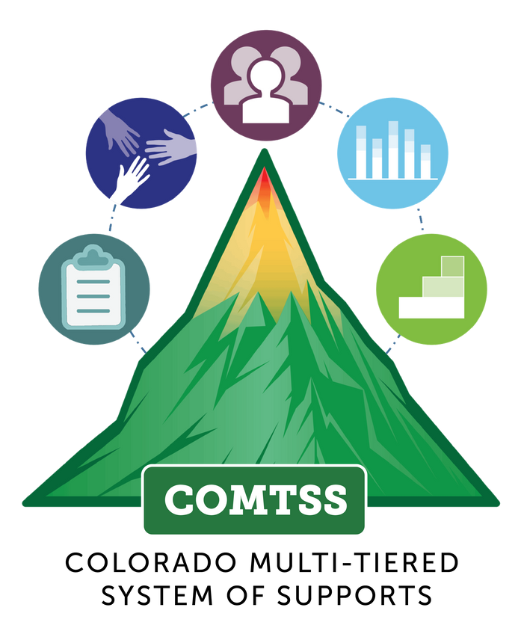
C O L O R A D O M U L T I - T I E R E D S Y S T E M O F S U P P O R T S

