Purpose
Identify and articulate each team/committee within the organization that targets the 4 key areas of comprehensive school safety planning (prevention/mitigation, protection, response, & recovery) in support of cross-collaboration and cohesion.

Process
Step One: Fill in the rows of the Committee Audit for all teams/committees your system has in place that target the continuum of school safety efforts. Be as specific as possible.
Step Two: Reflect on what you see in the committee audit.
- Are there multiple teams/committees that seek to affect the same outcomes?
- What do you notice about the personnel involved?
- Are different stakeholders represented?
- Do the members of different teams overlap?
- Do all your teams/committees/work groups have defined goals and outcomes?
Step Three: Look for and take note of overlaps, gaps, and needs.
- Do you have teams that address all 4 key areas of comprehensive safety planning?
- Are there intentional communication loops amongst the teams represented?
- Do any of the committees/teams target the same purpose and outcomes? Could their efforts be integrated?
- Do any of your teams need more clearly defined outcomes?
- Do any of your teams need additional representation?

Committee Audit Reflection
Committee Audit Protocol
- What do you notice about the current teams that support school safety efforts?
- When reflecting on 4 key areas of comprehensive safety planning, is there a need to add and/or repurpose teams?
- Is there team member representation that is lacking?
- How might you ensure communication and collaboration amongst teams? (E.g. Creating a multidisciplinary team, communication planning, integrated professional development.)
- What data-based decision-making protocol exists or is needed within these teams that supports promotion and prevention efforts?
- How might school safety efforts be strengthened by considering the above?

Committee Audit Protocol

Team/Committee | Purpose | Outcome(s) | Staff Involved | Data Collected/Utilized | Key Area(s) of Comprehensive Safety Planning

Committee Audit
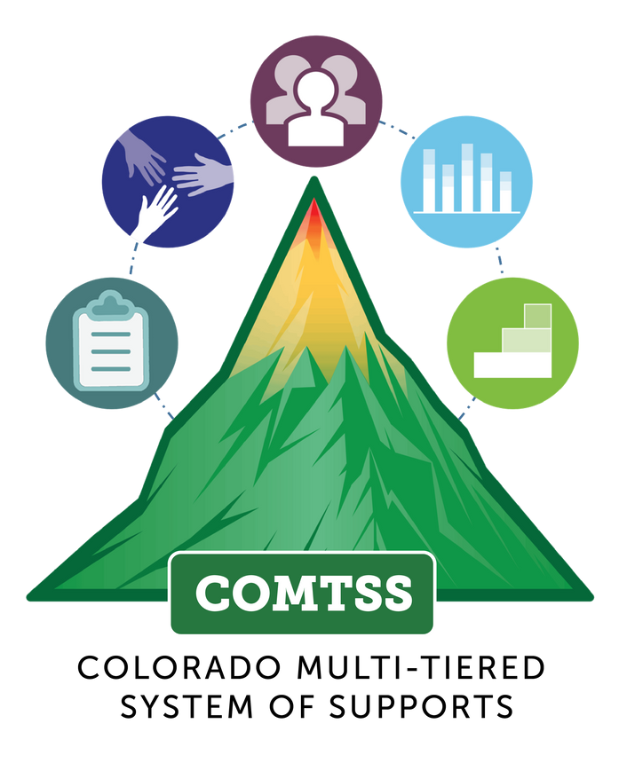
Adapted from the work of G. Sugai and J. Nagasaki
C O L O R A D O M U L T I - T I E R E D S Y S T E M O F S U P P O R T S

