Local Access Manager

Quick Reference Guide



This is a Quick Reference Guide of common tasks Local Access Managers (LAMs) will perform managing user accounts and access to CDE Online applications.

Contents

Logging In 2

Create an Account 3

Searching for a User 4

Using the Filters when Searching for a User 5

Assign a Role 6

Using the Filters when Managing Roles 8

Revoke a Role 10

Disable/Delete User Accounts 11

Export User Accounts 13

Bulk Changes 14

Adding LAMs 17

Application Specific LAMs 18

Password Management 20

User Management FAQs 24

Appendix 28

Logging In

From the IdM webpage at <https://www.cde.state.co.us/idm>, click on **Access Management**.

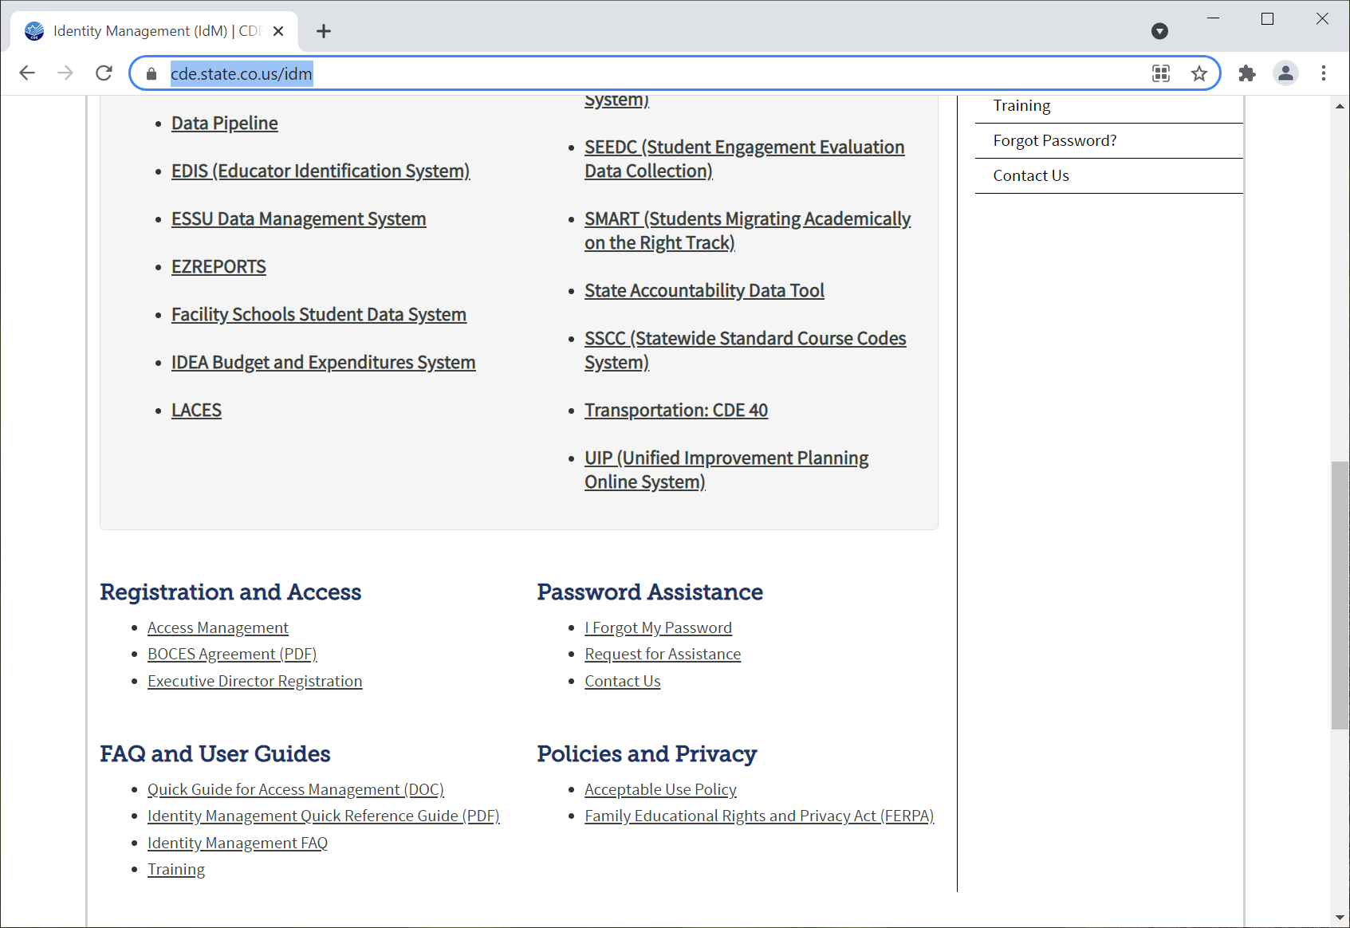

Enter your username (email) and password.

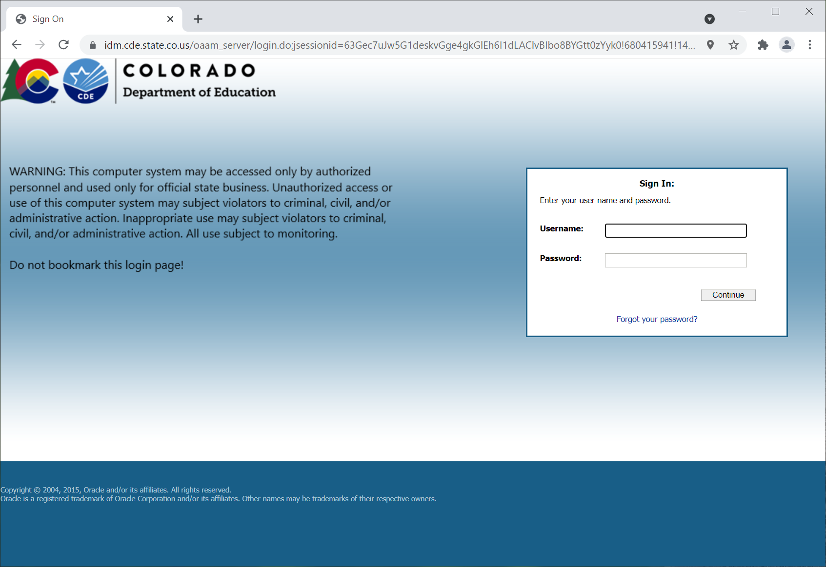

Create an Account

Once logged into your account, click on **New User**.

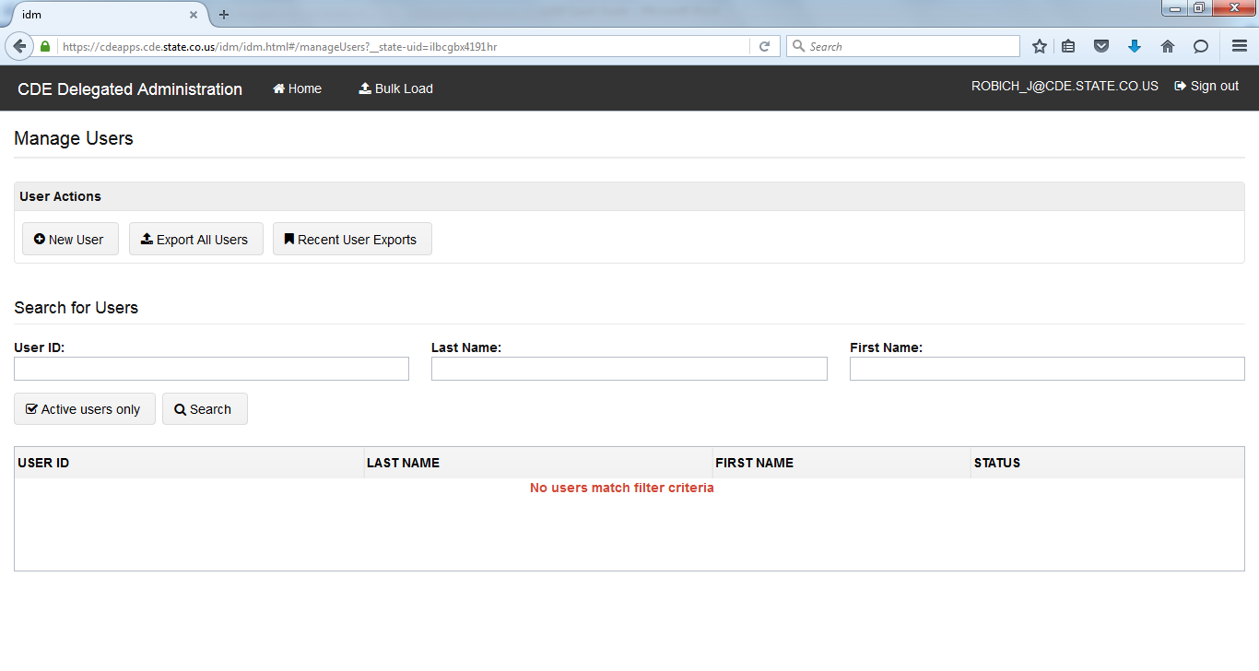

This is the “Manage User” area and it defaults to the **Profile** which is the first step to add a new account. Input user information. The following fields are **REQUIRED**: Email, First Name, Last Name, Organization (this will only bring the orgs for which you have access), Password. The EDID is only required for the Colorado Performance Management System (RANDA). The password should be random and it is not recommended to give all users the same password. CDE recommends selecting the box to **Reset password on next logon** for better security.

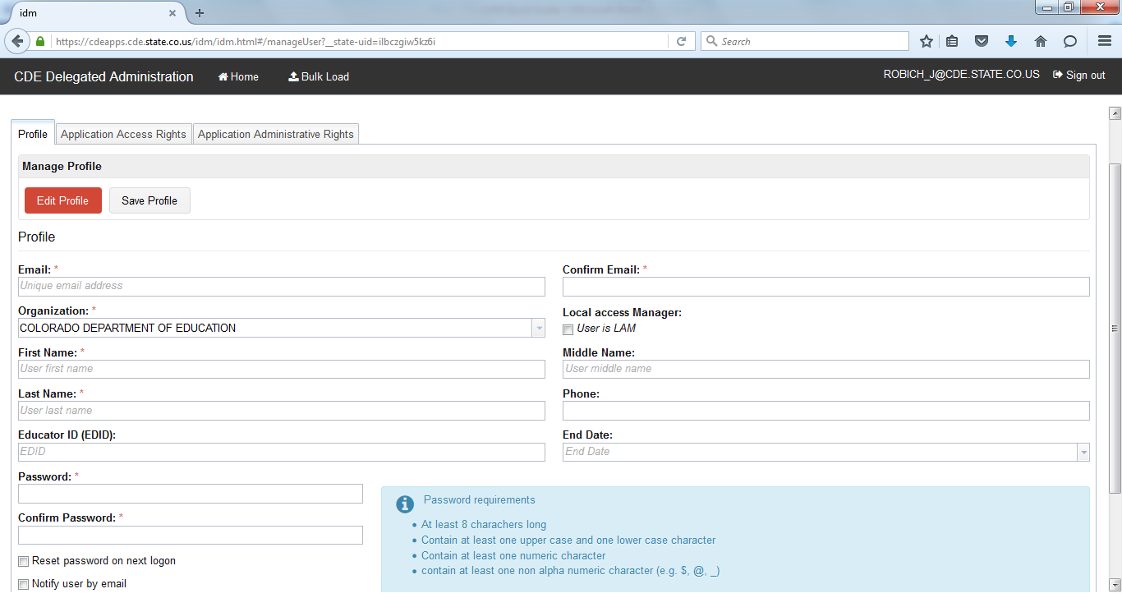

Click on **Save Profile** (bottom righthand corner). You can then add roles as needed by following the information below.

**Note: emails are not automatically generated based on adding users to the system. If you would like a user to know they’ve been added, LAMs may send one directly and you’ll want to include the password you created. While there is also a box to “Notify user by email”, it is not recommended because it does not include a link to the specific application or the role they now have; it only lets the user know they now have an account. A sample email is included in the Appendix.**

Searching for a User

When you log into the system, it defaults to the **Manage User** area. Under **Search for Users**, you will see the filters available to narrow your search. If you would like to see all the user accounts within your organization, you can enter a wildcard (*) in the **User ID** field and then hit Enter or Search and the full list will populate. **NOTE: The Active users only button is automatically checked. If you would like view all users, including inactive users, uncheck the box.**

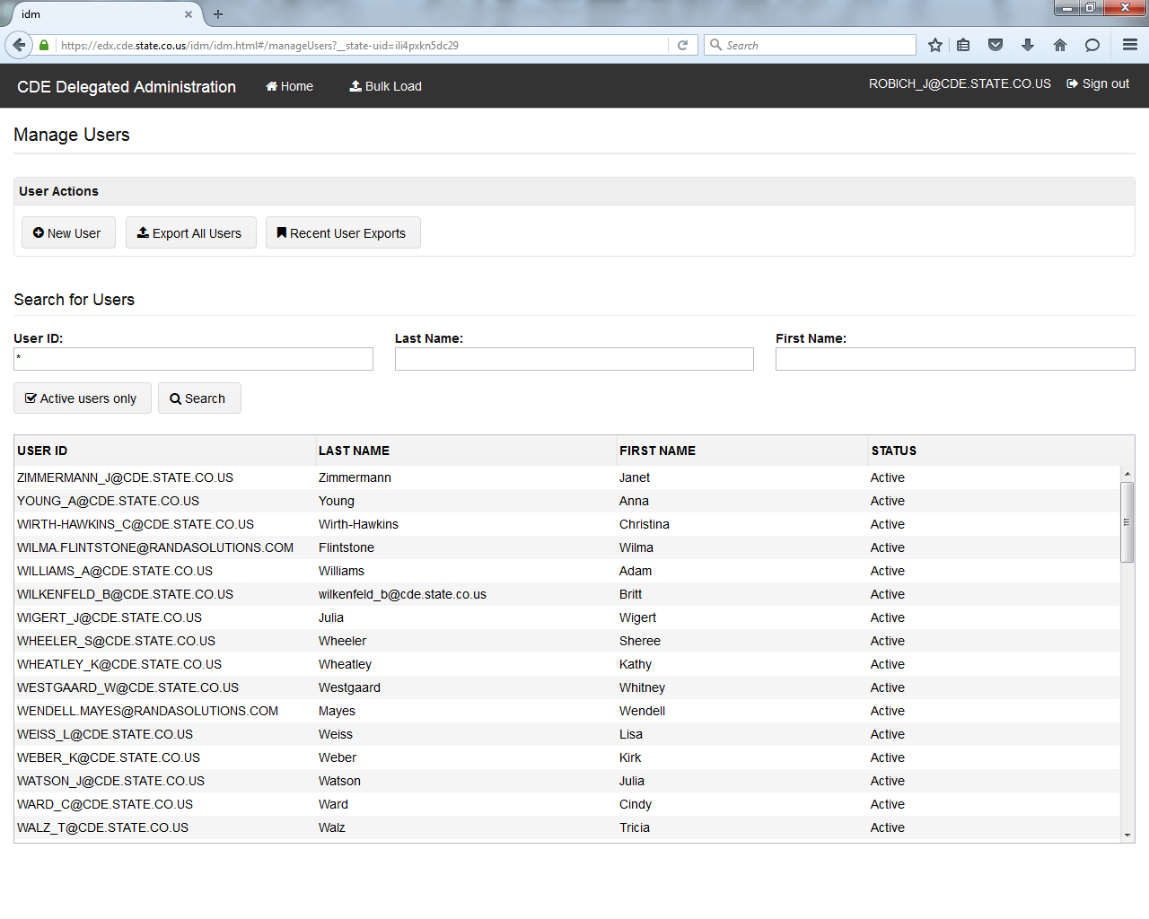

Once you find the user account you would like to view, click on it once to access their account.

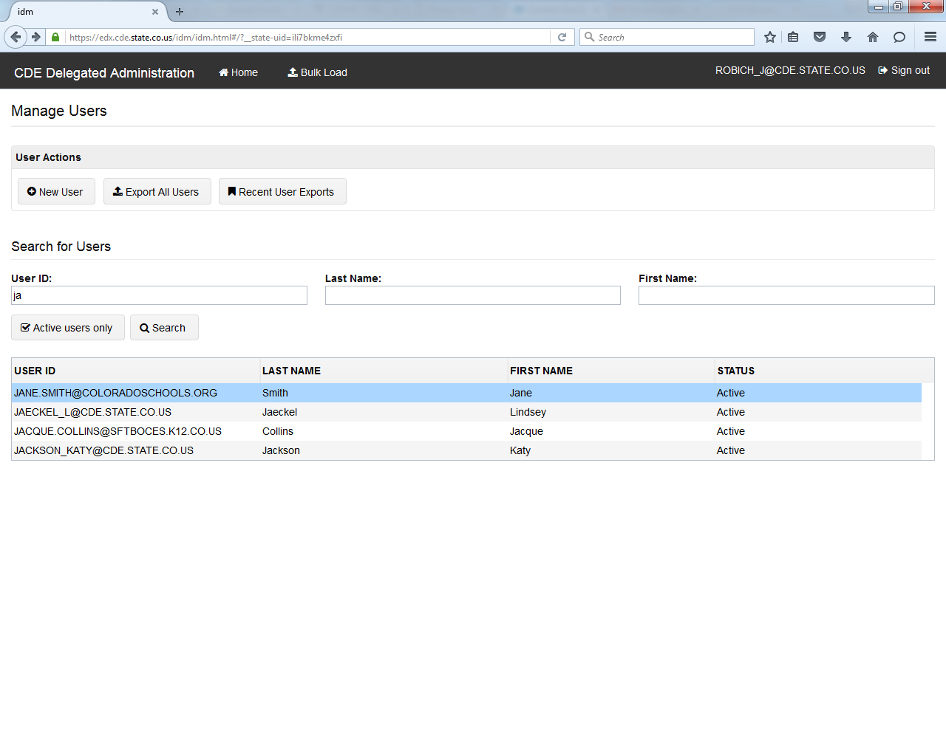

Using the Filters when Searching for a User

To use the filters, you do not necessarily need to use wildcards. However, when not using them, the search text must be at the beginning of the username or first/last name. E.g., when searching for Jane Smith in the username field, you can use “ja” as it starts her actual username, but using “sm” would not yield any results. You would instead need to use wildcards to find the username (*sm*).

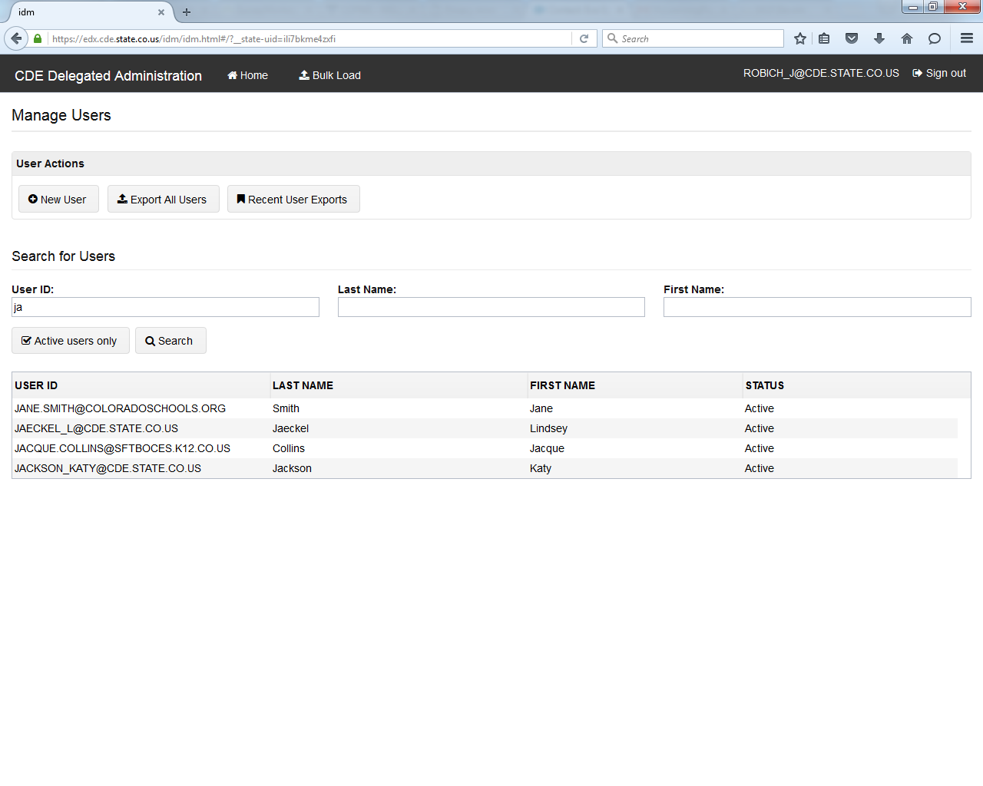

✓

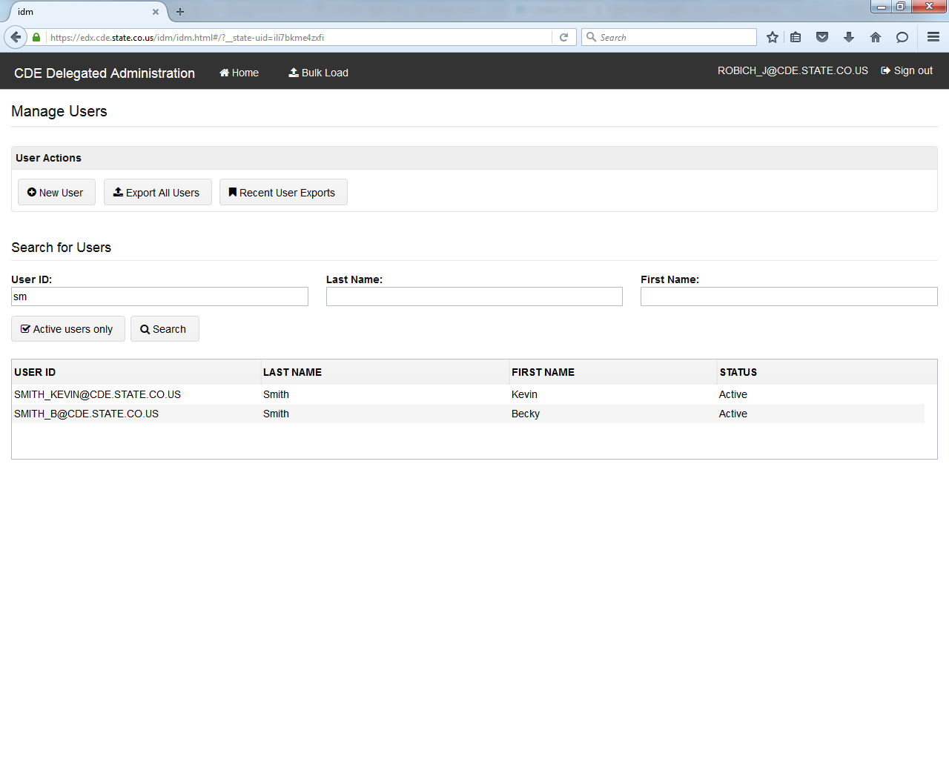

🗶

No Jane Smith found

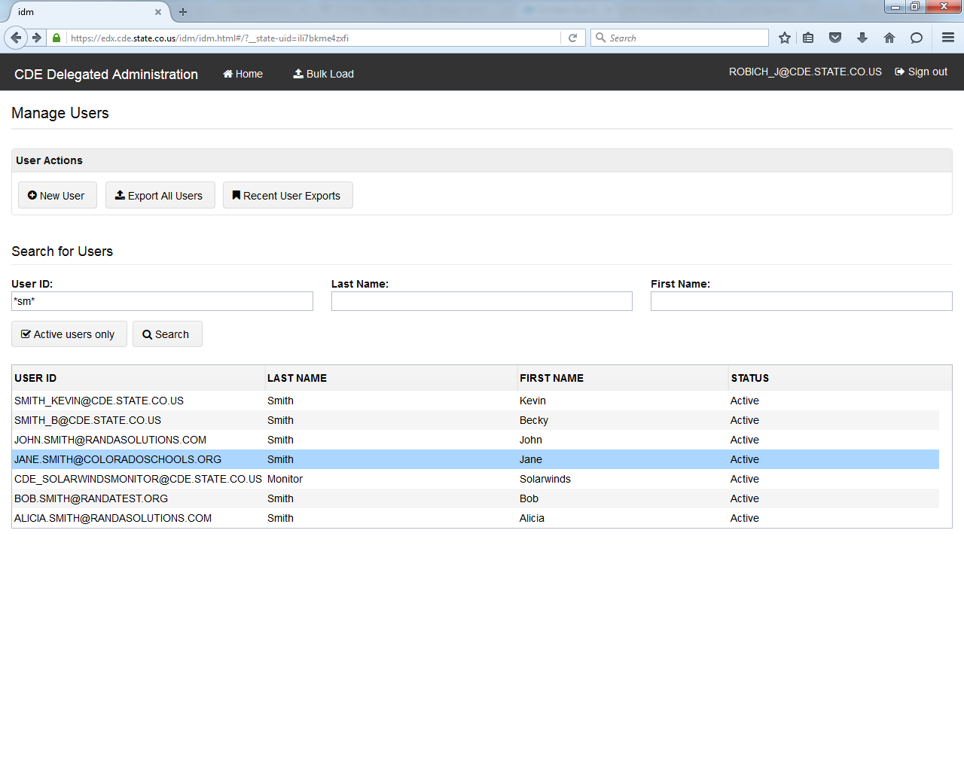

✓

Assign a Role

Once a user account has been created, a LAM may add a role. Once on the **Manage User** screen, click on the **Application Access Rights** tab.

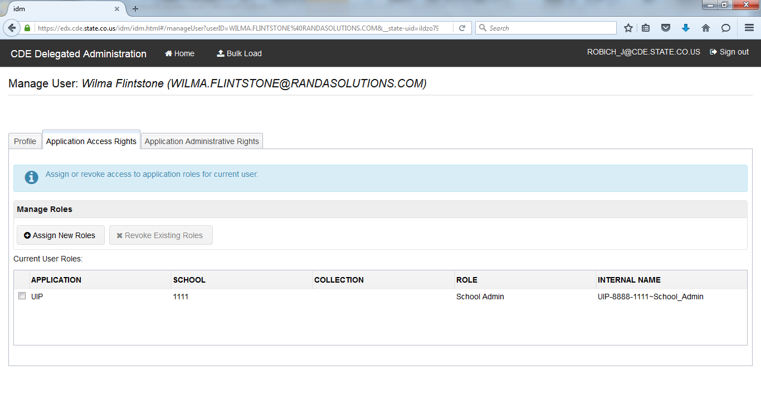

The user account you are editing will be displayed at the top of the screen.



Click on **Assign New Roles**.



All roles you have access to will populate below.

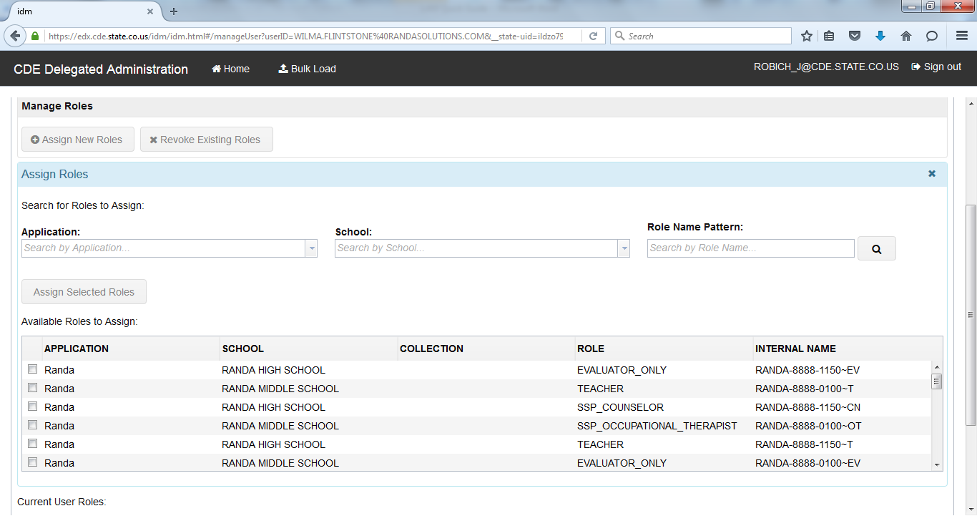

Select the role you would like to add by clicking the checkbox and then click on **Assign Selected Roles**. You also have the ability to use filters to search for roles, which is further detailed in the next section.

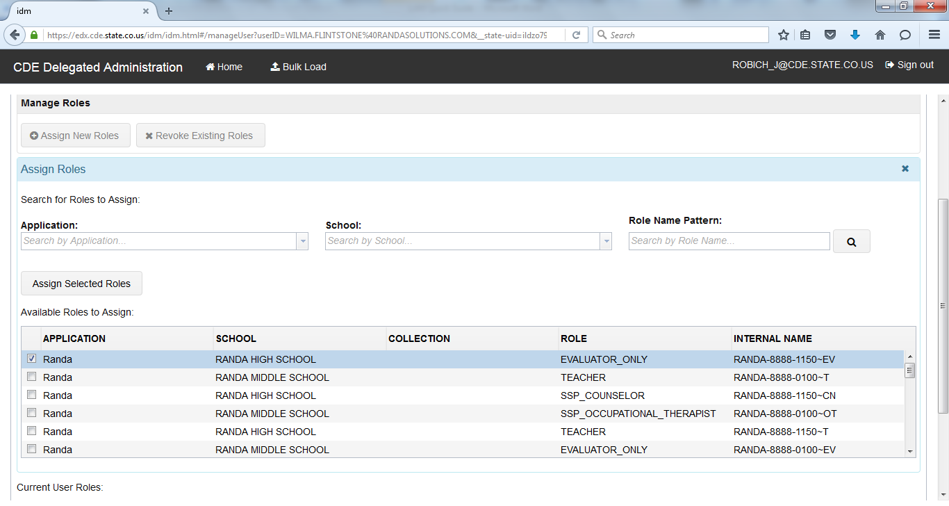

You should now see the role in the **Current User Roles** section.

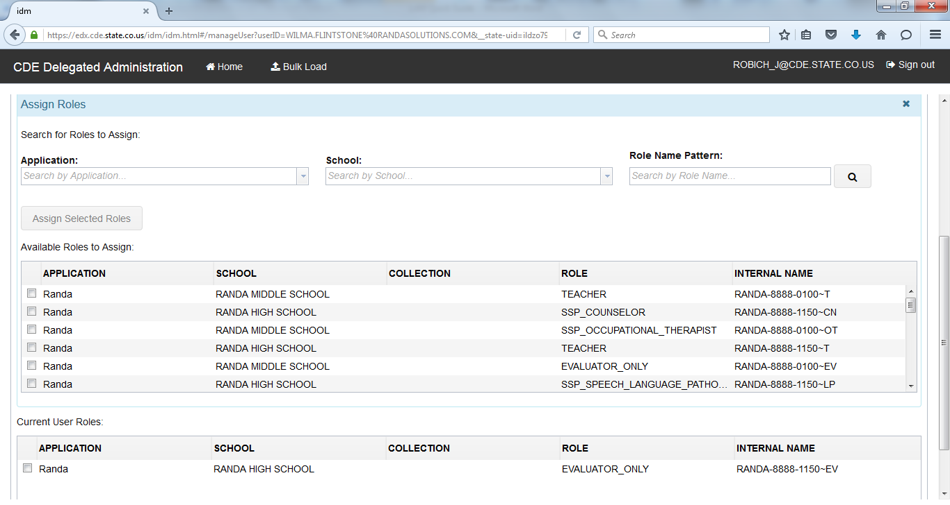

Using the Filters when Managing Roles

If you click on the down arrow, it will show all the applications/schools you have access to and you may select it from the list.

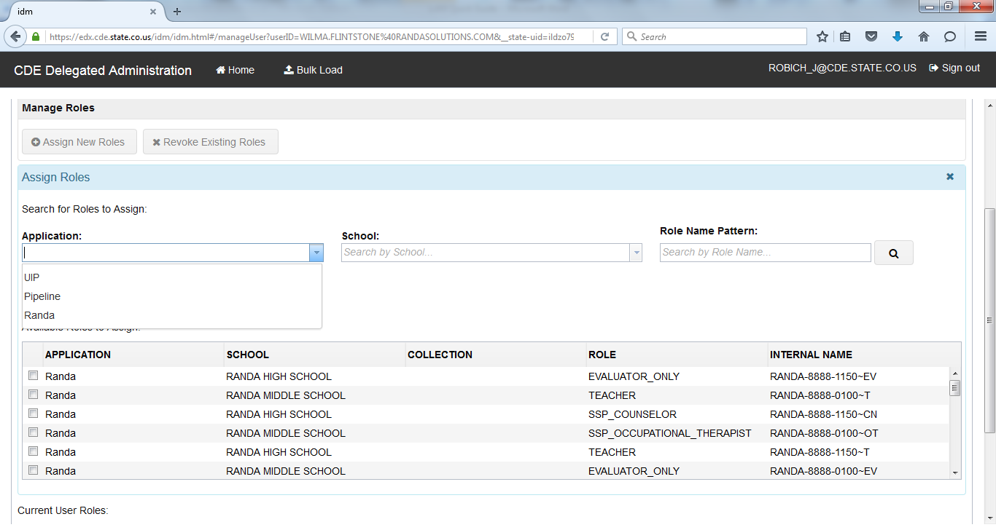

In the **Role Name Pattern** field, if you know some of the role name pattern, type it in and retrieve search results. Wildcards (*) are not needed, so long as the entry is within the role name pattern.

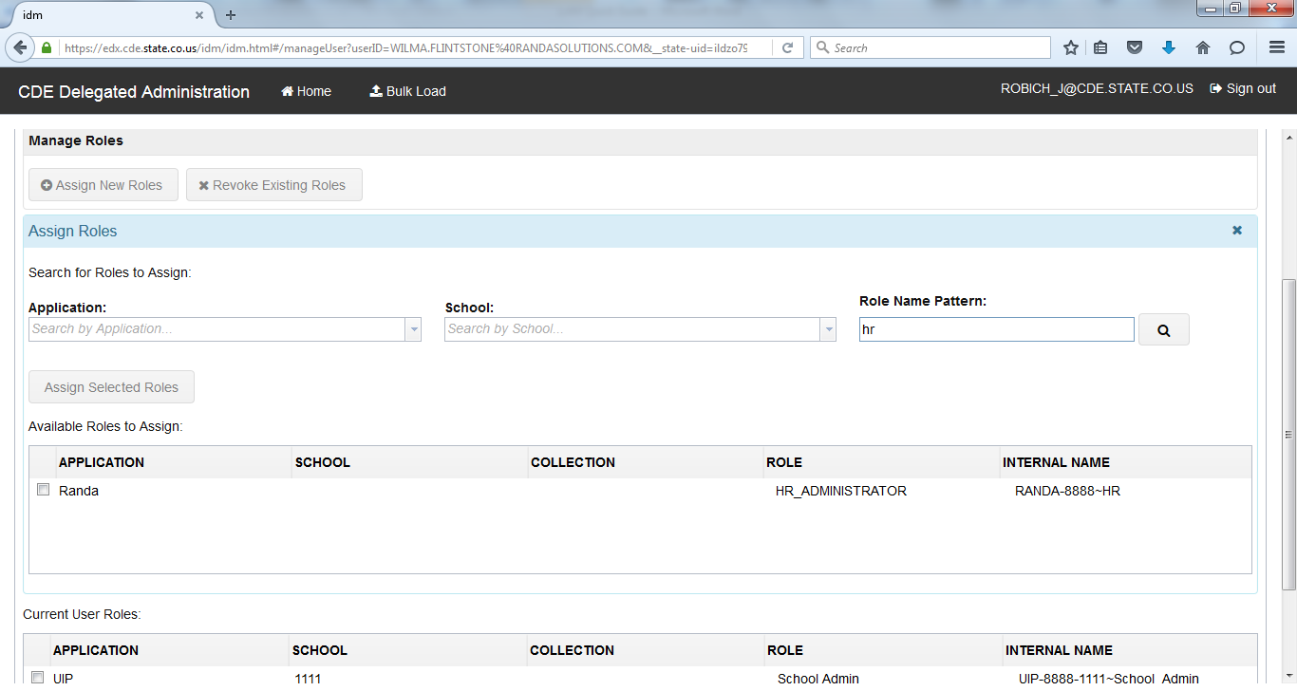

**Note: depending on which text you enter, it may result in a number of entries.**

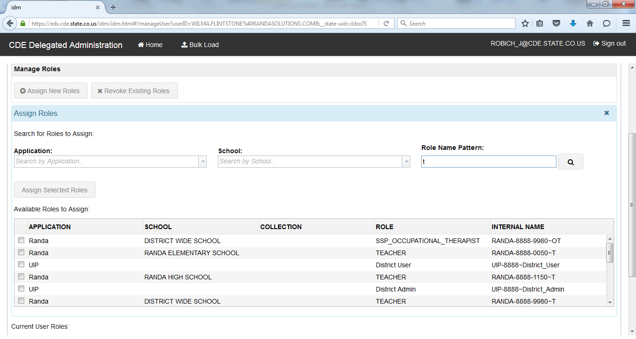

To further refine your search, you may use wildcards (*) to reduce the number of results. If using this function, it is recommended to apply the wildcard to both sides of the text.

**Note: the Role Name Pattern search field is based on the internal name. You may need to be familiar with the internal role names to use it (i.e., you would need to search by “OT” and not “therapist”). Additionally, when using multiple search phrases, the order of the search must be the same as the actual Role Name Pattern (i.e., search *0050*OT* and not *OT*0050*).**

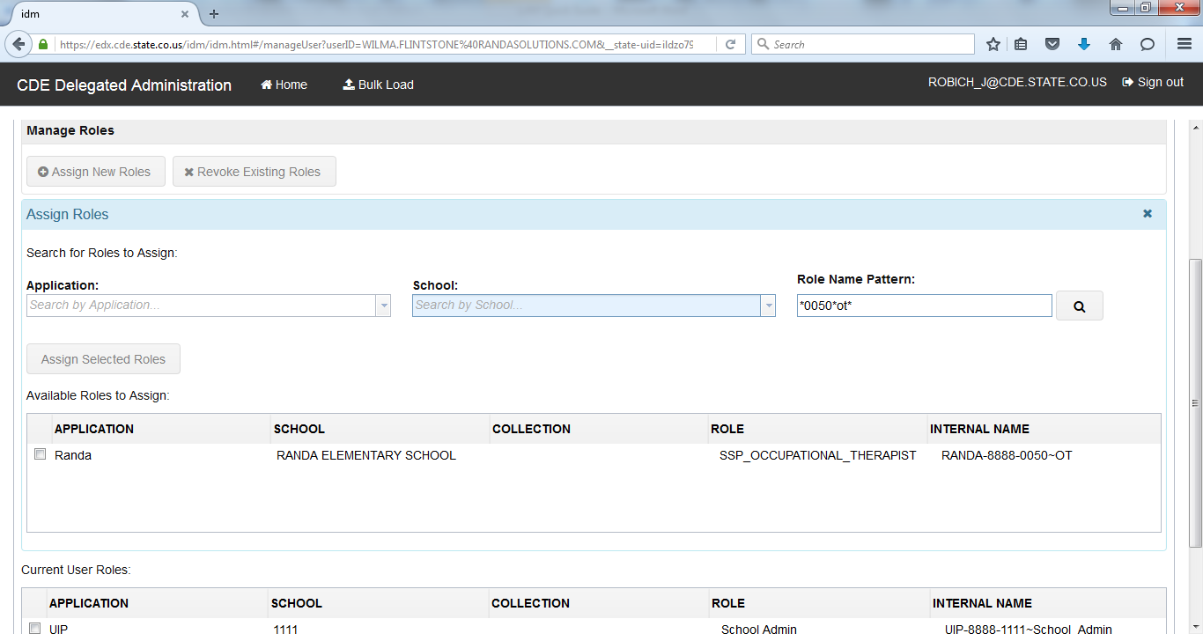

You may also use multiple search fields at one time to refine searches.

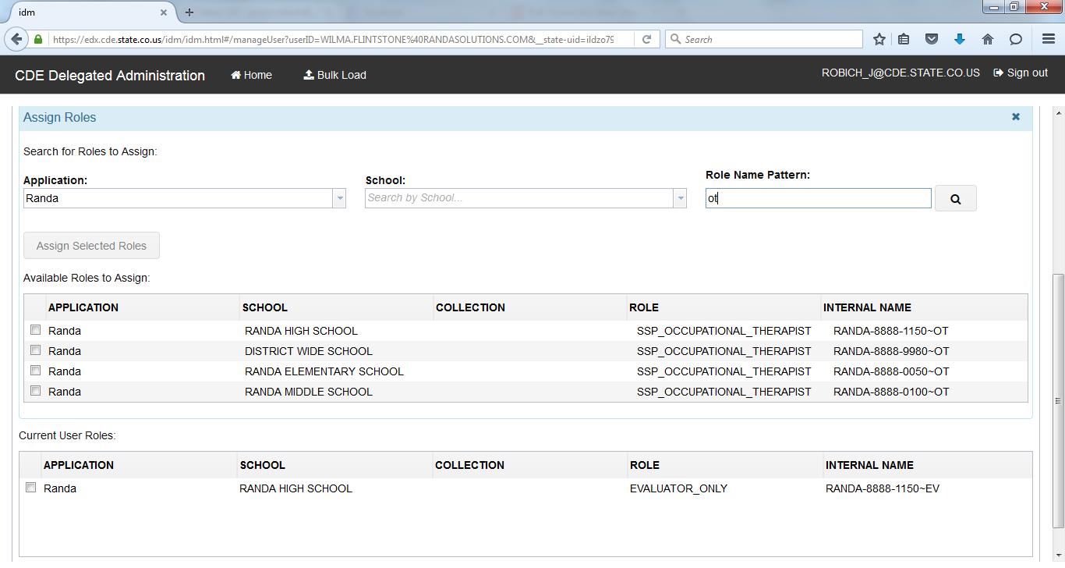

Revoke a Role

To revoke a role, scroll to the bottom of the page to review the **Current User Roles** assigned to the user.

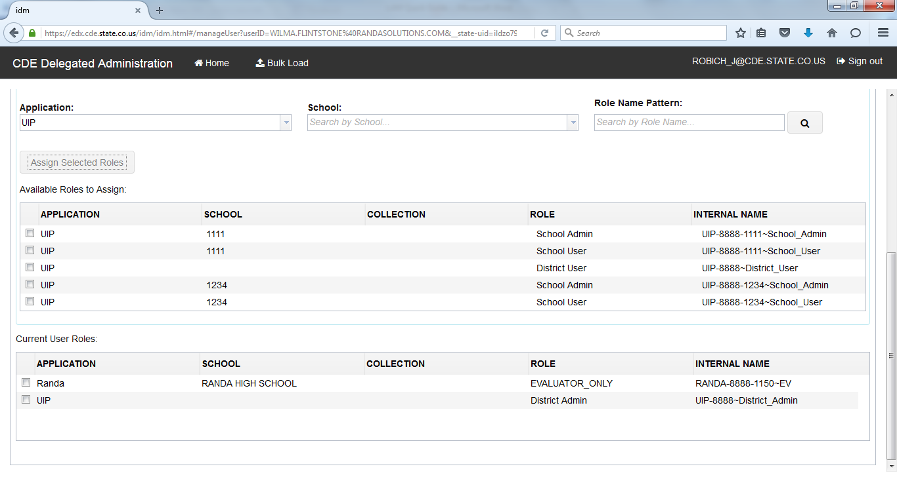

Check the role(s) you would like to remove. At the top of the page, click on **Revoke Existing Roles**.

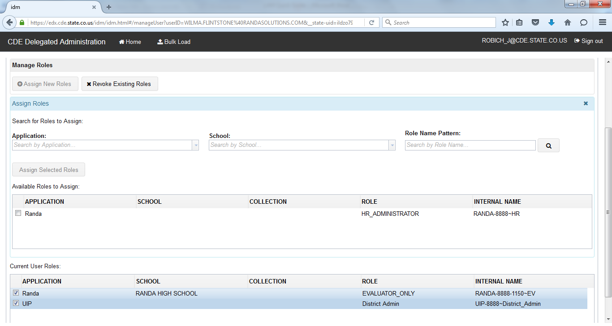

Disable/Delete User Accounts

Disable a User Account

Once you have found the user account you would like to disable, you default to the **Profile** tab of **Manage User.** Click on the **Disable** button. You will receive a note at the top saying the change has been saved.

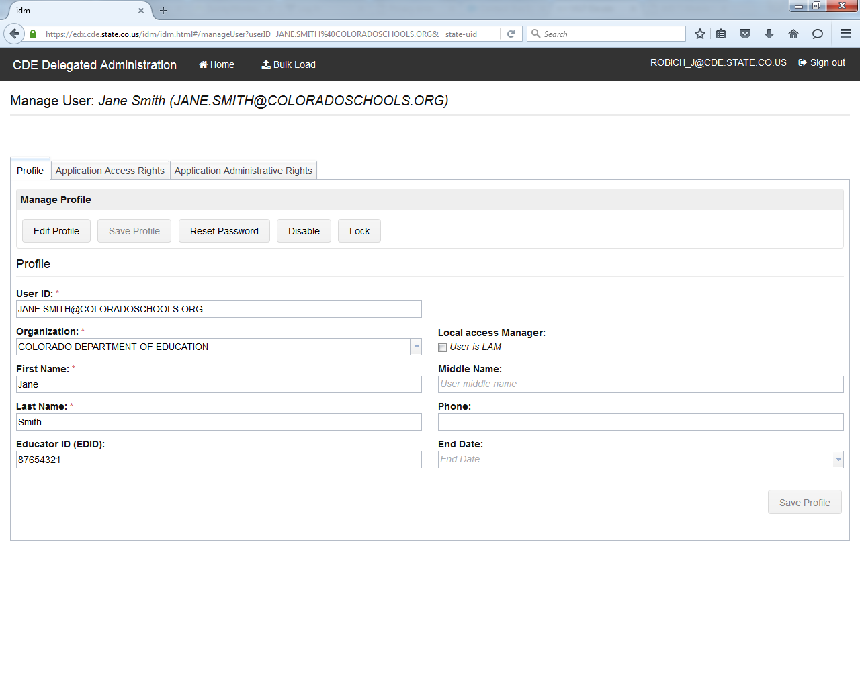

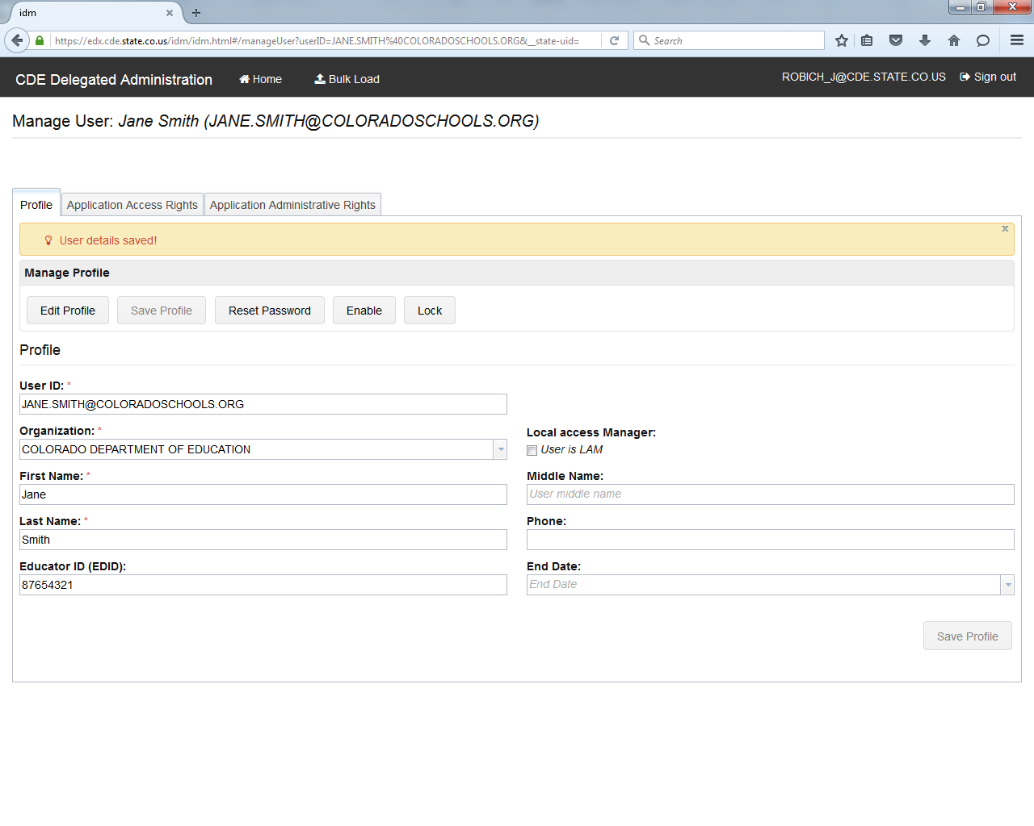

You may also set the **End Date** for a user, which will disable the account for the date specified. To do so, click on **Edit Profile.**

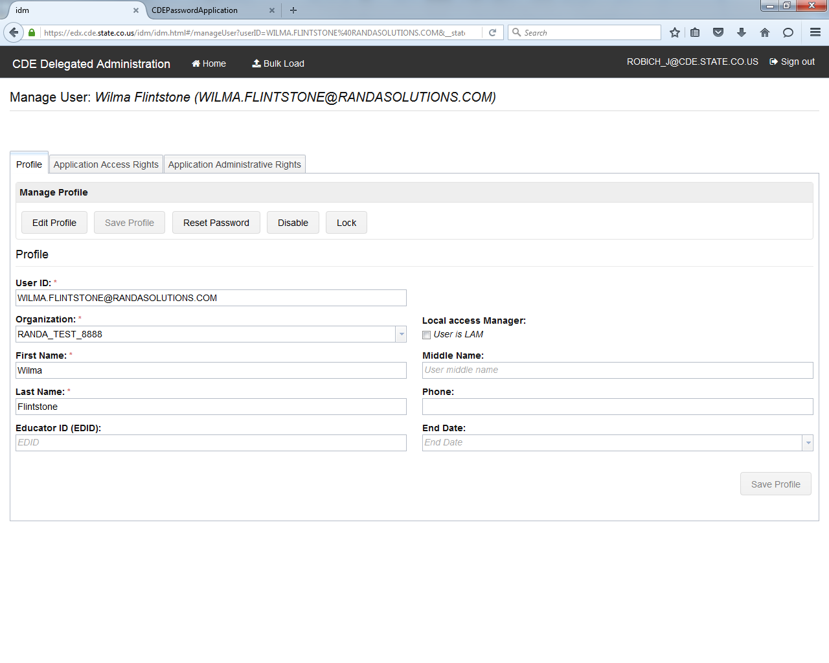

You can then enter the **End Date** in a MM/DD/YYYY format or click on the down arrow to select a date from the calendar.

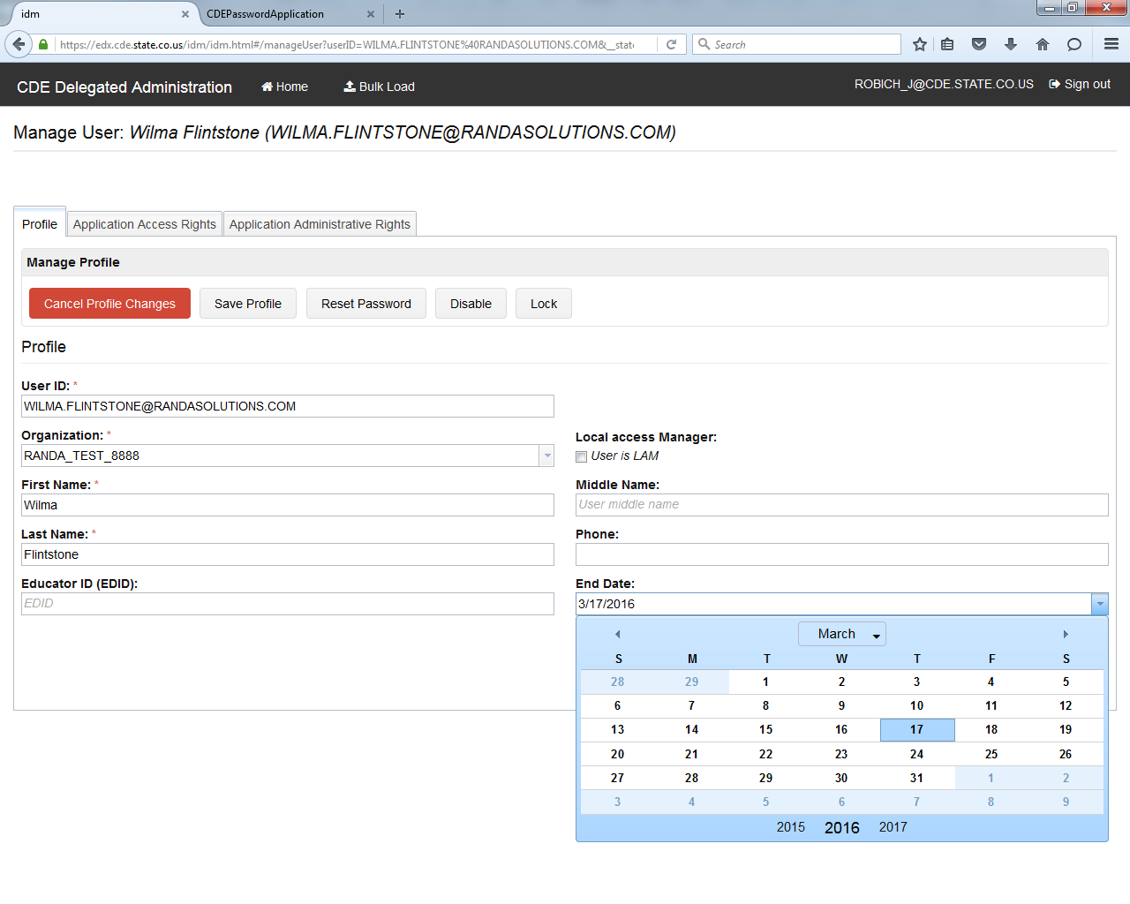

Once a user account is disabled, it will be fully deleted from the system after 90 days. All accounts should be current.

Export User Accounts and Roles

Creating the Export

To export all user accounts associated with your organization, click on **Export All Users**. The status will immediately display that it is processing. It may take some time to process the request.

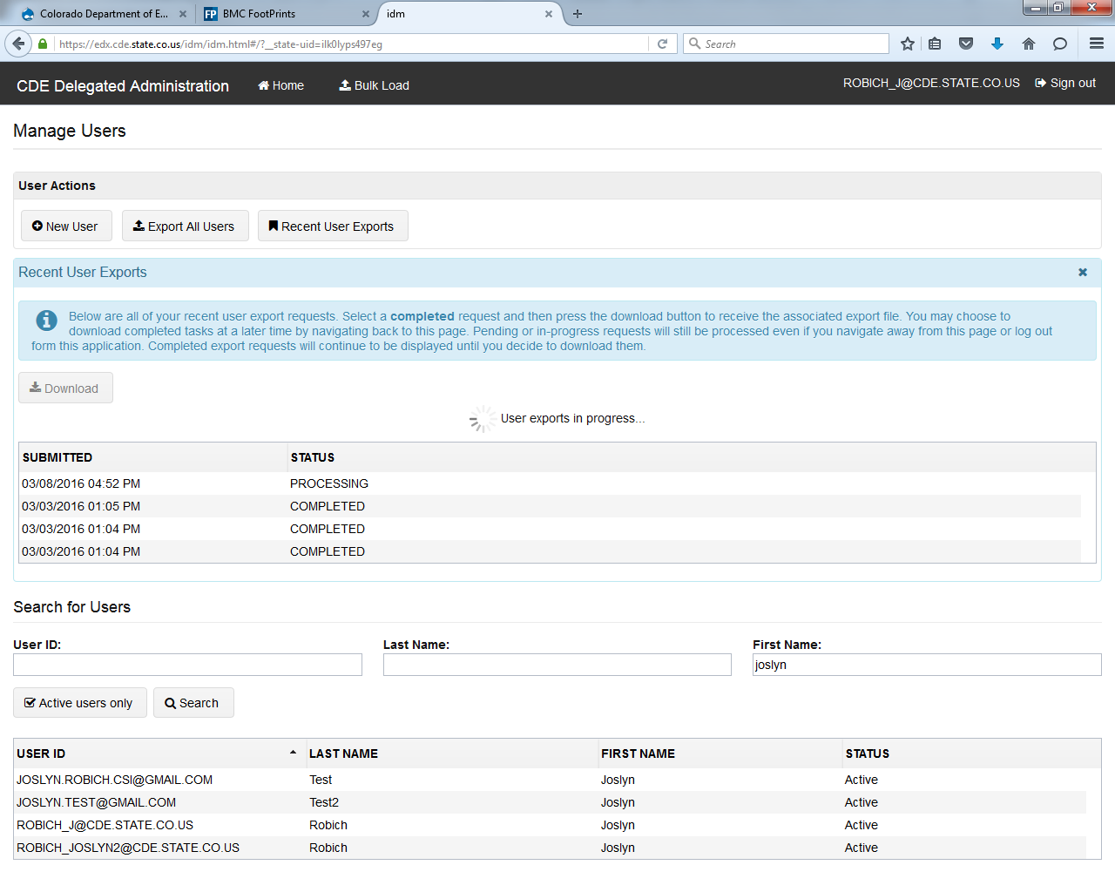

Once it shows a status of **COMPLETED**, highlight the file you would like to view and then click on **Download**.

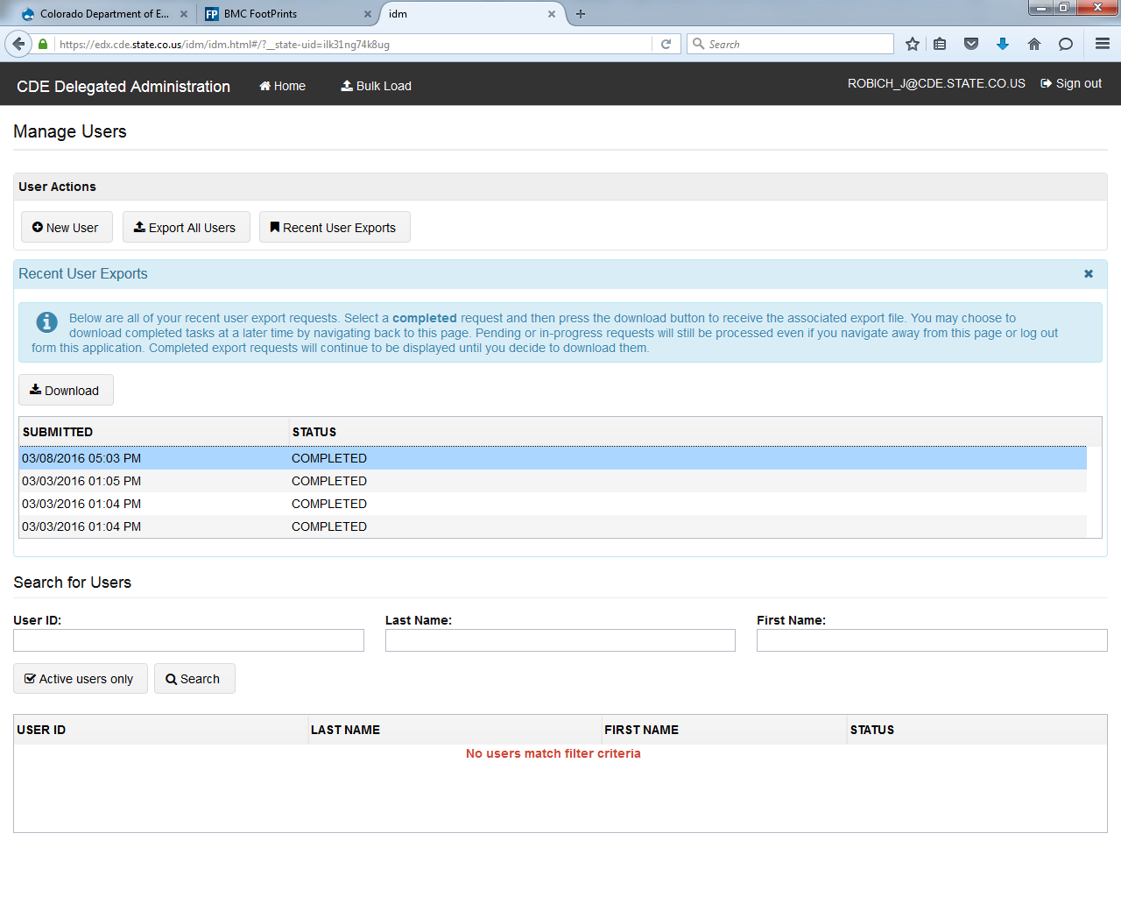

**NOTE: This will export all user information for individuals with accounts and this information is considered to contain Personally Identifiable Information (PII). Please make sure this export is treated appropriately.**

About the Export

The file includes the following information:

|  |  |  |  |  |  |  |  |  |  |  |  |
| --- | --- | --- | --- | --- | --- | --- | --- | --- | --- | --- | --- |
| **User\*** | **Title** | **First\*** | **Middle** | **Last\*** | **Educator ID (EDID)** | **Phone** | **LAM** | **Status** | **End Date** | **Groups To Add** | **Groups To Remove** |
|  |  |  |  |  |  |  |  |  |  |  |  |

**NOTE: While the last two columns say Groups To Add and Groups to Remove, it will actually display Groups Assigned to each user under the Groups to Add heading. This will make it easier to edit if the organization is using this as a default for a bulk upload.**

**Also, if a user has more than one group assigned, it will have a blank row underneath the user account it is associated with and only the role populating in the second row. It is not advised to use the sort function unless the full row is manually populated with the user information.**

Bulk Changes

Some organizations may wish to make multiple updates to user accounts at one time, especially at the beginning or end of a year. To make bulk changes, click on Bulk Load at the top of the webpage.

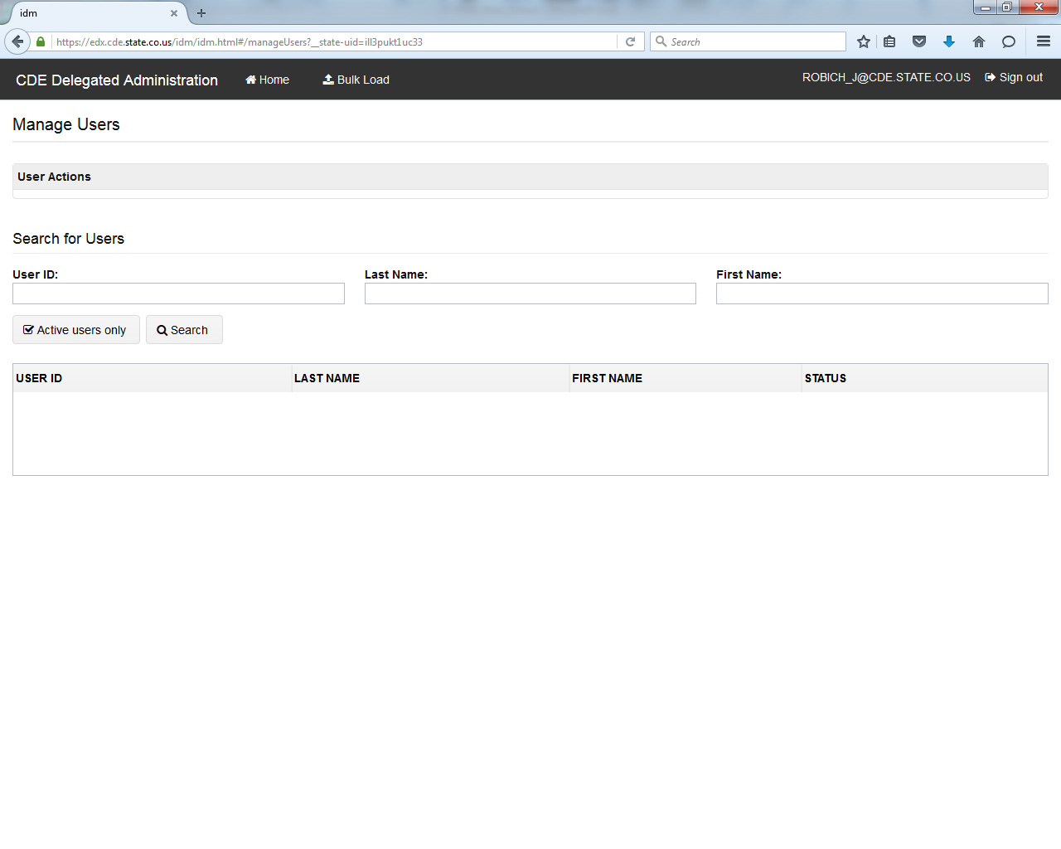

This brings you to **Bulk Load Users**. Organizations will have the option to upload using either a CSV file or an Excel file.

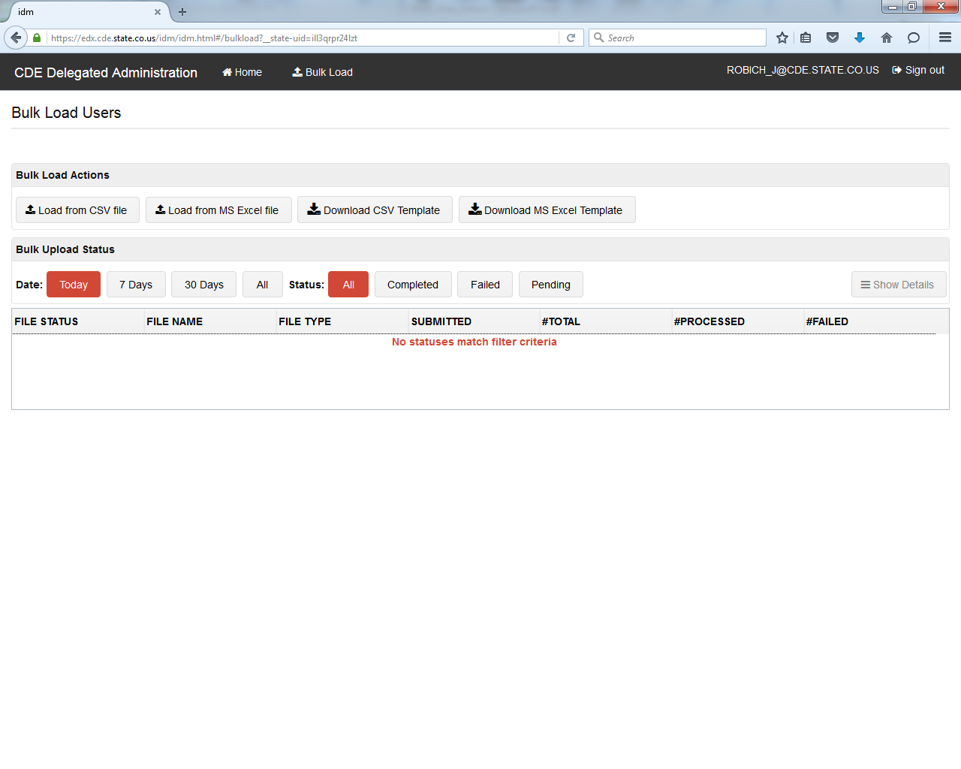

You can download the preferred file format as a starting point for making your **Bulk Load** file.



This will populate the file with appropriate column headers.

|  |  |  |  |  |  |  |  |  |  |  |  |
| --- | --- | --- | --- | --- | --- | --- | --- | --- | --- | --- | --- |
| **User\*** | **Title** | **First\*** | **Middle** | **Last\*** | **Educator ID (EDID)** | **Phone** | **LAM** | **Status** | **End Date** | **Groups To Add** | **Groups To Remove** |
|  |  |  |  |  |  |  |  |  |  |  |  |

Next, complete all the required fields to add or remove groups in bulk. **NOTE: If you need to make edits to the Colorado Performance Management System (RANDA), the EDID is required.**

Both the **Groups to Add** and **Groups to Remove** have drop down menus to ensure the roles are added with the correct naming convention.

**NOTE: It may be helpful to use the Export Users feature, especially for Groups to Remove, to start with a list of all users (as the file format is the same) and simply move the role from Groups to Add to Groups to Remove to use the Bulk Load.**

Once the file is ready, click on the file format used.

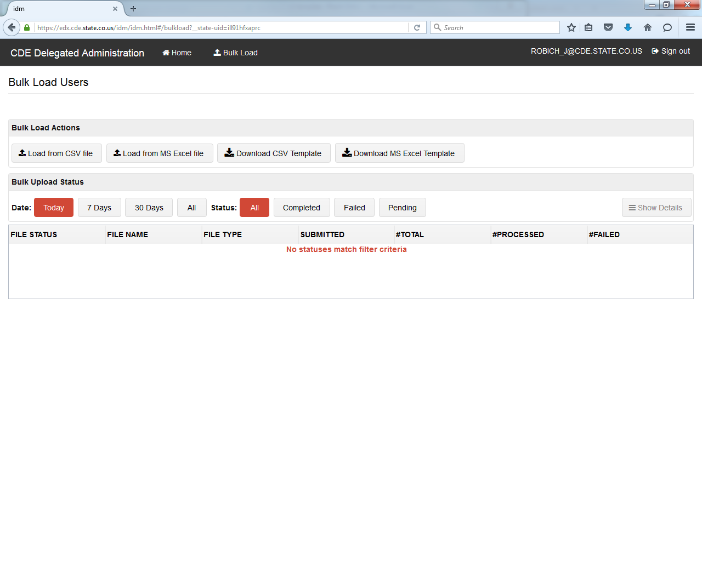

Click on **Browse for Files**.

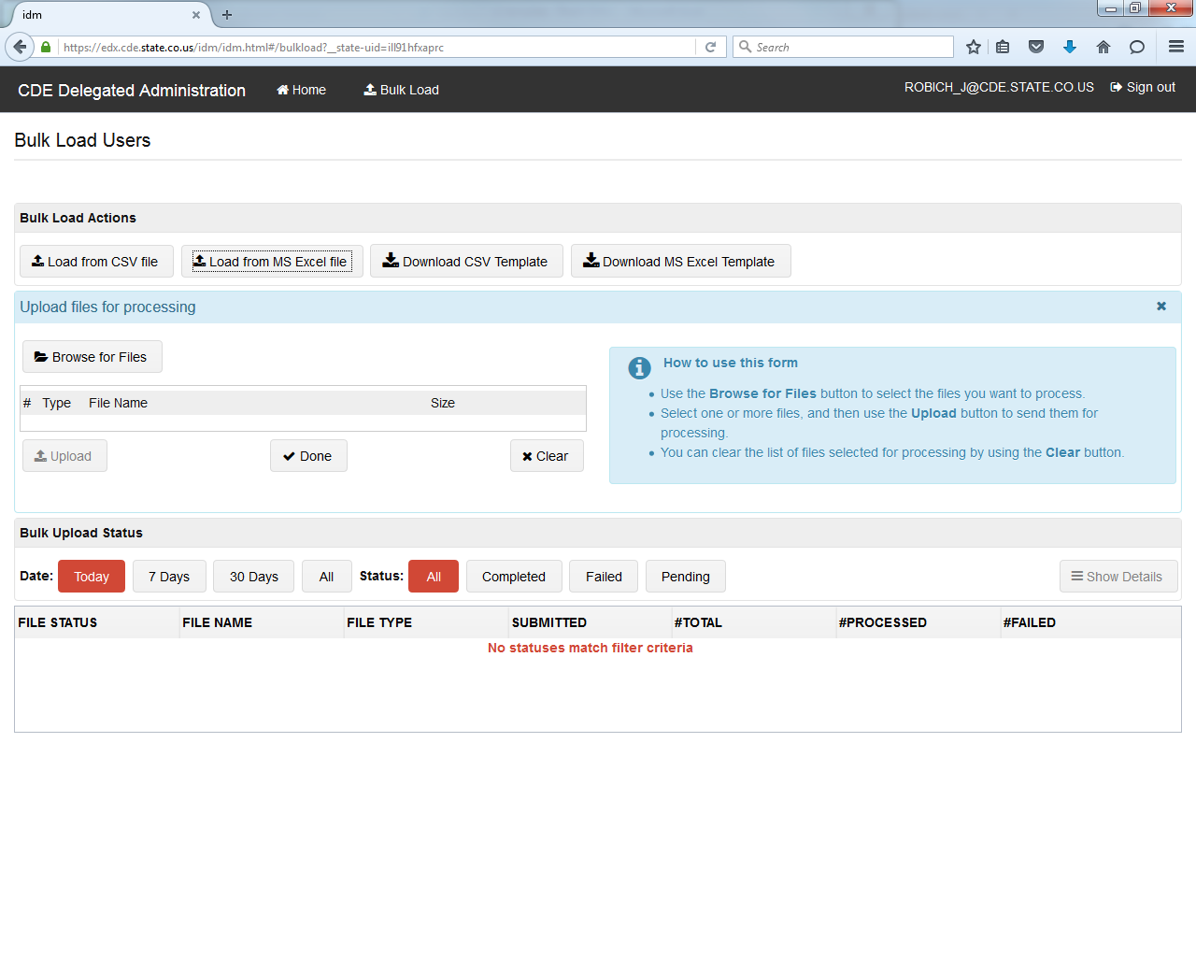

Locate the file and click on **Upload**.

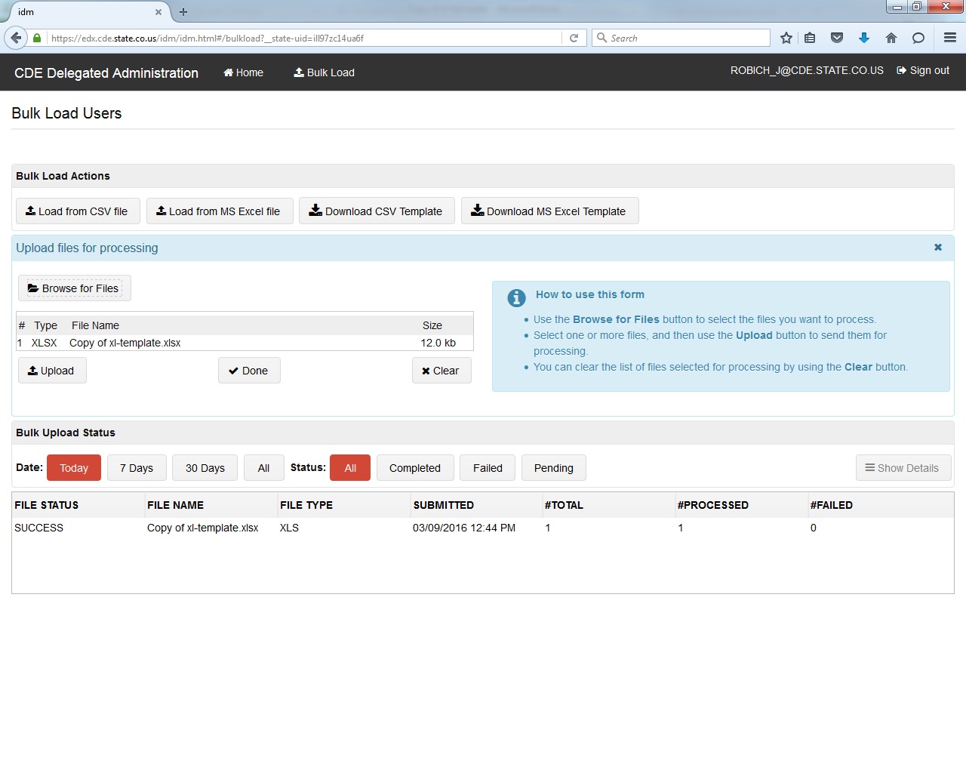

Once the **Bulk Load** is complete, it will display below and indicate if any submissions failed.

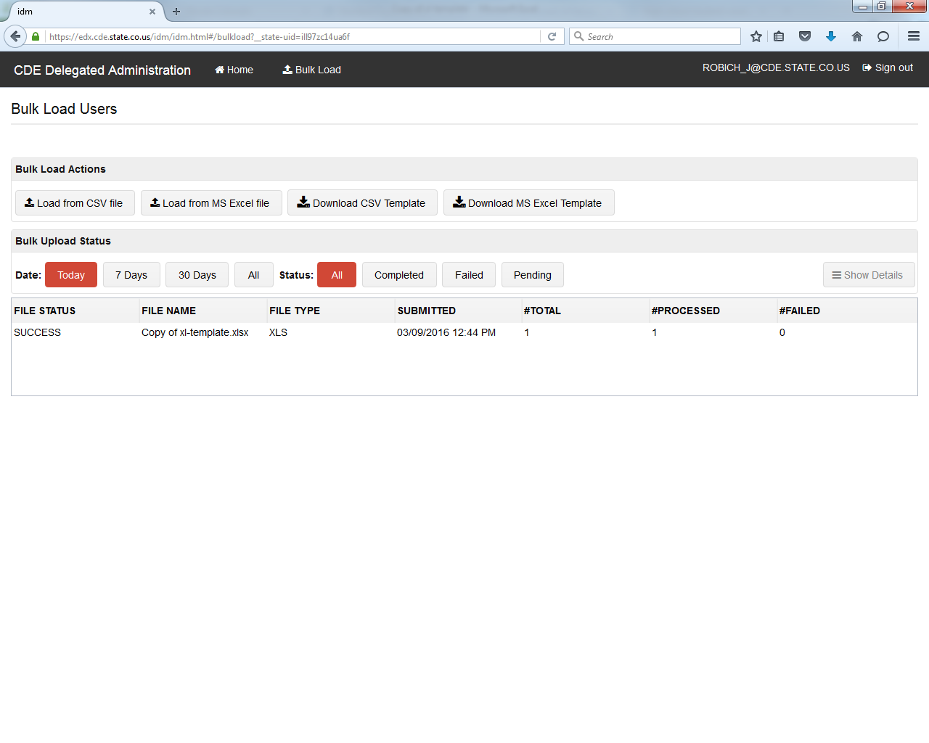

The LAM can then search for the new user account(s) to verify, if desired.

**NOTE: To send emails to new users, please work with CDE.**

Adding LAMs

Once you have found the user account you would like to add as a LAM, you default to the **Profile** tab of **Manage User.**



Then, click on **User is LAM** and **Save Profile**.

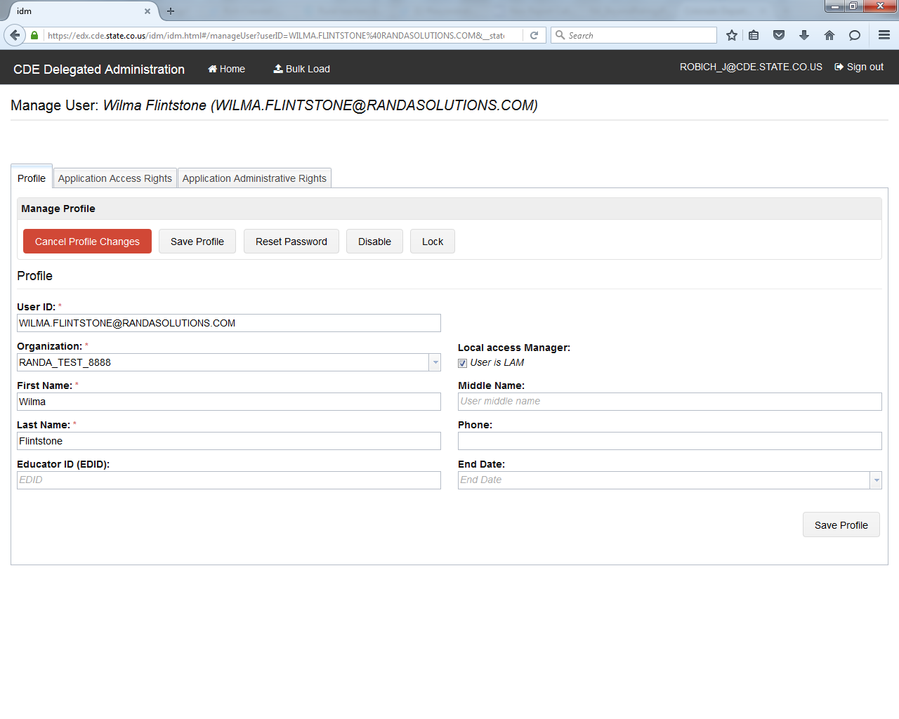

Application Specific LAMs­­­­­

The Application Specific LAM is a LAM that is restricted to only assigning roles for a specific application. For example, this would be for a person that is responsible for managing accounts and access only for RANDA.

Once you have found the user account you would like to add as a LAM for a specific application, you select the **Application Administrative Rights** tab**.**

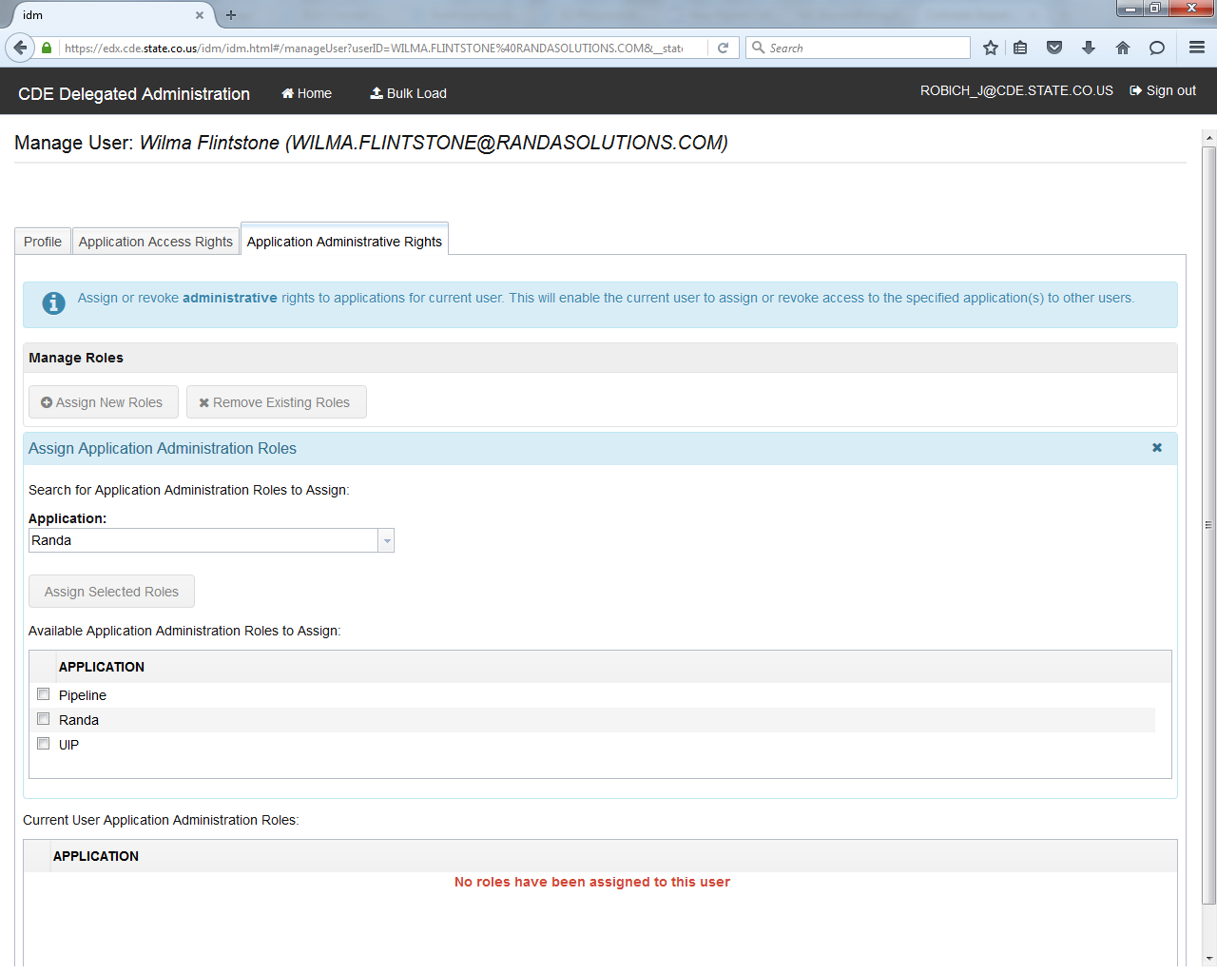

Next, find the application the user will manage, check the corresponding box, and then click on **Assign Selected Roles**. This button will not be active until you have selected at least one application.

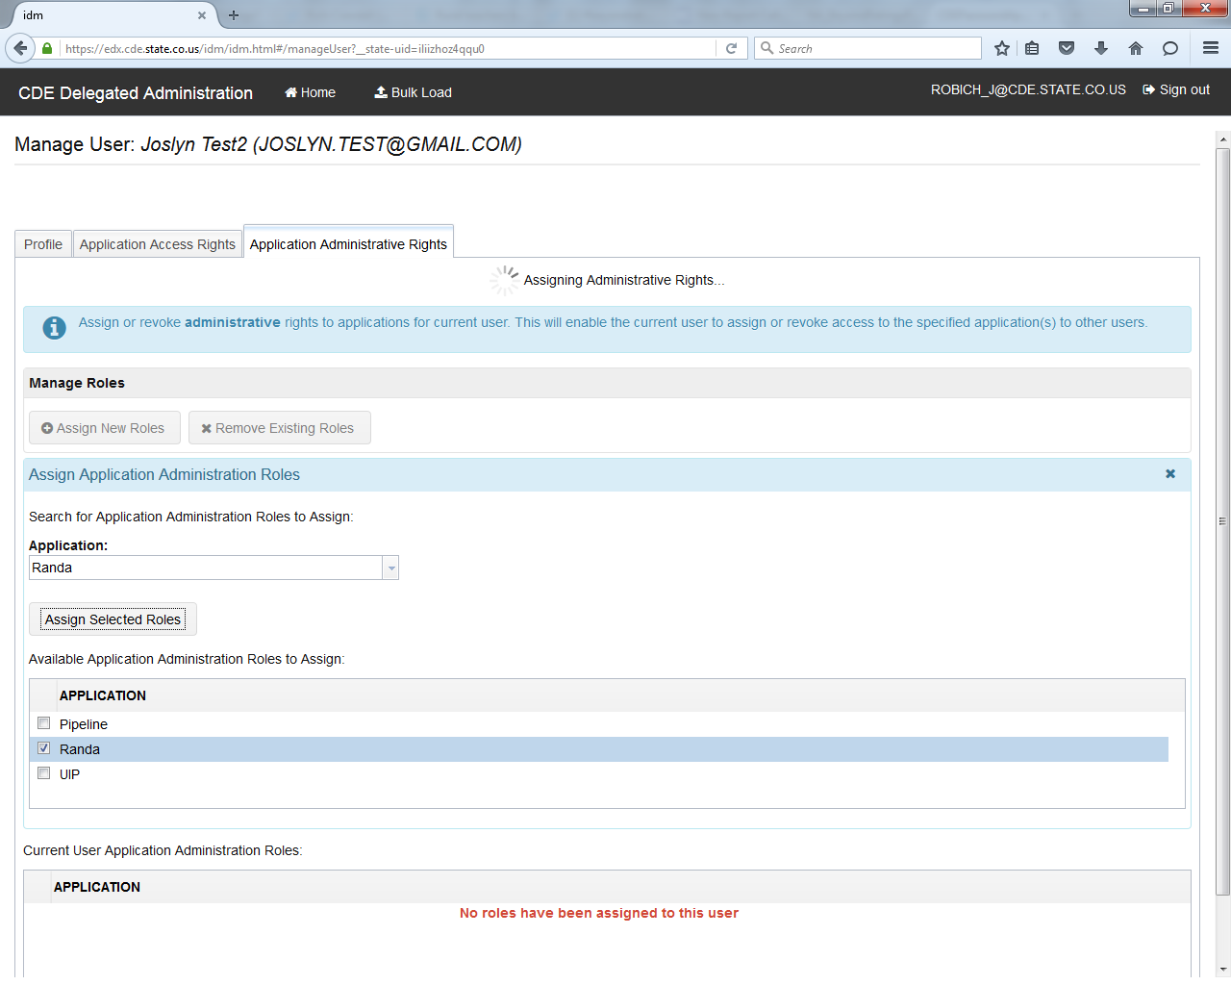

**NOTE:** Please note thatthis tab does not grant access to the application selected. Use the **Application Access Rights** tab instead. Assigning a role here will make the user a “restricted” LAM. Be sure to unassign this role if that’s not the intent.

**IMPORTANT:** Also, if the user account is already a LAM (with the “User is LAM” button checked) and an Application Administration Role is assigned, then that LAM will be restricted to only roles for the selected application. In this situation just unassigned that role to restore full LAM ability.

Password Management

It is recommended for users to set up their own password. For new users, LAMs can click on the **Reset password on next logon** box when creating the account.

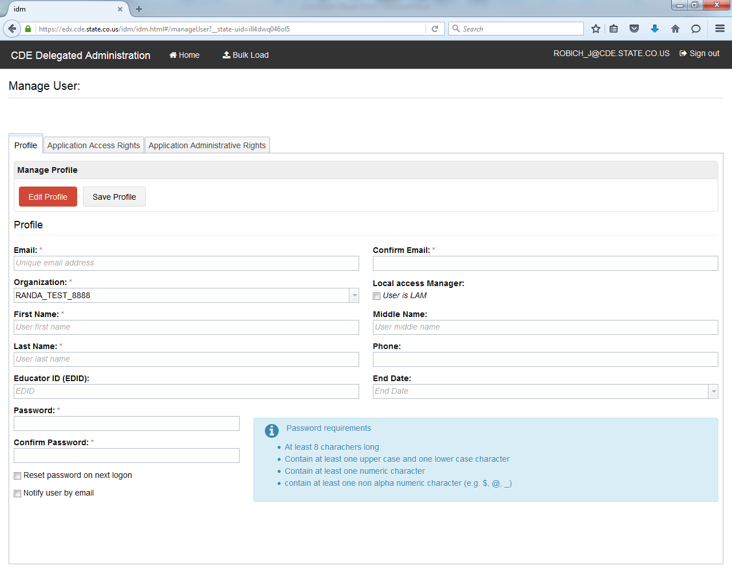

If an existing user needs a new password, LAMs can encourage users to reset their own passwords. For users of the Colorado Performance Management System (RANDA), there is a link on the login page they may use.

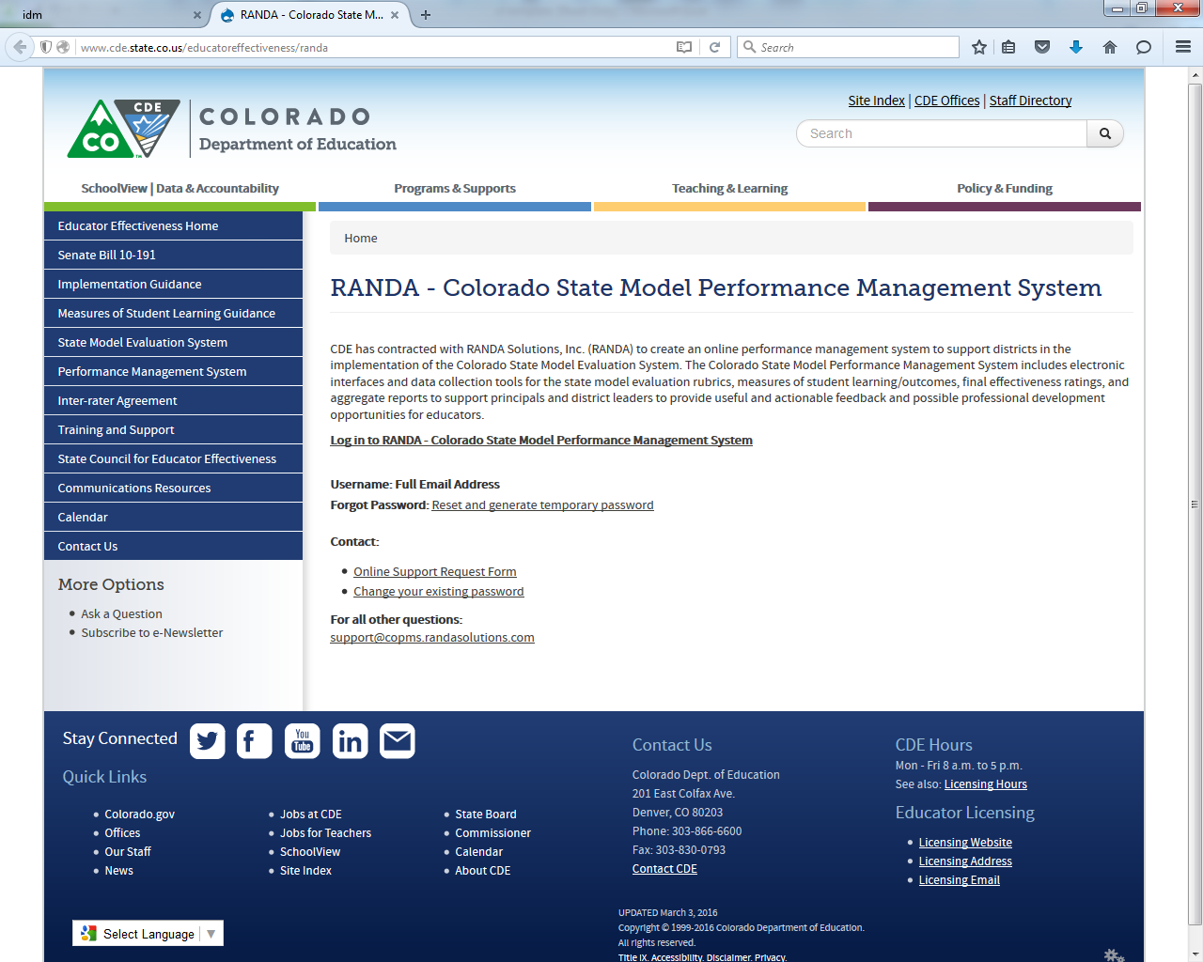

Users of the Colorado Performance Management System (RANDA) can also update their password via the help tab once inside the system.

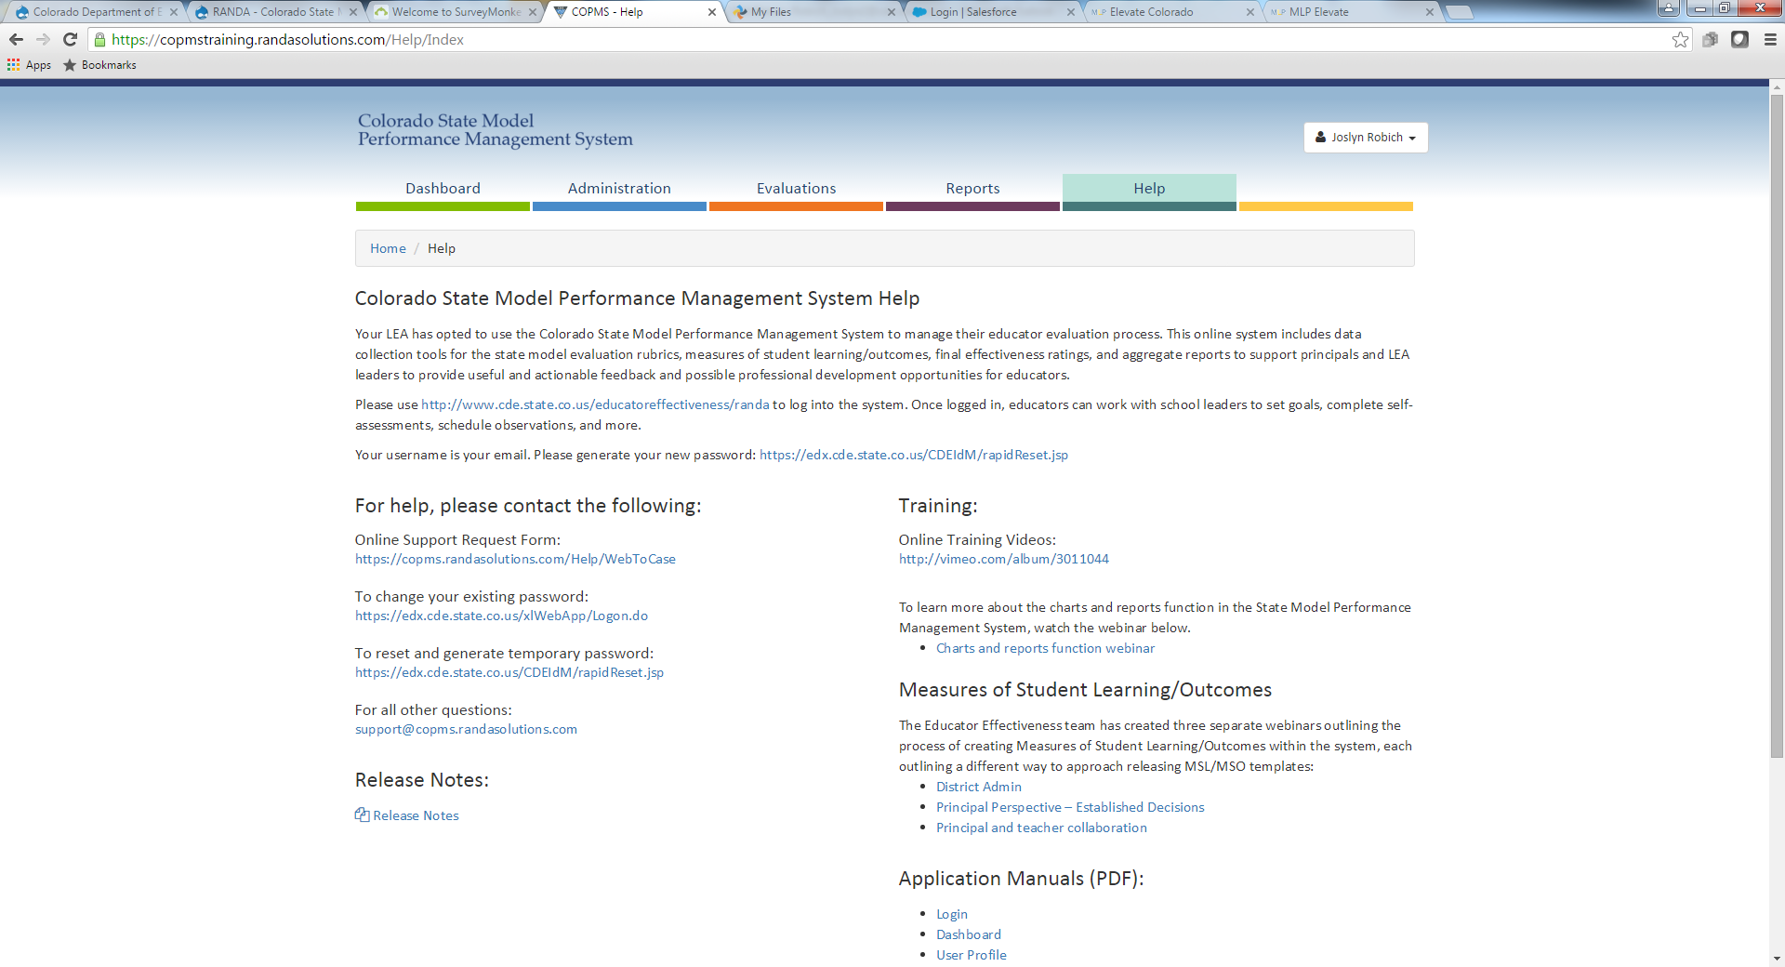

For users of other CDE applications (CEDAR, ESSU Data Management System, etc.), users may click on Change/Reset Password from the [Identity Management webpage](https://www.cde.state.co.us/idm).

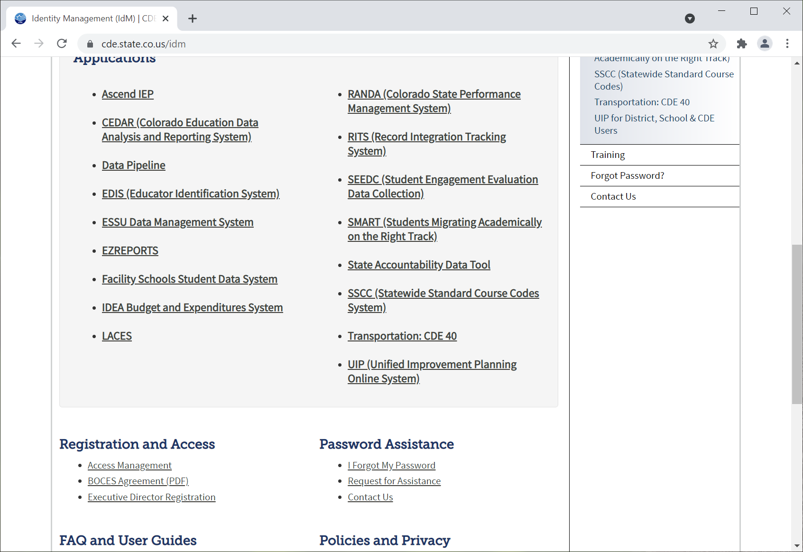

All of these methods will result in the user visiting this webpage at <https://edx.cde.state.co.us/passwordmanagement/CDEPasswordApplication.html>. The user will need to input their login (email address) and verify that they are a human.

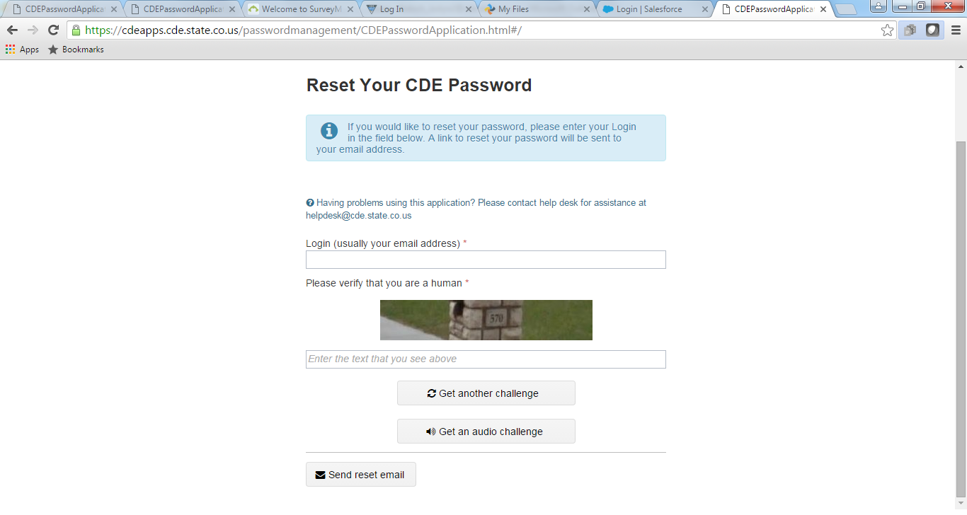

They will receive an email (included in the **Appendix**) with a link to choose their own password. The password requirements are outlined on the page for easy reference.

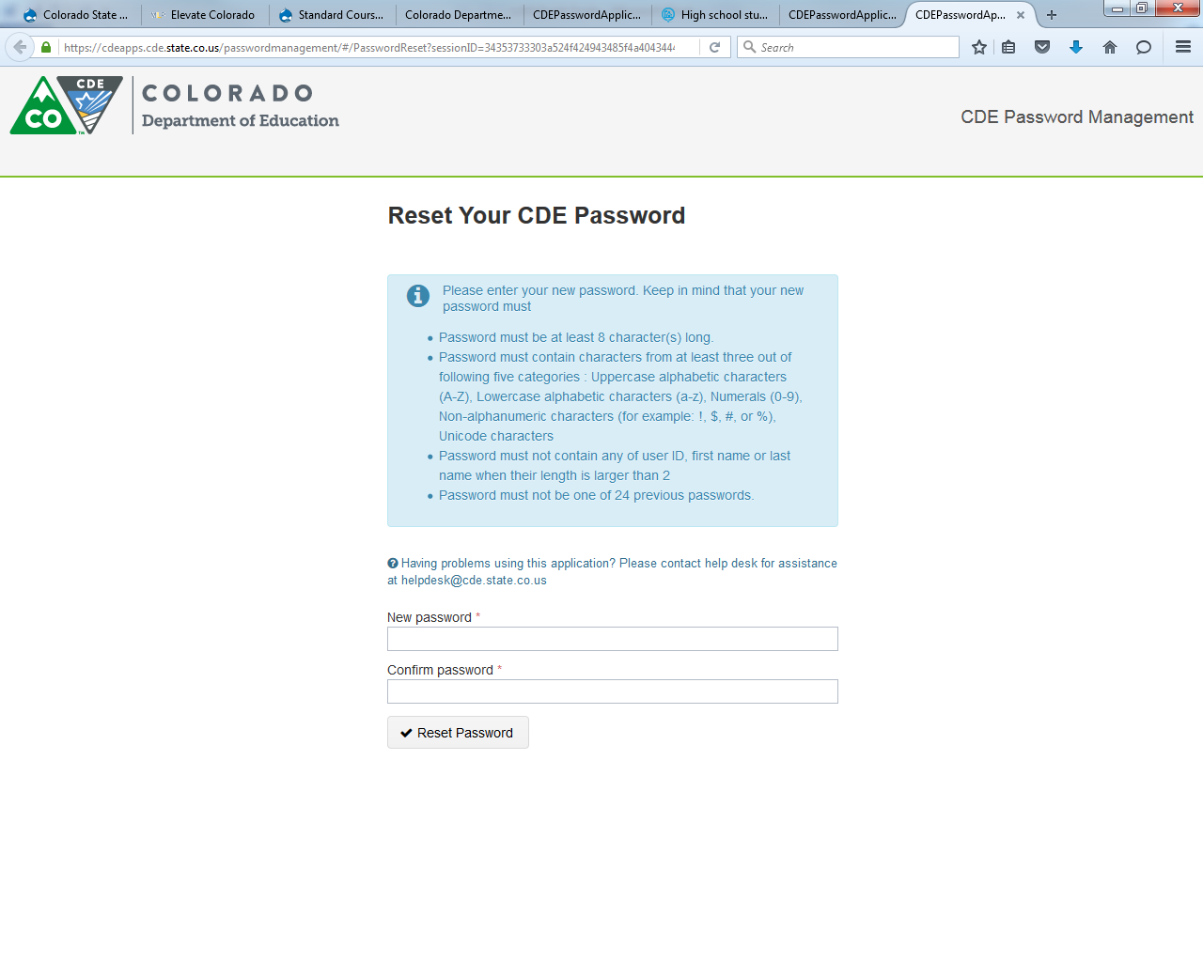

The user will then be able to visit the application they need to access and will receive an email to confirm the change (included in the **Appendix**).

**NOTE: The user will need to act on this email within 24 hours of receiving it.** If they miss this window, when they click on the link, it will display the message below.

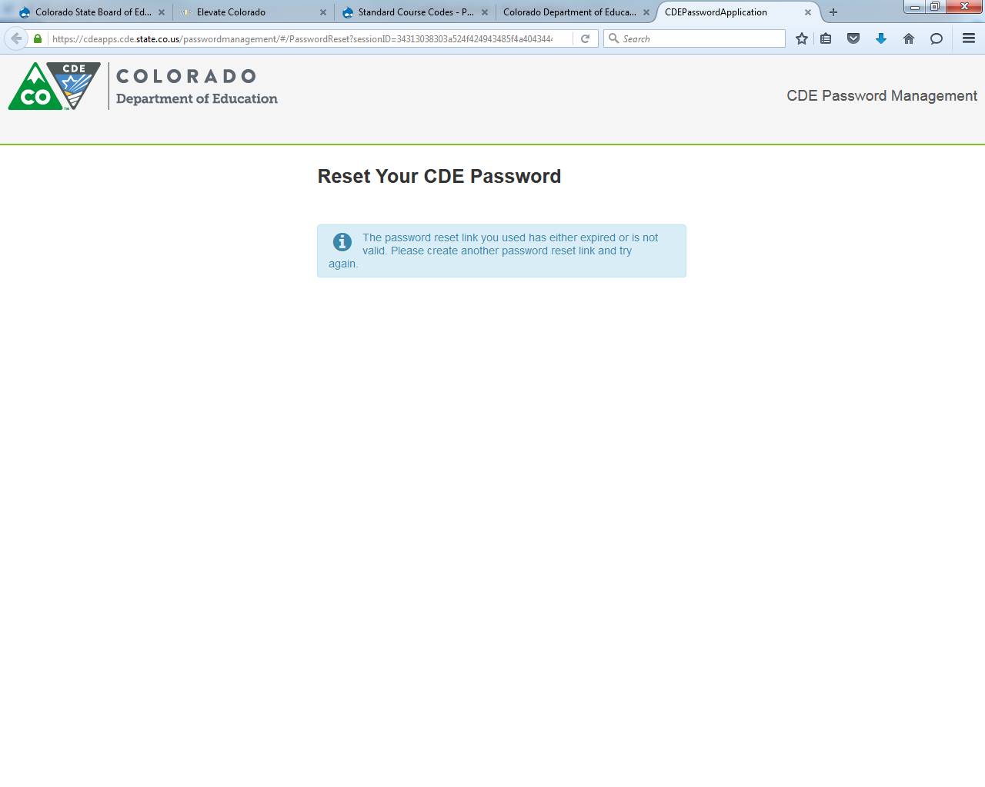

If a LAM would like to manually reset a password for an existing user, they may do so within **Manage User** by clicking on **Reset Password**.

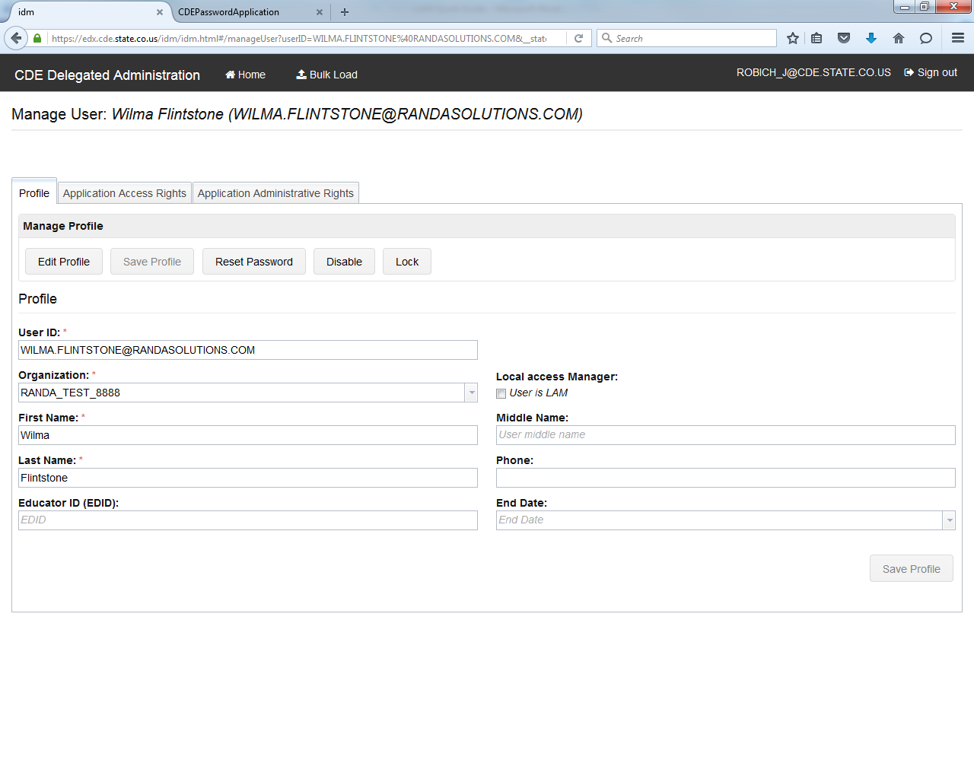

The LAM can enter a new password for the user and the password requirements are listed*. For maximum security, it is recommended to also check the **Reset password on Next Login** box and click on **Reset** to save.

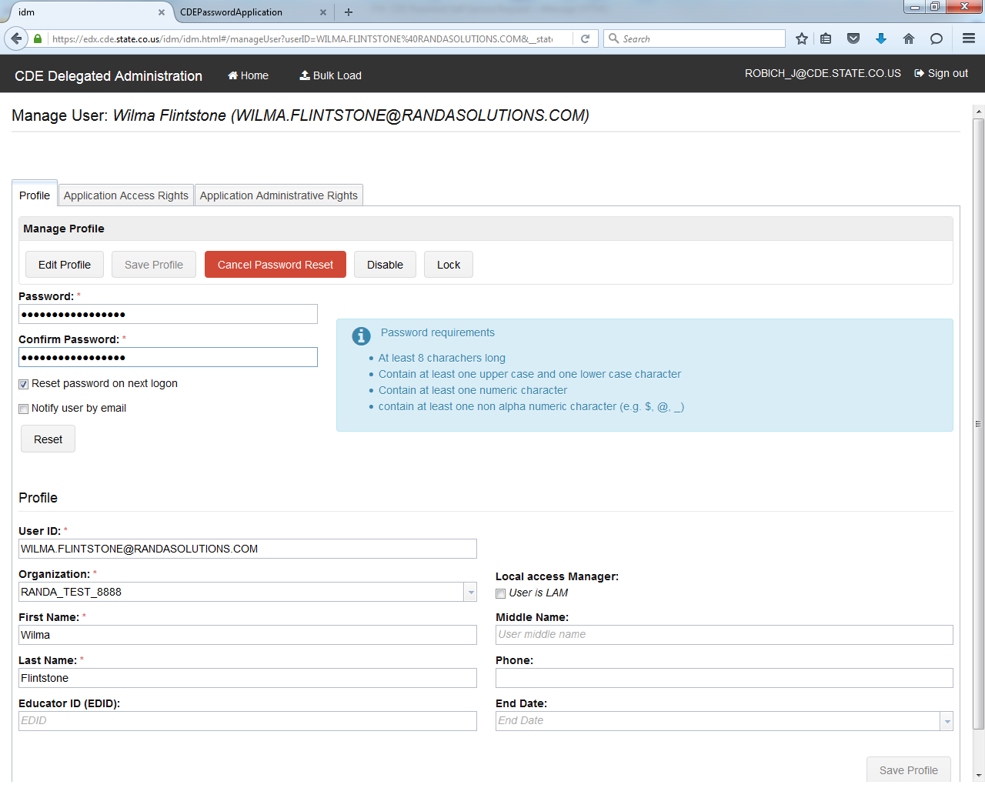

*At the time of this document draft, the **Password requirements** are listed incorrectly within IdM and the actual requirements are listed below. CDE is working to update this text.

* Password must be at least 8 character(s) long.
* Password must contain characters from at least three out of following five categories : Uppercase alphabetic characters (A-Z), Lowercase alphabetic characters (a-z), Numerals (0-9), Non-alphanumeric characters (for example: !, $, #, or %), Unicode characters.
* Password must not contain any of user ID, first name or last name when their length is larger than 2.
* Password must not be one of 24 previous passwords.

User Management FAQs

I made updates to one user’s account but need to make changes to another account. How do I search for another user?

Clicking on the **Home** button at the top of the page will bring you back to the landing page where you may add or search for a user.

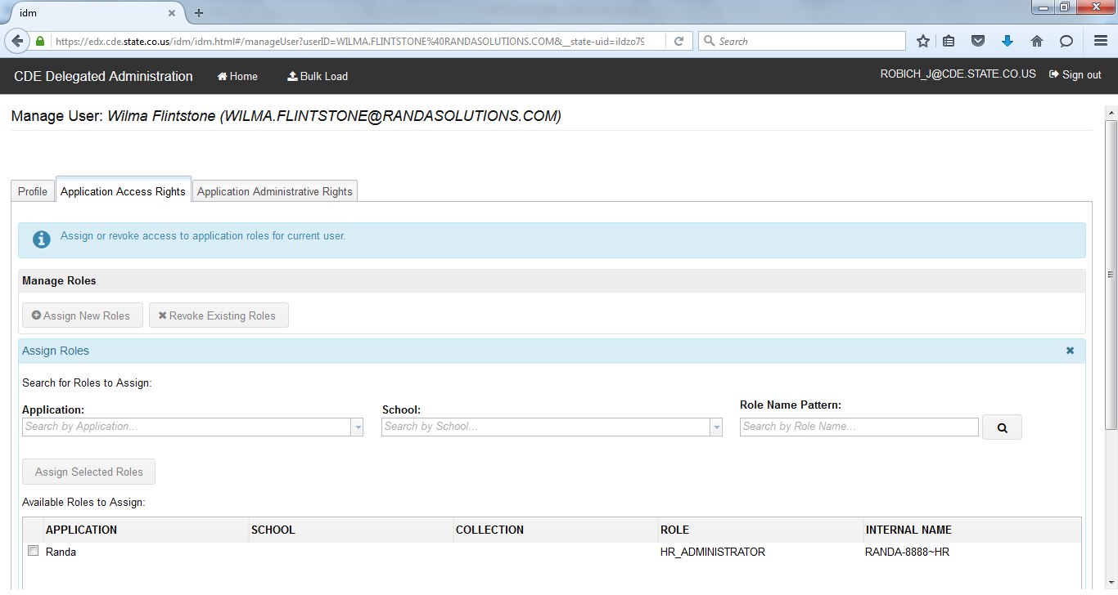

I am using the filters to search for a role, but it returned no results. How do I repopulate all the roles?

Clear all the search fields and hit **enter or** the click on the search icon 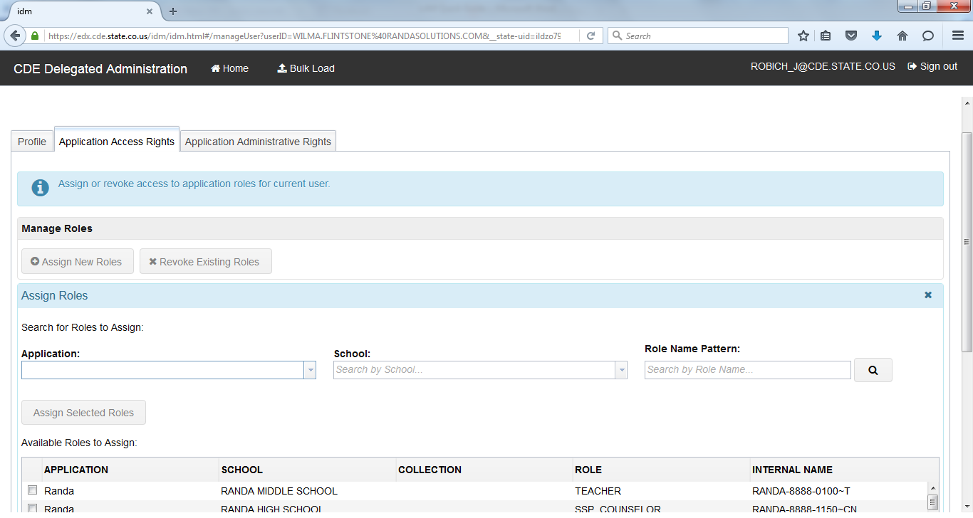to populate all results again.



Why did my search yield no results?

You may need to use wildcards (*) on either side of the text you are using to search in order to produce more results. If you are using more than one search keyword (e.g., *CN*1150*), you may need to switch the order or use just one search keyword.

What does the Lock button do?

Currently, the **Lock** button operates in the same manner as the **Disable** button; it will not allow a user to access CDE applications. However, the account will not be subject to the 90 day time limit before the account is deleted. CDE is currently investigating the possibility of removing the **Lock** button for better clarity.



Is there a way to sort the search results when searching for a user?

Yes, you can sort each of the search results by click on the column header. **NOTE: This does not work when managing roles.**

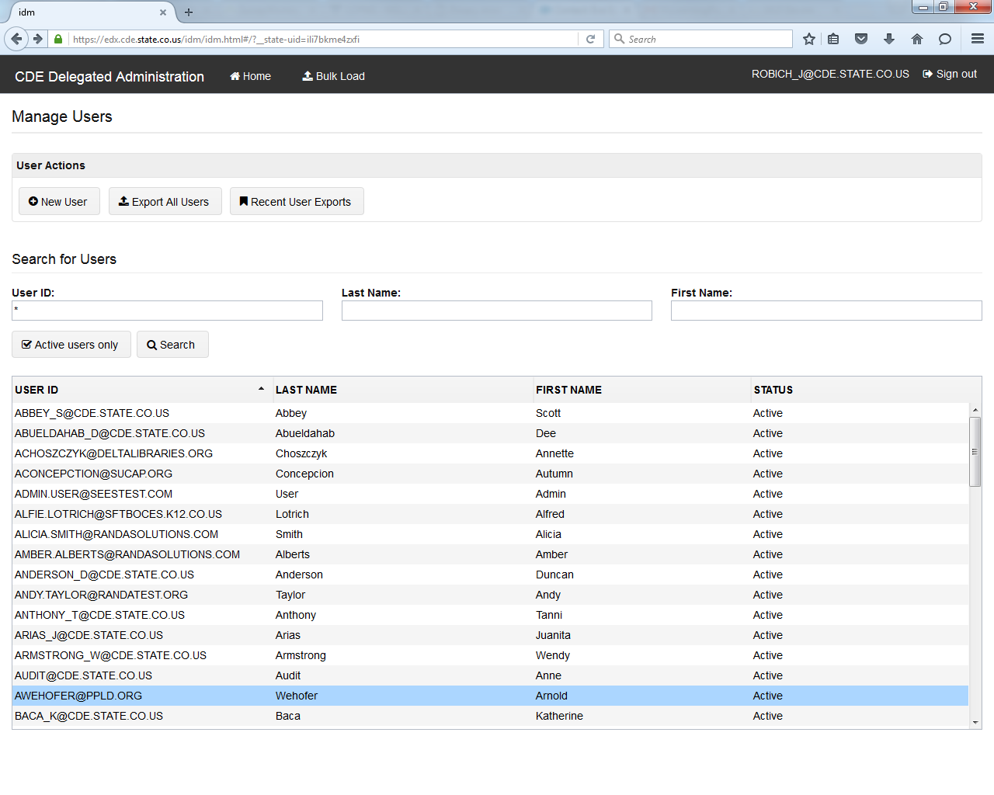

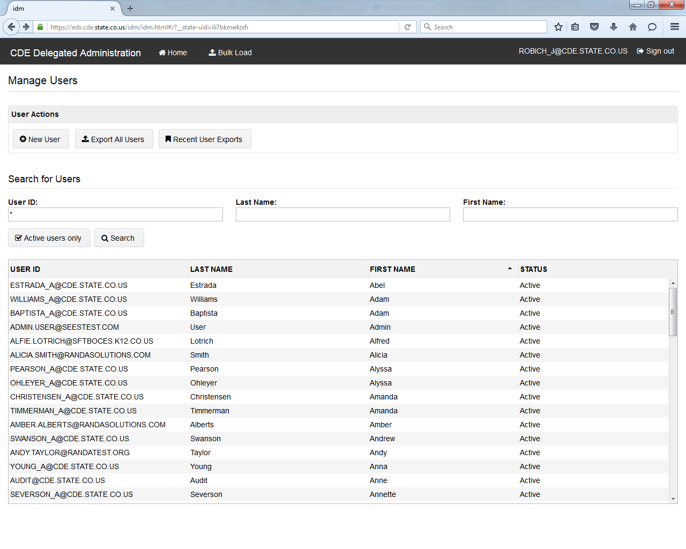

A user says they are receiving an error message at login saying to contact their Administrator but they are using the correct username and password. Why are they receiving this error?

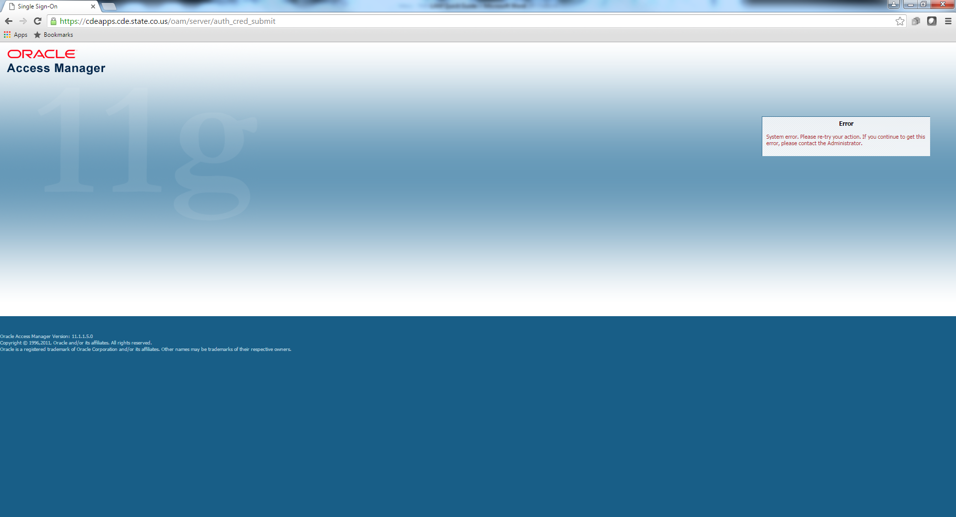

This is a bookmarking error. Due to some authentication that occurs, users cannot book the typical login page, which is not always intuitive.

Users only needing to access the Colorado Performance Management System (RANDA) should bookmark <https://www.cde.state.co.us/educatoreffectiveness/randa> --> then click "Login..." --> then move to the page to insert the username and password.

All other users accessing CDE applications should bookmark <https://www.cde.state.co.us/idm> and then click on the appropriate application on the left to access the login page.

The username is the full email address and users may request a new password at any time by visiting <https://edx.cde.state.co.us/passwordmanagement/CDEPasswordApplication.html>. If a user is locked out of their account, it will reset after 20 minutes.

Is there an email I can “whitelist” for my organization to ensure we do not miss any password emails?

Yes, all password emails will be sent from [NOREPLY@cde.state.co.us](mailto:NOREPLY@cde.state.co.us).

I’ve been trying to manually change a password for a user and it says it does not meet minimum requirements. I following the requirements listed on the screen. Why will it not let me change the password?

At the time of this document draft, the **Password requirements** are listed incorrectly within IdM and the actual requirements are listed below. CDE is working to update this text.

* Password must be at least 8 character(s) long.
* Password must contain characters from at least three out of following five categories : Uppercase alphabetic characters (A-Z), Lowercase alphabetic characters (a-z), Numerals (0-9), Non-alphanumeric characters (for example: !, $, #, or %), Unicode characters.
* Password must not contain any of user ID, first name or last name when their length is larger than 2.
* Password must not be one of 24 previous passwords.

Appendix

Sample email to new users

=======

SUBJECT: RANDA: Welcome to the Colorado State Model Performance Management System

=======

Your Colorado State Model Performance Management System (RANDA) account is now active.

**WEBSITE:** <http://www.cde.state.co.us/educatoreffectiveness/randa> **(HINT: bookmark this webpage; bookmarking other pages may display an error)**

**USERNAME:**

**PASSWORD:**

**FOR HELP, please contact the following:**

* To reset or change your password, please visit <https://cdeapps.cde.state.co.us/passwordmanagement/CDEPasswordApplication.html#/>
* For all other questions: [support@copms.randasolutions.com](mailto:support@copms.randasolutions.com)

Thank you,

Information Management Services



Initial Password Reset Email

**From:** CDE password manager [mailto:NOREPLY@cde.state.co.us]   
**Subject:** CDE Password Self Service Request

This is an automated message to inform you that you've requested to reset your CDE password. Please note that our system only allows 1 self service password reset per 24 hours.

Please follow this [link](https://cdeapps.cde.state.co.us/passwordmanagement/#/PasswordReset?sessionID=34313038303a524f424943485f4a404344452e53544154452e434f2e5553) to reset your password

If you did not initiate this password change, please contact help desk for assistance at [helpdesk@cde.state.co.us](mailto:helpdesk@cde.state.co.us).

**Please do not reply directly to this email. This is an outgoing email account only.**

Thank you

Password Confirmation Email

**From:** CDE password manager [mailto:NOREPLY@cde.state.co.us]   
**Subject:** CDE Password Self Service Request

This is an automated message to inform you that you've successfully reset your CDE password. Please note that our system only allows 1 self service password reset per 24 hours.

If you did not initiate this password change, please contact help desk for assistance at [helpdesk@cde.state.co.us](mailto:helpdesk@cde.state.co.us).

**Please do not reply directly to this email. This is an outgoing email account only.**

Thank you