COLORADO MULTI-TIERED SYSTEM OF SUPPORTS

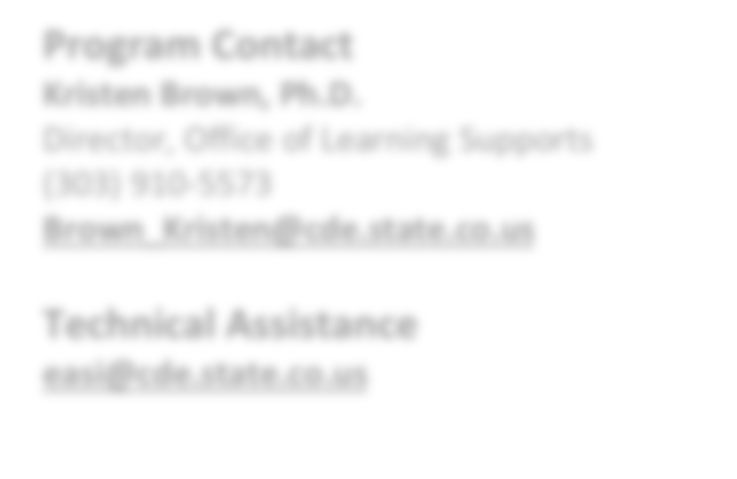

**EASI Route: Offered Services**

# Introduction

**C**olorado **M**ulti-**T**iered **S**ystem of **S**upports (COMTSS) is a prevention- based framework using team-driven leadership and data-based problem solving to improve the outcomes of every student through family, school, and community partnerships, comprehensive assessment, and a layered continuum of supports. Implementation science and universal design for learning are employed to create one integrated system that focuses on increasing academic and behavioral outcomes to equitably support the varying needs of all students.

**Program Contact**

**Kristen Brown, Ph.D.**

Director, Office of Learning Supports

(303) 910-5573

[**Brown_Kristen@cde.state.co.us**](mailto:Brown_Kristen@cde.state.co.us)

**Technical Assistance**

[**easi@cde.state.co.us**](mailto:easi@cde.state.co.us)

Our mission is to use systems level thinking to equip staff, teachers, and families to ensure that all students are afforded the opportunity to obtain an equitable education to succeed academically, socially, emotionally, and behaviorally over their lifespan.

COMTSS sees our partnerships with districts as an integral collaboration to achieve five major goals: 1) increase state leadership capacity for COMTSS infrastructure; 2) increase regional and district COMTSS capacity and sustainability; 3) increase preschool-12, school level capacity for COMTSS through the implementation of evidence-based practices, data- based problem solving, and short-cycle action planning; 4) support improved teacher effectiveness in the classroom; and

5) increase partnering with families, schools, and the community.

COMTSS includes five Essential Components that create a more efficient and effective system of supports that benefit the outcomes of all students including those in low performing schools:

1. **Team-Driven Shared Leadership**: Teaming processes and structures that focus on distributing responsibility and shared decision-making across and within regions, districts, and schools to effectively design and use systems of training, coaching, resources, implementation, and evaluation.
2. **Data-Based Problem Solving and Decision-Making**: A continuous improvement process used by teams to collect, analyze, and evaluate information to inform decision making at the system and student levels.
3. **Family, School, and Community Partnership**s: Families, early-childhood programs, schools, and communities actively partnering to develop, implement, and evaluate effective and equitable practices to improve educational outcomes for children and youth.
4. **Comprehensive Screening and Assessment System**: A Comprehensive Screening and Assessment System is the coordinated effort of gathering information across multiple measures to support decision making at the system and student level for the whole child.
5. **Layered Continuum of Supports (LCS) (Evidence Based Practices, Instruction, and Interventions)**: Ensuring that every student receives equitable whole child supports that are evidenced based, culturally responsive, matched to need, and developmentally appropriate through layered supports.

Updated August 2024

# Eligibility & Prioritization

***Eligibility.*** Districts with at least one school that meet the following criteria are eligible to apply:

* + Schools identified for improvement under ESSA as Comprehensive Support (CS), Targeted Support (TS), or Additional Targeted Support (ATS); and/or
  + Schools with a state identification School Performance Framework plan type of Priority Improvement, Turnaround, or On Watch

***Prioritization.*** In the event that not all EASI proposals can be funded, proposals that meet grant expectations will be funded in the order of the EASI school-level prioritization list. Schools with the highest number of prioritization points will be funded first. District-level supports will use the average prioritization of all EASI eligible schools. Details on how prioritization points are calculated and the points for each EASI eligible school are available on the [EASI Resources and](https://www.cde.state.co.us/fedprograms/easiappresourcesandtechnicalassistance) [Technical Assistance](https://www.cde.state.co.us/fedprograms/easiappresourcesandtechnicalassistance) webpage**.**

# Program Considerations & Fit

***Program Considerations***. LEAs considering applying for EASI supported COMTSS, should consider reviewing COMTSS materials and consulting with the program lead to ensure there is a clear understanding of the expectations of the support.

***Program Fit***. COMTSS may be a good fit for districts with schools receiving other school-level EASI supports. LEAs with active District Strategic Planning awards or multiple schools supported by the Transformation Network should not apply for COMTSS. Additionally, COMTSS is not a good fit for LEAs that are on Performance Watch or with a high concentration of schools on Performance Watch.

# Sequence of Program Support

The sequence of the work is determined in partnership with assigned COMTSS specialist, but will include the following technical support:

* COMTSS district and school trainings
* Monthly meetings to support action planning and implementation of COMTSS;
* Identification of clear goals and outcomes focused on student outcomes;
* Development of action plans that align with other initiatives and result in high quality, sustained implementation; and
* Creation of evidence-based personnel development and technical assistance activities for local schools.
* Use of tools and resources

# Available Funds & Duration

***Available Funds.*** Applicants may request up to the maximum award amount for the LEA. Award may be:

* Up to $20,000 per LEA in Year 1 (2024-25)
* Up to $80,000 per LEA in Year 2 (2025-26)
* Up to $80,000 per LEA in Year 3 (2026-27)

***Duration.*** Program support is designed to support LEAs for a period of 2.5 years.

# Allowable Use of Funds

Awarded funds can be used for the following purposes:

* + FTE for the COMTSS District Coordinator,
  + Activities related to professional development, including training fees, curricula school climate surveys, implementation tools, outcome measurement, time for collaboration, remote technology, travel, staff stipends,

salaries (benefits excluded), substitute pay to create time for job-embedded learning opportunities or other planned activities and other planned activities (excluding food purchases).

* + Monitoring and execution of the distribution, collection, standardization, and analysis of data collected.
  + Monitoring and performance of the distribution, collection, and analysis of implementation data indicate the degree to which the school, leadership team, and school staff implement COMTSS.
  + Funding from this opportunity may not be used to purchase food and must be used to supplement and not supplant any federal, state and local funds currently used to provide activities.

*Note- If entering indirect costs, the total request amount may not exceed the maximum allowable amount.*

***Fund Considerations***.

* + Funds from this opportunity must be used to **supplement and not supplant** any federal, state, and local funds currently being used to provide activities.
  + Post-award revisions must be approved by 06/30 and funds drawn down by 09/30 of each respective fiscal year.
  + A school or district may carry funds forward in alignment with funding source restrictions and with CDE approval. At the end of the grant performance period, any non-requested federal funds are reverted and any unspent state funds must be returned to the state.
  + CDE may terminate a grant award upon thirty days’ notice if it is deemed by CDE that the applicant is not fulfilling the requirements of the funded program as specified in the approved project application, or if the program is generating less than satisfactory results.
  + Multi-year or future award year amounts are contingent on allocations of state and federal funds to CDE in each respective fiscal year.

# Important Program Dates

|  |  |
| --- | --- |
| **Program Dates** | **Activity** |
| **September- December** | Meet with COMTSS Staff to discuss application and next steps |
| **December** | Application due |
| **February/March (post-revisions)** | COMTSS district kick-off event and ongoing district and school trainings and coaching to build effective COMTSS systems in district and schools |

**Evaluation and Reporting**

Each grantee of the program must, at a minimum, agree to the following evaluation, reporting, and/or progress monitoring components:

* + Integration of pathways work within the school or LEA’s Unified Improvement Plan (UIP)
  + If the school or district reaches the end of the Accountability Clock, the LEA will be expected to present its pathway plan—developed with CDE support—to the State Board of Education prior to any end-of-clock statutory deadlines. LEAs using grant funds for implementation activities will be required to comply with all progress monitoring requirements requested by CDE staff and the state board.
  + Annual Financial Report (AFR) each fiscal year by 09/30

Because successful implementation of COMTSS depends on the use of data to inform decisions, participating Colorado Multi-tiered System of Supports Districts (C-DITs) will be expected to use data throughout their implementation efforts. Additionally, data collection and submission to CDE will be expected. The data from participating C-DITs and schools includes facilitated submission of relevant aggregated academic, behavioral, and implementation fidelity data will be a function of program participation. The C-DIT and COMTSS staff will mutually decide upon, record, and monitor data throughout the project. This may be collected in the form of student outcome data, fidelity data, questionnaires, self-assessments, and participant reflections.

Each C-DIT will complete and submit the following to CDE each year of the project:

* [**Capacity building tools**](https://www.cde.state.co.us/mtss/23-24-requirements-ataglance):
  + District Capacity Assessment,
  + School Fidelity Assessment,
  + Look-For-Tool,
  + Family, School, Community Partnerships Self-Assessment
* Annual Financial Report.

*Note- All data collected will protect personally identifiable information (PII) protected and is only reported on an aggregate level for purposes of evaluating the EASI support and/or supporting future program improvements.*

# Program Assurances

***District Leadership Commitments:*** Districts will designate a C-DIT to work with and coordinate with COMTSS staff regarding technical assistance for implementation efforts. The C-DIT will:

* Include at least one designated executive district leader, who will attend at least 75% of monthly meetings;
* Include a C-DIT lead and point of contact for communications with CDE and meeting facilitation;
* Attend CDE sponsored district COMTSS trainings;
* Attend regional meetings with the COMTSS staff to complete various activities, including infrastructure evaluation, implementation plan development, initiative inventory completion, professional development planning, and ongoing monitoring of school-level implementation;
* Ensure that district and building leadership possess the qualifications and have committed the time necessary to accomplish activities to lead to student achievement gains;
* Conduct action planning-related professional development and technical assistance with participating COMTSS School Implementation Team (C-SIT) with the support of COMTSS staff;
* Foster principal leadership in schools and support leadership growth opportunities;
* Ensure that funds are being leveraged with other local, state, and federal funds (e.g., Titles I, II, III, V and IDEA) and that accountability for cost-effective management is provided; and
* Provide student, school, and district related data to CDE within the time frames specified.

***School Leadership Commitments:*** Participating schools will implement a COMTSS School Implementation Team (C- SIT). Each C-SIT will:

* + Provide CDE with evaluation information;
  + Attend online and face-to-face state-sponsored professional development opportunities;
  + Budget sufficient funds and time to participate in required activities; and
  + Exercise leveraging of Title I, IDEA, and other funding sources.

# ADDITIONAL INFORMATION AND RESOURCES

**Colorado Department of Education’s EASI Website** [**www.cde.state.co.us/fedprograms/easiapplication**](http://www.cde.state.co.us/fedprograms/easiapplication)