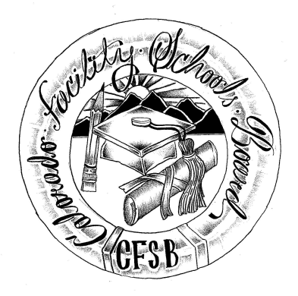
Colorado Facility Schools Board Meeting
April 17, 2025
9:30 a.m. – 2:00p.m.
In Person Venue: Shiloh FRP- 9700 E Easter Ln, Centennial, CO 80112

Time | Agenda Item | Participants
9:15am | Arrivals
9:30am | Board Meeting (Co-Chair calls meeting to order)  Approval of Minutes Action Item  Approval of Agenda Action Item | Board
9:35am | Public Comment –Members of the public who wish to address the board must sign up 24 hours prior to the meeting using this link – Public Comment Sign-up Sheet. Presentations are limited to 3 minutes, with a maximum of 10 people. Additional guidance on public comment on the following page. If you plan to attend a meeting and need translation or accommodations, please notify Lori Kochevar, Kochevar_L@cde.state.co.us, at least 2 weeks prior to the meeting date. Advance notice allows CDE time to set up requested accommodations or translation services before the meeting. | Board/ Public
9:40am  10:00am | Havern Autism Program request for approval as Specialized Day School/Approved Facility School Action Item – Vote  PRN Approval Presentation request for approval as Day Treatment/Approved Facility School Action Item - Vote | Robyn Ledebuhr/Board  David Molineux/Board
10:30am | Break
10:40am | Kaleidoscope 2025 | Tara Butler
10:50am | Review Facility Schools Board 2025-2026 Schedule | Darren Serrato/Judy Stirman
11:00am | Monthly reference to the Board’s governing documents. Advance prep for the June Board retreat; today's emphasis - Board leadership and performance and review of the process of strategic planning | Virginia Winter/Board
11:40am | Discussion of need for attendance/presentation at State Board of Education meeting in June regarding facility schools. | Board
11:45am | December Count PowerPoint | Robin Singer
12:00pm | Lunch
12:30pm | Accreditation Dialogue Item  Review draft of standards and indicators rubric, revisit definitions from March | Wendy Dunaway/ Board
1:15pm | Declare Next Month’s Board Dialogue Topic | Board/FS Staff
1:20pm | Confirm Board member tasked with April Board Corner | Darren Serrato
1:30pm | Team Updates | FS Staff
2:00pm | Adjournment of Meeting  Next Meeting Date – May 8, 2025.  In Person – ACES- 10255 West 104th Drive, Westminster, CO 80021 | Board

Colorado Facility Schools Board Meeting
Thursday, March 17, 2025
9:30 a.m. – 2:00p.m.

Additional information for those wishing to provide public comment –
This meeting will be open for members of the public for the entire meeting via the zoom link –
https://us02web.zoom.us/j/86214523756?pwd=52lw3cBCU4fao33TxNFB41V7QGatCK.1

Members of the public who wish to address the board must sign up 24 hours prior to the meeting using this link – Public Comment Sign-up Sheet. Presentations are limited to 3 minutes, with a maximum of 10 people. Additional guidance on public comment below.
Accommodation and Translation Notice:
If you plan to attend a meeting and need translation or accommodations, please notify Lori Kochevar, Kochevar_L@cde.state.co.us, at least 2 weeks prior to the meeting date. Advance notice allows CDE time to set up requested accommodations or translation services before the meeting.
If you have requested accommodations or translation services for a meeting and are then unable to attend, we ask for at least a 72-hour notice of cancellation, so that CDE can be proactive with cancelling requested accommodation services ahead of the meeting. Thank you!
Information regarding public comment:
DO:
§ Introduce yourself and where you are from. If you are speaking on behalf of an organization, identify the organization and your association.
DO: (Continued)
§ If speaking to a specific agenda item, limit your remarks to the subject of the agenda item and avoid repeating what others have said.
§ Be brief, to the point, and concise.
§ If you believe an issue needs to be explained in-depth, and you bring handouts, please pass them to staff prior to making your comments. Be sure to include your name and date of the meeting on the handout.
DO NOT:
§ Expect the board to answer any questions you may have.
§ Expect the board to be able to intervene with local school district issues. As Colorado is a local control state, district-specific issues should be resolved locally.
If you have questions about state law and local requirements, CDE staff may be able to assist you in finding an appropriate way to address your concerns.
§ Discuss personnel matters with the board. This should be done in private with the chair and/or vice-chair of the board.

