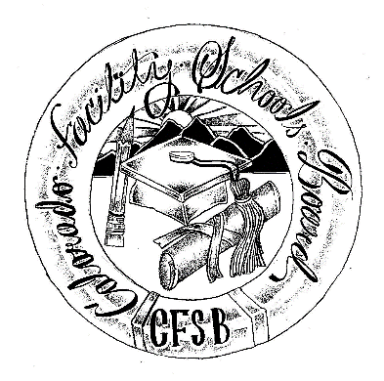

**Colorado Facility Schools Board**

**of Education**

**2024 - 2025 Meeting Schedule**

|  |  |  |
| --- | --- | --- |
| **Date** | **Time** | **Location** |
| **August 8, 2024** | 9:30am – Completion of agenda (usually 3:30-4pm) | **In Person** - Shiloh House Family Resource Pavilion - 9700 E Easter Ln, Centennial, CO 80112. |
| **September 12, 2024** | 9:30am – Completion of agenda (usually 3:30-4pm) | **In Person** - Shiloh House Family Resource Pavilion - 9700 E Easter Ln, Centennial, CO 80112. |
| **October 10, 2024** | 9:30am – Completion of agenda (usually 3:30-4pm) | **Virtual Only** – Virtual Only via [Zoom](https://us02web.zoom.us/j/89478350223?pwd=Q8qDi3ztMWvdE8bNWJdaTMdxecF7e0.1) |
| **October 24, 2024** | Board Presentation at Kaleidoscope Conference | The Adams 12 Conference Center 1500 E 128th Avenue  Thornton CO  80241 |
| **November 7, 2024** | 9:30am – Completion of agenda (usually 3:30-4pm) | **In Person** – TACT- 2960 S Umatilla St, Englewood, CO 80110 |
| **December 12, 2024** | 9:30am – Completion of agenda (usually 3:30-4pm) | **In Person** - Shiloh House Family Resource Pavilion - 9700 E Easter Ln, Centennial, CO 80112. |
| **January 9, 2025** | 9:30am – Completion of agenda (usually 3:30-4pm) | **Virtual Only-** Via [Zoom](https://us02web.zoom.us/j/84500956694?pwd=LqCVKZzbrf1fQyhDsYn3WbjWjYqpYT.1) |
| **February 13, 2025** | 9:30am – Completion of agenda (usually 3:30-4pm) | **In Person** – Spectra –  7205 West 120th Avenue,  Broomfield, CO 80020 |
| **March 13, 2025** | 9:30am – Completion of agenda (usually 3:30-4pm) | **In Person** - Shiloh House Family Resource Pavilion - 9700 E Easter Ln, Centennial, CO 80112. |
| **April 10, 2025** | 9:30am – Completion of agenda (usually 3:30-4pm) | **In Person** - Shiloh House Family Resource Pavilion - 9700 E Easter Ln, Centennial, CO 80112. |
| **May 8, 2025** | 9:30am – Completion of agenda (usually 3:30-4pm) | **In Person** – ACES- 8040 Southpark Ln, Littleton, CO 80120 |
| **June 12, 2025** | 9:30am – Completion of agenda (usually 3:30-4pm) | **In Person** - Shiloh House Family Resource Pavilion - 9700 E Easter Ln, Centennial, CO 80112. |