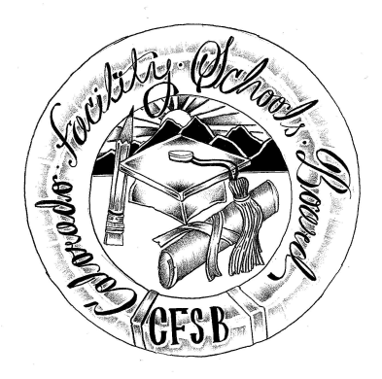

**Colorado Facility Schools Board Meeting**

**August 8, 2024**

**9:30a.m. – 3:30pm**

Venue: Shiloh House Family Resource Pavilion

9700 E Easter Ln, Centennial, CO 80112

In-Person

|  |  |  |
| --- | --- | --- |
| 9:15am  9:30am  9:35am  10:05am  11:15am  11:30am  12:15pm  12:45pm  1:10pm  1:30pm  1:50pm  2:00pm  2:10pm  2:20pm  2:45pm | Arrivals  Board Meeting (Co-Chair calls meeting to order)  Approval of Minutes Action Item  Approval of Agenda Action Item  Opportunity for the Public to Address the Board  Members of the public who wish to address the board must sign up prior to the meeting. Presentations are limited to 3 minutes. Maximum of 10 People.  TACT Presentation  Board Vote Action Item  Break  Austin Centers  Board Vote Action Item    Lunch  Board Work with G  Board Discussion IEPs / Facilities / Facility School and CHRP waivers  AI Question  Officer Roles for 24-25  Update on Accreditation  Update on Tuition Cost  Team Updates  Next Meeting Date – September 12, 2024 (Thursday)  Adjournment of Meeting | Board  Danny Combs/Lori McClurg  Brad Trout/ Lori McClurg  Virginia Winter  Doug Hainley  Steven Ramirez  Judy Stirman  Wendy Dunaway  Robin Singer  Facility Schools |