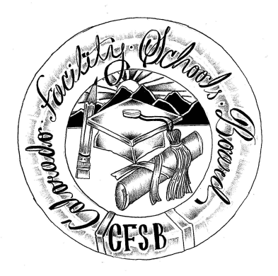

**Colorado Facility Schools Board Meeting**

**September 12, 2024**

**9:30a.m. – 2:00pm**

Venue: Shiloh House Family Resource Pavilion

9700 E Easter Ln, Centennial, CO 80112

In-Person

|  |  |  |
| --- | --- | --- |
| 9:15am  9:30am  9:35am  9:37am  9:40am  9:45am  9:55am  10:10am  10:25am  10:35am  10:40am  12:00pm  12:30pm  12:50pm  1:15pm  2:00pm | Arrivals  Board Meeting (Co-Chair calls meeting to order)  Approval of Minutes Action Item  Approval of Agenda Action Item  Opportunity for the Public to Address the Board  Members of the public who wish to address the board must sign up prior to the meeting. Presentations are limited to 3 minutes. Maximum of 10 people.  Board Seat Vacancy/School District Representative  Verify that a list of approved facility schools is publicly accessible/available (August / September)  Approve list of independent national accreditation organizations that accredit eligible facility schools as required by § 22-2-406(4)(a)(IV)(A)  Action Item – Board Vote  Request for approval to change facility school name from Hilltop Youth Services to Balanced Rock Community School.Action Item – Board Vote  Discussion of Updates to Board Operating Procedures  Updates regarding FS work group report draft  Senate Bill 23-219 Update/Technical Assistance Center  (TAC)Update  Break  Board Work: Aligning work with the strategic plan   * Board stewardship for documents * Prep for Kaleidoscope * Discuss FSB page for newsletter deadlines/expectations   Lunch  Monitoring Summary  Board Dialogue - Continued discussion of issues related to IEPs/Facilities/CHRP waivers  AI at IEP meetings  Facility Schools Team Updates  Adjournment of Meeting  Next Meeting Date – October 10, 2024 (Thursday)  In-Person at Shiloh House | Board  Judy Stirman/Betsy Peffer  Lori Kochevar  Wendy Dunaway  Sonjia Hunt  Jenna Zerylnick  Wendy Dunaway/Allie Miller  Virginia Winter  Robin Singer/Ann Symalla  Board  Facility Schools Team |