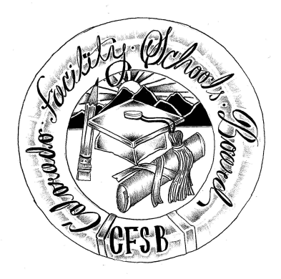
Colorado Facility Schools Board Agenda
December 7, 2023
9:30a.m. until the completion of the agenda

In-Person Only

9:30am  9:45am  10:00am  10:30am  10:35am  11:35am  12:15pm  1:00pm  1:30pm  1:40pm  2:00pm | Arrival  Board Meeting will start - Call to Order  Approval of Minutes  Approval of Agenda  Board Interview  Break  Board Development  Lunch  Facility Schools Unit Update  CDE/ESSU/Facility Internal Updates  Data Management and Systems Support  /December Staff  Monitoring/Updates from the Field/ Annual Report  IEP System Updates/ State Assessments/ELD Plan  Induction/Workgroup  Program Support  Attorney General’s Office update  Facility Schools Board Rulemaking Hearing/ 1 CCR304-1  Board Approval of Rules  Tuition Cost Update  Opportunity for the Public to Address the Board  Members of the public who wish to address the board must sign up prior to the meeting. Presentations are limited to 5 minutes.  Next Steps/Adjournment of Meeting  Next Meeting Date – January 11, 2024 | Action Item  Action Item  Board  Virginia Winter/Board  Judy Stirman  Lori Kochevar  Robin/Ann  Annie Haskins  Wendy Dunaway  Darren Serrato  Jenna Zerylnick  Board/Melissa Bloom  Board/Action Item  Facility Schools Staff  Members of the Public  Board

