Special Services Providers
Professional Practice Note Catcher

Critical Effects of S.B. 191
- Requires statewide minimum standards for what it means to be an “__________________” Special Services Provider
- Requires _____________ evaluation of all Special Services Providers
- Requires that all Special Services Providers be evaluated at least ___________ on the ___________ of the students they support

Key Priorities for Implementation of Colorado’s Special Services Provider Evaluation System
What are the 5 Key Priorities for Colorado’s Special Services Provider Evaluation System the State Council for Educator Effectiveness considered for their work?

- _____________________________________________________
- _____________________________________________________
- _____________________________________________________
- _____________________________________________________
- _____________________________________________________

Special Services Providers Historical Timeline – Key Understandings

2012-13 ______________________ _______________________________________
__________________________ ___________________________________
2013-14 _________ ____________________________________________________
2014-15 ______________________ _______________________________________
__________________________ ___________________________________
2015-16 _________ ____________________________________________________

Special Services Provider and Teacher Quality Standards
Write one or two words in the blank that best describes the context for each quality standard. The first one is done for you.

Standard | Special Services Providers | Teacher
1 | Professional Expertise | Know Content
2
3
4

Evaluation Process
Fill in the missing blanks for the Evaluation Process.
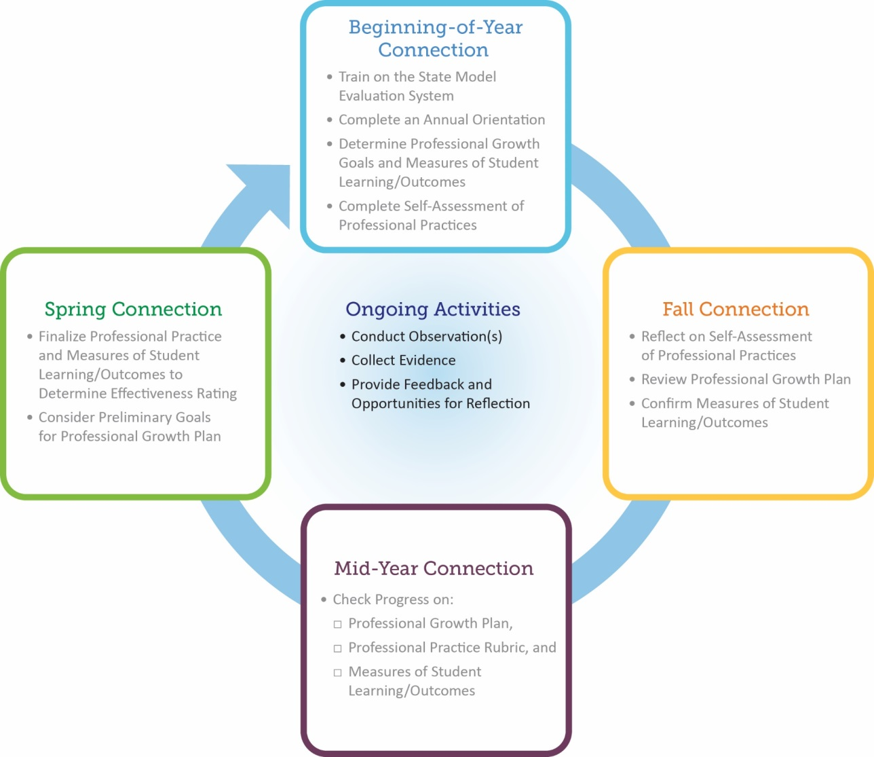

Artifacts
When are artifacts needed in the State Model Evaluation System?

