District User Manual
Data Pipeline
District User Manual
Document Control Information

Document information
Document Name | District User Manual
Project Name | Data Pipeline
Client | Colorado Department of Education (CDE)
Document Author | Prasanthi Kolluri/Ben Sprague
Document Version | 1.1
Document Status | Draft
Date Released | 7-May-2013
File Name | Data Pipeline District User Manual.docx

Document edit history
Version | Date | Additions/Modifications | Prepared/Revised by
0.1 | 29-Apr-2013 | Initial Draft | Prasanthi Kolluri/Ben Sprague
0.2 | 5-May-2013 | Edits, corrections as necessary | Chandrakant Nambiar
1.1 | 12-Jun-2013 | Added Troubleshooting information for Cognos and File upload | Ben Sprague

Document review/approval history
Date | Name | Organization/Title | Comments
7-May-2013 | Chandrakant Nambiar | Deloitte Project Manager | Approved

Distribution of final document
The following people are designated recipients of the final version of this document:
Name | Organization/Title
Dan Domagala | CDE/Chief Information Officer
Lisa Bradley | CDE/Project Manager

Contents
Introduction 1
Purpose 1
Annual LEA activities 2
Data Pipeline Basics 3
Accessing Data Pipeline 3
Operating System Requirements 3
Browser requirements 3
File Format Requirements 4
Understanding the Data Pipeline user interface 4
Single sign-on registration 5
Basics of user roles 6
Data Pipeline — Standard Application Screens 8
1. Format Checker 8
2. Data File Upload 12
3. Batch Maintenance 15
4. Validation Report 19
5. Add Record 21
6. Edit Record 25
7. Status Dashboard 33
8. Cognos Framework Reports 37
8.1 View Error Reports 37
8.2 View File Format Report 40
8.3 View Business Rules Report 41
8.4 View Codes Dictionary Report 43
8.5 View Data Dictionary Report 44
8.6 Modify browser settings 46
8.7 Modify CSV settings 47
10. Application Emails 48

Introduction
The Colorado Department of Education (CDE) is replacing the Automated Data Exchange (ADE) with Data Pipeline. After an Optimization phase, all ADE collections will be migrated to Data Pipeline. Several of the collections will be transformed into a combination of interchanges and snapshots, while others will remain relatively the same.

Purpose
The District User Manual contains information for LEA collection owners. This manual will provide instructions on File Upload, Status Dashboard, Add and Edit data screens, standard Cognos reports and standard application emails.
The manual addresses the following topics:
- Process prior to File Upload
- Format Checker
- Data File Upload
- Batch Maintenance
- Validation Report
- Edit Data
- Add Record
- Status Dashboard
- Meeting the Threshold
- Submit data to CDE

Note: Please note that throughout the document, the term “LEA” has been used to symbolize organizational units at the districts. This could include Boards of Cooperative Educational Services (BOCES) and Admin Units (AUs).

Annual LEA activities
Each year LEA users will be performing the following activities in Data Pipeline system:
- Upload collection data
- Review and edit individual record data in the system using Edit Record screen where applicable
- View Error and Business Cognos Reports
- Submit the corrected information to CDE
Note: Each collection may have its own unique processes that differ from the standard steps listed above.

Data Pipeline Basics

Accessing Data Pipeline
Open your internet browser and navigate to the Data Pipeline homepage here:
https://cdx.cde.state.co.us/pipeline

Operating System Requirements
It is recommended to use Windows XP or greater when working with Data Pipeline. If a user must use a Mac and an instance of the Macintosh OS, then ensure to use one of the browsers identified below.

Browser requirements

Enable cookies
The Data Pipeline application use cookies for session management. To enable cookies, follow the instructions below for the browser version you are using.
- Mozilla Firefox 16.x
  - Go to the “Tools” menu.
  - Select “Options.”
  - Select the “Privacy” icon in the left panel.
  - Choose to Remember History or Use Custom Settings for History.
  - Check the box corresponding to “Accept cookies from sites.” (Only applicable if Use
Custom Settings for History was selected).
Click “OK” to save changes.
- Microsoft Internet Explorer 8.x
  - Select “Internet Options” from the Tools menu.
  - Click on the “Privacy” tab.
  - Click the “Default” button (or manually slide the bar down to “Medium”) under “Settings.”
Click “OK.”

Enable JavaScript
In order to access the application, you will need to have JavaScript enabled in your browser. To do so, follow the instructions provided below:
- Internet Explorer 8.x
  - Select “Tools” from the top menu.
  - Choose “Internet Options.”
  - Click on the “Security” tab.
  - Click on “Custom Level.”
  - Scroll down until you see section labeled “Scripting.”
    - Under “Active Scripting”, select “Enable” and click OK.
- Mozilla Firefox 16.x
  - Select “'Tools” from the top menu.
  - Choose “Options.”
  - Choose “Content” from the top navigation.
Select the checkbox next to “Enable JavaScript” and click OK.

Allow pop-ups
The Data Pipeline application uses pop-ups to show some friendly confirmation messages. Unblock any pop-up blockers in your PC.

Enable auto refresh
In your browser’s Internet options settings, click on Check for newer version of stored pages on “Every Visit to the Page.”

File Format Requirements
A user may upload Excel, CSV, or text files to most Data Pipeline collections, although CDE may configure this for each collection and therefore some collection may only allow a subset of these files for upload. When using Excel the file must be an .xls or .xlsx file.
Note: If the user is using a Mac and an instance of the Mac OS, then Excel 2008 file or later is required.

Understanding the Data Pipeline user interface
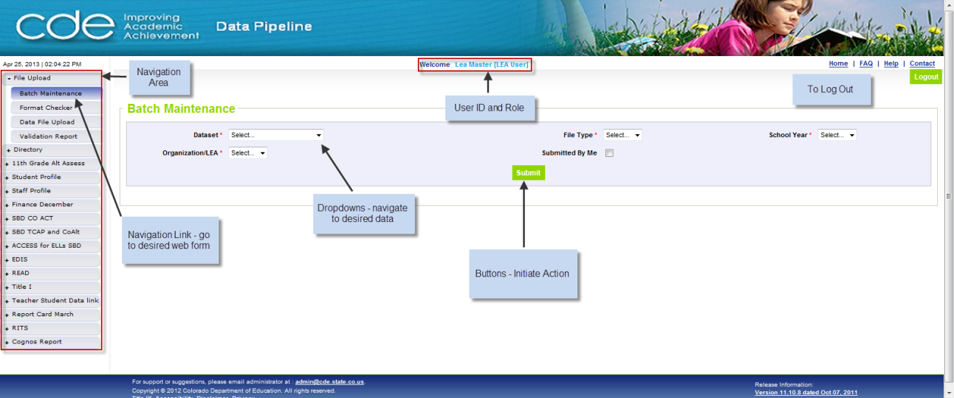
Figure 1: Data Pipeline Graphical User Interface (GUI)
All Data Pipeline Web forms have the following basic layout and user options:
A standard screen header contains the logo of CDE on the left and logo of Data Pipeline. Below the header is the User ID with the assigned role indicating who is currently logged in. The right side contains links to the Home Page, FAQ, Help, and the Contact pages.
The left menu pane consists of the navigation area that is dynamically configured based on the Data Pipeline module and the specific role(s) assigned to the user. It consists of a selectable menu with options. The menu options may consist of lower-level submenus in which case the higher-level menu option will be prefixed with a ‘+’ sign as shown above.
The Main application area occupies the bulk of the central portion of the screen as shown above and typically contains one or more buttons to initiate user actions such as Save, Submit, Cancel, etc. and may optionally contain other widgets represented as follows:
- Rectangular Edit Boxes — Allow for user input via keyboard.
- Radio Groups — Allow for selection of a single option from a list of possible choices.
- Dropdowns — contain an arrow pointing downward at the end of the field. Click the arrow to expand the dropdown to show possible choices. Highlight the desired data value and click to select the value.
- Check boxes — Allow for selection of multiple options from a list of possible choices. Click with the mouse to check or uncheck the field (a checked box indicates ‘Yes’ and an unchecked box indicate ‘No’).
- Pagination options on screens that contain large numbers of records.
Highlighted text fields in a colored background signify special meaning. Hovering over the field with the mouse will provide further messages to the user.
Underlined data items are hyperlinks that navigate to other pages when clicked with the mouse.
The standard screen footer contains additional links to Title IX, Accessibility, Disclaimer, and Privacy documentation. Additionally there are links to CDE Web pages, text to indicate the release number of the application with optional details on the features/defects in the current/prior release(s), and a link to the email address of the application administrator.

Single sign-on registration
A district user must request access to Data Pipeline through their Local Access Manager (LAM). When requesting access, provide the following information:
- User Name (typically, this is the user’s email id).
- Collection code (e.g. OCT for Student October, see below for more details)
- User role (e.g. LEA User, see below for more details)
Organization code (user’s District, BOCES, or AU code)
Note: Each organization may have a different internal process for handling user access.

Basics of user roles
Each LEA user is assigned to a role of LEA User, LEA Approver, or LEA Viewer. They are also assigned to a single organization, their organization. This limits the user’s access to the data pertaining to only their organization in the system.
Some general information to be aware of regarding user roles:
- A user name can be assigned to one and only one role for a specific collection. For example, a user cannot belong to both, LEA Approver and LEA User role for the same collection.
- A user name can be assigned to one and only one organization in Data Pipeline. For example, a user cannot belong to a district and an AU.
It is important to be aware of which roles apply to which collections. For example, several collections will not utilize the LEA Approver role and therefore no user should be assigned
this role for those collections.
When requesting access to a collection a request is typically submitted to the district LAM. Specify the user name and desired roles unless the organization has a standard process to be followed that is outside of the process outlined in this document:
PIPELINE-XXXX-<Application Code>~<Role>
<Application Code> - The numeric value of XXXX indicates the District, BOCES or Admin Unit code for which the user will have access. For collections that allow AU access this would be a five digit value.
<Role> - The table below lists what to include when requesting a role:
User Role | <Role> Field
LEA User | LEAUSER
LEA Approver | LEAAPPROVER
LEA Viewer | LEAVIEWER

The following table lists available application codes for which access can be requested.
Note: A user may only be assigned a single role for each collection. A user can be assigned to multiple roles across collections. A user can be assigned to one and only one organization across all collections in Data Pipeline.
Collection | Application Code
Student Profile & Enrollments | STD
Staff Profile & Assignments | STF
Special Education IEP Interchange | SPE
Discipline Interchange | DIS
Teacher Student Data Link Interchange | TSL
Title I Interchange | TI1
Math & Science Partnership | MSP
Student October | OCT
Student End of Year | SEY
RITS | RTS
EDIS | EDS
Reading to Ensure Academic Development (READ) | RED
11th Grade Alternate Assessment | 11G
Special Education December | DEC
Special Education End of Year | EOY
Special Education Discipline | SPI
Human Resources | HRD
Report Card March | RCM
Finance | FIN
ACT SBD | ACT
ACCESS for ELLs SBD | ACC
TCAP SBD | TCP
Directory | DIR

Once a user role and application code is selected, an example of how the user group in Identity Management may look is as follows:
PIPELINE-0010-TI1~LEAUSER

Data Pipeline — Standard Application Screens
The following sections outline each screen available for performing LEA actions. An overview will be provided of each screen and detailed step-by-step instructions about how to accomplish tasks for each screen.

Format Checker
Authorized LEA Users and LEA Approvers will have access to the File Upload functionality for collection records that can be submitted to the system through a file upload. When uploading a file (especially during the first few times) the format checker screen is usually a good place to start. The Format Checker is used to verify the length of the first record of a text file, or the field lengths of the first record of an Excel or CSV file submitted for a collection. If it is a text file and the length is greater than or equal to the expected record length the file will pass the format checker; text files less than the expected length will display an error message. The Format Checker does not check individual fields in text files but checks the overall length of the first record to see if it matches what is expected. For an excel or CSV file if the field is equal to or less than the expected length it will pass; if it is greater than the expected length it will fail.

When uploading a text file, if the text length is shorter than what is expected the system will return a message, “Line length does not match end position of file.” If the length is greater than expected the system will return a message, “The uploaded file exceeds the minimum length, but can be uploaded through the Data File Upload screen.”
Note: The Format Checker only validates the first line of a text file or the first record in the Excel file, assuming that the records following the first record in the file conform to the same layout as that of the first.

1.1 Execute Format Checker

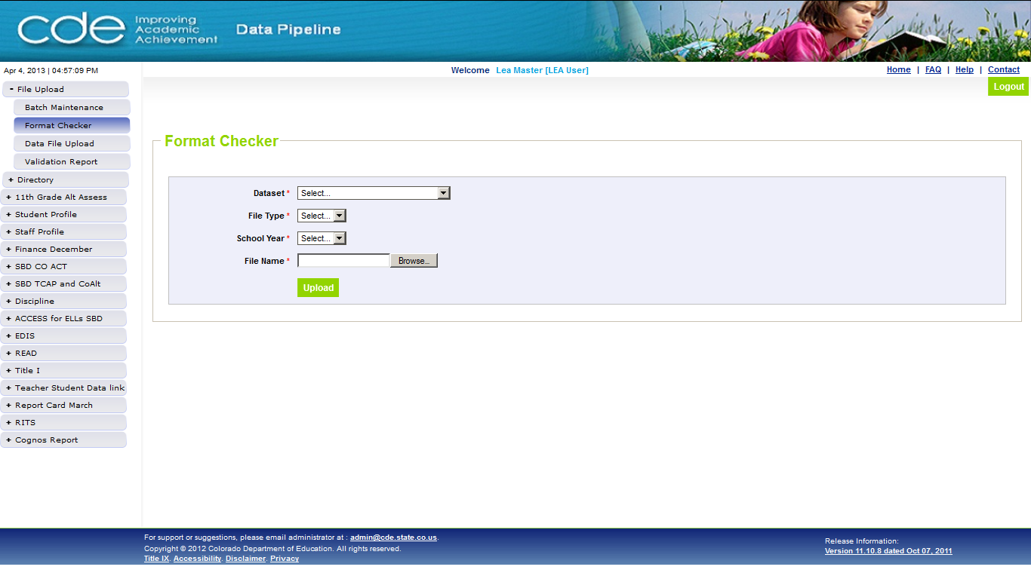
Figure 2: Format Checker

GUI description
Field # | Field name | Field Description/use | Mandatory | Max length | Constraints
1 | Dataset | Dropdown with all existing datasets that the LEA Approver/User has access to | Yes | N/A | None
2 | File Type | Populates based on the Dataset selection with all File Types that exist under the selected Dataset | Yes | N/A | None
3 | School Year | Dropdown that lists the school years for which the collection is open | Yes | N/A | None
4 | File Name | Path and Name of the file that is being uploaded to the system | Yes | N/A | Read-only

Button name | Button description | Preconditions | Postconditions | Negative action
Browse | Allows you to locate the file on your computer | -School Year, Dataset, and File Type must be selected | On click will display the location from which you can select the file from the computer | On click requests user to select all mandatory fields
Upload | Allows you to submit the file to the system | -School Year, Dataset, File Type and file name must be selected | On click will display the confirmation message | On click requests user to select all mandatory fields  An error message will be displayed if the uploaded file was not text or excel

Steps to perform
- Click on File Upload Format Checker from the Data Pipeline Home Page.
- Select Dataset
- Select File Type
- Select School Year
- Click on Browse to locate the file on your computer.
- Click on Upload to submit the file.

Note: When uploading an Excel file the system will only look at the first tab of data. If there is a blank data load or data appears to be missing, a good check is to confirm the data is present on the first sheet of the excel file that is being uploaded.

1.2 Format Checker Results
This page provides the format checker results of the upload to Data Pipeline. If any of the uploaded file fields doesn’t meet the requirements then the result will be displayed as “Fail” else the result will show up as “Pass”.
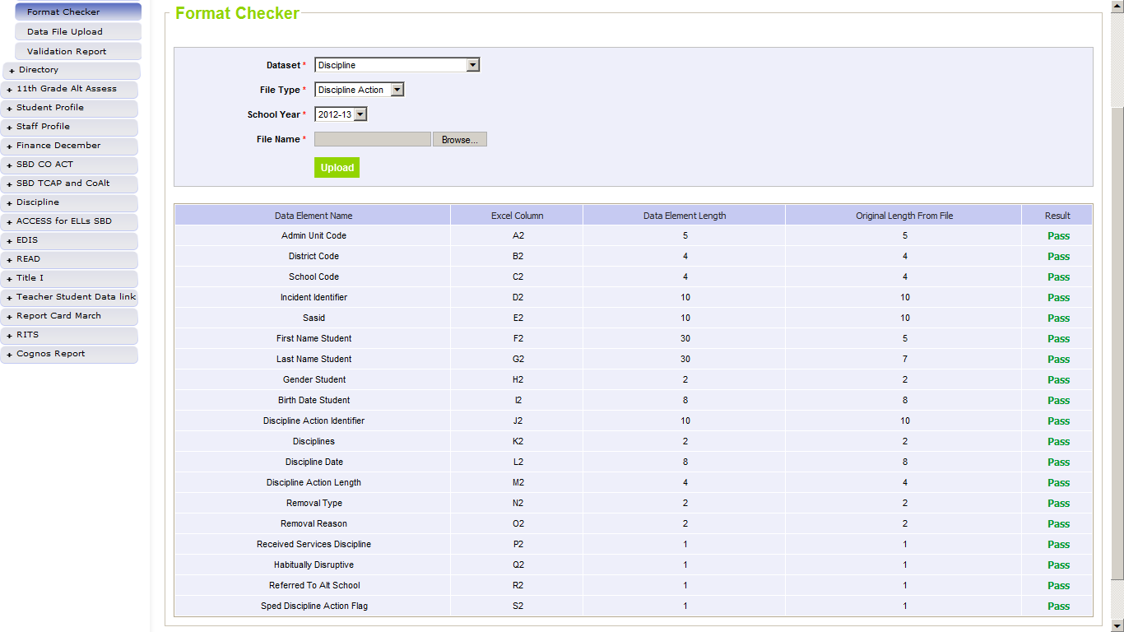
Figure 3: Format Checker Results for an Excel File Upload

GUI description
Field # | Field name | Field description/use | Mandatory | Max length | Constraints
1 | Data Element Name | Displays the name of the data element in the file layout | N/A | N/A | Read Only
2 | Excel Column | Displays the position number of each data element | N/A | N/A | Read Only
3 | Data Element Length | Displays the expected length of each data element as configured in the Data Pipeline system | N/A | N/A | Read Only
4 | Original Length from the file | Displays the length of each data element received from the uploaded file | N/A | N/A | Read Only
5 | Result | Indicates the Pass/Fail result of each data element | N/A | N/A | Read Only

Note that excel and CSV files must not be open; otherwise the file upload will fail and an error message will be displayed by the application as shown in Figure 4 below.

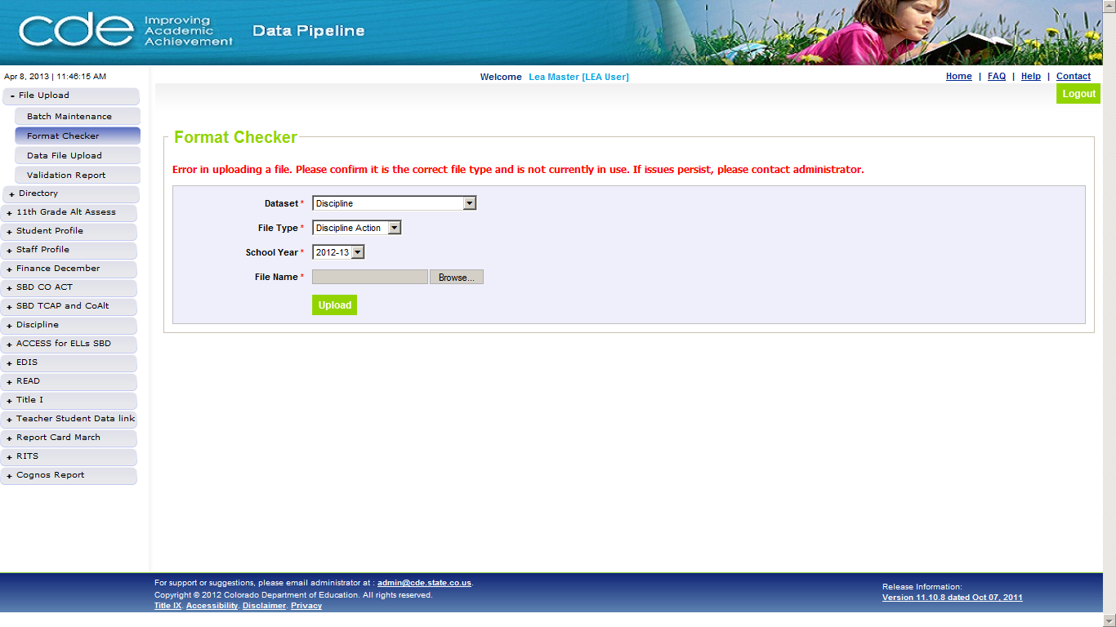
Figure 4: Format Checker Error
The above error message will be displayed if the uploaded file was not an allowable file format (text, CSV, Excel) for the selected File Type or when the excel or CSV file is open for editing when the user attempts to upload the file. If this error appears check to see if the file is open and if it is, then close the file and try uploading again.

Note: The application issues an error message if the excel file being uploaded is open on the computer from which the upload is triggered.

Data File Upload
The Data File Upload page allows authorized users to upload files for processing by Data Pipeline. An uploaded file can be an initial load, appended to an earlier upload, or can replace an earlier upload.
Once the desired collection is selected from the Dataset drop down menu, your LEA will automatically appear and populate.

2.1 Upload a File
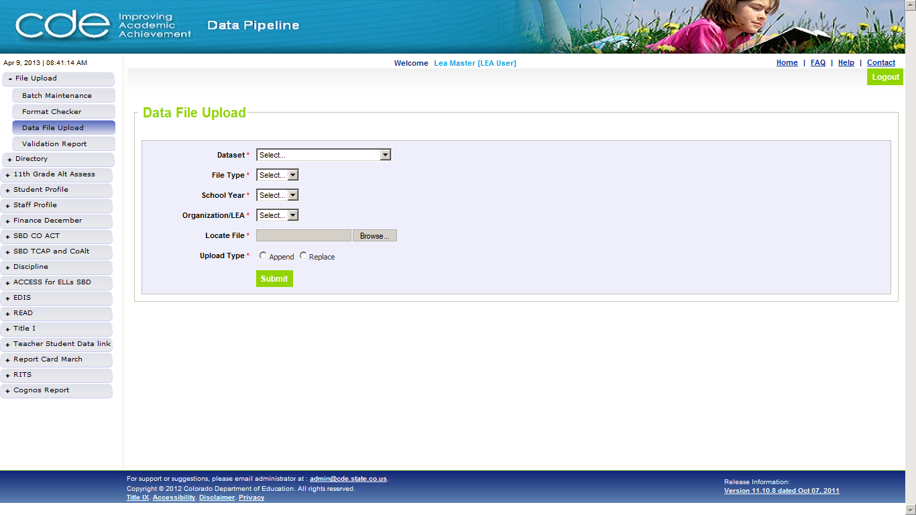
Figure 5: Data File Upload

GUI description
Field # | Field name | Field Description/use | Mandatory | Max length | Constraints
1 | Dataset | Dropdown with all existing datasets that the LEA Approver/User has access to | Yes | N/A | None
2 | File Type | Populates based on the Dataset selection with all File Types that exist under the selected Dataset | Yes | N/A | None
3 | School Year | Dropdown that lists the school years for which the collection is open | Yes | N/A | None
4 | Organization/LEA | User’s organization is populated automatically | Yes | N/A | None
5 | Locate File | Path and Name of the file that is being uploaded to the system | Yes | N/A | Read-only

Button name | Button description | Preconditions | Postconditions | Negative action
Browse | Allows you to locate the file on your computer | -School Year, Dataset, and File Type must be selected | On click will display the location from which you can select the file from the computer | On click requests user to select all mandatory fields
Append | Allows the user to add records to the data currently in the system for the selected school year, File Type, and organization | -School Year, Dataset, and File Type must be selected | -The records will be appended to the existing data | None
Replace | Deletes all previously existing data in the system for the selected school year, File Type, and organization | - School Year, Dataset, and File Type must be selected | -The records in the system will be erased and replaced with the current data | None
Submit | Allows you to upload the file to the system | -School Year, Dataset, File Type and file name must be selected | On click will display the confirmation | On click requests user to select all mandatory fields  An error message will be displayed if the uploaded file was not text or excel

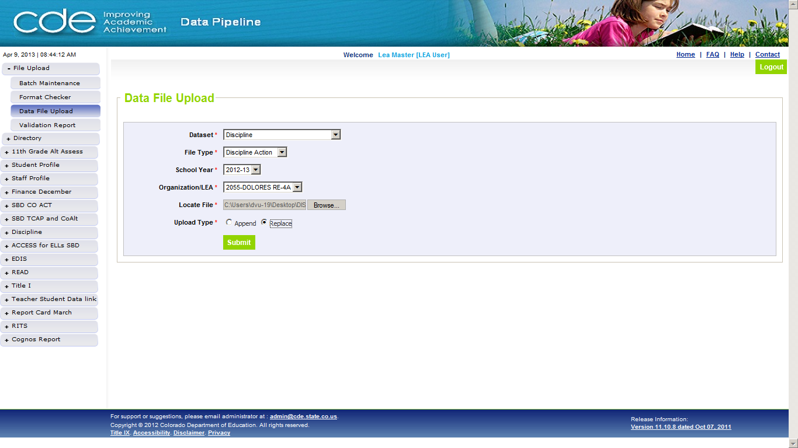Figure 6: Data File Upload

Steps to perform
- Click on File Upload Data File Upload from the Home Page
- Select Dataset
- Select File Type
- Select School Year
- Organization/LEA will be populated automatically
- Locate the file by clicking on the Browse button.
  - File name cannot contain any spaces
- Select Upload Type
  - User may select “Replace” or “Append”
  - Replace will permanently delete and replace any data currently existing in the system
  - Append will add records to the data currently in the system
- Click on Submit
Note: Files uploaded with the ‘Replace’ option will delete all previous records for the given School Year, Collection Type and Organization, including any records added or edited via the online web forms.
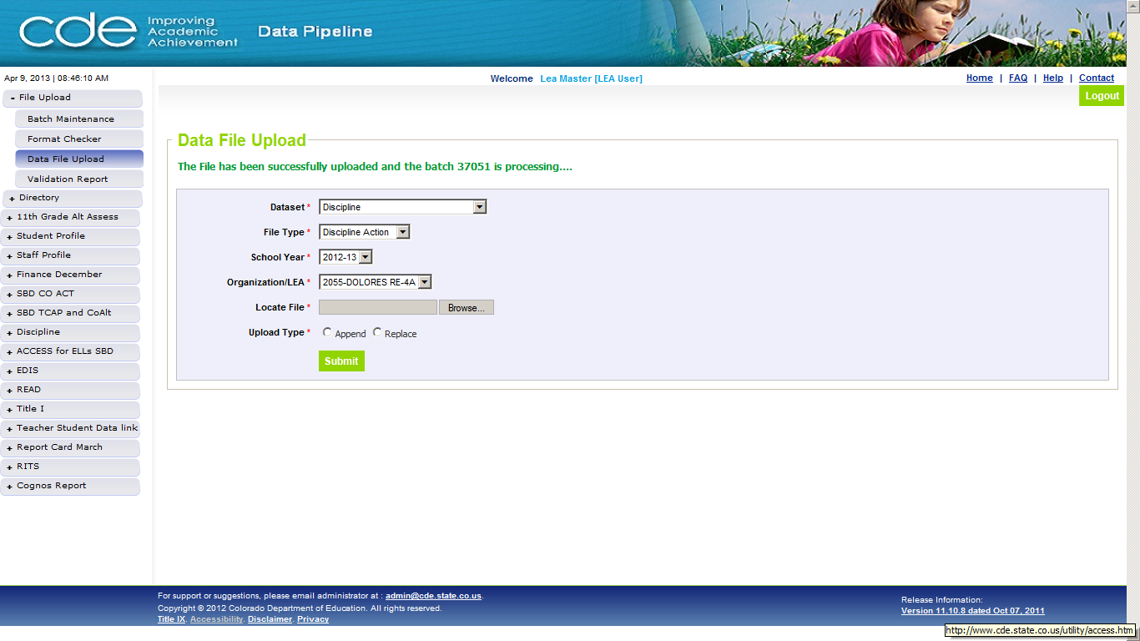
Figure 7: Data File Upload Confirmation
This page provides confirmation of the upload to Data Pipeline. If any of the configured file requirements are not met, the file will not be uploaded. If all records in the file do not pass the format check, an automated email will be sent to the user with details on the failure in the format of the record(s) which failed the check.

An automated email will be generated and sent to the user by Data Pipeline indicating success or failure of the submitted data file.

Note: When uploading an Excel file the system will only look at the first tab of data. If there is a blank data load or data appears to be missing, a good check is to confirm the data is present on the first sheet of the excel file that is being uploaded.

Batch Maintenance
The Batch Maintenance page provides information on all files submitted by the user and other users for that organization. This screen can be used to view the status of the files processing, record counts, error counts, and to delete or download specific batches.

3.1 View Batch Maintenance Screen
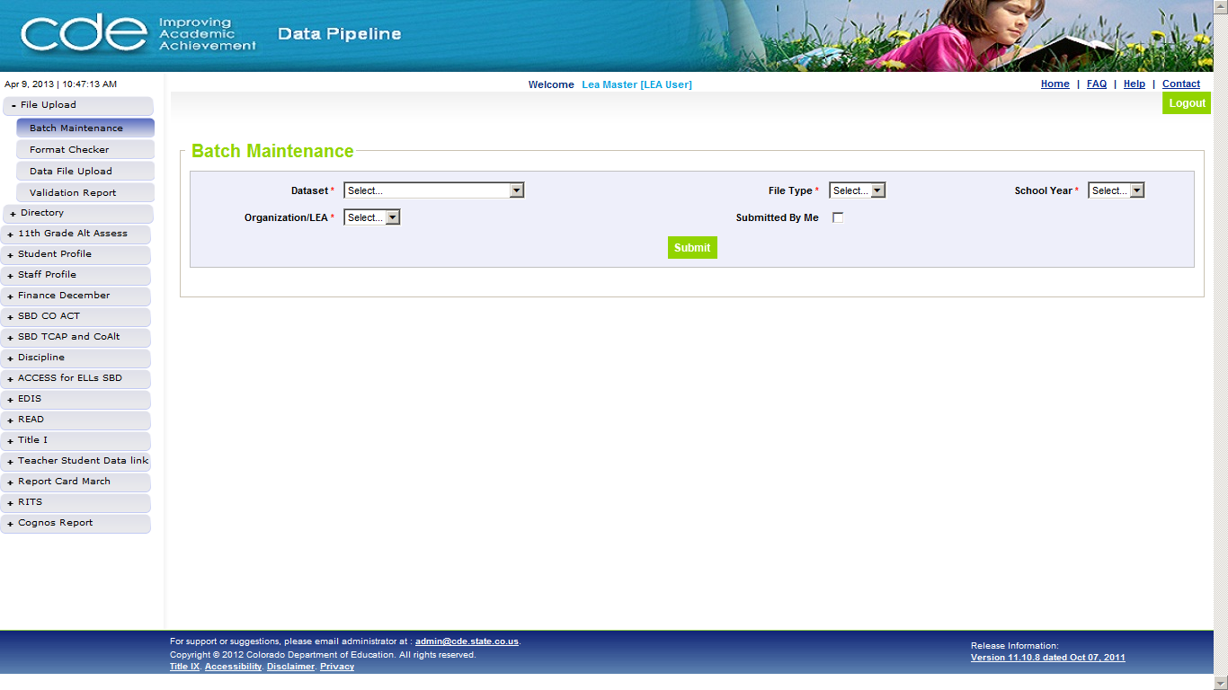
Figure 8: Batch Maintenance

GUI description
Field # | Field name | Field Description/use | Mandatory | Max length | Constraints
1 | Dataset | Dropdown with all existing datasets that the LEA Approver/User has access to | Yes | N/A | None
2 | File Type | Populates based on the Dataset selection with all File Types that exist under the selected Dataset. | Yes | N/A | None
3 | School Year | Dropdown that lists the school years for which the collection is open | Yes | N/A | None
4 | Organization/LEA | Organization is populated automatically | Yes | N/A | None

Button name | Button description | Preconditions | Postconditions | Negative action
Submitted By Me | Display the files that are uploaded only by the current user | -School Year, Dataset, and File Type must be selected | On click will display the files that are uploaded only by the current user | None
Submit | Shows the uploaded batches for the selected Dataset, school year and File Type. | -School Year, Dataset, File Type and file name must be selected | On click will display batches and the respective batch details | On click requests user to select all mandatory fields

Steps to perform
- Click on File Upload Batch Maintenance from the menu
- Select Dataset
- Select File Type
- Select School Year
- Organization/LEA will be populated automatically
- Click Submit
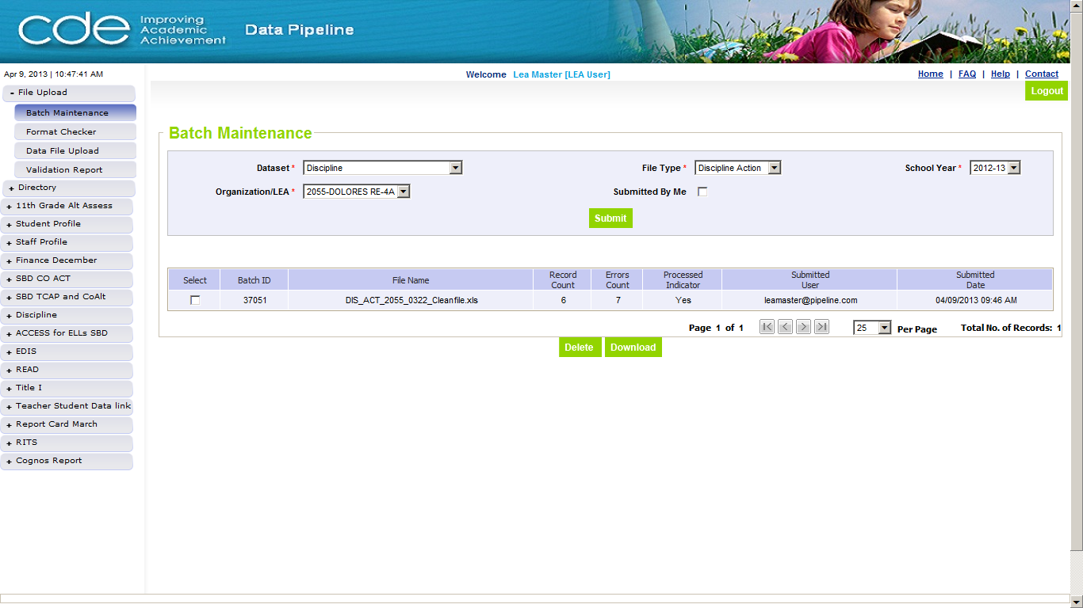
Figure 9: Batch Maintenance Results

GUI description
Field # | Field name | Field Description/use | Mandatory | Max length | Constraints
1 | Batch ID | System generated unique identifier which will be used for reference in future to track the file submissions. This number can be obtained from the Data File Upload Confirmation page and Upload Confirmation email | N/A | N/A | None
2 | File Name | The name of the uploaded file | N/A | N/A | None
3 | Record Count | The number of records in the uploaded file | N/A | N/A | None
4 | Errors Count | The total number of errors including SASID validation errors. This count may exceed the total record count, due to a single record having multiple errors This field always reflects the latest error count | N/A | N/A | None
5 | Processed Indicator | An indicator of the files processing status. The status is changed to ‘Yes’ after the file is processed. It will indicate “Processing” while the file is in process, and will indicate “No” if processing failed | N/A | N/A | None
6 | Submitted User | User Name of the user who uploaded the file to Data Pipeline | N/A | N/A | None
7 | Submitted Date | Date and time of the file upload to Data Pipeline | N/A | N/A | None

Button name | Button description | Preconditions | Postconditions | Negative action
Download | Allows the user to download the uploaded file which will include any changes made via the online Edit data page | -School Year, Dataset, and File Type must be selected | On click will download the file reflecting the changes made via online Edit data page | On click requests user to select all mandatory fields
Per Page | Allows you to select the number of batches to be displayed on each page | -Number of batches should be selected from the per page dropdown | On select will display the selected number of batches per page | None
Delete | Allows the user to delete the selected batch | - School Year, Dataset, and File Type must be selected | -The records pertaining to the selected batch will permanently deleted from the system | On click requests user to select all mandatory fields

Note: Checking Submitted By Me box will display the files that are uploaded only by you. Unchecking the Submitted By Me box will display the files uploaded by all users for the user’s organization.

3.2 Download Batch
Users may download batches once the processed indicator is marked as Yes.

GUI description
For GUI descriptions refer to GUI description under Section 3.1 View Batch Maintenance Screen

Steps to perform
- Select the checkbox next to the desired batch
- Click Download

A download screen will appear and provide the option for the user to download the file. The download screen will look different depending on the browser being used and the security settings. If the file will not download please first check browser security settings to ensure the data can be downloaded.
Note: The files corresponding to the Batch ID can only be downloaded if and once the batch has been processed by the system.

3.3 Delete Batch
Users may delete batches once the processed indicator is marked as No or Yes.

GUI description
For GUI descriptions refer to GUI description under Section 3.1 View Batch Maintenance Screen

Steps to perform
- Select the checkbox next to the desired batch
- Click Delete
- Confirm the Deletion on the popup box

Note: The file corresponding to the Batch ID can be deleted only if the file is not being currently processed by the system.

Validation Report
Validation report provides a summary of the errors encountered in the uploaded file.

4.1 View Validation Report
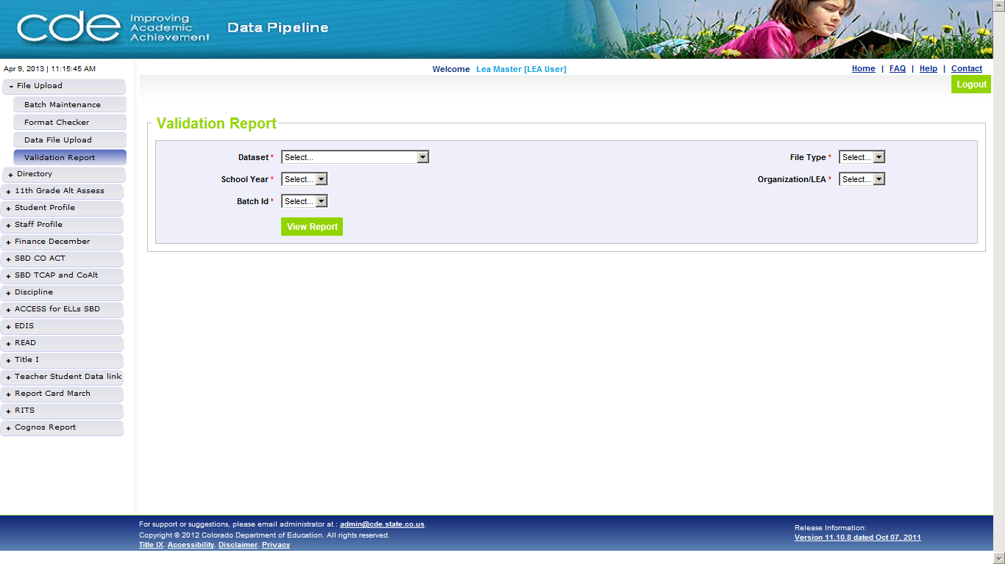
Figure 10: Validation Report

GUI description
Field # | Field name | Field Description/use | Mandatory | Max length | Constraints
1 | Dataset | Dropdown with all existing datasets that the LEA Approver/User has access to | Yes | N/A | None
2 | File Type | Populates based on the Dataset selection with all File Types that exist under the selected Dataset | Yes | N/A | None
3 | School Year | Dropdown that lists the school years for which the collection is open | Yes | N/A | None
4 | Organization/LEA | Organization is populated automatically | Yes | N/A | None
5 | Batch ID | System generated unique identifier which will be used for reference in future to track the file submissions. This number can be obtained from the Data File Upload Confirmation page, Batch Maintenance, and Upload Confirmation email | Yes | N/A | None

Button name | Button description | Preconditions | Postconditions | Negative action
View Report | Displays the error codes/message details | -School Year, Dataset, File Type and Batch ID must be selected | On click will display error summary report for the selected batch | On click requests user to select all mandatory fields

Steps to perform
- Click on File Upload Validation Report from the menu pane
- Select Dataset
- Select File Type
- Select School Year
- Organization/LEA will be populated automatically
- Select Batch ID
- Click View Report
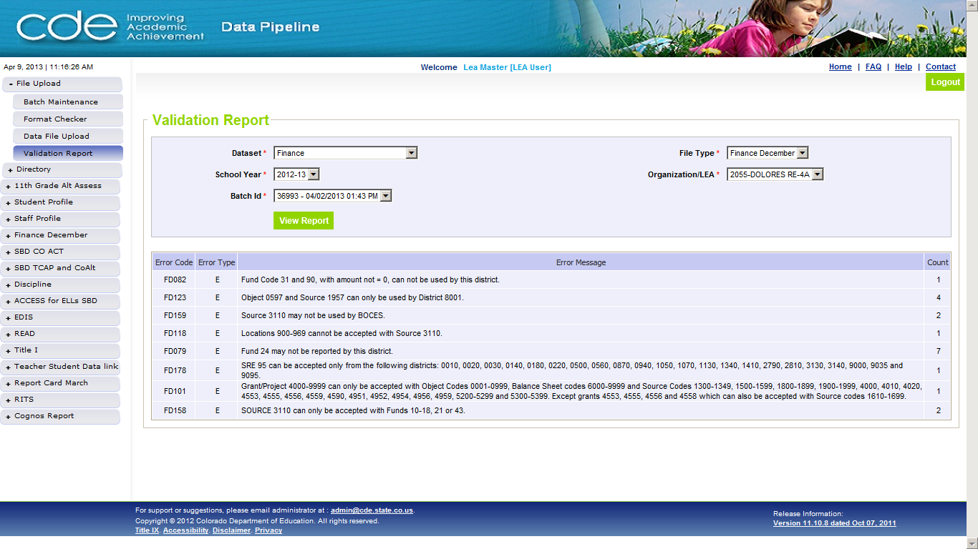
Figure 11: Validation Report Results

GUI description
Field # | Field name | Field Description/use | Mandatory | Max length | Constraints
1 | Error Code | Displays the business rule code | N/A | N/A | None
2 | Error Type | Displays the type of error (Error/Warning) | N/A | N/A | None
3 | Error Message | The message of the business rule that has been violated | N/A | N/A | None
4 | Count | Total number of errors encountered for each business rule | N/A | N/A | None

Add Record
In addition to the file upload functionality, some collections allow users to add individual records online through the Add Record screen. In order to add a record the collection should be open for data submission. The added records can be viewed from Edit Record screen and errors, if any, can be corrected through the Edit Record screen. Errors may also be viewed from Cognos reports in the same way as with file uploads.

1.1 Add Record through Add Record screen
From the initial screen, the user must select the File Type and the school year for which they wish to add record. The organization drop down will be auto-populated based on the logged-in district user.
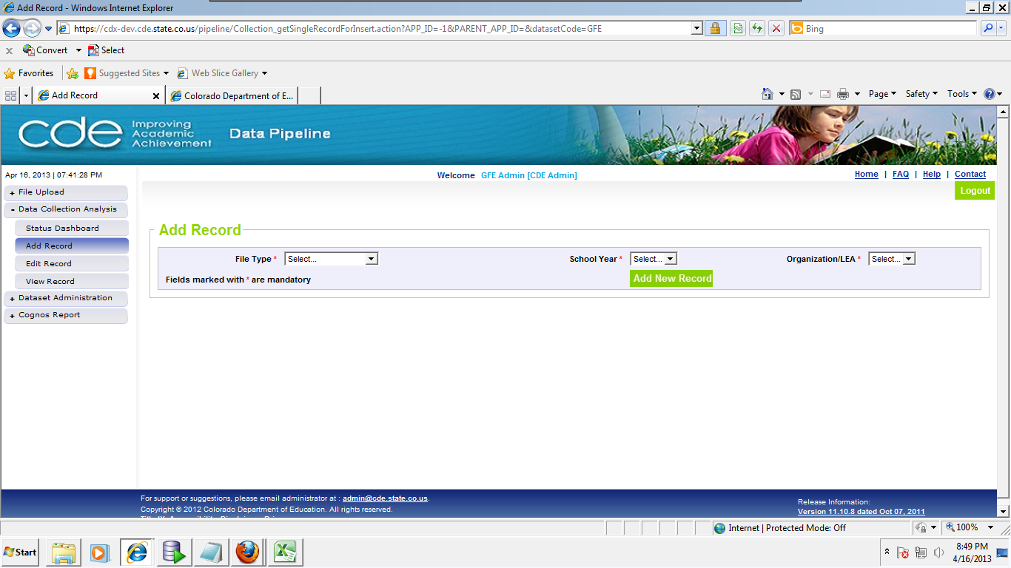
Figure 12: Add Record Input Screen

GUI description
Field # | Field name | Field Description/use | Mandatory | Max length | Constraints
1 | File Type | Populates based on File Types that exist under the Dataset as determined by the link the navigation the user clicked | Yes | N/A | None
2 | School Year | Dropdown that lists the school years for which the collection is open | Yes | N/A | None
3 | Organization/LEA | Organization is populated automatically based on user access | Yes | N/A | None

Button name | Button description | Preconditions | Postconditions | Negative Action
Add New Record | The button will bring up a screen with options to populate all data element values for the specified School Year, File Type and LEA. The user will have text fields to enter data element information unless a cross table business rule validation has been configured for the data element. In this case, a dropdown will be available with the applicable codes for choices. | - File Type, School Year, and Organization/LEA drop downs must have a selection. | Fields for adding a new record for the selected File Type are displayed. | On Click requests user to select all mandatory fields

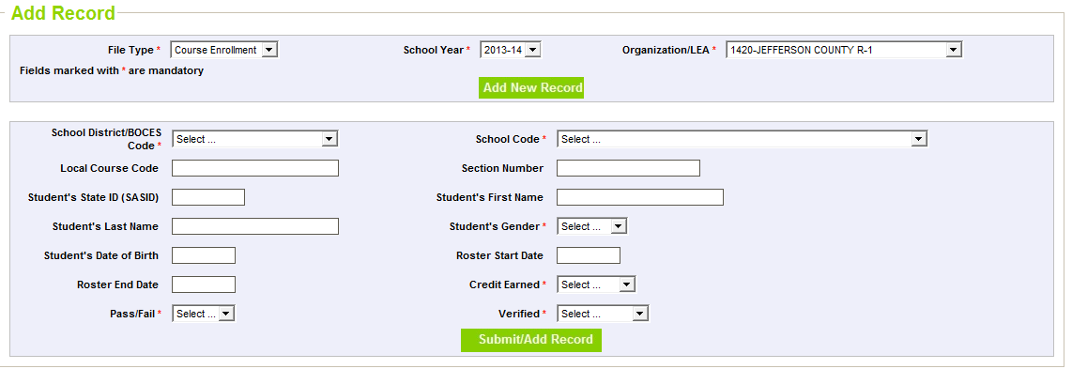
Figure 13: Add Record detail Screen
Data elements to be added for a record can be configured through File Format Developer screen. Mandatory rules, cross table, cross column, data type validation rules can be set through Business rule builder screen.
The following table describes how fields behave on the Add Record screen based on the type of business rule associated with that field.

Business Rule | Field Behavior | Example
Mandatory Check | Checks whether corresponding data element is empty when Submit button is clicked. Throws an error message if the field is empty  Error message to be displayed is configured from Business Rule builder screen | For example :  “First Name is mandatory”
Length Check | Checks the length of data element as configured from Business Rule Builder. Throws error message if the length check fails.  Error message to be displayed is configured from Business Rule builder screen | For example :  “SASID must be 10 digits”
Data Type Validation | Validates the data element confirms to specific data format. Throws an error message if it fails.  Error message to be displayed is configured from Business Rule builder screen | For example :  “SASID must be numeric”

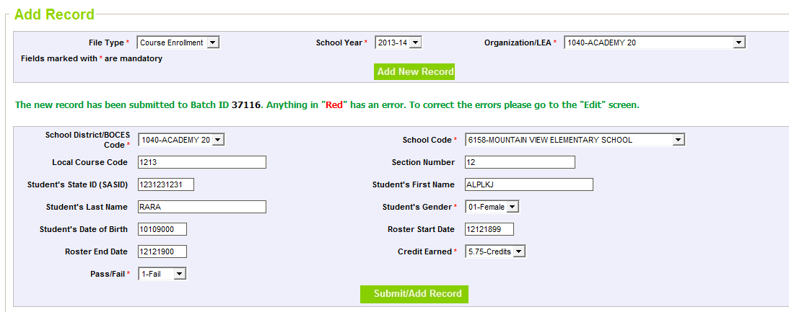
Figure 14: Submitted Record
After the user has submitted the values in the lower text panel and clicked the Submit/Add Record button a message will say that the record has been submitted and provide the Batch ID number. User can track the record in the Edit Screen using this Batch ID.

Steps to perform
- From the left navigation, select Data Collection Analysis Add Record
- Select a File Type
- Select a school year
- Organization/LEA will be populated automatically
- Click Add New Record button
- Fill in all the required fields that are configured
- Click on Submit/Add Record button
- Batch id is generated for the submitted record

Note:
- A new Batch ID is created for every record added. The new Batch ID is accessible from the Batch Maintenance menu option, Edit Record and the relevant Cognos reports.
- If the desired school year is not available, it is likely because the File Type has not been opened for data upload for the school year.
- Users may not be able to add records to a File Type which has already been approved by CDE (and hence, locked for data entry).

GUI description
Button name | Button description | Preconditions | Postconditions | Negative Action
Submit/Add Record | When the user finishes entering information for the record they may click this button to add the record to the collection | -All mandatory fields must contain valid text | Batch ID number is provided | Requests user to enter valid information in any mandatory field that is missing data or contains incorrect data

Edit Record
Once the user has uploaded data they will review errors in the file upload through Cognos Reports (described in a later section) or can view and edit records directly through the Edit Record screen. This screen enables a user to edit and delete records online. Records uploaded through File Upload screen as well as Add Record can be edited through this screen. Some collections have been configured with Edit Record screen capability, which other collections have not. For ease of use a user can search only errored records, search for specific data, and sort data based on different fields.

6.1 Edit and Save Record through Edit Record screen
From the initial screen, the user must select the File Type and the school year for which they wish to edit records.
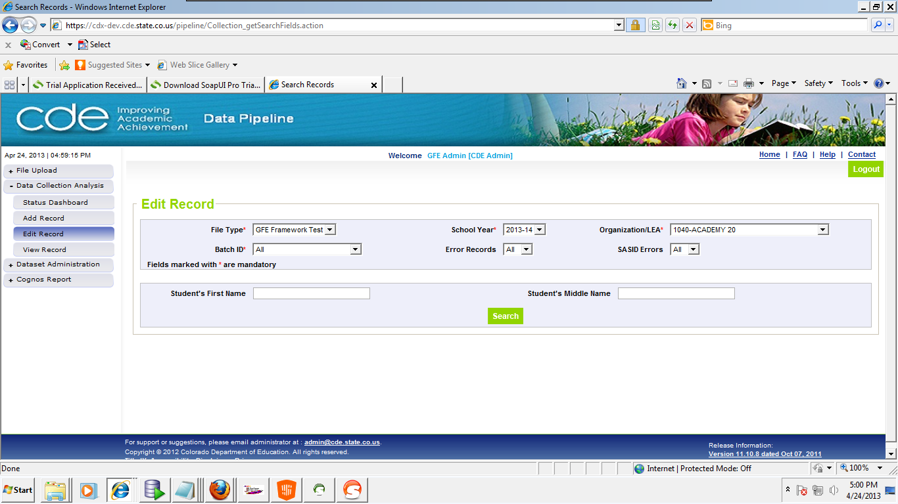
Figure 15: Edit Record Input Screen

GUI description
Field # | Field name | Field Description/use | Mandatory | Max length | Constraints
1 | File Type | Populates based on File Types that exist under the Dataset as determined by the link clicked on the navigation menu | Yes | N/A | - -File Type must be configured for Online Error Correction in the Create/Edit File Type screen.
2 | School Year | Dropdown that lists the school years for which the collection is open | Yes | N/A | - File Type must be selected
3 | Organization/Division | Populates based on File Types that exist under the Dataset as determined by the link the navigation the user clicked | Yes | N/A | - File Type, School Year must be selected.
4 | Batch ID | System generated unique identifier which will be used for reference in future to track the file submissions. This number can be obtained from the Data File Upload Confirmation page, Batch Maintenance, and Upload Confirmation email  -Drop down list will include "All" so user may search all batches that have been uploaded for a File Type and school year | Yes | N/A | - Organization/LEA must be selected.
5 | Error Records | Indicates if the system should search for all records in the batch(s), only error records in the batch(s) (Yes), or only valid records in the batch(s) (No) | Yes | N/A | - None
6 | SASID Errors | All − All records for the selected batch(s) will be displayed  Yes − Only records with SASID Validation errors will be displayed  No − Only records without SASID Validation errors will be displayed  If the collection has EDIDs instead then this will display as “EDID Errors”  If the collection does not have EDID or SASID then this field will not be displayed | Yes | N/A | - None

Button name | Button description | Preconditions | Postconditions | Negative Action
Search | Based on the Search Criteria this button should search the Batch ID and find all records that match the search criteria entered in the text fields. | Mandatory fields must be selected: File Type, School Year, Organization, Batch ID | Search results are displayed below. | Requests user to select mandatory fields

Additional search criteria are displayed when the user selects a File Type and school year. The search criteria is configured by the CDE collection owner and provides the user additional fields by which to search existing data. The additional search criteria will always be fields that are part of the File Type under which the user wishes to view or edit data. A user may enter partial text in the search criteria and return a match, for example, if a user enters “SMIT” into the Student’s First Name field, it would return records with first name of SMITH. The search criteria is not case sensitive so it would also return records with first name of smith.

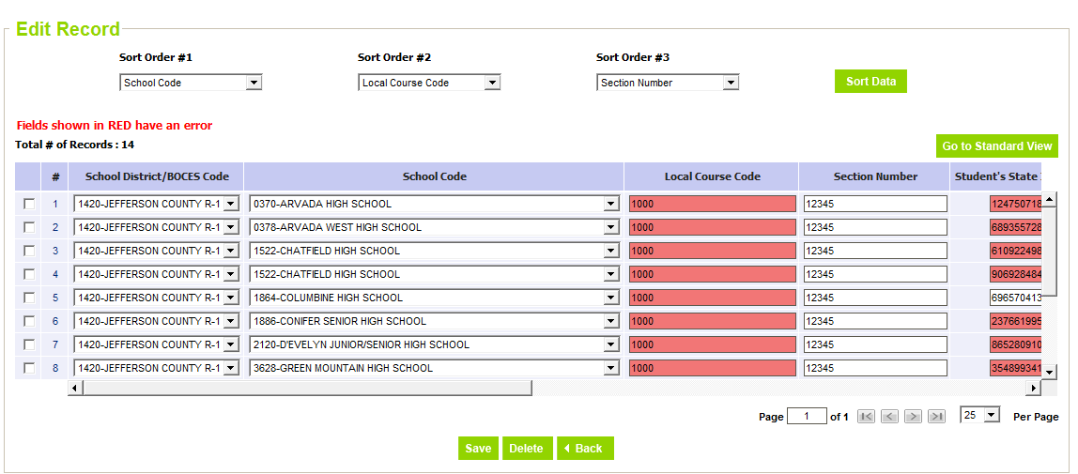
Figure 16: Edit Record detail Screen
Errored fields are highlighted in Red and fields with warnings are highlighted in Yellow. Two views are available to the user from this screen. The screen will default to the Compact view, listing the most important fields of the collection, but the user may also choose click on the “Go to Standard View” button, which is explained below. Some File Types contain many data elements, which do not all need to be viewed by the user every time the screen is accessed. By having a compact view and a standard view, the system will also load the data faster in the compact view because it will be a subset of all the data elements, while allowing the user to go to the standard view if the originally hidden fields must be accessed.

GUI description
Field # | Field name | Field Description/use | Mandatory | Max length | Constraints
1 | Total # of Records | The total number of records matching the selected search criteria | N/A | N/A | None
2 | SASID/EDID Status | This is the last column listed if the File Type has a SASID or EDID validation.  For use if SASID/EDID or any of the five demographic fields used for SASID validation are altered. Data Pipeline will automatically change SASID/EDID Status to “Pending” if any of these fields are altered. Once after the SASID/EDID is validated by the system, the status will change to completed. This indicates the validation has completed and does not indicate if the validation passed.  The four demographic fields used for SASID validation are: First Name, Last Name, Date of Birth, and Gender | N/A | N/A | None
3 | Sort Order Fields | There are three sort order fields. These may be selected by the user to change the order in which records are sorted. | No | N/A | None

Button name | Button description | Preconditions | Postconditions | Negative action
Go to Standard View | This button toggles the display between Compact View and Standard View. The button label displays the future state of the screen. Click the button to switch to the other state. | -School Year, Dataset, File Type and Batch ID must be selected and there should be records in the Search results screen. | On click will display the Standard View (displaying all the fields of the collection) | N/A
Go to Compact View | This button toggles the display between Compact View and Standard View. The button label displays the future state of the screen. Click the button to switch to the other state. | -School Year, Dataset, File Type and Batch ID must be selected and there should be records in the Search results screen. | On click will display the Compact View (displaying selected fields of the collection) | N/A
Check box | To Save or Delete specific records, check this box and then click the appropriate action. When a record is saved all business rules that apply to that record will be run. | -School Year, Dataset, File Type and Batch ID must be selected | On click the record will be selected | N/A
# (Hyperlink) | Displays the single record screen | -School Year, Dataset, File Type and Batch ID must be selected | On click displays the Standard View of the record selected | N/A
Sort Data | Displays the data in the selected order | -Sort order must be selected | On click displays the data in the selected sort order | N/A
Save | Save the record and submits the record for validation checks | -School Year, Dataset, File Type and Batch ID must be selected | On selecting a record and clicking on this button will save the data. | If a save button is hit without selecting the record all records will be saved.
Delete | Deletes the record from the system | -School Year, Dataset, File Type and Batch ID must be selected | On selecting a record and clicking on this button will delete the selected record from the system | On click displays an error message to select a record
Back | Cancels the changes and go back to the previous screen | -School Year, Dataset, File Type and Batch ID must be selected | On click will cancel the changes and go back to the previous screen | N/A
Per Page | Allows you to select the number of records to be displayed on each page | -Number of records should be selected from the per page dropdown | On select will display the selected number of records per page | N/A

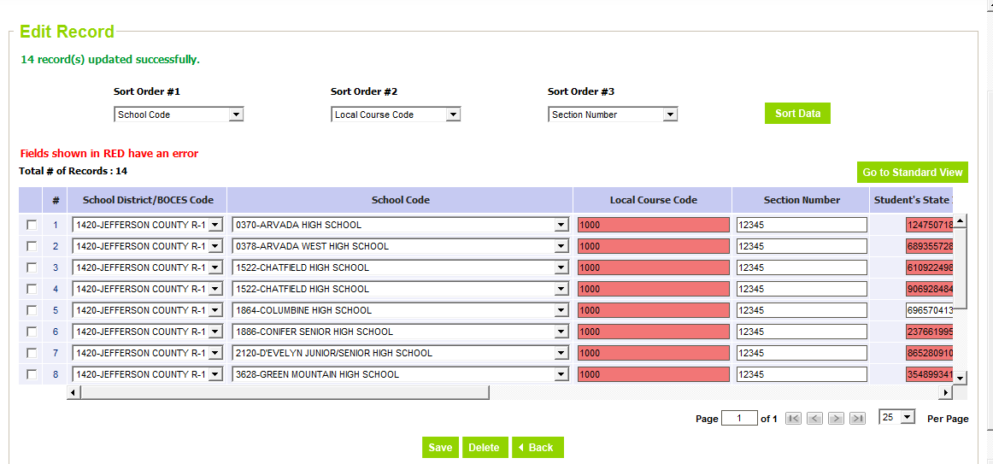
Figure 17: Saved Records
After the user has saved the updated values, a message will notify the user that the record(s) have been updated successfully. The user can edit a specific record and click on Save to update the record. The save will also trigger business rules and SASID/EDID validation to fire for the selected record(s) if applicable.
Note: Users may not be able to edit records on a File Type which has already been approved by CDE (and hence, locked for edits).

Steps to perform
- From the left navigation, select Data Collection Analysis Edit Record
- Select a File Type
- Select a School Year
- Organization/LEA will be populated automatically
- Select Batch ID
- Click Search button
- Update the required fields of the records
- Select the edited records and click Save button
- If no record is selected then the system will save all records on the screen after a confirmation message.
A successful message will be displayed, indicating the number of records updated.
Note: If the desired school year is not available, it is likely because the File Type has not been opened for data upload for the school year.

6.2 Delete Record through Edit Record screen
The user may also use the Edit Record screen to delete any erroneous records from a prior file upload or add record submission.
Figure 18: Edit Record Search Screen

Steps to perform
- From the left navigation, select Data Collection Analysis -> Edit Record
- Select a File Type
- Select a school year
- Organization/LEA will be populated automatically
- Select (optional) Batch ID. This could also be defaulted to “All”.
- Select (optional) Error Records. This could be defaulted to “All”, which returns all the records, or “Yes” to return the records in error, or “No” to return records that do not have any error.
- Select (optional) SASID Errors. This could be defaulted to “All”, which returns all the records, or “Yes” to return the records which have SASID errors, or “No” to return records that do not have any SASID error.
- Select or enter any additional search criteria (optional) on the Advanced Search dialog.
- Click Search button

Figure 19: Edit Record Detail Screen

Steps to perform
- Select the records to be deleted and click Delete button
Successful message is displayed indicating the number of records deleted.
Note: If the collection has already been submitted for approval and/or approved then the user may not be able to delete records. This would only apply to periodic collections; an approved snapshot would not impact interchange Edit Record screen functionality.
Note: If the desired school year is not available, it is likely because the File Type has not been opened for data upload for the school year.
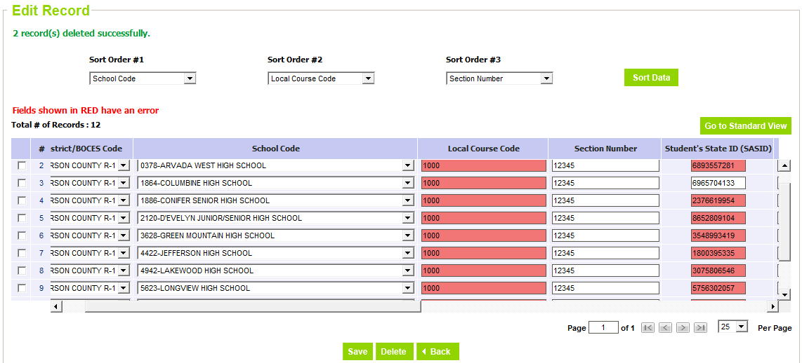
Figure 20: Deleted Records

6.3 Edit Data – Single Record Screen
The Edit Record screen also allows the user to view data in a detailed view by clicking on the hyperlink of an individual record. The hyperlink is the number of the row.
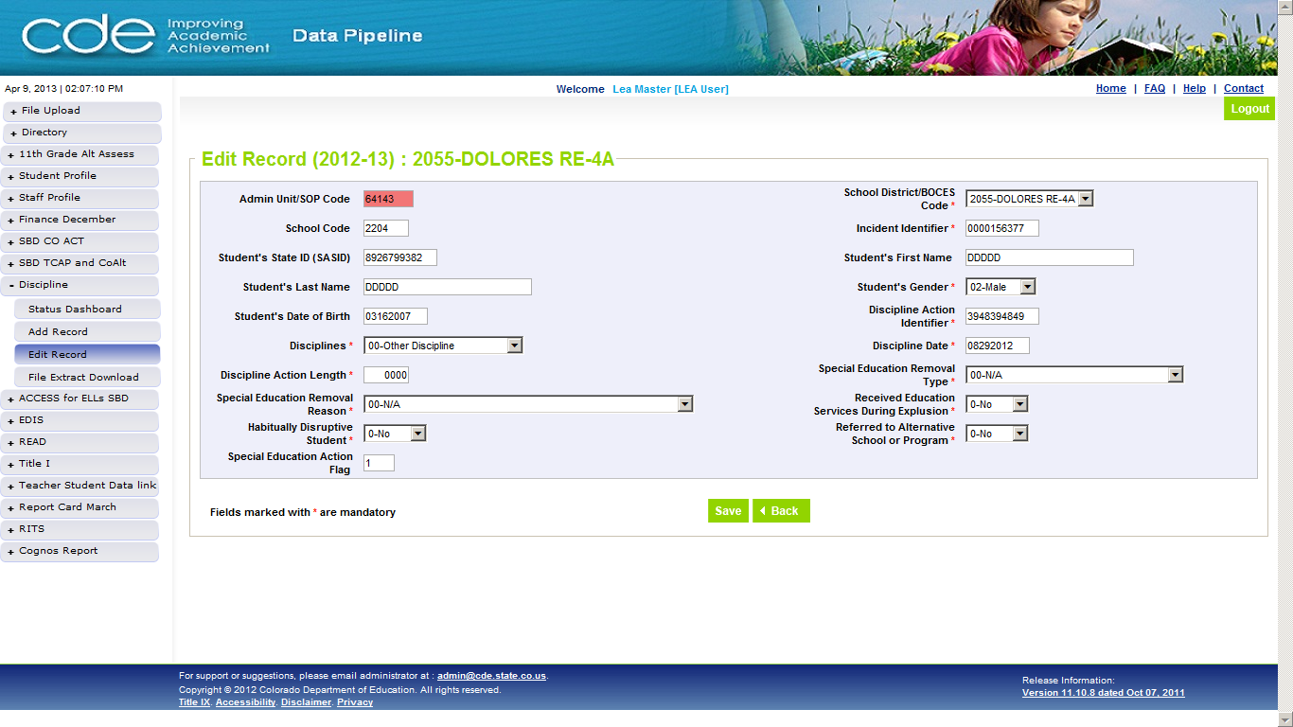
Figure 21: Edit Data - Single Record Screen

Steps to perform
- Please refer to Section 6.1 Edit and Save Record through Edit Record screen
- Click the # hyperlink of the record you wish to view
- Make changes and click Save

Status Dashboard

7.1 Status Dashboard
While the Organization/LEA activities apply to all types of collections, interchange, snapshot, and periodic, the major difference between the collection types is that interchange data is not approved while the other collections require some sort of approval. As a result the status dashboard screens look different for an interchange vs. a snapshot or periodic collection. The screen allows for activities such as submitting data to CDE for approval, and downloading sign-off forms (where applicable).
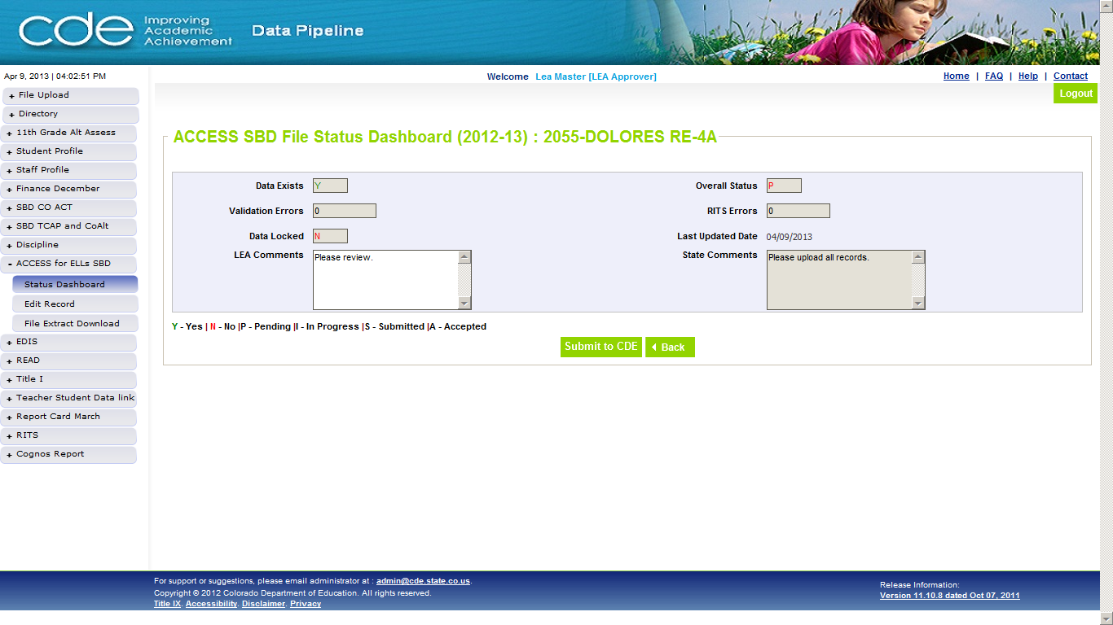
Figure 22: Status Dashboard Screen

Steps to perform
- Click on Collection Type Status Dashboard from the menu
- Select File Type, School Year, and Organization
- Click Submit
The following fields are displayed on the screen:

GUI description
Field # | Field name | Field Description/use | Mandatory | Max length | Constraints
1 | Data Exists | Yes – Indicates data has been processed  No – Indicates there is no collection data available | N/A | N/A | Read-Only
2 | Overall Status | P – Indicates data submission to CDE is Pending  S – Indicates data submission to CDE is Complete  A – Indicates data has been Accepted by CDE | N/A | N/A | Read-Only
3 | Validation Errors | Count provides the number of records with collection validation errors  0 – Indicates there are no collection validation errors  Blank – Indicates data has not been uploaded for this district | N/A | N/A | Read-Only
4 | RITS Errors | Count provides the number of records with RITS validation errors  0 – Indicates there are no RITS validation errors  Blank – Indicates the file has not been processed | N/A | N/A | Read-Only
5 | Data Locked | Yes – Indicates data is locked for editing  No – Indicates data is not locked for editing | N/A | N/A | Read-Only
6 | LEA Comments | LEA Comments: Comments entered by LEA Approver/User | N/A | 1000 | None
7 | State Comments | Comments entered by CDE Admin | N/A | 1000 | Read-Only
8 | Last Updated Date | Date of the latest activity performed on LEA collection data | N/A | N/A | Read-Only

7.2 Submit to CDE
After all the validation errors are corrected the LEA Approver user may choose to submit to CDE. In order to submit to CDE the following conditions must be met:

- Validation Error count must be 0.
- Collection must require a manual submission step, not all collections (for e.g. RITS, EDIS) do.

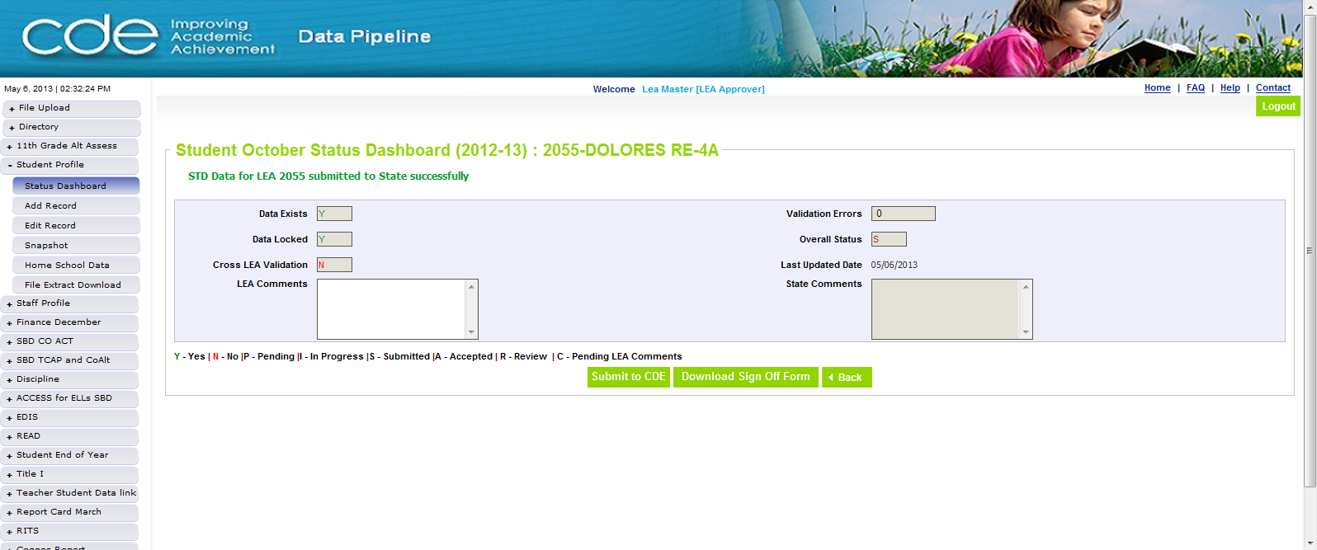
Figure 23: Submit to CDE success message

Steps to perform
To submit data to CDE:

- Click on Collection Type Status Dashboard from the menu
- Refer to Section 7.1 for field descriptions
- Click on the “Submit to CDE” button

When the user clicks on the “Submit to CDE” button:

- Data Pipeline will request confirmation of the requested action.
- If the request is confirmed, the data for the School Year and Collection Type will be submitted on behalf of the Organization/LEA. The system will display a message indicating the data was successfully submitted to CDE.
- Data Pipeline will send CDE an automated email of the successful submission
- The Overall Status on the Status Dashboard will change to “S”
- The data for the School Year and Collection Type will be locked preventing further corrections by the LEA.
Note: Only an LEA Approver role has access to the Submit to CDE button.

7.3 Download Sign Off Form
After a collection is submitted to CDE, some collections (for e.g. Student October) require the LEA Approver to download a sign-off form and fax the form to CDE. The sign-off form is accessible from the Status dashboard screen.

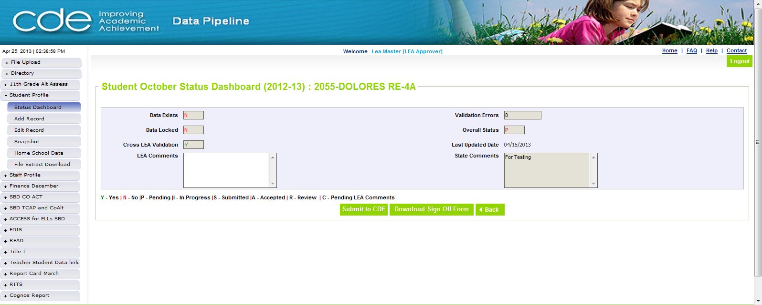
Figure 24: Download Sign Off Form

Steps to perform
To download the Sign off form:

- Click on Collection Type Status Dashboard from the menu
- Refer to Section 7.1 Status Dashboard for field descriptions
- Click on Download Sign Off Form button
- Data Pipeline will prompt the user to download the sign off form.

Cognos Framework Reports
Data Pipeline uses IBM Cognos Report for collection reporting. For ease of accessibility from Data Pipeline, a link has been provided at the bottom of the navigation links in Data Pipeline. Available on Cognos are collection specific reports and standard framework reports; the latter will be discussed in the following section. Each collection that has a file upload will have a standard error summary and error detail report and the user may access the Baseline folder, which contains file formats, business rules, a data dictionary, and a code dictionary. These six reports are outlined below.

8.1 View Error Reports
Error reports are available under each interchange, snapshot, and periodic collection folder on Cognos. The error summary report provides the user a quick view of which errors are firing and how many of each type of error. This can be beneficial in the initial stages of preparing a data collection. The error detail report provides the record information for which a specific error is being triggered.
Figure 25: Cognos Report Link in Data Pipeline

Steps to perform
- From Data Pipeline click the Cognos Report link at the bottom of the left navigation menu
- Navigate to the desired collection from the Cognos screen
- Navigate to the error detail or error summary report as desired

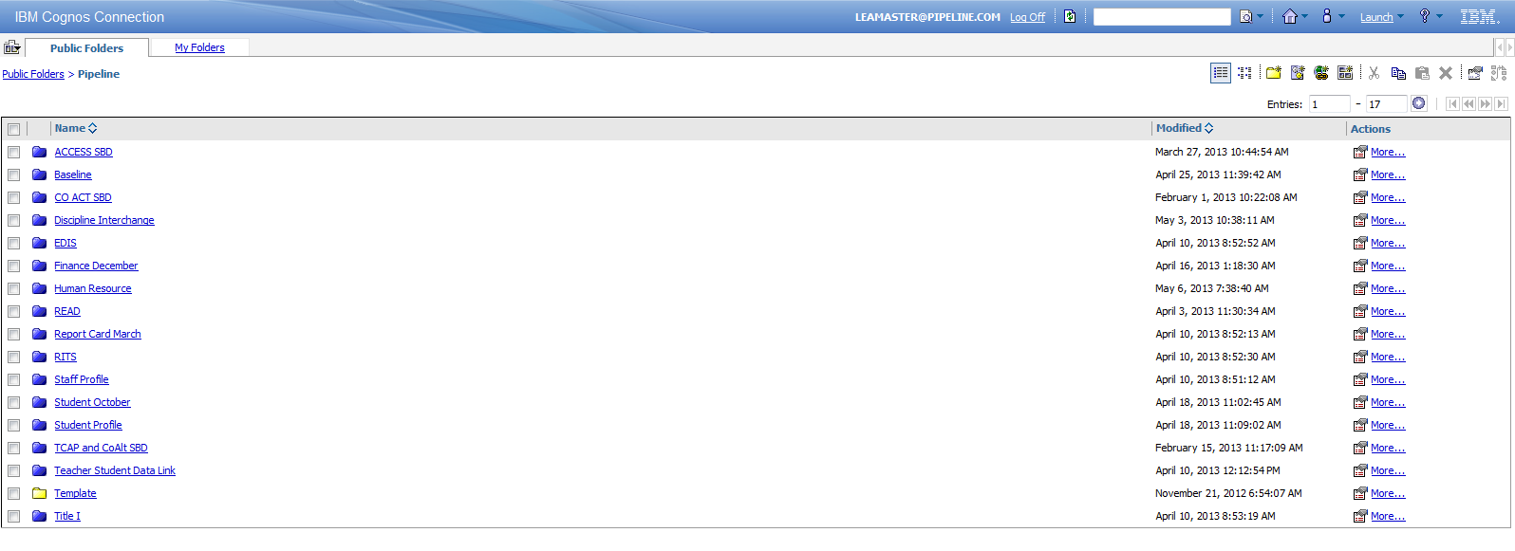
Figure 26: Initial Cognos Report Screen

Steps to perform
- From the error detail or error summary report –
  - Select school year
  - District will be auto-populated
  - Select Errors, Warnings, or both, Errors and Warnings (optional).
- Select Error Code to view any specific errors (optional)
- Click Finish

Figure 27: Error Report Prompt Screen
The prompt screen for both error reports is the same. Prompts are populated based on available data and user access. After clicking finish the user may view the error summary or error detail report screen, both of which are shown below.

GUI description
Field # | Field name | Field Description/use | Mandatory | Max length | Constraints
1 | School Year | Dropdown that lists the school years for which the collection is open | Yes | N/A | None
2 | District | Dropdown with the district or AU code for which the user has access | Yes | N/A | Defaulted to the organization of the logged-in district user
3 | Error Type | Drop down that lists the error types (error, warning) that the user would like to view for the collection | Yes | N/A | Available options:  - Errors & Warnings  - Errors  - Warnings
4 | Error Code | List of error codes that triggered for the selected district. If no error codes are selected then the system will select all error codes | No | N/A | None

Figure 28: Error Summary Report

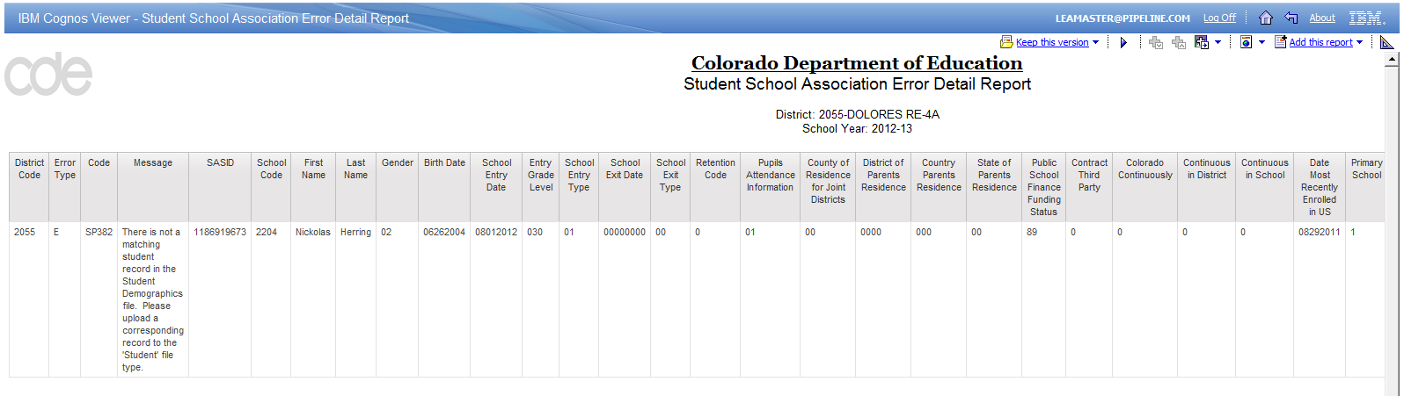
Figure 29: Error Detail Report
Once the user runs a report there are several options available to the user in terms of how they view the report.

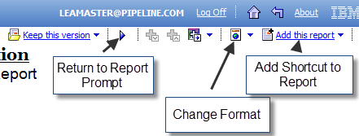
Figure 30: Cognos Report Functions

GUI description
Field # | Field name | Field Description/use
1 | Return to Report Prompt | Returns the user to the initial prompt for the report
2 | Change Format | Allows the user to view the report in PDF, Excel, or HTML. Most reports are defaulted to run in HTML but there are some exceptions
3 | Add Shortcut to Report | Adds this report to the “My Folders” section for the user. Allows for quick access to the report
4 | Log Off | Logs the user off from Cognos
5 | Home | Returns the user to the Cognos home page
6 | Back | Returns the user to the previous screen

8.2 View File Format Report
A user may download the file format report from Cognos. This report will provide file format information for File Types that exist in Data Pipeline and may be downloaded in PDF, Excel, or HTML format.

Steps to perform
- From Data Pipeline click the Cognos Report link at the bottom of the screen
- Navigate to the Baseline Folder
- Navigate to the File Format report
Figure 31: File Format Report Prompt

GUI description
Field # | Field name | Field Description/use | Mandatory | Max length | Constraints
1 | Select Year | Dropdown that lists school years for which data exists | Yes | N/A | None
2 | Select Dataset | Dropdown that lists all existing datasets for the selected school year | Yes | N/A | None
3 | Select File Type | Populates based on the Dataset selection with all File Types that exist under the selected Dataset. | Yes | N/A | None

Steps to perform
- Select School Year, Dataset, and File Type
- Click Finish
- The File Format report is displayed for the selected File Type and school year
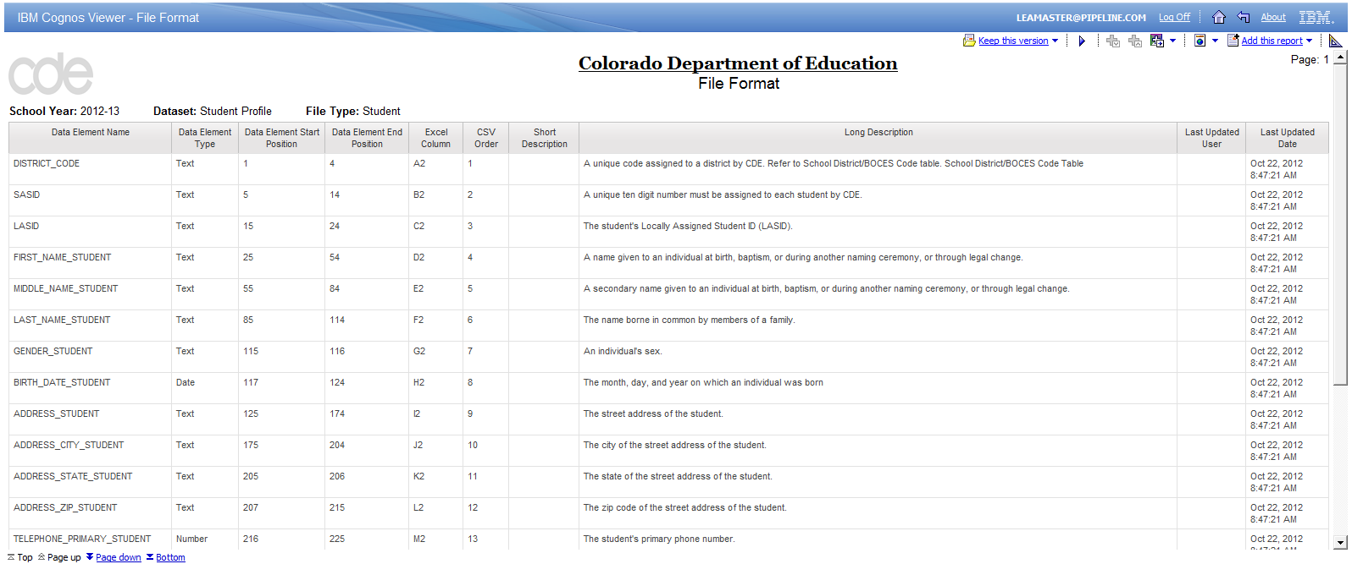
Figure 32: File Format Report

8.3 View Business Rules Report
A user may download the business rules report from Cognos. This report will provide business rule information for File Types that exist in Data Pipeline and may be downloaded in PDF, Excel, or HTML format.

Steps to perform
- From Data Pipeline click the Cognos Report link at the bottom of the screen
- Navigate to the Baseline Folder
- Navigate to the Business Rules report
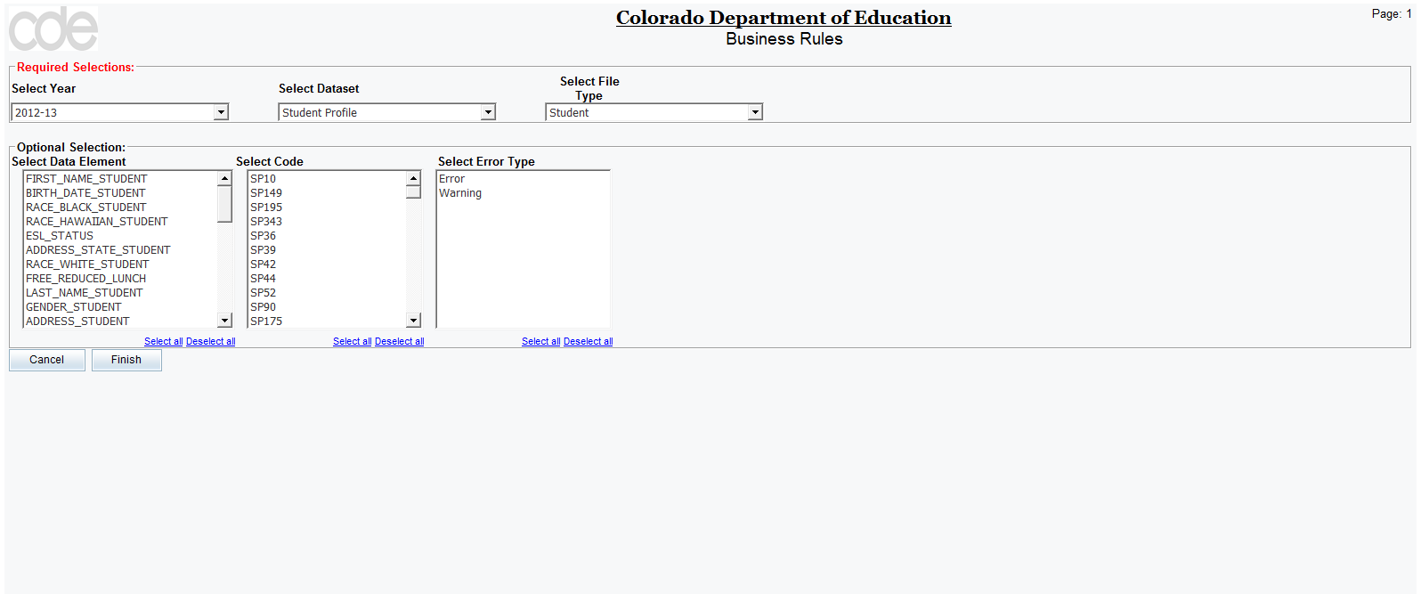
Figure 33: Business Rules Report Prompt

GUI description
Field # | Field name | Field Description/use | Mandatory | Max length | Constraints
1 | Select Data Element | List that includes all data elements in the selected File Type. User may select a specific data element(s) to view only business rules that apply to that element | No | N/A | None
2 | Select Code | List that includes all business rule codes associated with the selected File Type. User may select a specific code(s) to view only business rules that apply to that error code | No | N/A | None
3 | Select Error Type | By default the report will search for errors and warnings. User may use this field to select one or the other and search for only errors or only warnings | No | N/A | None

Note: The fields do not update with each selection. Therefore, if the user selects a data element and a code under which that data element does not exist then the report will return no results. It is advisable to use the data element and code fields separately.
For additional GUI descriptions refer to Section 8.2 View File Format Report.

Steps to perform
- Select School Year, Dataset, and File Type
- Select Data Element or Code or Error Type (optional)
- Click Finish
- The Business Rule report is displayed for the selected File Type and school year
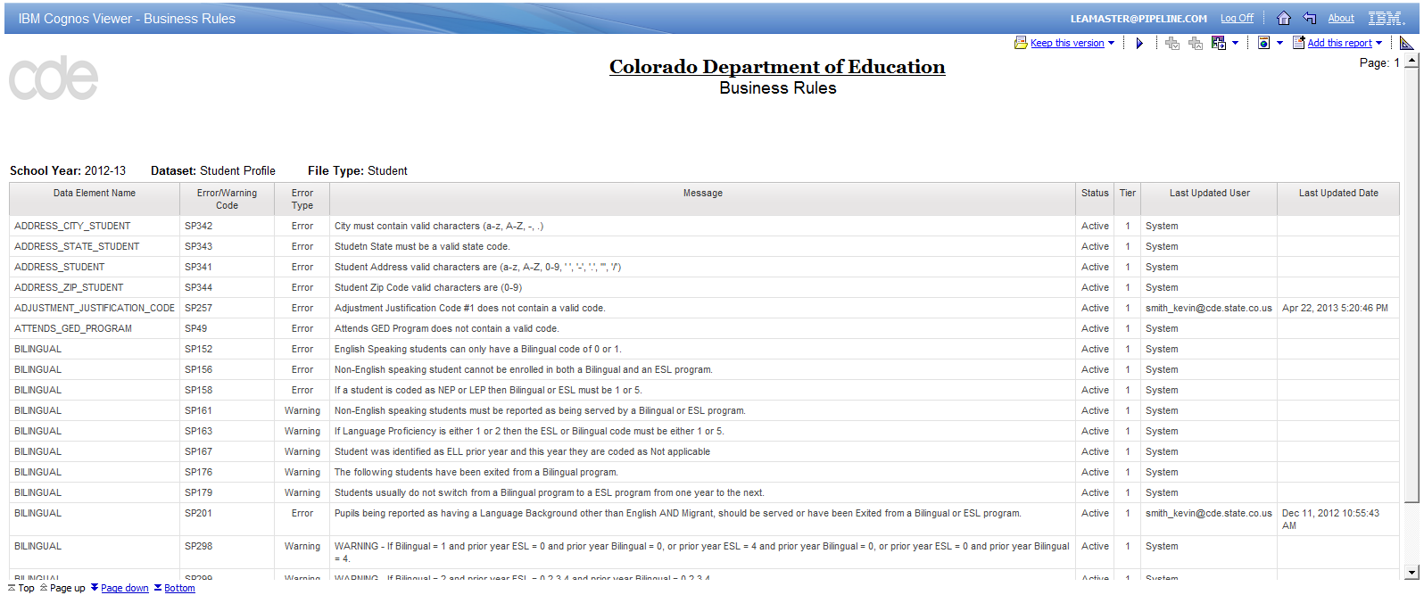
Figure 34: Business Rule Report

8.4 View Codes Dictionary Report
A user may download the codes dictionary report from Cognos. This report will list codes used by data elements in collections. This report may be downloaded in PDF, Excel, or HTML format.

Steps to perform
- From Data Pipeline click the Cognos Report link at the bottom of the screen
- Navigate to the Baseline Folder
- Navigate to the Codes Dictionary report
Figure 35: Codes Dictionary Report Prompt

GUI description
Field # | Field name | Field Description/use | Mandatory | Max length | Constraints
1 | Category | Dropdown that lists all available categories in the system. All codes are assigned to a category. If this is not selected then all categories will be displayed in the report | No | N/A | None

For additional GUI descriptions refer to Section 8.2 View File Format Report.

Steps to perform
- Select School Year
- Select Category (optional)
- Click Finish
- The Codes Dictionary report is displayed for the selected categories and school year
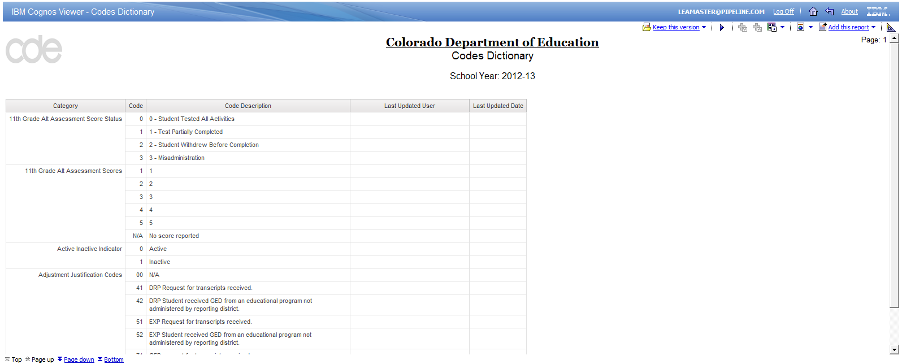
Figure 36: Codes Dictionary Report

8.5 View Data Dictionary Report
A user may download the data dictionary report from Cognos. This report will list data elements that exist in Data Pipeline and show the data type, length, description, display name, and Ed-Fi mapping. This report may be downloaded in PDF, Excel, or HTML format.

Steps to perform
- From Data Pipeline click the Cognos Report link at the bottom of the screen
- Navigate to the Baseline Folder
- Navigate to the Data Dictionary report
Figure 37: Data Dictionary Report Prompt

GUI description
Field # | Field name | Field Description/use | Mandatory | Max length | Constraints
1 | Keywords | Field to allow user to search data element names to find a specific data element. The search will be performed against the database field name, which is also listed in the file format report | No | N/A | None
2 | Data Element Results | List of data elements that match the search criteria | No | N/A | None
3 | Choice | User may select data elements from the search results and move them to the choice selection by clicking Insert or Remove. Any data elements present in this box will be included when the user clicks Finish | No | N/A | None

Steps to perform
- Search for a data element (optional)
- Select data element(s) and click insert to move to the choice field (optional)
- Click Finish
- The Data Dictionary report is displayed for the selected categories and school year
Note: If the user does not search for a specific data element then the report will list all data elements that exist in Data Pipeline.
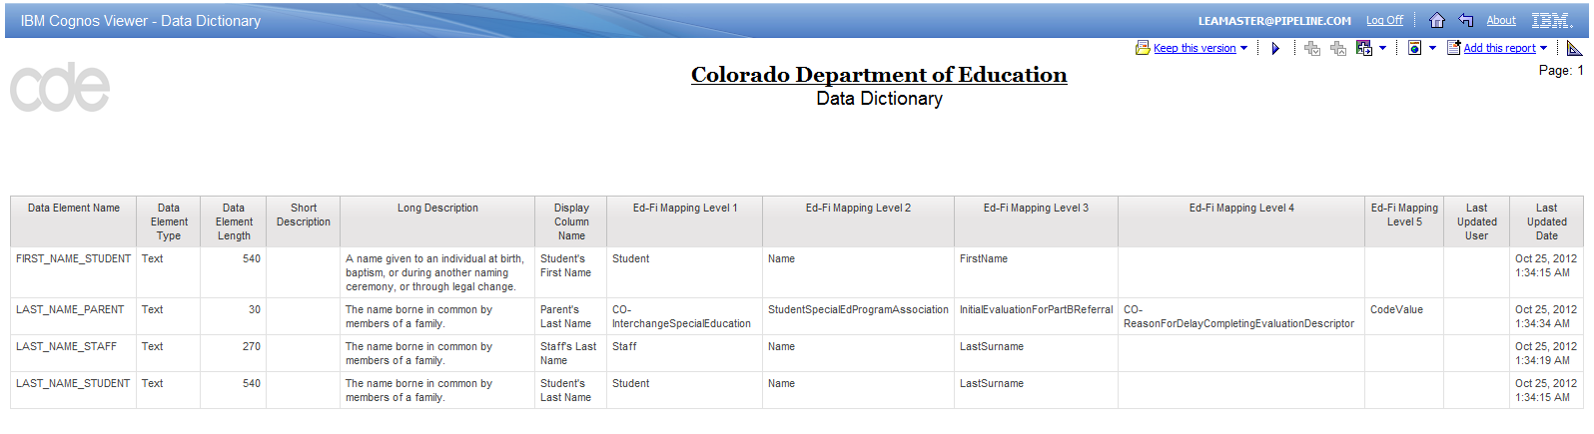
Figure 38: Data Dictionary Report

Troubleshoot Cognos Reports
Some users may have to modify browser requirements in order to download Cognos reports to Excel or PDF. Instructions for changing browser settings in Internet Explorer are provided below:

8.6 Modify browser settings
Internet Explorer 10 and above is not compatible with the Cognos application. A link to Cognos with a list of compatible browsers can be found here: http://www-01.ibm.com/support/docview.wss?uid=swg27021368.
District users should use the compatibility view option in Internet Explorer 10 or use one of the approved versions of Mozilla Firefox.
If the user can access Cognos reports and view them but cannot download the reports, this can be resolved by applying the following browser settings.
Step 1: Go to Tools -> Internet Options
Step 2: Select the Security tab
Step 3: Select Trusted sites
Step 4: Click Sites
Step 5: Ensure that the website alder.cde.state.co.us is listed as a trusted website. If it is not, please add it. Note: For best results add the website without “https://”
Step 6: Unselect the checkbox to require server verification. This un-selection is required only for piloting in the QA region. In Production, you may
Step 7: Click Close
Step 8: Click Custom Level (make sure “Trusted sites” is still selected)
Step 9: Scroll down to Downloads section and ensure all options are set to “Enable”.
Step 10: Click OK, Click Apply

8.7 Modify CSV settings
There is an option to download Cognos reports to a CSV file. Upon download, most computers will default download this file to Excel. In order to change the defult settings perform the following steps.
Windows 7
Go to Control Panel -> All Control Panel Items -> Default Programs -> Set Associations.

Step 1: Click on .csv
Step 2: Change Program
Step 3: Choose Notepad or WordPad or TextPad (if installed)
Step 4: Click OK

Windows XP
- Click on Start, then All Programs, then Accessories, and finally Windows Explorer.
- Click on the Tools menu option and then choose Folder Options....
- In the Folder Options window, click on the File Types tab.
- Under Registered file types:, scroll down until you see .CSV
- Click on the file extension to highlight it, once you've found .CSV
- Click the Change... button in the Details for the '[file extension]' extension area near the bottom of the window. The Open With dialog box should appear.
- Scroll through the options in the Programs area and choose the application that you want to open the file extension with when you double-click on the particular kind of file on your computer. Click Browse… to look for Notepad or WordPad (or any other text editor you have on your computer).
- Click the OK button on the Open With window.
- Click the Close button at the bottom of the Folder Options window.
- From this point forward, when you double-click on any file with this particular file extension, the program you chose in Step 7 will launch and load the particular file.

10. Application Emails
There are several types of standard emails within Data Pipeline. Each email is triggered by a different event within Data Pipeline and each is sent with the purpose of providing notification to the user. The various email types are listed below along with the event that triggers the email. The Subject and Content sections of the emails display variable names, which the system populates during email generation.
Note: The email subject and body are for illustrative purposes only. CDE Admin has the privileges to modify them as necessary for their respective collections.

File Upload SummAry NOTIFICATION
Event: Sent on File Upload to users associated with the district
Subject: Data Pipeline - <Collection Name>: File Successfully Processed
Content: <Dataset Name> Processed by Data Pipeline for School Year <School Year>:
Batch ID: <Batch ID>
District: <District Code> - <District Name>
Date: <Date> <Time>
Collection Type: <Dataset Name> - <File Type>
Name: <User Name>
User ID: <User ID>
Email: <User Email>
Record Count: <Record Count>
Error Count: <Error Count>

SNAPSHOT COMPLetion NOTIFICATION
Event: Sent when snapshot creation completes
Subject: Data Pipeline - <<Collection Name>>: Snapshot Created/Updated
Content: Snapshot Creation/Updation Processed by Data Pipeline for School year <School Year>:
District: <District Code> - <District Name>
Date: <Date>
Collection Type: <File Type>
Name: <User Name>
User ID: <User ID>
Email: <User Email>
Record Count: <Record Count>
Error Count: <Error Count>

SUBMISSION NOTIFICATION
Event: Sent when LEA submits data to CDE for approval from the status dashboard screen
Subject: Data Pipeline - <District Code> - <District Name> <<Collection Name>>: Record(s) is submitted for approval
Content: The Record(s) ( <Dataset Name> -<File Type>) for School Year <School Year> and LEA <District Code> - <District Name> has been submitted for your approval.
Please login to Data Pipeline to review this submission.

ACCEPT NOTIFICATION
Event: Sent when CDE Admin accepts LEA data from the status dashboard screen, only sent to users that belong to the district whose data was accepted
Subject: Data Pipeline - <<Collection Name>>: Data Accepted
Content: This is preliminary acceptance of LEA <District Code> - <District Name>, <Dataset Name> -<File Type> data for School year <School Year>. There might be a need to make corrections or re-submit as a result of State further review processes.

DATA Unlock NOTIFICATION
Event: Sent when CDE Admin unlocks district data from the status dashboard screen, only sent to users who are part of the district whose data is unlocked
Subject: Data Pipeline - <<Collection Name>>: Data is Unlocked
Content: The Record(s) ( <Dataset Name> -<File Type>) of LEA <District Code> - <District Name> for School Year <School Year> has been reviewed and requires correction. Please login to Data Pipeline to make necessary corrections.

CROSS LEA VALIDATION COMPLetion
Event: Sent when Cross LEA Validation completes
Subject: Data Pipeline - <<Collection Name>>: Cross LEA Validation Complete
Content: This is a notification email that Cross LEA Validation for School Year <School Year>: <File Type> has completed.

DATA Delete NOTIFICATION
Event: Sent when CDE Admin deletes district data, only sent to users that belong to the district whose data was deleted
Subject: Data Pipeline - <<Collection Name>>: Data Deleted
Content: Some fields have been changed, as a result the existing LEA <District Code> - <District Name> data for School Year <School Year> has been deleted.
<Dataset Name> -<File Type> data need to be submitted again.

REPORTS COMPLetion NOTIFICATION
Event: Sent when reports have completed generating, used for complex reports
Subject: Data Pipeline - <<Collection Name>>: Reports Run is Complete
Content: Reports are generated successfully for LEA <District Code> - <District Name> for the collection <Dataset Name> -<File Type> for School Year <School Year>. Please login to Data Pipeline to access the reports.

UNIQUE ID VALidation NOTIFICATION
Event: Sent on File Upload to users associated with the district
Subject: Data Pipeline - <<Collection Name>>: SASID Validation is Processed
Content: <Dataset Name> Processed by Data Pipeline for School Year <School Year>:
Batch ID: <Batch ID>
District: <District Code> - <District Name>
Date: <Date> <Time>
Collection Type: <Dataset Name> - <File Type>
Name: <User Name>
User ID: <User ID>
Email: <User Email>
Record Count: <Record Count>
SASID/EDID Error Count: <SASID/EDID Error Count>

About Deloitte
Deloitte provides audit, tax, consulting, and financial advisory services to public and private clients spanning multiple industries. With a globally connected network of member firms in 140 countries, Deloitte brings world-class capabilities and deep local expertise to help clients succeed wherever they operate. Deloitte's 165,000 professionals are committed to becoming the standard of excellence.
Deloitte's professionals are unified by a collaborative culture that fosters integrity, outstanding value to markets and clients, commitment to each other, and strength from cultural diversity. They enjoy an environment of continuous learning, challenging experiences, and enriching career opportunities. Deloitte's professionals are dedicated to strengthening corporate responsibility, building public trust, and making a positive impact in their communities.
Deloitte refers to one or more of Deloitte Touche Tohmatsu, a Swiss Verein, and its network of member firms, each of which is a legally separate and independent entity. Please see www.deloitte.com/about for a detailed description of the legal structure of Deloitte Touche Tohmatsu and its member firms. Please see http://www.deloitte.com/us/about for a detailed description of the legal structure of Deloitte LLP and its subsidiaries.
Internal Usage Statement
This publication is for internal distribution and use only among personnel of Deloitte Touche Tohmatsu, its member firms, and its and their affiliates. Deloitte Touche Tohmatsu, its member firms, and its and their affiliates shall not be responsible for any loss whatsoever sustained by any person who relies on this publication.
Copyright © 2013 Deloitte Development LLC. All rights reserved.
Member of Deloitte Touche Tohmatsu

