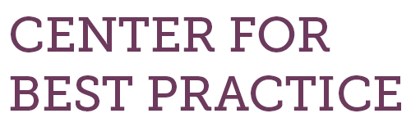
How to Do It: Tips for Implementation of assessment literacy

- Objective
  - How can providing your teachers with assessment literacy training transform instruction and improve student outcomes?
  - How can your school or district partner with the Colorado Department of Education to determine the best methods of preparing your staff for this endeavor?
  - Who will be involved in selecting and defining the goals specific to your site or district that will ultimately improve student performance?
- Preparation
  - Read about CDE’s Assessment Literacy Program.
    - If you are interested in working through the program’s online professional learning modules, contact Angela Landrum for a login.
  - Study some of the programs Centennial uses to support assessment literacy work:
    - Lucy Calkins’ Units of Study
    - The Workshop Model of reading and writing instruction
  - Put together a plan on how to sell this idea to your district administration, and, if you plan to seek innovation status, your school board.
- Implementation
  - Conduct formal or informal polling or surveying to be sure you have staff support for these changes.
    - If you are seeking innovation status, you will have to conduct a formal vote
  - Consider adopting the Workshop Model, Units of Study, or other programs that support smart use of formative classroom assessments
  - Make sure to plan thoroughly and carve out time for in-depth training for every staff member.
  - Be prepared to adjust your professional development schedule to add “data days” during which teachers do deep dives into formative assessment data and plan for each child.

- Assessment/reflection
  - What worked?
  - What did not work?
  - How can it be adjusted?

