Superintendents/Principals to Parents
Use this entire letter or just portions to help parents understand the upcoming statewide tests.

Dear parents,

It is hard to believe that the 2016-17 school year is more than half over and we are now preparing for the annual statewide assessments to begin.

We still have some hard work ahead of us before the end of school. As students advance in their learning throughout the school year, we use various tests to provide check-ins and give us feedback on their progress. Results of these tests help us know where we need to focus more time and where our students are excelling. In a few weeks we will begin the end-of-year state assessments for all students from third to ninth grade to determine how students progressed and if they’ve mastered the grade-level expectations for all students in Colorado.

The Colorado Measures of Academic Success (CMAS) assessments test students in third through ninth grade on English language arts and math with select grades taking science and social studies tests. The tests will be administered in [insert district/school] on [insert scheduled day].

Students in 10th grade will take the PSAT 10 on April 11 or 12. And, for the first time, 11th graders will take the SAT college entrance exam on April 11.

Here is a snapshot of what to expect:

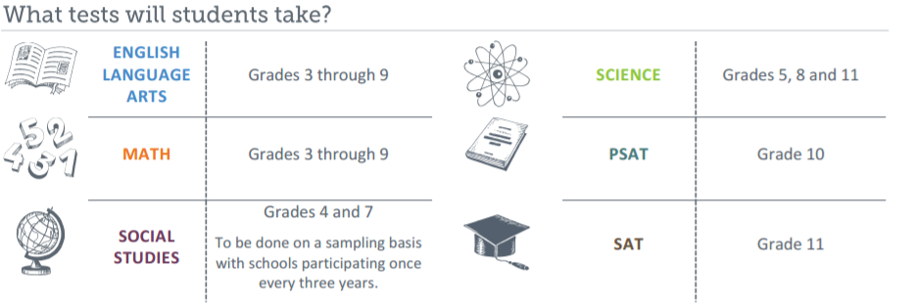

The state assessments are aligned with the Colorado Academic Standards and they serve as the only common measuring tool for all students in the state. They are designed to be administered online and feature a variety of interactive questions that are engaging and aligned with 21st century teaching and learning practices. The tests use advanced questioning and performance tasks to provide snapshot of what students know in relation to the standards.
Participation is important because results help educators and parents know whether students have mastered the content they need to know by the end of the school year and whether they are on track to be ready for college or careers after high school. The test results allow parents, students and teachers to compare to students across the district and state. In the case of the English language arts and math tests, students and parents can compare performance with students around the country.

Also, we can use CMAS results that will be released in August to make improvements to instruction or to develop additional support and enrichment for students who need more help mastering the standards.

[Add any district/school specific work happening around assessment implementation.]

