Core Program Summary
Collaborative Literacy

Information

This program was approved for use in:
- Kindergarten
- First Grade
- Second Grade

Core (Universal) Programming: A reading program that is used to help guide both initial and differentiated instruction in the regular classroom. It supports instruction in the broad range of reading skills (phonemic awareness, phonics, fluency, vocabulary, comprehension) required to become a skilled reader. It contains teacher’s manuals with explicit lesson plans and provides reading and practice materials for students (FCRR, n.d.).
Please access the scored rubric online to review the specific criteria and feedback for each approved core reading program.
Rubrics are available for all instructional program reviewed from the CDE upon request.
Please contact Marisa Calzadillas at Calzadillas_m@cde.state.co.us.
The Colorado Reading to Ensure Academic Development Act (READ Act), passed by the Colorado legislature in 2012, focuses on early literacy development for all students kindergarten through third grade and especially for students at risk of not reaching grade-level proficiency in reading by the end of third grade.
Included in the READ Act is the requirement that the department shall create an advisory list of evidence-based or scientifically based instructional programming in reading, pursuant to C.R.S. 22-7-1209.
The main purpose of the READ Act Advisory List of Instructional Programming is to provide districts and schools with a choice of instructional programming that adequately enhances teacher quality and is a major vehicle that schools/districts can utilize to upgrade their capacity as it relates to the implementation of the evidence-based literacy practices.

CDE Core Program Rating Summary
Kindergarten: Meets Expectations in all reading components First Grade: Meets Expectations in all reading components Second Grade: Meets Expectations in all reading components Usability: Meets Expectations
Review Comments: Reviewers note having an overview map of how to combine Being a Reader and Making Meaning would strengthen use/implementation.

Vendor Information and Program Summary

Vendor: Center for the Collaborative Classroom Publication year (or edition): 2016
Contact Information
Name: Andreia Simon
Role: Manager of Educational Partnerships, CO & NM
Address: 1001 Marina Village Pkwy, Suite 110 Alameda, CA 94501
Number: 512.787.3513
Email: asimon@collaborativeclassroom.org

Core Program Summary – Collaborative Literacy

Name: Jenn Kraisan Role: Regional Director
Address: 1001 Marina Village Pkwy, Suite 110 Alameda, CA 94501 Number: 636.675.2032
Email: jkraisan@collaborativeclassroom.org
Vendor provided summary: Collaborative Literacy is a rigorous, yearlong curriculum that addresses the core reading, writing, and speaking and listening skills that students need to thrive academically and socially. Collaborative Literacy transforms classrooms by:
- Connecting from and supporting pedagogy that aligns seminal and current research on literacy development into a coherent literacy curriculum
- Combining quality curriculum with diverse literature
- Fully integrating academic content with social skills development in every lesson
- Using formative and summative assessments to track student progress over time and make instructional decisions
- Helping teachers create safe, supportive classrooms that are rigorous and culturally responsive

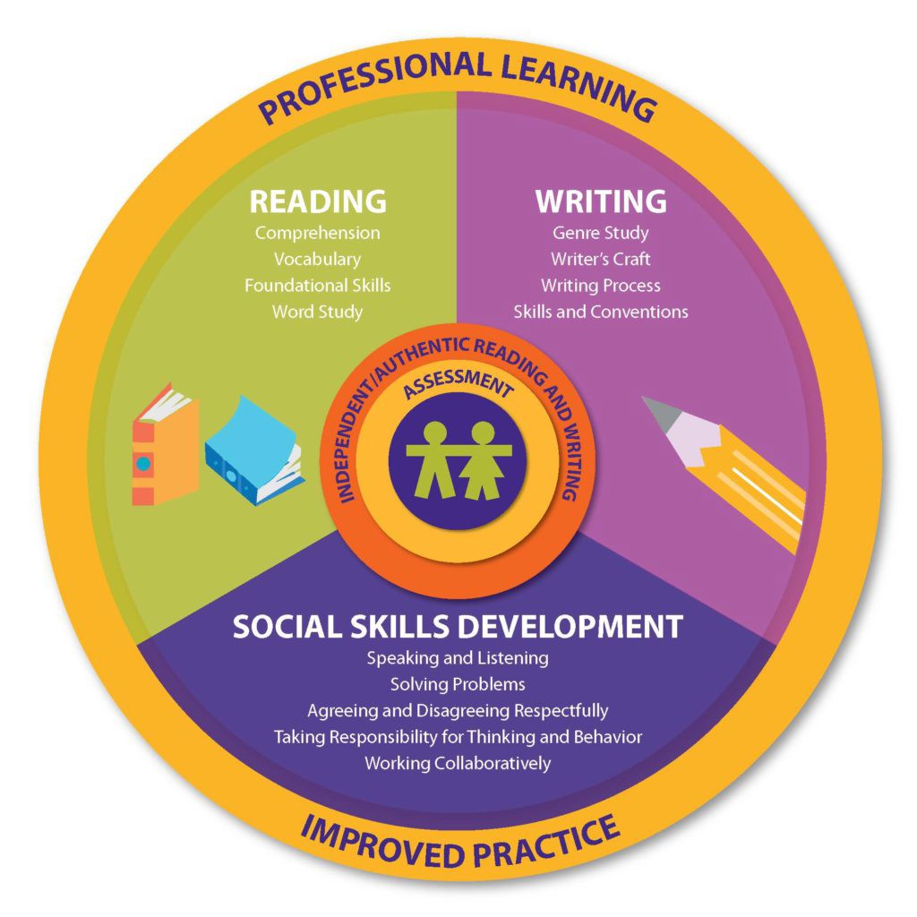
When taught together, the modules of Collaborative Literacy— Being a Reader, Making Meaning, and Being a Writer—form a comprehensive, research-based ELA curriculum. In grades K–2, the program utilizes a combination of whole-class and small-group instruction to help all students master the foundational skills and strategies required for literacy success. Built upon a continuum of early reading competencies, the program is designed to help teachers meet their students where they are academically and create an environment in which all students can grow as readers, independent learners, and caring members of the classroom community.

- Being a Reader helps all students master the foundational skills and strategies required for reading success through whole-class shared reading and word study, and small-group, differentiated foundational skills instruction.
- Making Meaning builds awareness and orchestration of comprehension and vocabulary strategies through the use of carefully selected nonfiction and fiction read-aloud trade books
- Being a Writer offers student-centric writing instruction that fosters students’ growth as skilled writers through the use of authentic, exemplar texts

As a Tier I program, Collaborative Literacy is aligned to work seamlessly with the SIPPS (Systematic Instruction in Phonological Awareness, Phonics, and Sight Words) program as a Tier II for students that require targeted, small-group intervention. Detailed teacher support for determining the appropriate pathway for tiered instruction is provided in the RTI/MTSS Guidance for Reading Instruction in Collaborative Literacy document.

