Summary of 2022-23 graduation and completion data release

Graduation rates improved in 2022-23
Overall, graduation rates in 2022-23 improved in comparison to 2021-22.
About 65% of districts had graduation rates that were the same or better than the prior year (120 of the 185 local education agencies or BOCES).

Extended graduation rates
Improvements were also evident in extended graduation rates, although not for all cohorts. This included:
- More students graduated in 5, 6, and 7 years in each of the most recent anticipated years of graduation.
- The most recent 5-year and 7-year extended graduation rates increased compared to the previous year.
- The AYG 2021 cohort continues to have lower extended year graduation rates than other graduating cohorts.
AYG | 4-year | 5-year | 6-year | 7-year
2022-2023 | 83.1% | available in 2023-24 | available in 2024-25 | available in 2025-26
2021-2022 | 82.3% | 86.1% | available in 2023-24 | available in 2024-25
2020-2021 | 81.7% | 85.7% | 86.7% | available in 2023-24
2019-2020 | 81.9% | 86.0% | 87.1% | 87.6%

Completion rates improved in 2022-23
1,028 students in the AYG 2023 cohort completed high school by receiving a certificate of high school completion or a High School Equivalency Diploma (HSED) instead of a regular high school diploma. Over the past 10 years, an additional 1.5% to 1.8% students complete high school in each AYG cohort. This has remained consistent even with the increase in graduation rates.
AYG | 4-year | 5-year | 6-year | 7-year
2022-2023 | 84.6% | available in 2023-24 | available in 2024-25 | available in 2025-26
2021-2022 | 84.1% | 88.3% | available in 2023-24 | available in 2024-25
2020-2021 | 83.2% | 87.7% | 88.9% | available in 2023-24
2019-2020 | 83.4% | 88.0% | 89.3% | 89.9%

4-year graduation by subgroups
Improvements were seen in most student subgroups including growth at a faster rate than the state (0.8% increase for all students) in the 4-year graduation rate of AYG 2023 compared to the 4-year graduation rate of AYG 2022 in many subgroups. However, substantial gaps remain. This is true by gender, race/ethnicity, and instructional program service type (IPST) groups.
Subgroup Category | AYG 2022 | AYG 2023 | Rate Change from Prior Year
Female | 85.7% | 86.0% | +0.3
Male | 79.1% | 80.3% | +1.2
American Indican or Alaskan Native | 65.4% | 68.0% | +2.6
Asian | 93.0% | 92.6% | -0.4
Black or African American | 77.4% | 78.6% | +1.2
Hispanic or Latino | 75.1% | 76.1% | +1.1
White | 87.3% | 88.0% | +0.7
Native Hawaiian or Other Pacific Islander | 61.1% | 70.9% | +9.8
Two or More Races | 81.3% | 83.5% | +2.2
Students with Disabilities | 67.9% | 69.3% | +1.4
English Learner | 69.4% | 69.4% | 0.0
Economically Disadvantaged | 71.9% | 73.3% | +1.4
Migrant | 69.0% | 67.2% | -1.8
Title 1 | 66.9% | 68.2% | +1.3
Homeless | 55.4% | 58.0% | +2.6
Gifted and Talented | 94.6% | 95.4% | +0.8
Military Connected | 89.7% | 90.4% | +0.7
Foster | 30.0% | 36.2% | +6.2

7-year completion by subgroups
When given more time to graduate or complete high school, many students are more successful. When comparing the 7-year graduation rate for AYG 2020 to the 4-year graduation rate for AYG 2020, many subgroups show more students graduating by their 7th year. In addition, with this additional time, some gaps narrow but not at a high enough rate to completely close the gaps.

Additional analysis/data trends
CDE is committed to supporting all students across all districts within Colorado so they may successfully graduate or complete high school. When analyzing graduation and completion data, a few other notable trends appear in the data:
- The AYG 2021 cohort was the first cohort to show a lower 4-year graduation rate than the previous AYG cohort. This trend has continued into the 5-year and 6-year rates of AYG 2021. These students were in their 3rd year of high school during the 2019-20 school year when the COVID-19 pandemic began. It appears they were the most impacted by the interruptions to their high school career in the 2019-20 and 2020-21 school years.
- Some regions of our state show higher 4-year graduation rates than others. Districts in the North Central, Northwest, and Metro regions had higher 4-year graduation rates than the state the past three years. Districts in the Pikes Peak, Northeast, and not affiliated with a region show a substantial gap between their 4-year graduation rates and the state for the past three years.
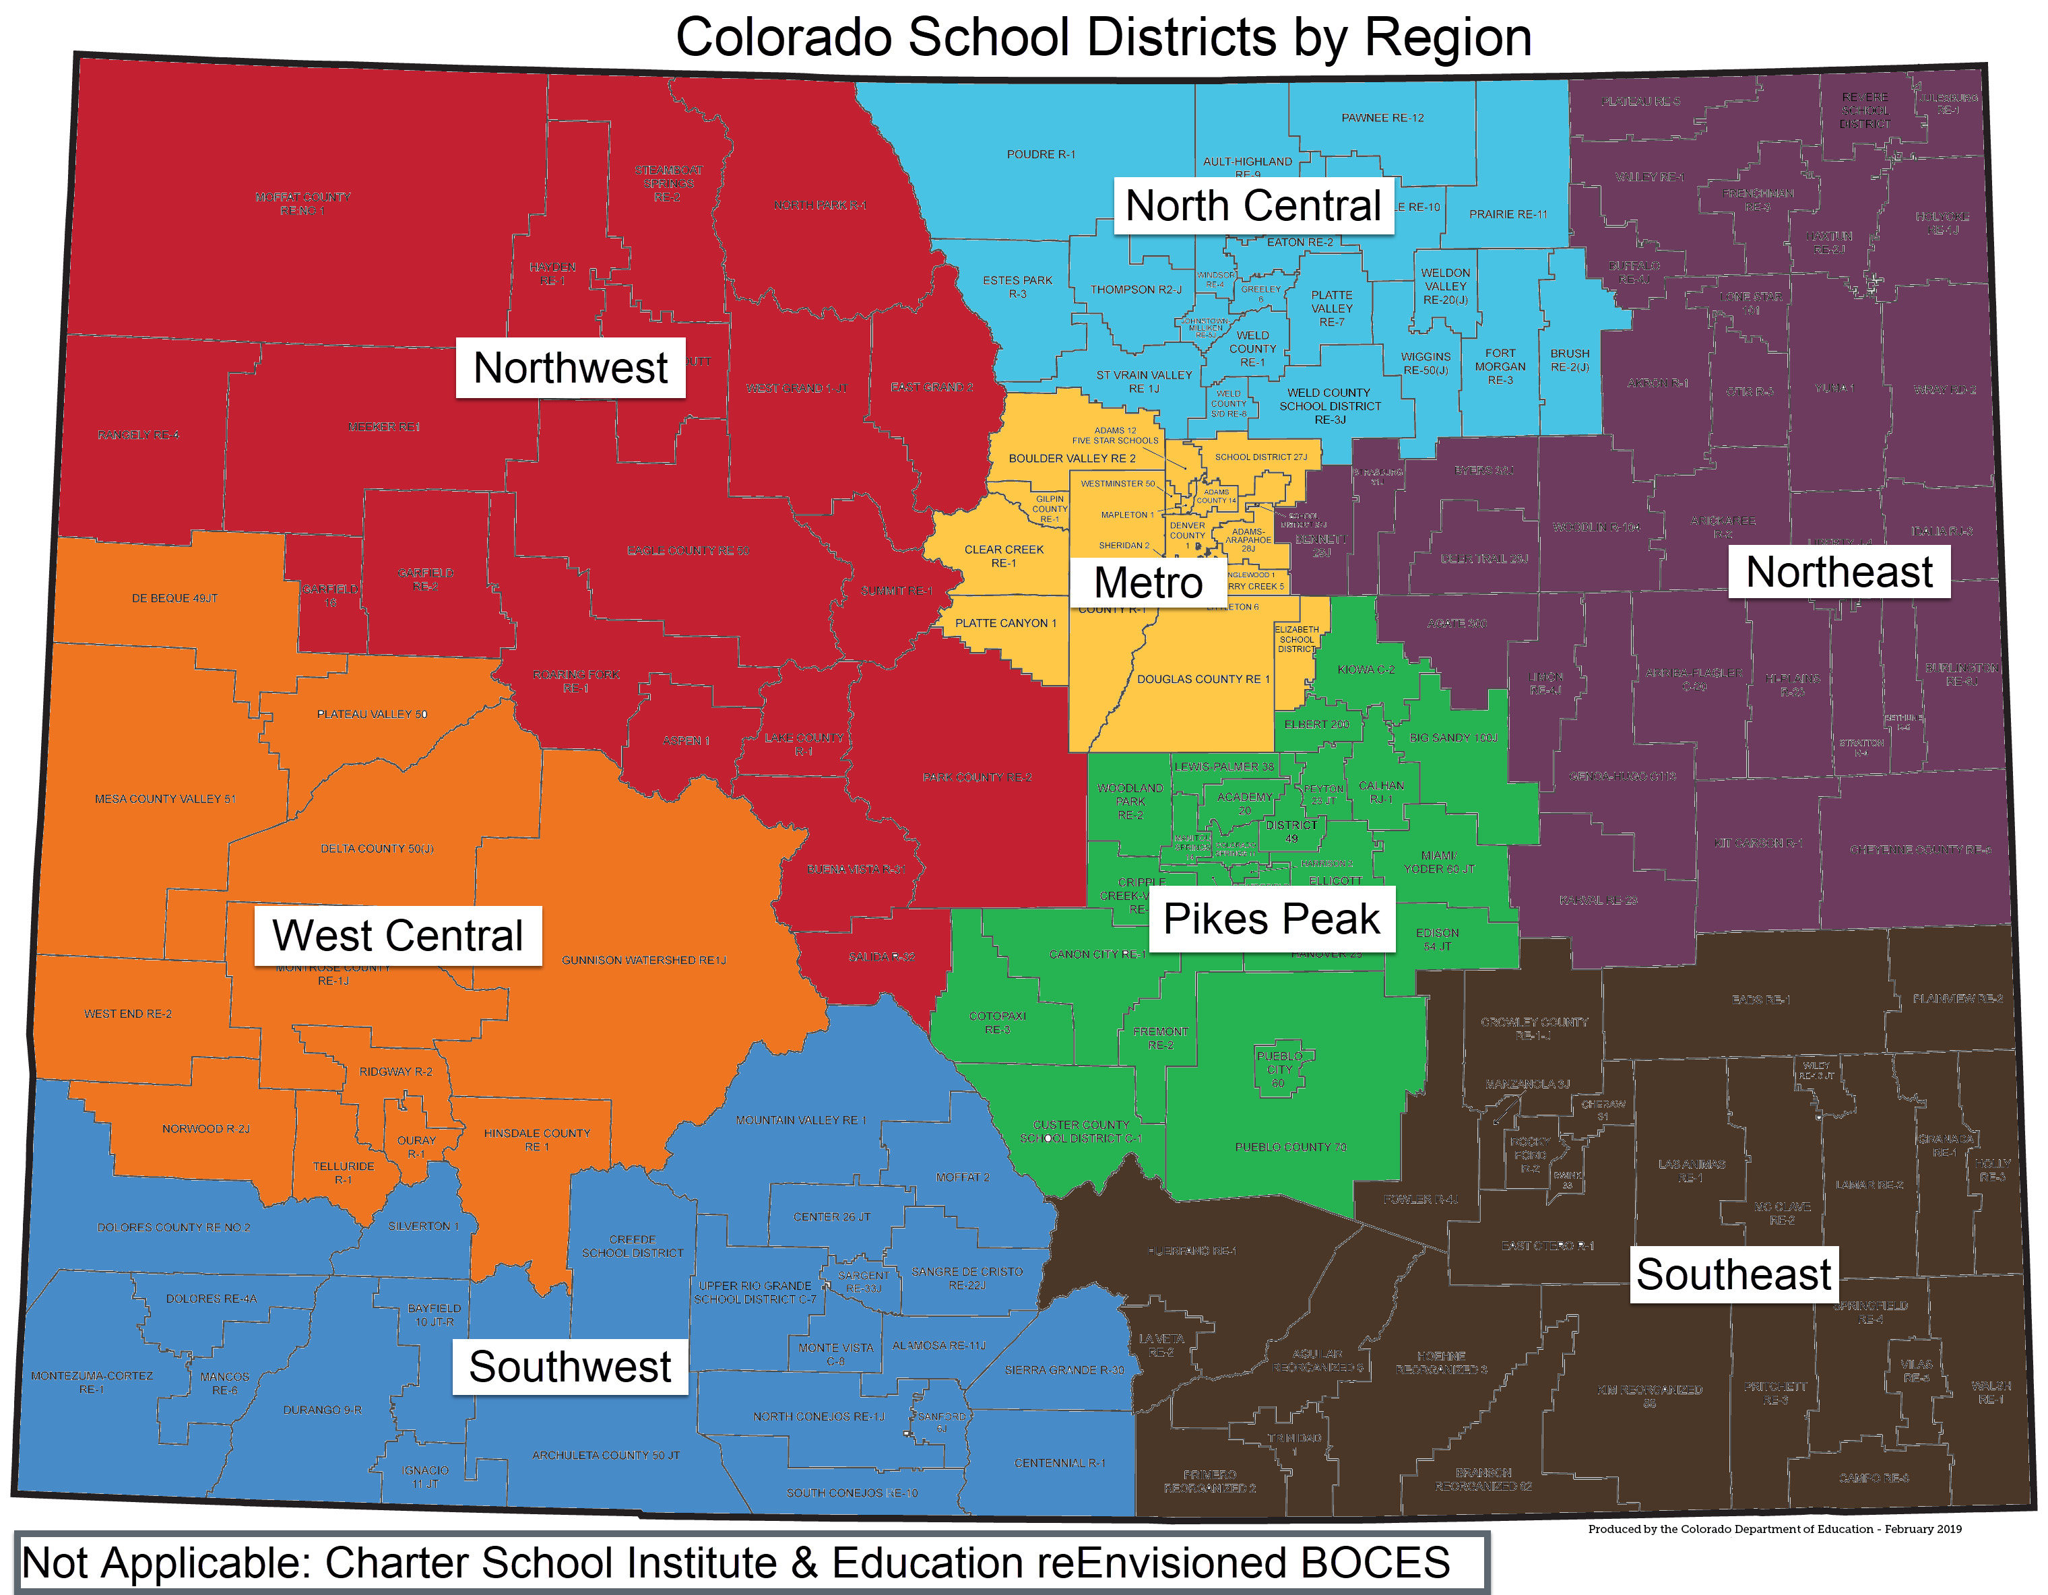
*See the Field Services—Regions webpage for a list of districts that comprise each region.

Resources
- CDE’s Office of Dropout Prevention and Student Re-engagement supports programs, identifies resources, and facilitates learning sessions focused on evidence-based practices to improve attendance, student engagement and connections to learning.
- CDE’s Office of Postsecondary and Workforce Readiness supports programs and strategies that support student access to career-connected learning options.
  - Colorado’s Graduation Guidelines information.
- CDE’s Data Services team collects and publishes annual graduation/completion data.

