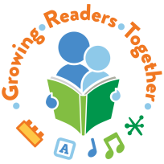

Growing Readers Together Evaluation
Brief Survey
Hello!
Your local public library is participating in an early literacy initiative called Growing Readers Together (GRT). We are interested in learning the results of the initiative, and hoping you might provide some feedback…..

What am I being asked to do and how long will it take?
- Please fill out the attached short survey. It should take you no more than 5 minutes.
- Return the completed survey to the librarian who’s hosting today’s activity.
- Please feel free to keep this page for your records.

What will be done with the survey responses?
- The librarian or host of today’s activity will send the completed surveys to the Colorado State Library.
- We will gather the responses from this library and add it to responses from other libraries to get an overall picture of the impact of Growing Readers Together.
- We will share results only with the libraries that are participating in GRT and with the Buell Foundation, which is Growing Readers Together’s sponsor.
- All responses are confidential. No individual responses will be shared and no identifying information is being collected.

Thanks for your consideration. If you have any questions, please contact:

Joyce Johnson
Growing Readers Together Coordinator
Colorado State Library, Colorado Dept. of Education
Direct: 303-866-6660
Email: Johnson_joyce@cde.state.co.us

