Division of Capital Construction
RFQ Scoring Tools Guide

When reviewing and evaluating RFQ responses from vendors, it is important for selection committees to put aside any personal biases for or against any specific respondee, and objectively evaluate what has been presented. The RFQ scoring tools are provided as a resource for district selection committees to accomplish that goal.

SCORING WORKSHEET
This worksheet is intended to be used by each committee member for each responding firm's submittal. In the case of a large number of responses, a first pass from individuals in the committee may be warranted to disqualify any responses with red flags or incomplete submittals prior to each member reviewing each submittal in detail, so that only the 'responsive' submittals are reviewed.
The scoring guide provides a breakdown, based on the criteria identified in the RFQ, of what might constitute a submittal that exceeds the standard, meets the standard, partially meets the standard, or does not meet the standard of expectations. By scoring responses this way, the goal is to score them as independent submittals, not in relation to one another. The RFQ responses that most consistently are believed to meet or exceed the standard will score the highest, and should constitute the short-list of firms invited for the following round of selection, if any.
While at first glance, most submittals are impressive and put the best face on each organization, the RFQs are designed to bring out the information that can help selection committees determine the level of qualifications and quality of approach each firm intends to bring to the project. Often evaluators will need to take note of evasive or vague language in submittals, and question whether a firm truly has the expertise requested, paying special attention to areas where requested information is not provided at all.
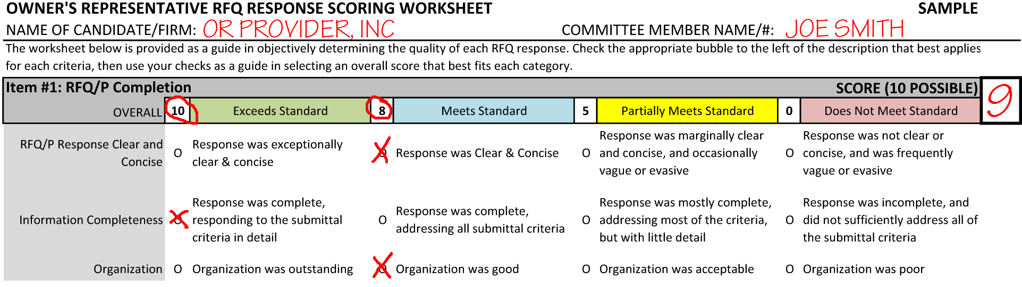
SAMPLE PORTION OF COMPLETED WORKSHEET
After all submittals have been independently reviewed and scored by the committee, there are two potential ways to discuss findings and determine the short-list:

Scoring Tally
This matrix simply gathers the total numerical score for each applicant from each committee member to determine the candidates with the highest scores. The top 3 candidates would be selected for the shortlist, unless a near tie gives the committee reason to believe that the fourth would also be equally competitive.
Committees may wish to discuss the submittals, after initial individual scoring and prior to final tally, by going through the scoring sheets by firm and noting any ‘exceeds standard’, 'does not meet standard' or 'partially meets standard' scores for group discussion. Occasionally one or two evaluators will miss something that others may have seen, and these scores may deserve to be adjusted up or down prior to determining the final numerical totals.

SCORING CRITERIA MATRIX
This spreadsheet can optionally be used by districts to document the individual evaluations of each criteria in a more comprehensive way. This provides applicants with improved feedback after the selection is completed, and serves to better document the rationale behind the selection. If you would like to utilize this matrix, please contact your Technical Assistance Representative for assistance. This could be completed either during selection or afterwards as part of the decision memorandum documentation.

