SAMPLE: Rationale and Replacement Plan for Waivers from State Statute and Rule

Contact Information
School Name: East Elementary Charter
School Address (mailing): 2468 Alpine Drive, Denver, CO 80203
Charter School Waiver Contact Name: Bob McDaniels
Charter School Waiver Contact’s Phone Number: 303-333-3333
Charter School Waiver Contact’s Email: bob.mcdaniels@eastelementarycharter.com
District Contact Name: Lynn Richards
District Contact’s Phone Number: 720-555-2222
District Contact’s Email: lrichards@Evansk12.co.us

Automatic Waivers
State Statute Citation | Description
C.R.S. § 22-32-109(1)(f) | Local board duties concerning selection of staff and pay
C.R.S. § 22-32-109(1)(t) | Determine educational program and prescribe textbooks
C.R.S. § 22-32-110(1)(h) | Local board powers-Terminate employment of personnel
C.R.S. § 22-32-110(1)(i) | Local board duties-Reimburse employees for expenses
C.R.S. § 22-32-110(1)(j) | Local board powers-Procure life, health, or accident insurance
C.R.S. § 22-32-110(1)(k)(I) | Local board powers-Policies relating the in-service training and official conduct
C.R.S. § 22-32-110(1)(ee) | Local board powers-Employ teachers’ aides and other non-certificated personnel
C.R.S. § 22-32-126 | Employment and authority of principals
C.R.S. § 22-33-104(4) | Compulsory school attendance-Attendance policies and excused absences
C.R.S. § 22-63-301 | Teacher Employment Act-Grounds for dismissal
C.R.S. § 22-63-302 | Teacher Employment Act-Procedures for dismissal of teachers
C.R.S. § 22-63-401 | Teacher Employment Act-Teachers subject to adopted salary schedule
C.R.S. § 22-63-402 | Teacher Employment Act-Certificate required to pay teachers
C.R.S. § 22-63-403 | Teacher Employment Act-Describes payment of salaries
C.R.S. § 22-1-112 | School Year-National Holidays

Non-Automatic Waivers: Statute Description and Rationale and Replacement Plan
C.R.S. § 22-9-106 Local Board of Education-Duties-Performance Evaluation System; C.R.S. § 22-2-112(1)(q)(I) Commissioner-Duties
Rationale: The East Elementary Charter Headmaster or designee must have the ability to perform the evaluation of all personnel. Should any other designated administrator not have a Principal Licensure, this should not preclude him or her from administering the evaluations under the direction of the Principal. The Board of Directors must also be able to perform the evaluation for the Headmaster. Additionally, East Elementary Charter should not be required to report its teacher evaluation ratings as a part of the commissioner’s report as required by C.R.S. § 22-2-112(1)(q)(I), but will still report on in-field/out-of-field.
Replacement Plan: East Elementary Charter will use its own evaluation system as agreed to in the charter contract with Pinetree School District. East Elementary Charter’s evaluation system will continue to meet the intent of the law as outlined in statute. Staff will be annually trained in this evaluation system. The methods used for the school’s evaluation system will include quality standards that are clear and relevant to the administrators’ and teachers’ roles and responsibilities, be based on research-based practices guiding the science of reading, have the goal of improving student academic growth, and meet the intent of the quality standards established in C.R.S. §§ 22-9-101 et seq. The school will not be required to report its teacher evaluation data through applicable state collections; however, teacher performance ratings data will be reviewed by the school and used to inform hiring practices and professional development. Core course level participation will continue to be reported pursuant to C.R.S. § 22-11-503.5, as this is a non-waivable statute.
Duration of Waivers: The waiver will extend for the duration of the contract.
Financial Impact: The school anticipates that the requested waivers will have no financial impact on the Pinetree School District or the East Elementary Charter budget.
How the Impact of the Waivers Will be Evaluated: Since teacher performance has a critical impact on the performance of the entire school, the impact of this waiver will be measured by the same performance criteria and assessments that apply to the school, as set forth in the charter contract. The Board of Directors of the school and school leader will annually evaluate the effectiveness of their evaluation system and make adjusts as they may deem appropriate.
Expected Outcome: If granted, the waiver will enable the school to implement its program and evaluate its teachers in accordance with its Performance Appraisal System, which is designed to produce greater accountability and be consistent with the school’s goals and objectives. This will benefit staff members as well as students and the community.

Non-Automatic Waivers: Statute Description and Rationale and Replacement Plan
C.R.S. § 22-32-109(1)(n)(I) Board of Education-Specific Duties School Calendar
C.R.S. § 22-32-109(1)(n)(II)(B) Board of Education-Specific Duties Adoption of District Calendar
C.R.S. § 22-32-109(1)(n)(II)(A) Board of Education – Teacher Pupil Contact Hours
Rationale: East Elementary Charter will prescribe the actual details of its own school calendar to best meet the needs of its students. As such, the school will have a calendar that may differ from the rest of the schools within Pinetree School District. East Elementary Charter will always meet at least the minimum required time and days as outlined in state law.
Replacement Plan: The final calendar and the school’s daily schedule will be designed and approved by the East Elementary Charter’s Board of Directors and will meet or exceed the requirements in state statute. The Board will adopt a policy that specifics a process regarding how and when a calendar is adopted and how changes to the calendar are made. A copy of the calendar will be distributed to parents of East Elementary Charter. To the extent possible, East Elementary Charter will endeavor to develop a calendar that aligns with the calendar of Pinetree School District.
Duration of Waivers: The waiver will extend for the duration of the contract.
Financial Impact: The school anticipates that the requested waivers will have no financial impact on the Pinetree School District or the East Elementary Charter budget.
How the Impact of the Waivers Will be Evaluated: The impact of this waiver will be measured by the same performance criteria and assessments that apply to the school, as set forth in the charter contract.
Expected Outcome: As a result of this waiver, the school will be able to operate in accordance with its own schedule, designed to meet the needs of its community and educational program, which is vital to the success of its program.

Non-Automatic Waivers: Statute Description and Rationale and Replacement Plan
C.R.S. § 22-32-109(1)(b) Local Board Duties Concerning Competitive Bidding
C.R.S. § 22-32-110(1)(y) Local Board Powers-Accepting Gifts, Donations, and Grants
Rationale: In order to manage its own budget and finances, East Elementary Charter must be granted the authority to develop its own financial policies and practices. East Elementary Charter, rather than Pinetree School District, is in the best position to know what goods and services are needed and which vendors and providers may be available.
Replacement Plan: East Elementary Charter Board of Directors will adopt a policy concerning competitive bidding, as required by applicable law, and for selecting successful bidders on projects/contracts. East Elementary Charter will ensure the process is open, transparent, and in compliance with all applicable rules and regulations. Additionally, the board will adopt a policy for accepting gifts, grants and donations.
Duration of Waivers: The waiver will extend for the duration of the contract.
Financial Impact: The school anticipates that the requested waivers will have no financial impact on the Pinetree School District or the East Elementary Charter budget.
How the Impact of the Waivers Will be Evaluated: The impact of this waiver will be measured by the same performance criteria and assessments that apply to the school, as set forth in the charter contract.
Expected Outcome: East Elementary Charter expects that, because of this waiver, it will be able to manage its own financial affairs.

Non-Automatic Waivers: Statute Description and Rationale and Replacement Plan
C.R.S. § 22-63-201 Employment Certificate Required
Rationale: East Elementary Charter must be granted the authority to hire teachers and principals that will support the school’s goals and objectives. The principal will not function as a traditional District school principal, but rather will be responsible for a wider range of tasks and act as the school’s chief executive officer. East Elementary Charter will seek to attract principals and teachers from a wide variety of backgrounds, including, but not limited to teachers from out-of-state, teachers with a lapsed Colorado certificate, persons with several years of successful teaching experience in a setting not requiring a license, as well as persons with business or professional experience.
Replacement Plan: All East Elementary Charter employees will meet the guidelines set forth in the Colorado state ESSA plan, specifically (1) endorsement on a Colorado teaching license; (2) holding at least a BA or higher in the relevant subject area; (3) completing 36 semester credit hours in the subject matter in which s/he teaches; or (4) passing a State Board approved content exam in the relevant subject area. All school employees will meet applicable fingerprinting and background check requirements. Special Education Teachers will hold the requisite state license and endorsement. East Elementary Charter will report the number of in-field/out-of-field teacher designations, years of experience of teachers, or any other requirements promulgated by CDE.
Duration of Waivers: The waiver will extend for the duration of the contract.
Financial Impact: The school anticipates that the requested waivers will have no financial impact on the Pinetree School District or the East Elementary Charter budget.
How the Impact of the Waivers Will be Evaluated: The impact of this waiver will be measured by the same performance criteria and assessments that apply to the school, as set forth in the Charter Agreement.
Expected Outcome: As a result of this waiver, East Elementary Charter will be able to operate in accordance with its own program and hire teachers that best fit the school’s design, which is vital to the success of its program.

Non-Automatic Waivers: Statute Description and Rationale and Replacement Plan
C.R.S. § 22-63-202 Teacher Employment, Contracts in Writing-Duration-Damage Provision
C.R.S. § 22-63-203 Probationary Teachers-Renewal and Non-renewal of Employment Contract
Rationale: To manage its own personnel, East Elementary Charter must be granted the authority to select its own teaching staff, develop its own employment agreements and terms and conditions of employment.
Replacement Plan: All East Elementary Charter employees will be employed on an at-will basis. East Elementary Charter has written teacher agreements with the terms of non-renewal and renewal of employment agreements, and payment of salaries upon termination of employment of a teacher. As a result of these waivers, the school will be able to employ professional staff possessing unique skills and/or background, filling all staff needs.
Duration of Waivers: The waiver will extend for the duration of the contract.
Financial Impact: The school anticipates that the requested waivers will have no financial impact on the Pinetree School District or the East Elementary Charter budget.
How the Impact of the Waivers Will be Evaluated: The impact of this waiver will be measured by the same performance criteria and assessments that apply to the school, as set forth in the Charter Agreement.
Expected Outcome: East Elementary Charter expects that, as a result of this waiver, it will be able to manage its own personnel affairs.

Non-Automatic Waivers: Statute Description and Rationale and Replacement Plan
C.R.S. § 22-63-206 Transfer of Teachers
Rationale: East Elementary Charter has a unique curriculum for which having the proper teaching staff is essential. No other school nor Pinetree School District should have the authority to transfer its teachers into or from East Elementary Charter.
Replacement Plan: East Elementary Charter will not participate in the district’s transfer policies and procedures; however, to the extent that teachers are transferred to other positions or grades within the school, there shall be no discrimination shown toward any teacher in the assignment or transfer of that teacher because of sex, sexual orientation, marital status, race, creed, color, religion, national origin, ancestry, or membership or non-membership in any group or organization. Race includes hair texture, hair type, or a protective hairstyle that is commonly or historically associated with race.
Duration of Waivers: The waiver will extend for the duration of the contract.
Financial Impact: The school anticipates that the requested waivers will have no financial impact on the Pinetree School District or the East Elementary Charter budget.
How the Impact of the Waivers Will be Evaluated: The impact of this waiver will be measured by the same performance criteria and assessments that apply to East Elementary Charter, as set forth in the Charter Agreement.
Expected Outcome: East Elementary Charter expects that, as a result of this waiver, it will be able to manage its own personnel affairs.

Non-Automatic Waivers: Statute Description and Rationale and Replacement Plan
C.R.S § 22-7-1014(2)(a) Preschool Individualized Readiness Plans – School Readiness – Assessments
Rationale: East Elementary Charter is a data driven school that is constantly evaluating and assessing students’ academic readiness, character development, and physical well-being in order to ensure student success. East Elementary Charter already has strong programs and assessments in place that assess students’ school readiness relating to physical well-being, social-emotional development, language and comprehension development, cognition, and general knowledge (literacy and mathematics).
Replacement Plan: Every kindergarten student at East Elementary Charter will be administered a school readiness assessment within the first 60 calendar days of the school year. The assessment instruments used will be research based, reliable and valid. East Elementary Charter intends on using the below assessment instrument(s) to assess each of the domains outlined in the statute:

Physical well-being & motor: {Insert assessment name}
Social and Emotional: {Insert assessment name}
Language & Comprehension: {Insert assessment name}
Cognition: {Insert assessment name}
Math: {Insert assessment name}
Literacy: {Insert assessment name}

The data collected from these assessment(s) will be used to develop an individualized readiness plan for each kindergarten student and will inform individual learning plans, RtI, and drive classroom instruction within the school. This school readiness data will not be used to deny admission or progress to first grade. The data collected will be made readily available to Pinetree School District, and East Elementary Charter will report this data, as required by State law.
Duration of Waivers: The duration of the contract.
Financial Impact: The school anticipates that the requested waivers will have no financial impact on Pinetree School District or the East Elementary Charter budget.
How the Impact of the Waivers Will be Evaluated: The impact of this waiver will be measured by the performance criteria and assessments that apply to East Elementary Charter.
Expected Outcome: As a result of this waivers, East Elementary Charter will be able to implement the necessary policies to increase student achievement within existing structures.

NOTE: This statute requires each school to administer a school readiness assessment to every Kindergarten student within 60 days from the start of the school year. Waiver from this only waives the school from having to use one of the 4 state board approved school readiness assessments (TS Gold; High Scope COR; NC KEA; DRDP-K 2015). Schools with this waiver still must administer a kindergarten readiness assessment that assess all domains (physical well-being, social-emotional development, language and comprehension development, cognition, general knowledge – math, and general knowledge – literacy).

If your school is using one of the listed assessment instruments lists below, then a waiver for 22-7-1014(2)(a) is not necessary.
- Acadience Learning, Acadience Math K-6
- Curriculum Associates, Brigance
- HighScope Educational Research Foundation, COR for Kindergarten
- Illuminate Education, FastBridge
- Istation, Indicators of Progress (ISIP) Math
- North Carolina Kindergarten Entry Assessment
- NCS Pearson, Developmental Indicators for the Assessment of Learning (4th Edition)
- Renaissance Learning, myIGDIs ProLADR
- Teaching Strategies, GOLD
- WestEd, Desired Results Developmental Profile

If your school is not using one of these, please indicate how your school intends to meet the 6 domains. Please refer to the chart below for guidance.

For additional information please visit Assessment Choices and School Readiness Plans

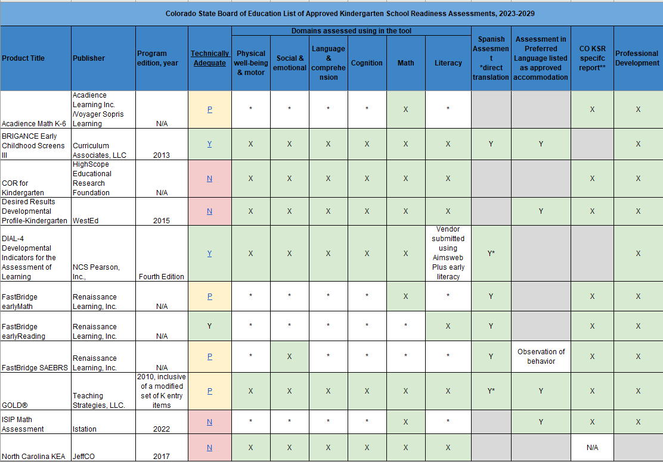

For additional information please visit Assessment Choices and School Readiness Plans

