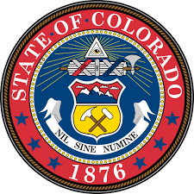

Colorado High School Seal of Biliteracy for High School Diplomas
This certifies that

[Student Name]

has completed the requirements for graduation as prescribed
by the Colorado Senate Bill 17-123, and is therefore entitled to this Seal of Biliteracy

Principal District Coordinator

