Using the Enrollment Upload Template to Add Students

This is the most efficient procedure for uploading multiple new student users to EP. Data managers may also manually enter individuals. See Add a Student Record Manually on page 64.

NOTE: A district or state may have a system in place for submitting multiple student records to EP. Before using the below procedures, check with the SAA and/or the Service Desk.
When using the enrollment file upload, each row with a new student identifier results in the creation of a new student record. A row with an existing or previously enrolled/uploaded student identifier updates the record. When a student record has been deactivated (occurs July 31 each year), the upload will reactivate the student record.
HINT: Up to 5,000 records at a time may be loaded. However, large files may load slowly and can be difficult to troubleshoot. Loading 100 records or fewer is recommended to more easily enable troubleshooting.
- Click Settings.
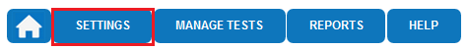
- Click Students.
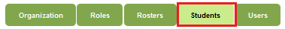
- From the Select Action drop-down menu, select Upload Enrollment.
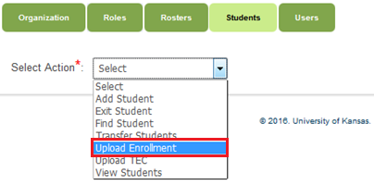
- Apply filters in the Select Organization fields to choose the necessary level.
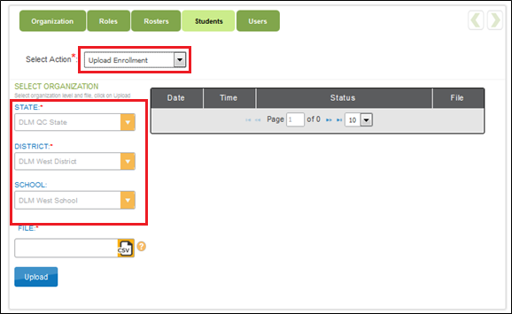

NOTE: If the list does not include the correct option, account permissions may need to be changed. Contact the state-level data manager or SEA.
HINT: When choosing to upload a file, hovering over the question mark next to the file upload reveals an option to download the template for the matching upload.
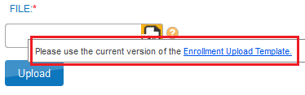

- Click to find the CSV file on the computer. A browser window appears.
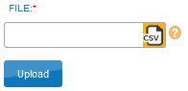
- Locate the CSV file that was just created.
- Click the file name to select it.
- Click Open. The filename appears in the File field.
HINT: Verify that the file has a .csv file extension. Filenames with extensions ending in .xls or .xlsx will be rejected.
- Click Upload.
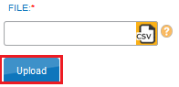
- The confirmation message indicates the number of records uploaded and, if applicable, the number of records rejected.
- Click the CSV file under File to see error messages related to the upload.
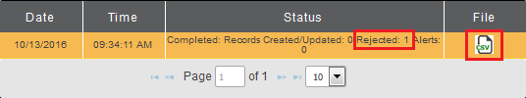
HINT: Alerts in the enrollment upload are to notify users that the student is also enrolled in another school.
Each line in the CSV file is one record.

Enrollment Field Definitions
Column Letter in Enrollment File | Field | Format; Length | Required | Definition | Special Notes
A | AYP_School_ Identifier | Alphanumeric; 30 | No | The unique code that has been assigned to the school as listed in the state organizational table. | Use the School Number provided in the state organizational table. If the code is numeric and contains leading zeroes, use an apostrophe to preserve a leading zero in the organization number. Check that the leading zero is retained after each save.
B | Attendance_District_Identifier | Alphanumeric; 30 | Yes | The unique code that has been assigned to the district where the student attends school. This identifies the parent organization for a school (such as the school district). | Use the District Number provided in the state organizational table. If the code is numeric and contains leading zeroes, use an apostrophe to preserve a leading zero in the organization number. Check that the leading zero is retained after each save. The number must match one in the organization, or the file upload will fail.
C | Student_Legal_ Last_Name | Alphanumeric; 60 | Yes | The student’s last name.
D | Student_Legal_ First_Name | Alphanumeric; 60 | Yes | The student’s first name.
E | Student_Legal_  Middle_Name | Alphanumeric; 60 | No | The student’s middle name.
F | Generation_Code | Alphanumeric; 10 | No | The part of the student’s name used to denote the generation in his/her family (e.g., Jr., Sr., III, etc.)
G | Gender | Numeric; 1  0 = Female  1 = Male | Yes | The student’s gender.
H | Date_of_Birth | MM/DD/YYYY; 10 | Yes | The date (month, day, and year) on which the student was born.
I | Current_Grade_  Level | Numeric; 2  3-12. Do not use leading zeroes. | Yes | The grade level or primary instructional level at which a student enters and receives services in a school or an educational institution during a given academic session. For example, 3=third grade, 11=eleventh grade. | This field determines the grade-level assessment to which the student is assigned. Each state should refer to their state’s DLM webpage with regard to direction on a student’s grade level.
J | Local_Student_ Identifier | Alphanumeric; 10 | No | The unique code assigned to the student by the school or local education agency. | If the code is numeric and contains leading zeroes, use an apostrophe to preserve leading zeroes in a student’s local student identifier.
K | State_Student_ Identifier | Numeric; 10 | Yes | The student’s state ID number. | If the code is numeric and contains leading zeroes, use an apostrophe to preserve leading zeroes in a student’s local student identifier.
L | Current_School_  Year | YYYY; 4 | Yes | The ending year of the current school year (e.g., for the 2017–2018 school year, enter 2018). | Use 2018 for all of the students taking the DLM assessments.
M | Attendance_School_ Program_Identifier | Alphanumeric; 10 | Yes | The school code (typically four digits) or other location identifier that represents where the student attends school. This is the school whose staff will see the student information, including the student username and password. | Use the School Number provided in the state organizational table.  If the code is numeric and contains leading zeroes, use an apostrophe to preserve the leading zeroes. Check that the leading zero is retained after each save. The number must match one in the organization, or the file upload will fail.
N | School_Entry_Date | MM/DD/YYYY; 10 | Yes | The date on which the student enrolls and begins to receive instructional services in a school. If the student leaves and then re-enrolls, this date should reflect the most recent enrollment date.
O | District_Entry_Date | MM/DD/YYYY; 10 | No | The date (month, day, and year) on which the student enrolls and begins to receive instructional services in a school district.
P | State_Entry_Date | MM/DD/YYYY; 10 | No | The date on which the student enrolls and begins to receive instructional services in the state. If the student leaves the state and then re-enrolls in school, this date should reflect the most recent enrollment date.
Q | Comprehensive_ Race | Numeric; 1 | Yes | General racial category (or categories) that most clearly reflects the individual’s recognition of his or her racial background. | Details about potential values are provided in a separate table below.
R | Primary_Disability_ Code | Alpha; 2 | Yes | Indicates whether or not the student has an active Individual Education Plan (IEP) under the Individuals with Disabilities Education Act (IDEA—Part B). | Details about potential values are provided in a separate table below.
S | Gifted_Student | Alpha; 5  TRUE  FALSE | No | Indicates whether or not the student has an active Individual Education Plan (IEP) for giftedness. | Leave blank for students taking the DLM assessments.
T | Hispanic_Ethnicity | Alphanumeric; 3 | Yes | The code that reflects the individual’s recognition of his or her Hispanic ethnicity background (Yes or No).
U | First_Language | Alphanumeric; 2 | No | The code for the primary language or dialect (not ethnicity) of the student. | Details about potential values are provided in a separate table below.
V | ESOL_Participation_Code | Numeric; 1 | Yes | The type of ESOL/Bilingual Program in which the student participates. | English for Speakers of Other Languages (ESOL). Details about potential values are provided in a separate table below.
W | Assessment_  Program_1 | Alphanumeric; 30 | Yes | The code to enable the DLM system and the FC survey for the student. | Enter the code “DLM” for students taking the DLM assessments.
X | Assessment_  Program_2 | Alphanumeric; 30 | No | Allows the student to be assigned to an additional assessment program. | Leave blank
Y | Assessment_  Program_3 | Alphanumeric; 30 | No | Allows the student to be assigned to an additional assessment program. | Leave blank

Comprehensive_Race
Entry | Definition
1 | White
2 | African American
4 | Asian
5 | American Indian
6 | Alaska Native
7 | Two or More Races
8 | Native Hawaiian or Pacific Islander

Primary_Disability_Code
Entry | Definition |  | Entry | Definition
AM | Autism |  | ND | No disability
DB | Deaf/blindness |  | OH | Other health impairment
DD | Developmentally delayed  (ages 3-9 only) |  | OI | Orthopedic impairment
ED | Emotional disturbance |  | SL | Speech or language impairment
HI | Hearing impairment |  | TB | Traumatic brain injury
ID | Intellectual disability |  | VI | Visual impairment
LD | Specific learning disability |  | WD | Documented disability
MD | Multiple disabilities
EI | Eligible individual
DA | Decline to answer

First_Language
Entry | Definition |  | Entry | Definition
Blank | English |  | 24 | Hindi
1 | Chinese (Mandarin or Cantonese) |  | 25 | Urdu
2 | Dinka (Sudanese) |  | 26 | Swahili
3 | French |  | 27 | Nepali
4 | High German |  | 28 | American Sign Language (ASL)
5 | Hmong |  | 29 | Serb
6 | Khmer (Cambodian) |  | 30 | Croatian
7 | Korean |  | 31 | Turkish
8 | Lao |  | 32 | Karen languages (e.g., Burma, Myanmar)
10 | Filipino or Tagalog (Philippines) |  | 33 | Haitian/Haitian Creole
11 | Russian |  | 34 | Gujarati
13 | Spanish |  | 35 | Punjabi
14 | Vietnamese |  | 36 | Pashto
15 | Arabic |  | 37 | Dari
16 | Other |  | 38 | Quiche
17 | Somali |  | 39 | Mam
18 | Thai |  | 40 | Ilokano
19 | Portuguese |  | 41 | Visayan
20 | Farsi (Iranian) |  | 42 | Low German
21 | Chuukese (e.g., Marshall Island, Micronesian) |  | 43 | Other Signed Language
22 | Bosnian |  | 44 | English—with other language background
23 | Burmese |  | 45 | Native American Languages

English for Speakers of Other Languages (ESOL)_Participation_Code
Entry | Definition
0 | Not an ESOL eligible student and not an ESOL monitored student
1 | Title III Funded
2 | State ESOL/Bilingual Funded
3 | Both Title III and State ESOL/Bilingual Funded
4 | Monitored ESOL student
5 | ESOL program eligible, based on an English language proficiency test, but not currently receiving ESOL program services. Example: Parents/guardians who have waived their child out of ESOL services, but the district is still obligated to provide ESOL support.
6 | Receives ESOL services and not funded with Title III and/or State ESOL Funding

