Guidance for Finalizing Accreditation Categories and Submitting Requests to Reconsider for District Accreditation Ratings and School Plan Types

June 2023

Table of Contents
Overview 4
Submitting Accreditation Categories 5
General Accreditation Process 5
District Updates 9
Accreditation Process for New Schools 9
Accreditation Process for Insufficient State Data Ratings 9
Accreditation Process for Using a District-Created School Performance Framework 9
Request to Reconsider 11
Request to Reconsider Submission 11
Unified Improvement Plan (UIP) Submission Flexibility for Request to Reconsider Participants 12
Summary Requirements for a Request 12
Conditions for a Request 14
1) Body of Evidence of Student Performance 14
2) Accountability Participation Impact 17
3) Calculation Error 18
4) Impact of Alternative Education Campuses on the District Framework 18
5) Districts with a Single School 18
6) Districts with a Closed School 19
7) Change to Insufficient State Data 19
8) Grade Reconfiguration 19
Reviewing and Approving Requests 20
Note on Alternative Education Campuses 20
Note on Schools and Districts on Performance Watch (including Sites with Board Orders) 20
Final District Accreditation Rating and School Plan Types 21
District Appeals Process 21
Accreditation Contract 21
Technical Assistance and Support 22
Request to Reconsider Tools and Resources 22
Appendix A: Accreditation Form 24
Accreditation Form (Login Page) 24
Accreditation Form (Main Page) 25
Accreditation Form (Request to Reconsider Tab) 26
Appendix B: Grade Configurations and State Data Availability 27

Overview
The Education Accountability Act of 2009 (S.B. 09-163) and H.B. 18-1355 authorize the Colorado Department of Education to conduct an annual review of the performance of public schools and districts in the state. Based upon that evaluation, the Department then makes recommendations to the State Board of Education concerning the type of school improvement plan to be implemented in each school and the accreditation category and improvement plan for each district. The process for determining each district’s initial accreditation rating and each school’s initial plan type and the process for submitting district and school plans are outlined in the Colorado District Accountability Handbook.
The purpose of this document is to outline the process for all districts to annually accredit their schools, and the process for districts to make changes to preliminary district ratings or school plan types. See Figure 1 for a basic overview of this process.
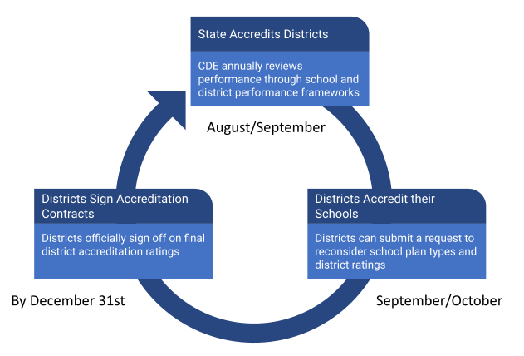
Figure 1. State Accreditation Process

Submitting Accreditation Categories

General Accreditation Process
All districts/Local Education Agencies (LEAs) must submit the Accreditation Form housed within the UIP/ACI online system by September 22, 2023. The form is available to district accountability contacts (access and permissions are described in this guide). The form’s purpose is to:
- Begin the process of finalizing school plan types and district accreditation ratings;
- Provide district updates for unique circumstances (e.g., new schools); &
- Indicate intent to pursue a request to reconsider.
The form includes detailed instructions concerning the required information, including the following:
- A determination from the district on whether it wants to pursue changes to the preliminary plan types. See the section below on “Changes to Ratings” for a description of options;
- Assurance that the district’s selections have been verified by their superintendent/executive director, as well as the local board chair and charter school’s board chair (as applicable).
- If the district does not use the State’s school performance framework and school plan types to accredit schools, the district must attach a description of their accreditation process in the Accreditation Form (details of this process are described in the District Updates section of this document). The methodology must meet or exceed the state’s approach.
Accreditation categories must be submitted to CDE by the district rather than by individual schools. If different school performance frameworks are used for different groups of schools (e.g., charter schools), then the district must attach an explanation of each specific framework in the Accreditation Portal. Figure 2 describes the major steps in the district and school accreditation process in more detail.

Figure 2. Detailed District and School Accreditation Process
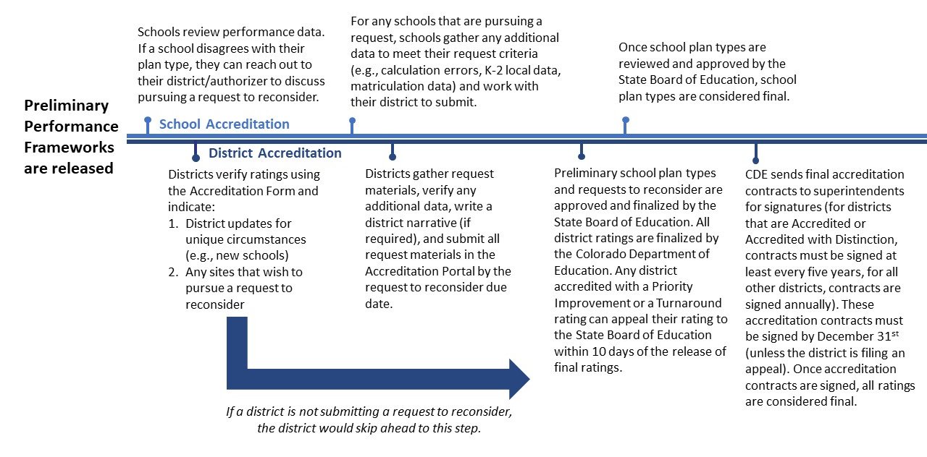
Changes to Ratings. For eligible schools and districts that want to request changes to preliminary performance framework ratings, there are three potential pathways:
- District update: For eligible schools who received the preliminary plan type of (1) “New School”, (2) “Insufficient State Data: No Students at Grade Levels Tested for State Assessments”, or (3) “Insufficient State Data: Small Tested Population” and (4) districts that want to use a district-created School Performance Framework to decrease a school’s plan type. A description of this process is available in the District Updates section of this document.
Note: The State Board of Education is responsible for approving final school plan types and accrediting all school districts in the state annually. Any requests to change ratings are not guaranteed until finalized by the state board. For districts, there is an appeals process described in the Final District Accreditation Rating section of this document.
- Request to reconsider: For eligible schools and districts that meet one of the following conditions for a request, (1) Body of Evidence, (2) Accountability Participation Impact, (3) Calculation Error, (4) Impact of Alternative Education Campuses on the District Performance Framework, (5) Districts with a Single School, (6) Districts with a Closed School, (7) Change to Insufficient State Data, and (8) Grade Reconfiguration. Request to reconsider is limited to changes to overall ratings and/or plan types and will not result in changes to the underlying data available in the performance framework, including the sub-indicator ratings. More information about this process, including a description of these request conditions, is available in the Request to Reconsider section of this document.
- CDE administrative change: Only occurs in rare special circumstances and must be done in consultation with CDE. For these changes, CDE makes the final determination on whether a district is qualified to make a change through this pathway. Before discussing with CDE, the district should consult this guidance to determine whether the request (1) does not meet one of the existing conditions for a district update or request to reconsider and (2) should have been resolved by an existing data collection process that has already occurred (such as the Student Biographical Data collection). To consult with CDE on whether a request may meet a unique condition for consideration, email accountability@cde.state.co.us.
Figure 3 describes each of these pathways for state accountability rating adjustments in more detail.
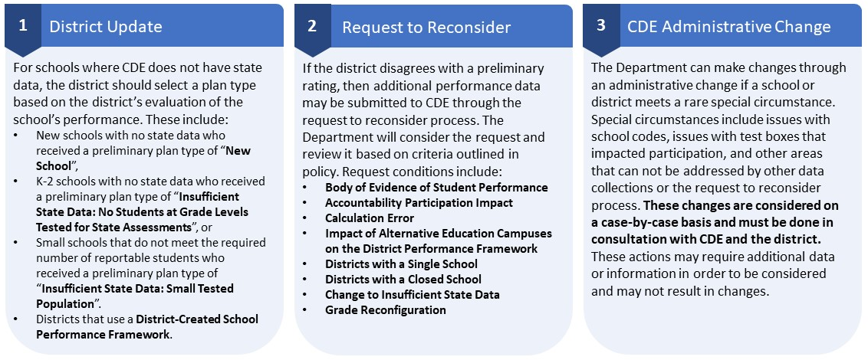
Figure 3. Pathways for State Accountability Rating Adjustments

Form Submission. The Accreditation Form is the first step toward finalizing district accreditation contracts. This is where the district indicates agreement with the preliminary plan types for the district and its schools -- or to indicate the intent to pursue a change to the state’s preliminary plan type assignments. The form guides users to select the accreditation options available for their district (i.e., selecting a rating, no changes, or change requested) and to assure these selections have been verified by the superintendent and local board chair. The form is pre-populated with the preliminary plan types for sites based on the 2023 preliminary plan types.

If assigned staff are having issues accessing the form, contact your district’s Local Access Manager (LAM) and ensure the individual is assigned an “Accountability Contact” role, as described in this guide. The form does not need to be emailed once submitted. The submission is automatic and includes name, email address, and date of submission based on the user’s login information and submission time. See Appendix A: Accreditation Form for a walkthrough of the form.
Finalizing Ratings. For districts that are not participating in a request to reconsider, final plan types will be shared with the State Board of Education for finalization at the November board meeting. Note that districts participating in a request to reconsider have additional requirements and timelines for submission based on their request conditions. Ratings/plan types for those schools and districts will be scheduled for finalization at the December State Board of Education meeting. See the Request to Reconsider section for more information.
Once the district’s rating and all school plan types are finalized, districts that have earned an Improvement, Priority Improvement or Turnaround rating or received an Insufficient State Data rating will need to sign the district’s accreditation contract. Other districts (i.e., Accredited, Accredited with Distinction) may sign their contract or roll it over from the previous year for up to five years. See the Final District Accreditation and School Plan Types section for more information.
Note: If the district does not submit the form by the September 22, 2023 deadline or indicate to the department the need for an extension, the Department will consider the district accreditation rating final and will submit school plan types to the state board for approval and finalization.

District Updates
In Colorado, districts are responsible for accrediting their schools. In accrediting schools, districts must consider a variety of factors. In particular, accreditation categories must be comparable to the state designation or may be more rigorous. There are, however, some unique situations (e.g., new schools, limited state data) that may be addressed through the Accreditation Form so they can be approved and finalized by the State Board of Education. Eligible processes are outlined below.

Accreditation Process for New Schools
Districts should select a plan type for new schools using the dropdown on the Accreditation Form. Since CDE does not have data for these schools, the plan type should be based on the district's own evaluation of the school's performance.

Accreditation Process for Insufficient State Data Ratings
For districts or schools that did not receive a CDE plan type because of low participation on state assessments, not enough state data, or they are small sites that do not meet the required number of reportable students, the accreditation form will be pre-populated with “Insufficient State Data”, “Insufficient State Data: No Students at Grade Levels Tested for State Assessments”, or “Insufficient State Data: Small Tested Population”.
- For districts and schools labeled “Insufficient State Data”: the district will not be eligible to assign an accreditation rating or plan type and will maintain the “Insufficient State Data” rating/plan type and any associated clock status. This rating indicates that the state does not have sufficient information to populate a rating, but the site has enough eligible students to have made a rating possible.
- For districts and schools labeled "Insufficient State Data: Small Tested Population" or “Insufficient State Data: No Students at Grade Levels Tested for State Assessments”: Since CDE does not have data for these sites and the site does not have enough eligible students to make a rating possible, the plan type should be based on the district's evaluation of the site’s performance. If the 2022 rating/plan type was Priority Improvement or Turnaround or the site was considered on performance watch (i.e., on clock, on watch, on hold), including Year 0, the district or school will maintain the "Insufficient State Data" rating/plan type.

Accreditation Process for Using a District-Created School Performance Framework
If a district is using a school performance framework different from the state’s to accredit their schools, the district must attach a description of their accreditation process in the Accreditation Form, including:
  - Performance indicators the district evaluates and the measures, metrics and cut-points used to evaluate them
  - Weighting of the performance indicators the district evaluates, and how they roll up into an accreditation category
  - Accreditation categories for the district’s schools (e.g., the ratings given to schools and how they translate to CDE plan types)
  - Percent of schools in each of the district’s accreditation categories based on the district's school performance framework results
  - Actual accreditation results for the district’s schools (e.g., each school's accreditation report, or an Excel spreadsheet with each school's result)
  - Link to additional information on the district's school performance framework (if available)
If the district-created school performance framework is deemed to be more rigorous than the state school performance framework, CDE will defer to the district-created framework rating only if the rating shows a lower rating than the state school performance framework. If the district-created school performance framework shows a higher rating than the state school performance framework, the district can submit additional evidence through request to reconsider to support the higher rating.
For districts that have not submitted a district-created framework in the past, it is highly recommended that districts work with CDE by August 1st to ensure enough time to evaluate the alternative frameworks. If a proposal is submitted after that date, CDE cannot guarantee qualified staff to provide a thorough review before the finalization of frameworks in that year. There is also the possibility that the Department will not approve or will conditionally approval the district-submitted frameworks. In this case, it is likely the district will not have enough time to address changes before the finalization of frameworks in that same school year. We would anticipate that it may take as long as a year for districts to receive approval.

Request to Reconsider
If, in reviewing overall performance or the performance of an individual school, a district determines that a different accreditation rating or plan type assignment better describes the performance of students, then the district may engage in the request to reconsider process. The process is available to request a change in district rating or school plan type (e.g., request a change from Priority Improvement - Year 2 On Clock to Improvement - Year 2 On Watch based upon additional compelling evidence).
Note: There is no total participation eligibility requirement to participate in request to reconsider in 2023 (unless specified by the request condition). In 2022, the state board instituted a 90% total participation requirement to be able to engage in the request to reconsider process. This participation requirement has expired.
Table 1 has scenarios of the accountability clock over time if approval is granted through the 2023 request to reconsider process. A site can only request a change in rating by one level (e.g., change from Priority Improvement to Improvement). Changes of more than one level are not permitted (e.g., change from Priority Improvement to Performance). For additional scenarios and the requirements associated with each, see the Performance Watch Labels and Progression fact sheet on the CDE website.
Table 1: Examples of Request to Reconsider Results Over Time
2022  Final Plan Type  (Note: Transitional year where clock exit was available through request to reconsider only) | 2023  Preliminary Plan Type  (Automatic clock exit and advancement resumes) | 2023  Final Plan Type  (Approved Request to Reconsider) | 2024  Final Plan Type
Priority Improvement - Y3 On Clock | Priority Improvement - Y4 On Clock | Improvement - Y3 On Watch | Improvement (Fully exited performance watch)
Improvement | Priority Improvement - Y1 On Clock | Improvement (Fully exited performance watch) | Improvement

Request to Reconsider Submission
Districts have the opportunity to review the state identified district or school rating from the performance framework. If a district disagrees with the preliminary rating, the district must indicate “Request Changed Rating” using the Accreditation Form within the UIP/ACI online system. For a walkthrough (including screenshots) of the accreditation form, see Appendix A: Accreditation Form.
Final Submission. Once the Accreditation Form is submitted, an Accreditation Requests tab will be available for each district and school. For any request to reconsider, each tab will include one area to upload evidence and draft a narrative response per district and/or school(s). Final submission of the request form and any accompanying materials is due October 16, 2023. Any requests submitted by the deadline will be considered part of public record. If the district would like to avoid public reporting on a request, the district can select “Rescind Request” at the bottom of each request tab before the deadline. This will also mean that CDE will not review the request any further. For additional support, see Technical Assistance and Support. See Figure 4 for a full timeline of the process.
Note: If a site receives an approved request, this may impact the district or school’s clock expectations (e.g., planning requirements, parent notification) and supports (e.g., EASI grant eligibility).
Figure 4. Timeline for Accreditation and Request to Reconsider Submissions
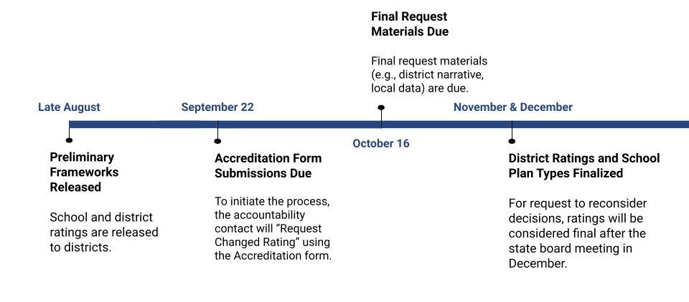

Unified Improvement Plan (UIP) Submission Flexibility for Request to Reconsider Participants
Districts and schools that indicate they are participating in a request to reconsider in the Accreditation Form may request an extension to submit their UIP by January 16, 2024. Districts will make selections for the January submission flexibility in the box on the Plan Details section of the “My District/My School” tab in the UIP/ACI online system. This extension is optional and any districts participating in a request may still choose to submit their UIP or their school’s UIPs during the typical October 16, 2023 due date.

Summary Requirements for a Request
The Department will only consider requests that meet one or more of the conditions for a request in assigning a different district accreditation category or school plan type given through the district or school performance framework report. See Figure 5 for a request decision tree.
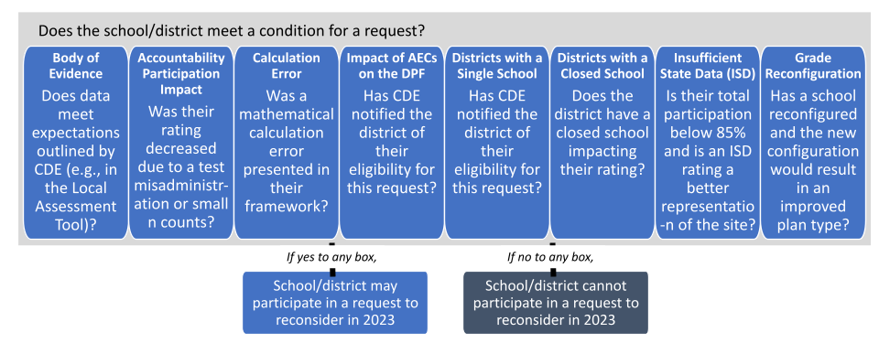
Figure 5. Decision Tree for Making a Request

Districts must submit the following in the Accreditation Portal by the due date:
A complete Accreditation Form (see Appendix A: Accreditation Form).
A district narrative that presents the district’s rationale for participating in the request process and why the district proposes a different accreditation rating or school plan type. See the website for example district narratives. At a minimum, this statement should:
- Include the condition of the request per the next section;
- Include a description of any relevant data analysis or rationale associated with the request.
District narratives are not required for Impact of AECs on the DPF or Districts with a Single School requests.
Submission of supplemental data through the 2023 Local Assessment Tool excel template, the Matriculation Body of Evidence excel template, or other data in coordination with CDE. Attach the completed data templates and any additional required materials (e.g., verification of enrollment/enlistment for matriculation requests) on the Accreditation Changes tab. Supplemental data templates are required only for Body of Evidence requests.
Request to reconsider submissions that do not include all applicable criteria by the deadline of October 16, 2023 will not be accepted. All documentation received by October 16, 2023 will be considered final and part of public record.

Conditions for a Request
A request must meet one or more of the following conditions to be recommended to the state board for approval:

Body of Evidence of Student Performance
Body of evidence requests rely on valid and reliable data demonstrating the progress the district/school has made in its performance on the state’s key performance indicators (i.e., achievement, growth, postsecondary workforce readiness) overall and for individual disaggregated groups, and in meeting the minimum expectations set by the state, district, or the school. Alternative Education Campuses (AECs) are not eligible for this pathway. For body of evidence requests, CDE will review the following supplemental information:
- Local Data Submission for Districts and Traditional (non-AEC) Schools: Student performance on interim assessments is reviewed by CDE, with a performance standard set on these assessments by CDE in consultation with the vendor. Performance data must be submitted using the 2023 Local Assessment Tool excel template. Submissions must be based upon results from student performance in grades Kindergarten through 2nd on nationally normed local assessments and must be representative of the referenced student population. To ensure all local assessment data are appropriate and sufficient for consideration as part of the request process, the following requirements will apply:
  - All local assessment data must come from nationally normed interim or benchmark assessments and include both achievement score results and a growth or progress metric (examples include but are not limited to: NWEA, iReady, STAR, Acadience).
  - Data will only be accepted from non-tested grade levels (e.g., grades K-2). State assessment data ensures comparability between districts and alignment to state standards. Local data is not appropriate to supplant state data in tested grade levels.
  - Minimum 95% participation rate (denominator based on entire enrolled student population) for each applicable grade level or student group is required for consideration. This will ensure local results adequately represent district or school enrollment across included grade levels and disaggregated student groups. Also note that the participation rate has been a long standing requirement for this particular condition.
  - Data must be submitted for English Language Arts (at a minimum) and Mathematics (if it is administered). Data for Science, Social Studies or other locally tested content areas will not be considered for this process.
  - Data should be reported consistently for all grades and student groups administering the same assessment, and CDE may reject requests where data has been selectively reported.
  - Districts and schools must have at least 16 valid student test scores for achievement and 20 for growth. Smaller systems can report grade-specific results that fall below these minimum reporting requirements for consideration in consultation with CDE, but the local data tool will be considered Personally Identifiable Information (PII) and will not be released publicly.
  - All submitted performance data must have been collected during the 2022-23 school year and can only represent the most recent year of result. Submitted achievement data must represent End of Year (e.g., final testing period, Spring) student results, and growth data must represent student progress from Beginning of Year (e.g., Fall) to End of Year (e.g., Spring).
  - Achievement and growth expectations corresponding to the rating categories of Does Not Meet, Approaching, Meets, and Exceeds have been established by CDE using historical national norming information for each assessment.
  - Performance data must be included for all class level/content area/indicator combinations in the framework. Therefore, Insufficient State Data ratings are not permitted to participate in this request type.
  - The tool will automatically score submitted results and total up indicator and overall totals to determine whether the submitted local data results in an improved plan type or district rating. If the tool states your school/district meets the criteria for a request, this does not necessarily mean CDE will recommend the request for approval or that the request will be approved by the State Board. Any supporting documentation will be evaluated on a case‐by-case basis to determine appropriateness for inclusion.
  - If a school or district has questions about the submission process, see the section on Technical Assistance and Support.
- Matriculation Data Submission for Districts and Traditional (non-AEC) Schools: CDE will consider additional data around matriculation that may have not been captured with this measure or included in H.B. 15-1170. Matriculation data must be submitted using the 2023 Matriculation Body of Evidence excel template. To ensure matriculation data are appropriate and sufficient for consideration as part of the request process, the following requirements will apply:
  - Submitted student records must match the students reported in the district/school’s student-level matriculation data file. The denominator of the calculation should not vary from the total student records reported in the performance framework.
  - Submitted student records must capture students who matriculated after the 2022 End-of-Year (EOY) data collection was finalized. This request type excludes EOY data submission and verification concerns which resulted in uncorrected errors on the district/school performance framework(s).
  - A student can only be counted once in the numerator even if that student has multiple pathways (e.g., a student who enlisted in the military and received a CTE credential should only be counted as having matriculated once in the calculation).
  - Performance data must be included for all class level/content area/indicator combinations in the framework. Therefore, Insufficient State Data ratings are not permitted to participate in this request type.
  - Any matriculation data included for this request must also include appropriate documentation and verification of enrollment/enlistment in the Accreditation Portal (e.g., proof of out-of-country CTE, 2-yr/4-yr enrollment, gap year with acceptance letter to higher education institution, evidence of military enlistment, verification of death).
  - The excel template will automatically calculate whether the submitted student records result in an improved plan type or district rating. If the tool states your school/district meets the criteria for a request, this does not necessarily mean CDE will recommend the request for approval or that the request will be approved by the State Board. Any supporting documentation will be evaluated on a case‐by-case basis to determine appropriateness for inclusion.
  - If a school or district has questions about the submission process, see the section on Technical Assistance and Support.
- Postsecondary and Workforce Readiness: The Department will review supplemental trend analysis indicating improved performance over time on additional post-secondary measures. This includes AP/IB exams and/or remediation rates, a minimum 95% participation rate of the applicable student population is required for consideration.
- Small Districts and Schools: For smaller schools and districts, data submitted through the body of evidence may be weighed more heavily. To strengthen the district narrative, small districts and schools should mention any reasons why state data may not be fully representative or may not be able to be reviewed due to small N size.
- Plan for Improvement: Districts and schools may utilize their Unified Improvement Plan to strengthen their district narrative, demonstrate an upward trajectory of student performance, and to describe plans for sustained continuous improvement. To request improvement planning support from CDE, contact uiphelp@cde.state.co.us.
- Extenuating Circumstances: CDE will review supplemental material for districts and schools concerning the extent to which the school or district has been subject to an event that has caused significant disruption during the school year, including but not limited to acts of violence, the death of students or staff, or natural disasters such as fire, flood, earthquake, avalanche or tornado, but not including the broader impacts of the COVID-19 pandemic.
To be considered, the district must complete a district narrative describing the rationale for the request that includes a description of any of the supplemental information the district chooses to submit for their request.

Accountability Participation Impact
Districts and schools who had their rating “decreased due to participation” by not meeting the 95% accountability participation rate in English language arts and math may make a request around the following conditions (requests will not be considered around revising the way the accountability or total participation rate appears on the frameworks or revising the “low participation” or “met participation” descriptors):
- A district or school can request to use the two-year participation rate (or the single year participation rate) if the district or school is not meeting the accountability participation rate requirement in the frameworks.
- CDE will consider issues of N count (i.e., exception for smaller districts/schools) in reviewing requests to reconsider based on participation rates. This includes issues for sites with fewer than 50 students enrolled in tested grades or instances in which one or two non-participants resulted in a decreased rating.
- If the 95% accountability participation rate requirement has not been met due to reasons other than parent refusals, such as test misadministration, the district and school has a clear and justified reason why students did not count as participants, and a plan to ensure participation improves in the future, CDE may consider a request to reconsider. There may be special considerations given to schools or districts with a test misadministration. In rare instances, a test misadministration may deem some tests invalid, and thus, lower the overall participation rating, once parent excuses are removed, for a school or district to less than 95%. Depending on the size of the district or school, particularly smaller sized districts or schools, the few non-participants may have a larger impact on the district or school than it would a larger district. If the district and/or school has historically met the 95% accountability participation rate requirement on state assessments and the district or school acknowledges the errors in the misadministration and has made changes to ensure these errors do not happen in the future, a request may be considered.
To be considered, the district must complete a district narrative describing the rationale for the request that includes any additional data or information that is relevant for the review team.

Calculation Error
Districts and schools may submit a request to reconsider based on a mathematical calculation error in the data presented in the performance frameworks. This generally excludes data issues that should have been addressed through the Student Biographical Data (SBD) collection as that is considered the opportunity for LEAs to make those corrections. To be considered, the district must complete a district narrative describing the rationale for the request that includes any additional data or information that is relevant for the review team.

Impact of Alternative Education Campuses on the District Framework
As per S.B. 13-217 and 1 CCR 301-1, CDE may re-evaluate the accreditation category for districts that serve a significant number of students in Alternative Education Campuses (AECs). CDE recognizes the unique circumstances and needs of students enrolled in AECs, and that the performance frameworks could be considered a disincentive for authorizing AECs. Thus, districts which serve large numbers of AEC students may submit a request to reconsider its DPF rating if it meets the following criteria:
- Removing the data for students enrolled in the AEC(s) from the calculations of the district’s performance on the performance indicators would otherwise cause the district to receive a higher accreditation rating; and
- The AEC(s) has/have earned a Performance plan type; or the AEC(s) no longer serves students.
- For those districts that serve only AEC(s), the calculations of the district’s performance on the Performance Indicators on the AEC School Performance Framework would allow the district to receive a higher accreditation rating.
CDE staff will calculate the impact data on a district’s rating and will notify eligible districts. AEC SPF ratings will not be available until after the release of the preliminary performance frameworks, so once those are completed, CDE will identify which districts are eligible for this request. If recommended for approval through this pathway, the district does not need to supply further evidence (e.g., body of evidence, district narrative). The district does, however, need to complete the Accreditation Form, available in the Accreditation Portal tab within the UIP/ACI online system, to indicate whether the district wants to request a changed rating.

Districts with a Single School
Districts with a single school may elect to use the School Performance Framework rating as the district accreditation rating, when there is only one public school in a district. CDE will notify districts if they are eligible for this condition. If eligible, the district does not need to supply further evidence (e.g., body of evidence, district narrative). The district does, however, need to complete the Accreditation Form, available in the Accreditation Portal tab within the UIP/ACI online system, to indicate whether the district wants to request a changed rating.

Districts with a Closed School
Districts with Priority Improvement or Turnaround Plan types that have closed a district school (e.g., due to low performance), may request a reconsideration for re-calculating the District Framework with the closed school removed. To be considered, the following information needs to be submitted through the request to reconsider process:
- A district narrative asserting how the data reported on the district performance framework is impacted by the closed school and why it does not represent the current student population.
- Data that shows what the district’s rating would be with the closed school removed from performance framework calculations (a template is available here for your use).

Change to Insufficient State Data
For districts and schools experiencing low participation on state assessments, a change in plan type to “Insufficient State Data” may be requested if the district can establish that the tested population is not representative of the overall student population. This option is available only to schools or districts with total participation rates at or below 85%. To be considered, the following information needs to be submitted through the request to reconsider process:
- A district narrative asserting that due to high-levels of parent excuses/non-tested students on the state assessment the data reported on the district and/or school performance framework(s) is not representative of the student population in the district/school and the reasons why.
- Data that shows how the participating students are not representative of the total school/district population (a template is available here for your use).

Grade Reconfiguration
Schools that have changed the grade levels they serve for the 2023-24 school year (e.g., K-8 school that now serve only grades K-5) can request a changed rating based on their new grade configuration. The final rating would be based on the inclusion of the newly added or removed grade levels on the performance framework (e.g., elementary/middle performance framework would now be an elementary performance framework). To be considered, the following information needs to be submitted through the request to reconsider process:
- A district narrative asserting how the data reported on the school performance framework is impacted by the grade reconfiguration and why it does not represent the current student population.
- Data that shows what the school’s rating would be given the adjusted grade levels (a template is available here for your use).

Reviewing and Approving Requests
Upon receipt of any final materials in the Accreditation Portal, the Department will review the request and formulate a recommendation as to the district’s final accreditation rating or the school’s plan type. The review will be conducted by a cross-unit CDE team. CDE staff will evaluate the extent to which the request meets the conditions and criteria outlined in this document and whether the additional evidence supports a different rating. The staff will then make a recommendation to the Commissioner as to the district's final accreditation rating and school plan types. The Commissioner will request the state board to approve the Department’s recommendations on school plan types at the State Board of Education Meeting in December. All ratings will be considered final after the state board votes to approve in December.
If a request is not recommended for approval: If a request does not meet expectations, then the Department will not recommend the request for approval to the State Board of Education. The site’s rating or plan type would remain unchanged and all clock expectations (e.g., planning requirements, parent notification) and supports (e.g., EASI eligibility) would continue. Note that any final submissions for request to reconsider are considered public record, even if the requests are not approved. If the district would like to avoid public reporting on a request, the district can select “Rescind Request” at the bottom of each request tab before the October 16 deadline. In addition, schools and districts can utilize office hours or contact CDE for support on requests before they are submitted (see the section on Technical Assistance and Support for details).
If a request is recommended for approval: If after consideration of the additional evidence through the request to reconsider process, the state board approves the recommended district accreditation category or school plan type, only the final determination will be reported on the district or school performance framework report posted online on SchoolView. Note, however, that the initial data on the performance indicators and percent of points earned will not change.

Note on Alternative Education Campuses
The Selection of Measures process for Alternative Education Campuses (AECs), which includes participation in the AEC Actual Measures and Data Pipeline Collection, is currently the process whereby CDE accepts and incorporates local measure data into the AEC School Performance Framework for both schools with an AEC designation already in place and schools which are receiving an AEC designation for the first time. Note that the inclusion of local data or measures is not an option for districts to submit for the AEC performance framework for the Body of Evidence condition through the request to reconsider process; therefore, submission of these local measures through the Selection of Measures process (the Actual Measures and Data Pipeline Collection) must occur before the frameworks are generated.

Note on Schools and Districts on Performance Watch (including Sites with Board Orders)
For schools and districts with board orders, an approved request may impact a number of things, including requirements (e.g., improvement planning, parent notification), grants and supports (e.g., EASI prioritization or even eligibility), and a state board order (if applicable). For sites with a board order that are eligible, districts should indicate on the Accreditation Form whether the site would like to change or remove their board order in the “District Narrative” box. Discuss the implications of this change with your district’s assigned Turnaround Support Manager.

Final District Accreditation Rating and School Plan Types
The State Board of Education is responsible for annually accrediting all school districts in the state. The Department will finalize district ratings and make its final recommendations on final plan types to the State Board of Education as early as November 2023. For schools and districts participating in request to reconsider, the Department will finalize district ratings and make final recommendations on new plan types to the state board no later than December 2023. Current accreditation contracts are available here: https://www.cde.state.co.us/accountability/districtaccreditation.

District Appeals Process
If a district does not agree with their accreditation category of Accredited with Priority Improvement Plan or Accredited with Turnaround Plan once finalized, the district has the opportunity to file an appeal to the state board. The district must provide written notice to the State Board Office their wish to appeal within ten days of receiving notification of their final accreditation rating (for additional detail on next steps, see 1 CCR 301-1, section 5.11: “Rules for the Administration of Accreditation of School Districts”).

Accreditation Contract
The accreditation contract documents that the district is in good standing with the state and remains in compliance as laid out by state statute and regulated by the state board.
Districts Accredited with Insufficient State Data, Improvement, Priority Improvement, Turnaround: Once district accreditation ratings and school plan types are finalized by the State Board of Education in November and December, districts must annually complete the accreditation contract for their district. The accreditation contract will be made available to superintendents via DocuSign and must be signed by both the district superintendent and the local school board president by the end of December.
Districts Accredited or Accredited with Distinction: If requested by the district or local board, a customized accreditation contract will be made available to superintendents via DocuSign; district superintendent and board presidents will have until the end of December, to sign it. Otherwise the existing contract will be automatically renewed. Contact accountability@cde.state.co.us to request an updated contract. CDE recommends that a new contract be signed when there is a new superintendent and/or board president. Otherwise, contracts must be signed at least every five years.

Technical Assistance and Support
Informational Webinar and Office Hours: CDE staff will hold an accreditation and request to reconsider informational webinar Thursday, Aug. 17 at 1pm. Click here to register. This webinar will be recorded and posted publicly on the request to reconsider website. If a district would like individualized assistance from CDE, register for Office Hours (held via Zoom) here. Office Hours will begin Thursday, Aug. 17 and will be held from 3-4 pm every Tuesday and Thursday until the request to reconsider process concludes.
General Request to Reconsider Questions and Support: Contact accountability@cde.state.co.us or Aislinn Wales, wales_a@cde.state.co.us or (720) 614-2151.

Request to Reconsider Tools and Resources
Local Assessment Tool: CDE has created the 2023 Local Assessment Tool template in Microsoft Excel for districts and schools to submit local Kindergarten through 2nd grade data as part of the Body of Evidence pathway. The intention for this template is to minimize the level of effort required when submitting additional data for untested grade levels and student groups and shorten the timeline for CDE to approve requests. To assist in the submission process, CDE has created an accompanying resource that describes considerations for how to find the data that is needed for the Local Assessment Tool. This document, Finding Achievement and Growth Data for the Local Assessment Tool, includes participation considerations and where achievement and growth data is located for each of the major interim assessment platforms included within the tool. To ensure a successful submission, the district should submit the completed template in the Accreditation Portal along with a district narrative describing why the district is participating in a request. Contact CDE for the following:
- To submit a nationally normed assessment that is not listed in the tool. The assessment must have both an achievement and growth measure and must include benchmarks or cut points associated with Spring achievement data and Fall to Spring growth data.
- To submit multiple years of data. Before contacting CDE, the school or district must demonstrate that the data is comparable to the data from the 2022-2023 school year (e.g., testing modalities are comparable across time and student participation was consistent across time).
- To submit data not included in the 2023 Local Assessment Tool. The Department may be able to analyze the local data using past templates, however, it will lengthen the overall process and may not result in an approved request. If the same assessment is available in the 2023 tool as in past templates, the school or district must use the 2023 template (which has updated cut scores and benchmarks from the vendors).
- To discuss any concerns with the tool or the submission process in general.
Matriculation Body of Evidence Request Template: CDE has created the Matriculation Body of Evidence template in Microsoft Excel for districts and schools to determine whether adding students that may have been miscoded or matriculated after the End of Year Collection window (e.g., students who took a gap year and then matriculated) would result in a change to the overall rating on the performance framework. The school or district must use the student level matriculation data file (shared through Syncplicity) to determine which students may have been miscoded as not having matriculated where the school/district has evidence otherwise. To ensure a successful submission, the district should submit the completed template, any documentation, and a district narrative that describes why the district is participating in a request in the Accreditation Portal. Contact CDE for the following:
- To discuss what type of documentation is needed. In order to verify that a student has matriculated, CDE needs documentation that shows the matriculation option for that student (i.e., 2-year, 4-year, CTE, military). There are a variety of sources that may be applicable. CDE can discuss what would be appropriate for the district to investigate.
- To discuss any concerns with the tool or the submission process in general.
Example of the Request to Reconsider Excel Templates
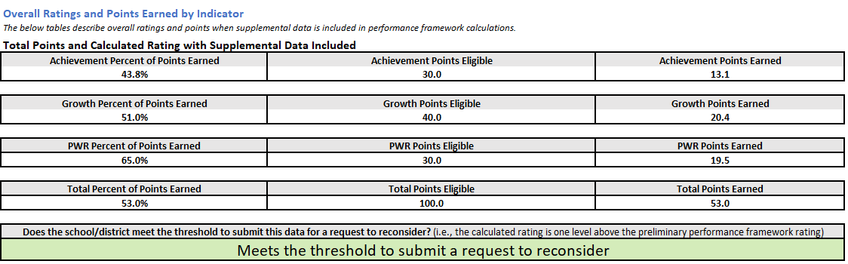
District Narrative Examples: CDE has created district narrative templates for multiple request types. In addition, CDE provided examples of past district narratives to support districts in completing this requirement.
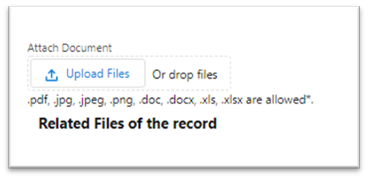
Feedback from CDE on Submission: If a district would like to share either the Local Assessment Tool or the Matriculation Body of Evidence Request template with CDE staff for feedback, it must be attached to the Accreditation Portal in the online system (see image). Student Personally Identifiable Information (PII) should not be sent over email and will not be accepted. This process is optional. Schools and districts must submit the final version in the portal by the final October 16th due date.

Appendix A: Accreditation Form
This form is used to verify district ratings, school plan types, and clock statuses and to indicate participation in a request to reconsider. If anyone in the district is having issues accessing the form, contact the district’s Local Access Manager (LAM) and ensure the individual is assigned an “Accountability Contact” role, as described in this guide. For additional support, fill out the assistance request form using your district’s information.

Accreditation Form (Login Page)
To log in, go to the UIP/ACI online system login page, located at https://www.cde.state.co.us/uip/uip-online-system.
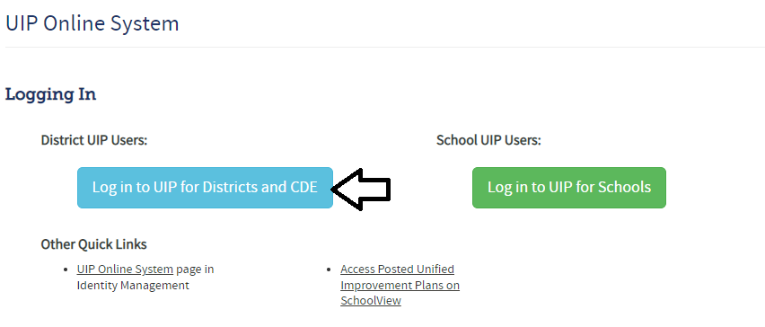

Accreditation Form (Main Page)
To find the form, go to the “Accreditation Portal” tab at the top of your screen (shown below).
The form includes instructions for the various accreditation pathways (e.g., new schools, insufficient state data ratings, requests to reconsider). The form is pre-populated with the preliminary ratings/plan types/clock year for schools and districts (it does not reflect any request to reconsider decisions). The form guides users to select the accreditation options available for their district (either “No Change Requested” or “Request Changed Rating”). Dropdowns are available for new schools or eligible Insufficient State Data ratings to select a rating type based on the district’s evaluation of performance.
Select “No Change Requested” (if the district does not want to participation in a request to reconsider for that site) or “Request Change Rating” (if the district does want to participate in a request to reconsider for that site).
Select rating using the dropdown (for new schools or Insufficient State Data: Small Tested Population or Insufficient State Data: No Students Tested)
Submit the form and submit the assurance.
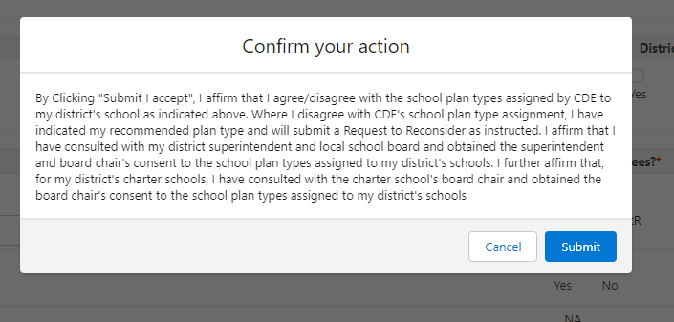

Accreditation Form (Request to Reconsider Tab)
Once the form is submitted, an Accreditation Requests tab will appear for each site (click on Accreditation Requests to see the tab).
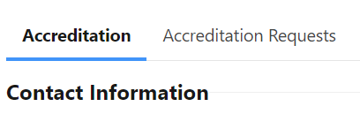
Each site that is eligible for a request will have their own tab. Complete the dropdown for the request type and submit any additional materials required for that condition on each tab. Once all tabs are submitted, your requests are complete. See the “Status” indicator for whether you have successfully submitted each tab.

Appendix B: Grade Configurations and State Data Availability
The charts below show the state-level data* (English language arts/evidence-based reading and writing, math, and science) available by grade level.
2023 Achievement Data Availability at each grade level:
Grade/ Subject | K | 1 | 2 | 3 | 4 | 5 | 6 | 7 | 8 | 9 | 10 | 11 | 12
ELA/EBRW | N/A | N/A | N/A | Yes | Yes | Yes | Yes | Yes | Yes | Yes | Yes | Yes | N/A
Math | N/A | N/A | N/A | Yes | Yes | Yes | Yes | Yes | Yes | Yes | Yes | Yes | N/A
Science** | N/A | N/A | N/A | N/A | N/A | N/A | N/A | N/A | N/A | N/A | N/A | N/A | N/A
2023 Growth Data Availability at each grade level:
Grade/ Subject | K | 1 | 2 | 3 | 4 | 5 | 6 | 7 | 8 | 9 | 10 | 11 | 12
ELA/EBRW | N/A | N/A | N/A | N/A | Yes | Yes | Yes | Yes | Yes | N/A | Yes | Yes | N/A
Math | N/A | N/A | N/A | N/A | Yes | Yes | Yes | Yes | Yes | Yes | Yes | Yes | N/A
Science | N/A | N/A | N/A | N/A | N/A | N/A | N/A | N/A | N/A | N/A | N/A | N/A | N/A
*WIDA ACCESS achievement data is not included in performance frameworks but is included on the CDE website. ACCESS growth results are included in performance frameworks and are available on the ACCESS growth results page.
**Science achievement results are informational in 2023 and are not included in the 2023 performance frameworks for points.
2023 Postsecondary Workforce Readiness Data Availability:
For high school grade levels, postsecondary and workforce readiness data reported in the frameworks (i.e., graduation, dropout, matriculation rates) are lagged from the 2021-22 school year.

Note: The word “district” is used as an umbrella term throughout this document and captures traditional school districts, Boards of Cooperative Educational Services (BOCES), and the Colorado Charter School Institute.

